Nofit LRT Extension
Building the Car, Bus and Rail Demand Matrices from the Travel Habits Survey
Methodology, tests and results, in plain language
Date: 20 September 2026
Notebooks: THS_2017_cosine_GEH_tests, THS_2017_KS_tests, THS_2017_MSSIM_tests, THS_2017_two_mode_matrix, THS_2017_three_mode_2022
Outputs: Output/ths2017/tests/, Output/ths2017/two_mode/, Output/ths2017/three_mode_2022/

Contents

1. Summary
This report explains how a new set of morning-peak travel demand matrices was built for the Nofit LRT extension study, how it was tested, and what the results say. It is written for readers who know what a demand matrix is but do not want to read the code.
Three pieces of work are covered:
- Tests. A series of similarity tests (cosine similarity, GEH, Kolmogorov–Smirnov and structural similarity) comparing the household survey matrix, the cellular-phone matrix and the hybrid matrix that combines them.
- A survey-only matrix. A matrix built only from the survey trips file, split into car and transit, with the bus part corrected using RavKav ticketing data and the on-board bus survey.
- A 2022 base. That matrix moved from its 2018 base year to 2022 and split into three matrices: car, bus and rail.

The main numbers
Matrix (morning peak 6:00–9:00, both trip ends inside the study area) | 2018 base | 2022 base
Car | 1,283,589 | 1,353,798
Bus (public bus, Matronit and shared taxis) | 128,920 | 131,504
Rail (door-to-door survey trips) | 5,109 | 4,050
Bus share of car + bus + rail | 9.1 % | 8.8 %
Bus share, trips with both ends in the LRT corridor | 14.7 % | 14.0 %

The main findings
- Survey versus cellular. The two matrices agree on the broad regional pattern (cosine 0.92 at superzone level, far above chance) but disagree on volumes and trip lengths. The survey expands to 3.6 times the cellular morning volume, and the gap is largest for short trips: the survey's median trip is 2 km, the cellular one 7.6 km. Even with all trips inside one cellular zone removed, the gap stays.
- The hybrid. It equals the survey at superzone level and follows the cellular structure below it, which is what its design intends.
- Ticketing coverage is uneven. In the Haifa metropolitan superzones the ticketing data records about as many bus boardings as the survey expands to (ratio 0.9–1.5). In seven superzones — the Nazareth area, Shefa-'Amr / Tamra, Sakhnin, Daliyat al-Karmel / Isfiya, Ma'alot, Safed and Beit She'an — it records only a fifth to two fifths. These are mostly Arab-sector and peripheral localities. We read this as a coverage gap in the ticketing extract, not as a survey error, and kept the survey volumes there.
- Calibration works where it is applied. Where ticketing is trusted, the calibrated bus matrix agrees much better with the ticketing matrix than the raw survey did (on the 28 sub-areas: 67 % of bus flow within GEH 5, against 30 % before, which equals the survey's own day-to-day agreement).
- Moving to 2022. Car grows 5.5 % on population and employment growth; bus is anchored to 2022 ticketing counts; rail follows the national ridership drop. Trip rates per person are held at the 2018 survey level.

2. The data used
Source | What it is | How it is used here
Travel Habits Survey 2018, trips file (trips_ths_2017.xlsx) | One row per activity for 16,401 surveyed people on two survey days (day 1 and day 2). Each row carries the zone, the departure hour, the mode used to get there and an expansion weight. | The base of everything: trips are formed from consecutive activities, kept if they leave between 6:00 and 9:00, and expanded with the weights. The older activities file (days 10 / 20) is not used.
Cellular OD matrix 2018–19 | Morning-peak trips between 1,270 national zones, from phone records, average weekday. | Only in the tests, as the second view of the same travel. Not used in the survey-only matrix.
RavKav bus ticketing, May 2022 | Every bus journey on four Tuesdays: boarding and alighting stops, linked transfers, expansion to all passengers. | Sets how many bus journeys start in each superzone. Journeys are counted once, not per transfer.
On-board bus survey, 6:00–9:00 | For each boarding zone, where passengers said they were going. | Sets the destination pattern of bus trips where the household survey is too thin.
Zonal socio-economic files 2020 and 2025 (BU scenario) | Population and employment per zone, observed 2020 and forecast 2025. | Splits big survey zones into study zones, and grows the matrix from 2018 to 2022.
Train smartcards 2019 | Station-to-station morning trips. | A rail alternative for corridor loading; the survey rail matrix is the door-to-door one.
Zone keys and TAZ map | Links between the survey's zone system, the cellular zones, the 778 study zones (TAZs), 36 superzones and 28 named sub-areas; zone centroids. | Zone conversion; trip lengths.

Words used in this report
- OD matrix. A table with one row per origin zone and one column per destination zone. Each cell holds the number of trips from that origin to that destination in the morning peak.
- TAZ, superzone, sub-area, corridor. The 778 study zones. Superzones group them into 36 larger areas; the 28 sub-areas are named districts around the LRT corridor; the corridor itself is 119 TAZs.
- Expansion weight. The number of real trips each surveyed trip stands for. A survey of about 4,100 households is scaled up to the whole population this way.
- Destination pattern. The share of an origin's trips going to each destination, ignoring how many trips the origin makes. Comparing patterns separates "where do people go" from "how many travel".
- Shrinkage (empirical Bayes). When a survey zone has too few observations, its destination pattern is pulled part-way toward a reference pattern. The pull is weaker the more observations the zone has. The strength is a single number, k, chosen by testing on held-out data.
- Furness (iterative proportional fitting). A standard way to scale a matrix so that its row totals and column totals hit given targets while keeping its internal pattern.

3. Part A — the survey-only matrix

3.1 From activities to trips
The survey file lists the places each person visited during the day, in order. A trip runs from one place to the next. Its departure hour is the hour the person left the first place, and its mode is the mode used to reach the second place. Trips leaving between 6:00 and 9:00 are kept. Each trip counts with its expansion weight. Trips with either end outside the study area are set aside (about 5 % of the weight).
The two survey days are averaged cell by cell to give a representative weekday. The two days are also kept separately, because their agreement with each other is the yardstick for every test: no other source can be expected to match the survey better than the survey matches itself on another day.

3.2 From survey zones to study zones without cellular data
The survey records places in a national system of 2,636 zones. A key file maps them to 1,250-zone units, and each of those holds up to eight study TAZs. The earlier pipeline split trips among those TAZs using cellular flows. For the survey-only matrix, the split uses the 2020 zonal file instead: trips are shared out among a zone's TAZs by population on the origin side and by employment on the destination side. Where a zone has no population, employment is used, and where it has neither, the split is equal.
Below the 1,250-zone level the TAZ detail is therefore a population / employment split, not something the survey observed. Superzone and sub-area figures are the fair level for judging the survey.

3.3 Modes
The trips file codes the main mode of each trip. The codes were read through the file's own mode groups and the 2018 codebook:
Component | Main mode codes | Weekday trips (2018) | Treatment
Car | 10 driver, 11 passenger | 1,283,589 | Survey only
Bus | 3 public bus, 4 Matronit | 116,083 | Calibrated to ticketing (Part C)
Taxi-type | 5 special taxi, 8 group taxi | 18,266 | Survey only; folded into the bus matrix in 2022
Rail | 7 train | 5,109 | Survey only
Other (walk, bicycle, …) | 1, 2, 9, 12, 13, 99 | 645,111 | Reported, not part of the car / transit matrices

Before calibration, transit (bus + taxi-type + rail) is 9.8 % of car + transit trips.

4. Part B — how the survey compares with the cellular and hybrid matrices
Four families of tests were run on three matrices: the survey (built from the trips file exactly as in the pipeline), the cellular matrix (with each cellular trip counted once when converted to TAZs), and the primary hybrid matrix. All tests are run at four levels: 36 superzones, 25 GS zones, the 28 sub-areas and the 778 TAZs.
Two yardsticks are used everywhere. The first is the survey's day 1 against its day 2: this is the best agreement anyone can expect, because it is the same survey on another day. The second is a chance level, obtained by scrambling the geography of one matrix and repeating the test: anything at that level is meaningless.

4.1 Cosine similarity — is the demand in the same cells?
Cosine similarity lays both matrices out as long lists of cells and measures the angle between them. It equals 1 when the two lists are proportional, and it ignores the total volume. It is driven by the largest cells, so it is also computed without the diagonal (trips that stay inside one zone) and on destination patterns.
Level | Day 1 vs day 2 | Survey vs cellular | Hybrid vs cellular | Hybrid vs survey | Chance level
Superzone (36) | 0.996 | 0.915 | 0.917 | 1.000 | 0.58
GS (25) | 0.999 | 0.953 | 0.963 | 0.994 | 0.28
Sub-areas (28) | 0.997 | 0.897 | 0.902 | 0.960 | 0.20
TAZ (778) | 0.972 | 0.442 | 0.734 | 0.432 | 0.14
Cosine similarity of the raw matrices. Chance level = mean over 2,000 (300 at TAZ) geography scramblings.
What it says: the survey and the cellular matrix share a real regional pattern (0.92 at superzone level, against 0.58 by chance), but they are well below the survey's own consistency (0.996). At TAZ level the survey and cellular agree only at 0.44; the hybrid, which was built on the cellular structure, sits at 0.73. Per origin, the worst-matching superzones are the corridor superzones 10 and 11, and the mismatch there is on the diagonal: without it they score 0.75 and 0.69.
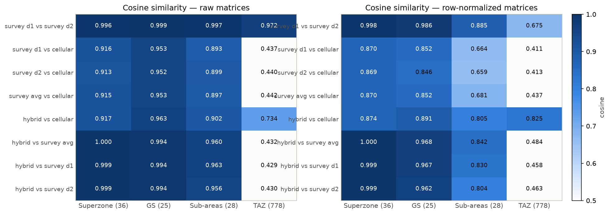
Figure 1. Cosine similarity for every pair and level, raw matrices (left) and destination patterns (right).

4.2 GEH — cell by cell, are the volumes within the usual tolerance?
GEH is the statistic used to validate traffic counts. For two hourly flows m and c it is the square root of 2(m − c)² / (m + c); values under 5 are usually called a good match and under 10 acceptable. The three-hour matrices are divided by 3 first. Because GEH needs a common scale, it was run in two ways.

The scale audit
Before any rescaling, the survey carries 2,068,158 morning trips inside the study area and the cellular matrix 580,506: 3.6 times more. On trips between different cellular zones the ratio is 2.2. The difference is in short trips: 47 % of survey trips stay inside one cellular zone, against 14 % of cellular trips. After one overall scale factor, only 11 % of superzones have origin totals within GEH 5 of each other. In plain words, the cellular product misses many short trips and its zone totals differ from the household expansion by more than a single factor. This answers the first part of task B1 in the task list.

The pattern test
The cellular matrix was then given the survey's origin totals (so each origin has the same departures in both) and compared cell by cell. The share of flow within GEH 5 is:
Level | Day 1 vs day 2 | Survey vs cellular | Hybrid vs cellular | Hybrid vs survey
Superzone | 46 % | 6 % | 5 % | 94 %
GS | 39 % | 1 % | 2 % | 52 %
Sub-areas | 63 % | 9 % | 13 % | 15 %
TAZ | 79 % | 46 % | 67 % | 39 %
Share of flow in cells with GEH < 5, hourly flows, cellular given the survey's origin totals.
GEH is harsh at aggregate levels because the cells are large (a superzone cell can carry 6,000 trips an hour, where GEH 5 means about ±4 %). Even the two survey days pass in under half of superzone flow. Read against that ceiling, survey and hybrid agree with cellular on 5–13 % of flow at the aggregate levels, against 39–63 % for the two survey days. At TAZ level the hybrid is closest to cellular, as designed.
For the corridor: the cellular pattern puts 1.8 times the hybrid's flow from outside into the corridor, and 0.75 times its flow inside the corridor. Cellular sees the corridor as a stronger attractor of inbound trips and a weaker container of local ones. The biggest disagreements are the internal cells of Kiryat Motzkin–Bialik, Kiryat Ata South, Tirat Carmel and Kiryat Yam.

4.3 Kolmogorov–Smirnov — are the trip lengths the same?
A KS test compares two distributions and reports D, the largest gap between their cumulative curves, and where that gap sits. Here it was applied to the distribution of trips by straight-line centroid distance (the trip length distribution), with and without the diagonal, per origin superzone, per corridor class, and to how concentrated each matrix is in its big cells. No classical p-values are reported: the expansion weights would make everything significant. Instead D is judged against the day 1 vs day 2 value and against a household bootstrap of the survey (200 resamples).
Distribution | Day 1 vs day 2 | Survey vs cellular | Hybrid vs cellular | Hybrid vs survey
Trip length, all cells | 0.009 | 0.423 | 0.249 | 0.192
Trip length, without intra-TAZ cells | 0.011 | 0.374 | 0.242 | 0.153
Trip length, without intra-cellular-zone cells | 0.009 | 0.301 | 0.179 | 0.185
Per-origin trip length (flow-weighted) | 0.034 | 0.450 | 0.284 | 0.236
Trip length, corridor to corridor | 0.017 | 0.387 | 0.276 | 0.123
Flow concentration, TAZ level | 0.028 | 0.499 | 0.310 | 0.252
KS statistic D (largest gap in cumulative trip share).
What it says: the survey and the cellular matrix describe different trip-length populations, not noisy versions of one. The median centroid distance is 1.95 km in the survey, 7.6 km in cellular and 3.8 km in the hybrid; the bootstrap spread of D is about ±0.01, so a D of 0.42 is nowhere near noise. The gap is not only the diagonal: with every cell inside one cellular zone removed, D is still 0.30 and sits at 4.5 km, so the cellular product is also short of trips between neighbouring zones. Every origin superzone shows it (D from 0.28 to 0.72, worst in the corridor superzones 10 and 11). Inside the corridor the hybrid keeps the survey's lengths (D = 0.12 against the survey). The cellular matrix is also far more diffuse: 52 % of its trips sit in cells with fewer than 10 trips an hour, against 11 % of survey trips.
One calibration check: against the distances the survey itself reports, the centroid proxy overstates short trips (median 1.95 km versus 1.11 km reported). Both matrices carry the same proxy, so the comparison is fair, but absolute lengths under 1 km are a zone-geometry artefact.
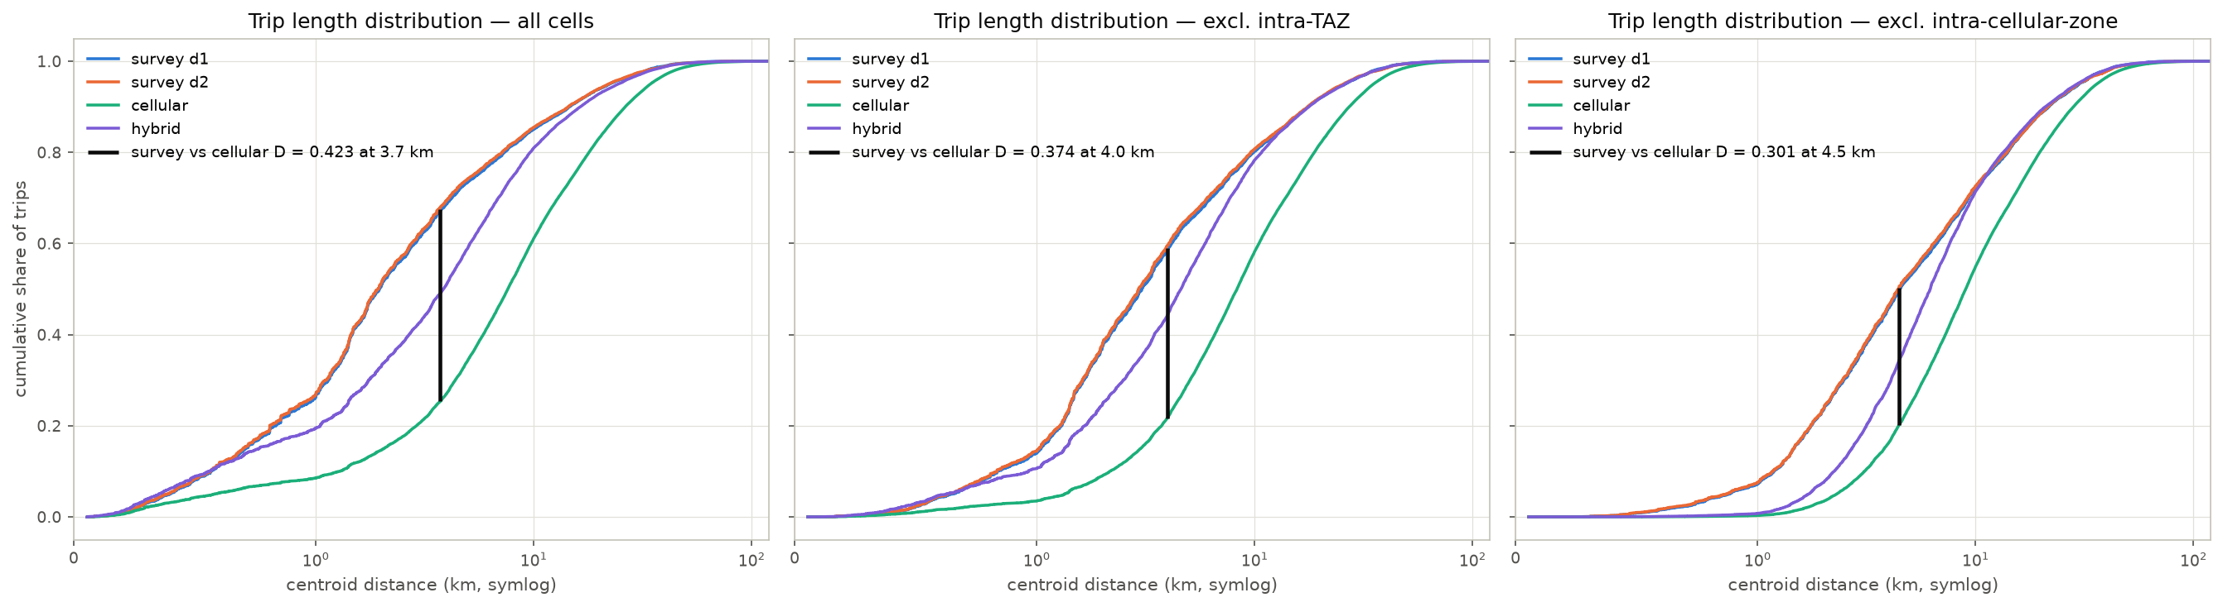
Figure 2. Cumulative trip length distributions; the black bar marks the KS gap between survey and cellular.

4.4 MSSIM — do the matrices agree neighbourhood by neighbourhood?
The structural similarity index comes from image comparison and was proposed for OD matrices by Djukic, van Lint and Hoogendoorn. It slides a small window over the matrix and compares, inside each window, the average level, the spread and the correlation of the two matrices, then averages over windows. It rewards getting the neighbourhood right: trips moved to an adjacent zone cost little, trips moved across the region cost a lot. For that to work, neighbouring rows must be neighbouring zones, so TAZs were ordered along a space-filling curve of their centroids. Windows of 5 to 25 zones were tested, on raw trips and on log(1 + trips).
Level, window, scale | Day 1 vs day 2 | Survey vs cellular | Hybrid vs cellular | Hybrid vs survey
TAZ, 9, raw trips | 0.999 (0.98) | 0.993 (0.99) | 0.978 (0.93) | 0.994 (0.99)
TAZ, 9, log | 0.814 (0.14) | 0.128 (0.02) | 0.475 (0.03) | 0.388 (0.11)
Superzone, 3, log | 0.686 (0.07) | 0.362 (0.09) | 0.441 (0.09) | 0.938 (0.06)
Sub-areas, 3, log | 0.619 (0.07) | 0.257 (0.05) | 0.678 (0.08) | 0.370 (0.06)
MSSIM; the chance level (one matrix's zones scrambled) in brackets.
What it says: on raw trips the index cannot tell anything apart. Every pair, and the chance level, scores about 0.99, because the index's constants are set from the largest cells and those swamp the small cells that make up almost the whole matrix. On the log scale it becomes informative. Survey against cellular is close to chance at TAZ level (0.13, chance 0.02, ceiling 0.81) and its weakest term is the local level, which is the short-trip gap seen window by window. The hybrid sits between its two sources: it is the survey at superzone level (0.94) and closer to cellular on the sub-areas (0.68). The zone ordering and the window size change the results by less than 0.05.
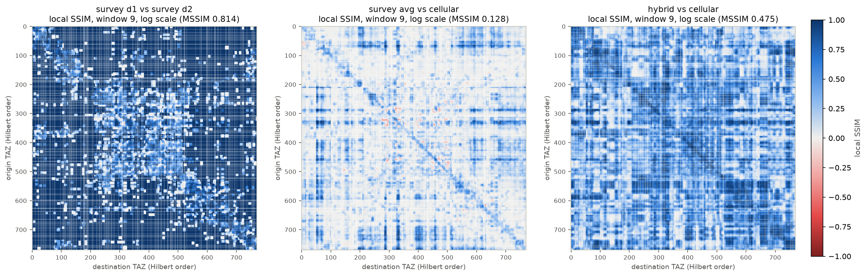
Figure 3. Local similarity maps (window 9, log scale): where the matrices agree (blue) and where they do not (white).

4.5 What the tests mean together
- The survey and the cellular product see the same broad geography but a different mix of trips. The cellular product misses short trips and spreads the rest thinly across many cells; the survey is concentrated and short. This is a difference in what each source records, not sampling noise.
- Survey rows are stable from day to day at superzone level, thin at TAZ level. That is why any fusion should take the survey's pattern at the superzone scale and borrow finer structure elsewhere.
- The hybrid does exactly that, and the tests confirm it: identical to the survey at superzone level, closest to cellular below it. Its corridor cells inherit the survey's short-trip character.
- Absolute volumes rest on the survey expansion only; the cellular product cannot anchor them until its trip definition is known.

5. Part C — calibrating the bus part with RavKav and the on-board survey

5.1 Why calibrate, and what each source is good at
The household survey observed about 820 bus trips a day across 36 superzones, so many superzones have only a handful of bus trips and their destination patterns are noisy. Two other sources describe the same bus travel:
- RavKav ticketing is close to a census. It says how many people boarded where, on four Tuesdays in May 2022, with transfers linked so each journey is counted once. Its weak point is destinations, which are inferred by an algorithm, and its origins are boarding stops rather than homes.
- The on-board survey asked passengers where they were going, so it gives a good destination pattern per boarding zone, but no volumes.
The repository already combines the two into a "RavKav × on-board" matrix: ticketing volumes spread over on-board destinations. The calibration lets each source do what it is good at, at the scale where it is reliable, in the same spirit as the cellular hybrid.

5.2 The three steps
- Step 1 — destination pattern. At superzone level, each origin's survey destination pattern is blended with the RavKav × on-board pattern. The weight on the survey is n / (n + k), where n is the number of survey bus trips observed from that origin and k is a constant chosen by validation (see 5.3). Origins with many observations keep their own pattern; thin ones lean on ticketing.
- Step 2 — volumes. The survey's bus departures per superzone are replaced by the RavKav journey boardings of that superzone, where ticketing is a credible census (see 5.4 for where it is not).
- Step 3 — TAZ detail. Inside each origin superzone, the split of departures among TAZs blends the survey's home-based shares with RavKav boarding shares, with the same weight as step 1. Inside each destination superzone, the split of arrivals blends survey arrival shares with on-board alighting shares.

5.3 Choosing the shrinkage constant
The cellular hybrid chose k by cross-day validation: a blend built on day 1 has to predict day 2. Here that criterion gave k = 0, meaning "never lean on ticketing at all". That answer is suspect. The two survey days are the same households, and bus commuters repeat the same trip on both days, so day 2 is not an independent test of day 1. Instead the sampled households were split at random into two halves, forty times, and the blend built on one half had to predict the other half. That criterion has a clear best value at k = 5. With it, the survey weight is 0.86 on average (from 0.29 in the thinnest superzones to 0.97 in the best observed).
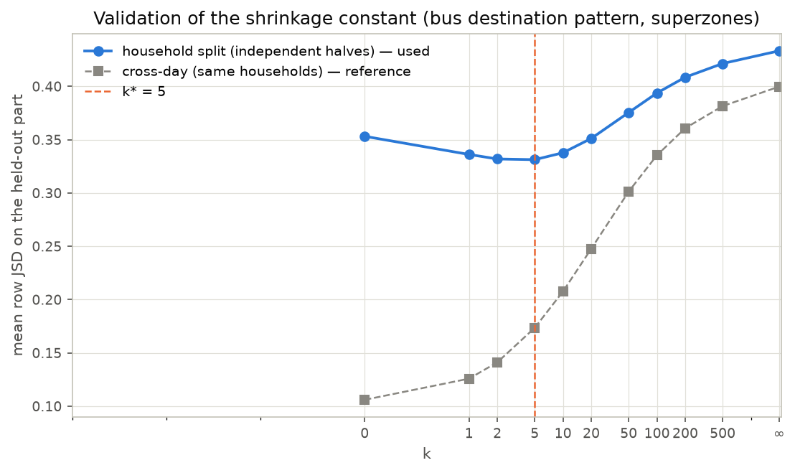
Figure 4. Prediction error of the held-out half (blue, used) and of the other survey day (grey, reference) against the shrinkage constant k.

5.4 What the ticketing data covers
Comparing RavKav boardings with survey bus departures per superzone gave a clear geographic pattern. Across the Haifa metropolitan area the ratio is 0.9 to 1.5, consistent with the regional level of 0.8 and the modest ridership decline documented for 2018 to 2022. In seven superzones it is far lower:
Superzone | Main localities | Survey bus departures | RavKav boardings | Ratio | Survey trips observed
19 | Nazareth, Kafr Kanna, Reineh | 12,429 | 2,643 | 0.21 | 88
30 | Sakhnin, Arraba | 1,017 | 290 | 0.28 | 10
34 | Ma'alot-Tarshiha, Beit Jann | 2,783 | 888 | 0.32 | 30
33 | Safed and surroundings | 3,156 | 1,058 | 0.34 | 21
37 | Beit She'an valley | 1,917 | 722 | 0.38 | 13
4 | Shefa-'Amr, Tamra | 2,073 | 872 | 0.42 | 35
23 | Daliyat al-Karmel, Isfiya | 1,828 | 789 | 0.43 | 29
Superzones where the ticketing data records less than half the survey's bus trips.
These seven superzones are 76 % Arab-sector population, against 19 % elsewhere. A five-fold gap on 88 observed trips (Nazareth) cannot be sampling noise. The raw ticketing file records about 3,500 morning boarding legs in the Nazareth superzone against 12,400 survey-expanded bus trips, so the shortfall is in the ticketing volume itself, not in how journeys were placed on the map. The files carry route ids but no operator field, so we cannot tell which operators the extract covers; that question has been added to the task list for the data provider.
Rule adopted: where the ratio is below 0.5, the ticketing is treated as under-covering and the survey volume is kept. Elsewhere the RavKav volume replaces the survey's. Two further flags are shown in the factor table: transfer hubs (superzones 12 and 13, where leg boardings far exceed journeys, so the ticketing origin is where people change buses) and superzones with only two observed survey trips (31, 38), where the RavKav volume is the only usable number.

5.5 Results and validation
Component | Survey 2018 | After calibration
Bus (public bus + Matronit) | 116,083 | 110,654
of which in the seven guarded superzones (survey volume kept) | 25,203 | 25,203
of which RavKav-anchored | 90,880 | 85,452
Bus if RavKav were applied everywhere (sensitivity) |  | 92,713
Transit total (bus + taxi-type + rail) | 139,458 | 134,029
Transit share of car + transit | 9.8 % | 9.5 %

Against the RavKav × on-board matrix, the calibrated bus matrix scores:
Comparison | Cosine, superzones | Cosine, sub-areas | Flow within GEH 5, sub-areas
Raw survey bus vs ticketing matrix | 0.589 | 0.745 | 30 %
Calibrated bus vs ticketing matrix | 0.658 | 0.882 | 67 %
Calibrated bus vs raw survey bus | 0.959 | 0.883 | 45 %
Survey bus, day 1 vs day 2 (yardstick) | 0.880 | 0.911 | 67 %
Agreement with the ticketing matrix before and after calibration.
On the 28 sub-areas the calibrated matrix now agrees with ticketing as well as the survey agrees with itself from day to day. Destination totals were never forced, yet they moved closer to the on-board alightings (cosine 0.86, from 0.78). The calibration also moved the transit share inside the corridor from 12.7 % to 14.7 % of corridor-to-corridor trips.
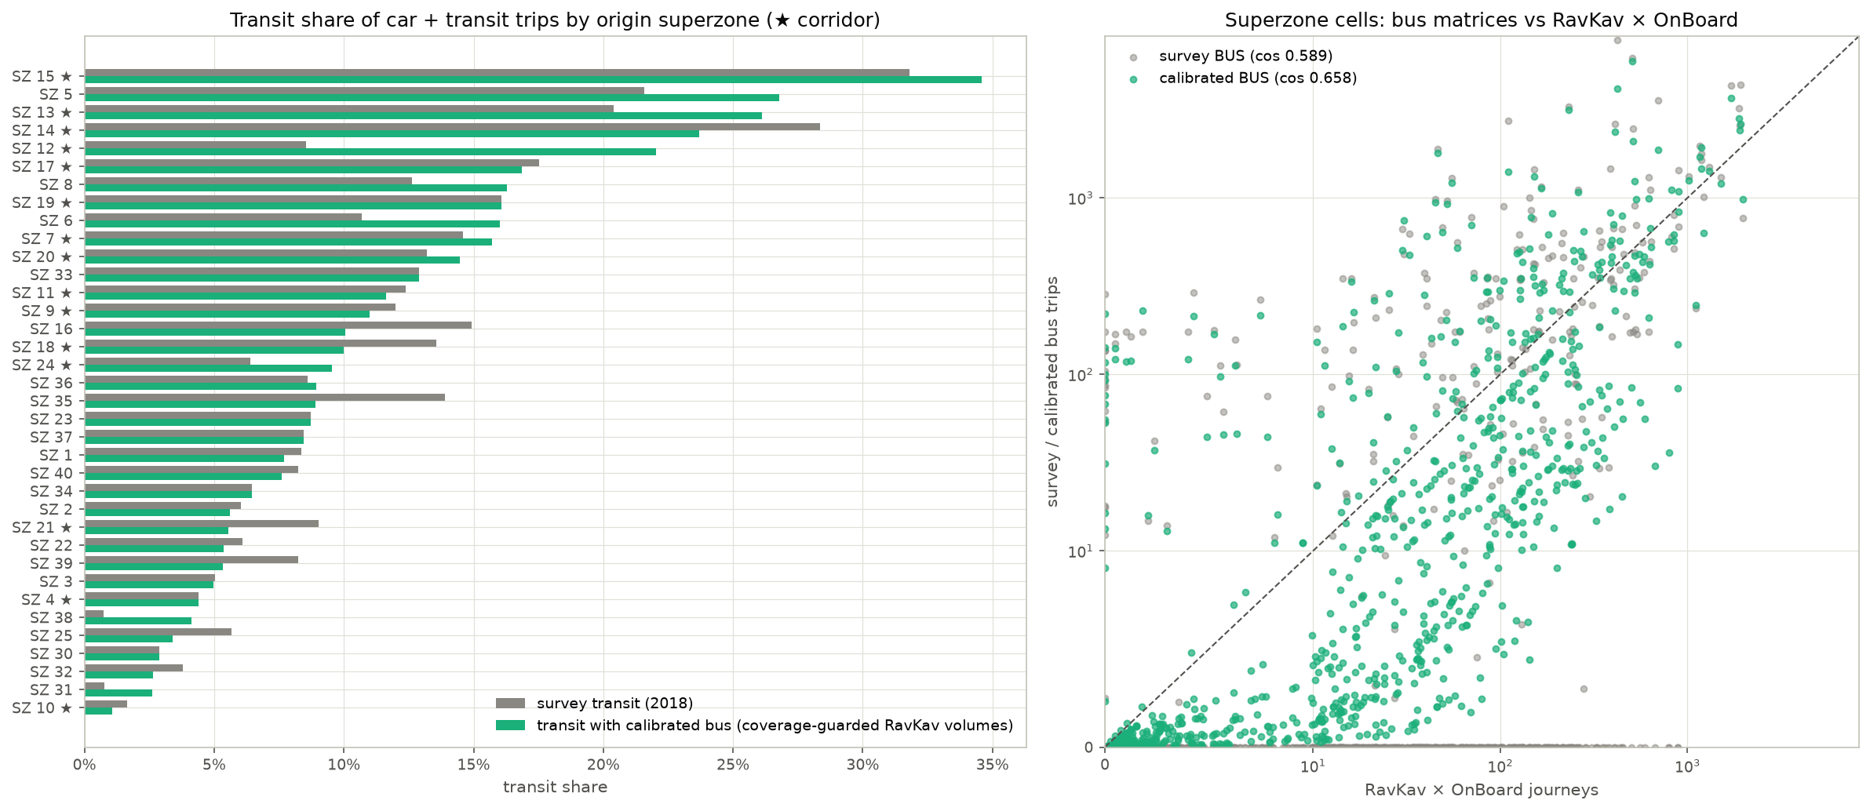
Figure 5. Left: transit share by origin superzone before and after calibration. Right: superzone bus cells against the ticketing matrix, survey (grey) and calibrated (green).

6. Part D — moving to 2022 and splitting into car, bus and rail

6.1 The idea
The survey describes 2018. The ticketing data describes May 2022, which is also the base year the study uses. Rather than mix years, everything of survey vintage is moved to 2022 with the same convention the repository already uses at area level, now applied at TAZ level.
The convention holds trip rates constant: each TAZ keeps its 2018 trips per resident on the origin side and its 2018 trips per job on the destination side. Growth comes from the zonal files: the change from 2020 (observed) to 2025 (forecast, BU scenario), taken at four fifths of the five-year change to represent 2018 to 2022. A TAZ uses its own factor only if its 2020 base is at least 500 people (origins) or jobs (destinations); smaller zones take their superzone's factor, and pure employment zones take the employment factor on the origin side too. The car matrix is then Furnessed to the grown row and column totals, with the overall total set by the origin side, so employment growth only reshapes where trips go.
Layer | How it moves to 2022
Car | Furnessed to population-grown origins and employment-grown destinations: +5.5 %
Bus, RavKav-anchored superzones | Already May 2022 counts; untouched
Bus, the seven guarded superzones | Rows grown by their TAZ population factor: +5.9 %
Taxi-type (folded into the bus matrix) | Furnessed like car: +6.0 %
Rail (survey, door-to-door) | Scaled by the national rail ridership change 2019 → 2022 (54.7 M / 69.0 M = 0.793); rail recovery lagged, so a demographic factor would overstate it

6.2 Results
Trips by corridor class | Car 2018 | Car 2022 | Bus 2018 | Bus 2022 | Rail 2018 | Rail 2022
Corridor → corridor | 66,610 | 72,331 | 11,524 | 11,737 | 0 | 0
Corridor → outside | 44,039 | 47,011 | 11,476 | 11,580 | 368 | 292
Outside → corridor | 94,672 | 89,181 | 20,622 | 20,883 | 3,302 | 2,618
Outside → outside | 1,078,268 | 1,145,275 | 85,299 | 87,304 | 1,439 | 1,141
All | 1,283,589 | 1,353,798 | 128,920 | 131,504 | 5,109 | 4,050
The three 2022 matrices by corridor class (bus includes taxi-type).
Two things stand out. Car trips from outside into the corridor fall by 6 % while every other class grows. This is because the BU-2025 forecast puts employment growth in the corridor TAZs below the regional average; it is a property of the demographic scenario, not of the survey, and the HS scenario would move it. And the survey rail matrix has no trips with both ends in the corridor at all: rail trips are few in the survey (54 observed over two days) and mostly cross the study boundary. The 2019 smartcard station-to-station matrix, scaled to 2022, carries 763 trips with both stations in the sub-area and is saved beside the survey rail matrix for corridor-loading work.
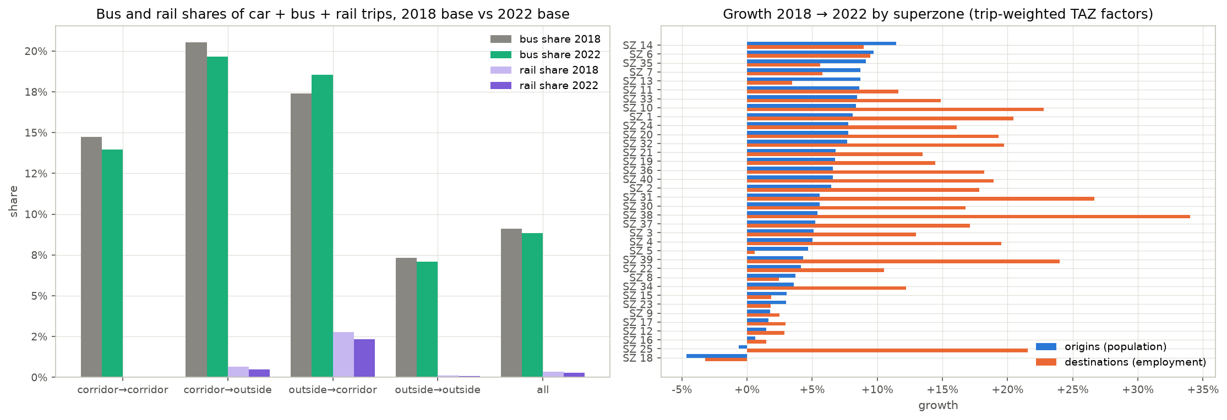
Figure 6. Left: bus and rail shares by corridor class, 2018 and 2022 bases. Right: growth factors 2018 → 2022 by superzone.

7. What to keep in mind
- Two frames. Ticketing journeys start at the boarding stop and include non-residents; survey trips start at the front door and cover residents. At superzone level the two mostly coincide, except at transfer hubs. The calibrated volumes are right for corridor loadings and slightly too concentrated for door-to-door demand at the hubs.
- Ticketing coverage. The ticketing extract under-records bus travel in the Arab-sector and peripheral superzones. Until the provider confirms which operators and fare types it covers, RavKav volumes should not be used outside the metropolitan core.
- Trip rates are frozen. Growth to 2022 keeps 2018 trip rates and uses a forecast, not observed 2022 data. Changes in age structure, car ownership or working from home are not represented. Screenline counts (task B1) would be the natural check for the car layer.
- TAZ detail is synthetic. Below the 1,250-zone level the survey's TAZ detail is a population / employment split; for the cellular matrix it is a replication of coarse zones. TAZ-level agreement between them is flattered by construction; superzones and sub-areas are the fair level.
- Rail is thin. 54 observed rail trips over two days make the survey rail matrix a rough sketch. Use the station-based smartcard matrix where station origins are acceptable.
- Cellular volumes. The cellular product records 3.6 times fewer morning trips than the survey expansion and misses short trips in particular. Its trip definition (dwell time, minimum distance) is needed before it can anchor volumes anywhere.

8. Files
Notebook | What it does | Main outputs
THS_2017_cosine_GEH_tests.ipynb | Cosine and GEH tests, scale audit, corridor classes | Output/ths2017/tests/cosine_geh_summary.csv and related tables; figures cosine_geh_*.png
THS_2017_KS_tests.ipynb | Trip-length and concentration KS tests with household bootstrap | Output/ths2017/tests/ks_summary.csv and related; figures ks_*.png
THS_2017_MSSIM_tests.ipynb | Structural similarity by window, scale and ordering; local maps | Output/ths2017/tests/mssim_headline.csv and related; figures mssim_*.png
THS_2017_two_mode_matrix.ipynb | Survey-only car / transit matrix; bus calibration to RavKav × on-board | Output/ths2017/two_mode/: car_taz.csv, transit_taz.csv, bus_calibrated_taz.csv, calibration factor / lambda / validation tables, mode shares
THS_2017_three_mode_2022.ipynb | Move to 2022; split into car, bus, rail | Output/ths2017/three_mode_2022/: car_2022, bus_2022, rail_2022 at TAZ / superzone / sub-area; growth factors; summaries

Full method details, with every number, are in METHODOLOGY.md sections 6j to 6n of the repository.

