Nofit LRT Extension — Demand Forecast
BU vs HS Demographic Scenarios: Do We Need a Matrix per Scenario?
September 2026 · analysis notebook: Demographic_scenario_comparison.ipynb

1. Question and data
New zonal forecasts were added under Input/Demographic_Forecast/ (781 study TAZs each): Zonal_2020.csv (observed base year) and two scenarios for 2040 and 2050 — Business as Usual (BU) and the Housing Strategy plan (HS). Before building forecast-year demand matrices, we test whether the two scenarios differ enough inside the research area (the 205-TAZ / 28-area sub-area, 119 of whose TAZs form the LRT corridor) to require a separate matrix per scenario, or whether one matrix can serve both.
The test criterion follows from how forecast matrices are produced in this study (Vintage_alignment_2022.ipynb): the base matrix is Furnessed with per-area growth margins — POPULATION on the origin side, EMPL_TOT on the destination side — at the 28-aggregated-area resolution. Two scenarios need two matrices if and only if their per-area margins differ materially. Data integrity was verified first: all five files carry an identical 781-TAZ set with no duplicates, covering all 205 research-area TAZs.

2. Test 1 — Regional and corridor totals
Population by zone class (HS/BU difference in the Δ columns):
Zone class | 2020 | BU 2040 | HS 2040 | Δ 2040 | BU 2050 | HS 2050 | Δ 2050
LRT Corridor (119 TAZ) | 222,117 | 316,404 | 318,465 | +0.7% | 389,835 | 390,730 | +0.2%
Research non-corridor (86 TAZ) | 206,115 | 277,781 | 292,676 | +5.4% | 314,355 | 342,755 | +9.0%
Research area (205 TAZ) | 428,232 | 594,185 | 611,141 | +2.9% | 704,190 | 733,485 | +4.2%
Rest of study area | 2,128,252 | 2,835,734 | 2,975,422 | +4.9% | 3,236,445 | 3,552,935 | +9.8%
Whole study (781 TAZ) | 2,556,484 | 3,429,919 | 3,586,563 | +4.6% | 3,940,635 | 4,286,420 | +8.8%

Employment by zone class:
Zone class | 2020 | BU 2040 | HS 2040 | Δ 2040 | BU 2050 | HS 2050 | Δ 2050
LRT Corridor (119 TAZ) | 165,344 | 220,719 | 224,052 | +1.5% | 253,524 | 267,972 | +5.7%
Research non-corridor (86 TAZ) | 68,690 | 95,323 | 103,842 | +8.9% | 112,097 | 121,420 | +8.3%
Research area (205 TAZ) | 234,034 | 316,042 | 327,894 | +3.8% | 365,621 | 389,392 | +6.5%
Rest of study area | 719,628 | 1,096,981 | 1,131,709 | +3.2% | 1,294,443 | 1,381,583 | +6.7%
Whole study (781 TAZ) | 953,662 | 1,413,023 | 1,459,603 | +3.3% | 1,660,064 | 1,770,975 | +6.7%

On totals the scenarios are nearly interchangeable: corridor-wide population differs by +0.7% (2040) and +0.2% (2050); employment by +1.5% and +5.7%. If totals were the whole story, one matrix would suffice.

3. Test 2 — Per-area Furness margins (the operative test)
Growth factors g = X_scenario / X_2020 per aggregated area are exactly the quantities that become Furness margins. At this resolution the scenarios diverge sharply, and the divergence is concentrated along the corridor. Most divergent areas, population, 2050:
Area | Corridor | Pop 2020 | g BU 2050 | g HS 2050 | HS/BU − 1
Tirat Carmel | yes | 24,681 | ×4.87 | ×1.56 | −68%
Neot Peres | yes | 4,211 | ×0.92 | ×3.29 | +256%
Bat Galim | yes | 4,729 | ×0.96 | ×1.89 | +97%
Lower City | yes | 2,651 | ×1.55 | ×2.19 | +41%
Matam | yes | 390 | ×1.07 | ×24.83 | +9,266 ppl*
Kiryat Ata Center | yes | 13,606 | ×1.34 | ×2.81 | +110%
Kiryat Ata East | mixed | 9,047 | ×0.97 | ×2.40 | +148%
Kiryat Yam | no | 57,332 | ×1.47 | ×1.86 | +27%
Kiryat Motzkin–Bialik | no | 100,512 | ×1.67 | ×1.40 | −16%
* Small 2020 base (390 residents) makes the ratio unrepresentative; the absolute HS−BU difference is shown instead.
- Tirat Carmel (south-western corridor anchor): BU grows it ×4.9 by 2050 (24.7k → 120.1k residents); HS caps it at ×1.6 (→ 38.6k) — an 82,000-person swing in a single corridor area.
- Inner Haifa absorbs what HS removes: Neot Peres, Bat Galim and the Lower City double–triple under HS but stagnate under BU, and HS places ~9.7k / 3.5k residents in the Matam and Kiryat Nahum employment districts where BU keeps essentially none.
- The Kiryat Ata end flips the same way: Center ×2.8 vs ×1.3, East ×2.4 vs ×1.0; among non-corridor research areas Kiryat Yam gains +27% population / +52% employment under HS while Kiryat Motzkin–Bialik loses 16%.
- Breadth: population margins differ by more than 10% between scenarios in 17 of 22 populated research areas in 2040 and 18 of 22 in 2050 (employment: 11 and 16 of 28 areas).
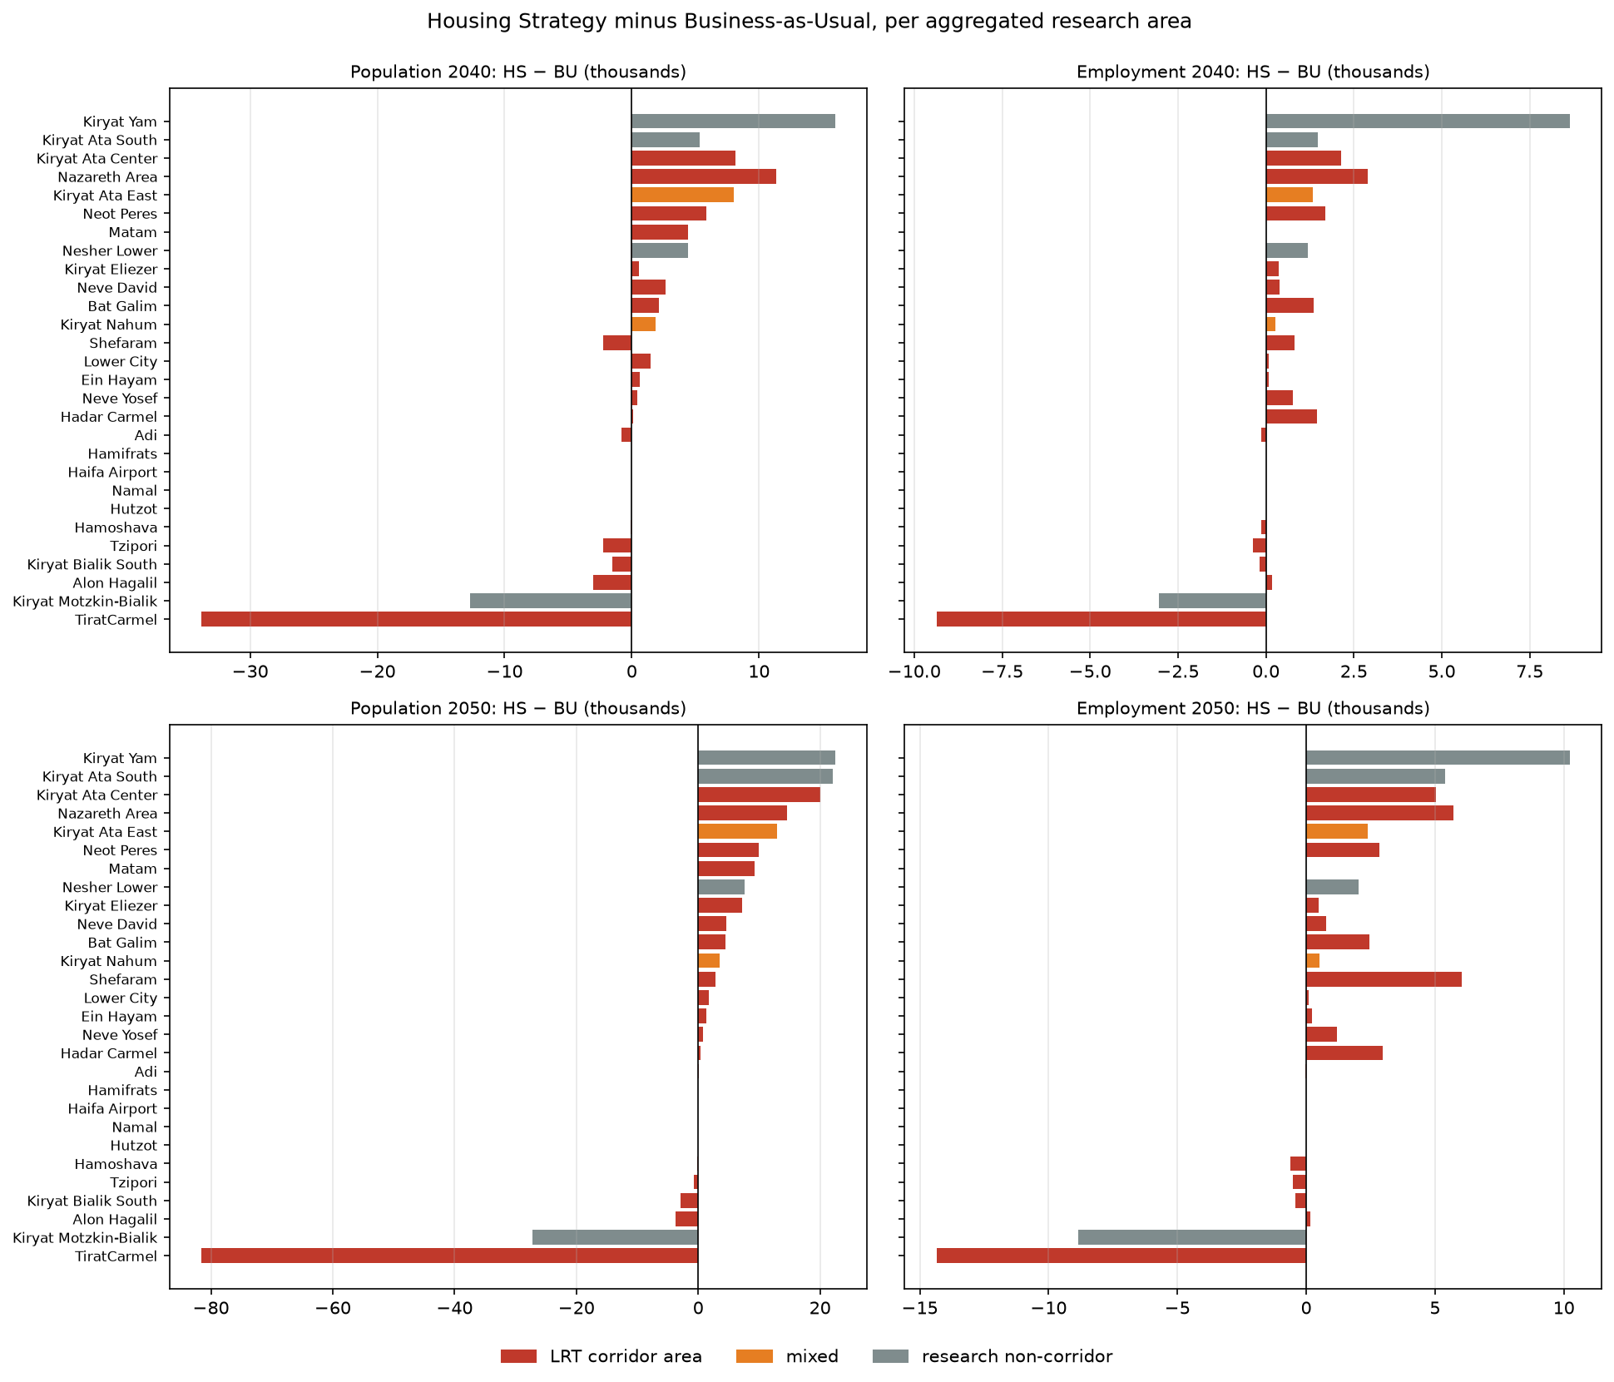
Figure 1 — Housing Strategy minus Business-as-Usual per aggregated research area (thousands). Corridor areas in red.

4. Test 3 — TAZ-level divergence
Within the 205 research-area TAZs (TAZs with BU value > 200 counted):
Year / variable | TAZ correlation r | TAZs differing > 20% | Median |HS−BU|
2040 population | 0.875 | 54 of 125 | 16%
2040 employment | 0.952 | 59 of 160 | 11%
2050 population | 0.702 | 77 of 124 | 26%
2050 employment | 0.891 | 81 of 160 | 20%

By 2050 the population correlation between scenarios falls to r = 0.70 and a majority of substantive TAZs differ by more than 20% — far beyond anything a single matrix could represent.

5. Conclusion and recommendation
The two scenarios describe the same amount of regional growth put in different places. BU concentrates growth at the greenfield south-western terminus (Tirat Carmel); HS shifts it into urban infill in the Haifa core and Kiryat Ata. These are opposite loading patterns along the same LRT alignment, so a shared matrix would misstate corridor flows for either scenario.
Recommendation: build a separate demand matrix per scenario and year — BU-2040, BU-2050, HS-2040, HS-2050. The cost is modest: each is the same 2022 base matrix Furnessed with that scenario-year’s margin file (same procedure as the 2022 vintage alignment, four runs instead of one). The margin tables are already produced in the required form by the analysis notebook.
Outputs: Output/demographics/scenario_totals_by_class.csv, Output/demographics/scenario_comparison_area.csv, Output/figures/scenario_BU_vs_HS_areas.png.

