Nofit LRT Extension — OD Demand Study
PCA Eigenvector Charts
Where the shared survey / cellular destination patterns sit on the map
Companion report to THS_PCA_eigenvector_maps.ipynb · September 2026

Summary
The Principal Component Analysis (PCA) notebooks of this study established that the 2018 Travel Habits Survey and the cellular-derived matrix are built from the same dominant destination-choice patterns at superzone level, and that they disagree almost only on the intra-zone diagonal. Those notebooks report the evidence as statistics (subspace overlap, cross-explained variance, Tucker congruence) and chart only two loading vectors as bars. This report closes that gap: it draws the eigenvectors themselves on the study geography so that each component can be read as a spatial pattern and its fit judged by eye.
Outcome. The four leading eigenvectors are four legible regional patterns — Haifa core vs periphery, north vs south, Yizre'el/Nazareth vs Upper Galilee–Golan, and Western Galilee/Akko vs Golan — and every one of them appears in the cellular matrix, in both survey days, and in the 2017 trips-file survey, with congruences of 0.82–0.97. The survey's eigenvectors are stable; what sampling noise changes is their eigenvalues (a flat ≈ 5 % each instead of 14 / 13 / 11 / 8 %). Reconstructing origin profiles from the eigenvectors reproduces which region each origin favours but not the diagonal self-containment spike, which is the eigenvector view of the divergence the superzone correction factors were designed to resolve.

1. Main goal
The OD demand pipeline fuses the household survey with the cellular matrix: cellular supplies the population-scale spatial prior, the survey supplies evidence at the scale where it is reliable (36 superzones). The PCA suite was built to test whether that design is justified — whether the two sources really describe the same destination-choice structure — and where exactly they part ways.
The goal of this piece of work is interpretive rather than statistical: to make the eigenvectors visible. Specifically, to answer for each leading component
- what pattern it encodes — which destinations it contrasts, and which origins express it;
- where it fits on the map — whether the pattern is a recognisable region-to-region relationship of the study area;
- whether the survey shows the same pattern — judged against the survey's own day-to-day noise and against the independent 2017 survey source; and
- how well the eigenvectors fit an origin's actual destination profile, and what they leave behind.

2. Data
Input | Content | Role
Output/prob_sz_cellular.csv | Cellular AM-peak (6:00–9:00) OD probabilities, 36 × 36 superzones, rows sum to 1 | Population-scale reference
Output/prob_sz_10_weighted.csv, prob_sz_20_weighted.csv | THS 2018 activities source, household-weighted (wf_new), survey day 10 and day 20 | Survey evidence; day 20 is the noise benchmark for day 10
Output/ths2017/study_taz/matrix_avg_ALL_sznew.csv | THS 2017 trips-file source, day-average, converted to superzones (row-normalised here) | Independent-source robustness check
Input/TAZ_North/TAZ_North.shp | 781 study TAZ polygons; the SUPERZONE field is the 36-zone SZ_NEW system | Geography for the maps
Input/Demographic_Forecast/TAZ_shp, Input/Submatrix_tazs.xlsx | Sub-district per TAZ; research-area names inside the LRT corridor | Reading aid for superzone numbers

The superzones are numbered rather than named. Table 2 gives each one a reading aid: its dominant sub-district and, inside the LRT corridor, the research areas it contains.
SZ | Sub-district | Corridor areas | SZ | Sub-district | Corridor areas
1 | Akko |  | 20 | Yizre'el | Nazareth Area
2 | Akko |  | 21 | Yizre'el | Tzipori
3 | Akko |  | 22 | Yizre'el
4 | Akko | Shefaram | 23 | Haifa
5 | Haifa | Kiryat Yam | 24 | Hadera | Tirat Carmel, Matam
6 | Haifa | Kiryat Motzkin–Bialik | 25 | Hadera
7 | Haifa | Kiryat Motzkin–Bialik, Kiryat Ata Center | 30 | Akko
8 | Haifa | Kiryat Motzkin–Bialik, Kiryat Yam | 31 | Golan
9 | Haifa | Kiryat Ata East / South | 32 | (Upper Galilee)
10 | Akko | Alon Hagalil | 33 | Tzfat
11 | Haifa | Adi, Kiryat Ata South | 34 | Akko
12 | Haifa | Namal, Hamifrats, Haifa Airport | 35 | Kinneret
13 | Haifa | Lower City, Hamoshava, Hadar Carmel | 36 | Yizre'el
14 | Haifa | Hadar Carmel | 37 | Yizre'el
15 | Haifa | Kiryat Eliezer, Neot Peres, Neve David | 38 | Hadera
16 | Haifa | (Carmel) | 39 | Hadera
17 | Haifa | Neve Yosef | 40 | Hadera
18 | Haifa | Nesher Lower, Hamifrats
19 | Yizre'el | Nazareth Area
Table 2. Superzone reading aid. Sub-district is the modal value over the superzone's TAZs; SZ 32 has no sub-district code in the source.

3. Method

3.1 PCA framing
Each origin superzone is an observation; its row-normalised destination-share profile (36 shares) is the feature vector. The 36 × 36 probability matrix is column-centred and decomposed by singular value decomposition. Three objects come out of it:
- Eigenvectors (loading vectors) — directions in destination space: one signed weight per destination superzone. These are drawn as destination maps.
- Origin scores — the projection of each origin's profile on an eigenvector. These are drawn as origin maps.
- Eigenvalues — the variance each component carries, reported as a share of the total.
The two maps read together: an origin's profile equals the mean profile plus the sum over components of score × eigenvector, so origins coloured red on a score map send more trips than the average origin to destinations coloured red on the matching loading map, and fewer to the blue ones.

3.2 Matching components across sources
Components of different matrices are not automatically in the same order, and an eigenvector's sign is arbitrary. The top six components of each survey matrix are therefore matched one-to-one to cellular's top six by the Hungarian algorithm on the absolute Tucker congruence (the dot product of unit-norm loading vectors; |φ| ≥ 0.85 is conventionally the same component, 0.65–0.85 similar), exactly as in the parent notebook, and each matched survey eigenvector is sign-aligned to its cellular partner. Every chart shares one colour scale within a column so that the survey and cellular eigenvectors are directly comparable.

3.3 Benchmarks
Following the convention of the PCA suite, no survey-vs-cellular comparison is read in isolation. Survey day 20 is charted next to day 10: the difference between the two survey days is what sampling noise alone does to an eigenvector, and any survey-vs-cellular difference smaller than that is not interpretable. The 2017 trips-file survey — the pipeline's primary fusion source, processed by an independent chain — is the second benchmark: a pattern present in both survey vintages is a property of AM-peak destination choice in the study area, not of one survey's processing.

3.4 Geography and chart set
TAZ polygons are drawn in their superzone's colour on a diverging blue–grey–red scale centred on zero; superzone labels sit at the area-weighted centroid of the superzone's TAZs. The Haifa-bay superzones (5–18) are too small to read at study-area scale, so every map carries a zoom inset of the metro core. Seven charts are produced, in the order in which they are best read:
# | Chart | Question it answers
1 | Eigenvectors as destination maps (cellular, survey day 10, survey day 20; PC1–PC4) | What does each pattern look like, and does the survey draw the same map?
2 | Loadings ranked by destination | How large is each destination's weight — including the small Haifa-bay zones?
3 | Origin-score maps | Which origins express each pattern?
4 | Biplots on the leading plane | How do origins and destinations sit together on PC1 × PC2?
5 | Axis-meaning checks | Is PC1 self-containment or core-vs-periphery? Is PC2 north–south?
6 | Reconstruction fit | How much of a real profile do the eigenvectors reproduce, and what is left?
7 | 2017 trips-file eigenvector maps | Do the patterns survive a change of survey source?

Context from the parent notebook is reproduced first (Figures 1–2) so that the report is self-contained: the subspace-overlap curves that motivated the eigenvector charts, and the original two-bar component match.

4. Results

4.1 Starting point — the parent notebook's evidence
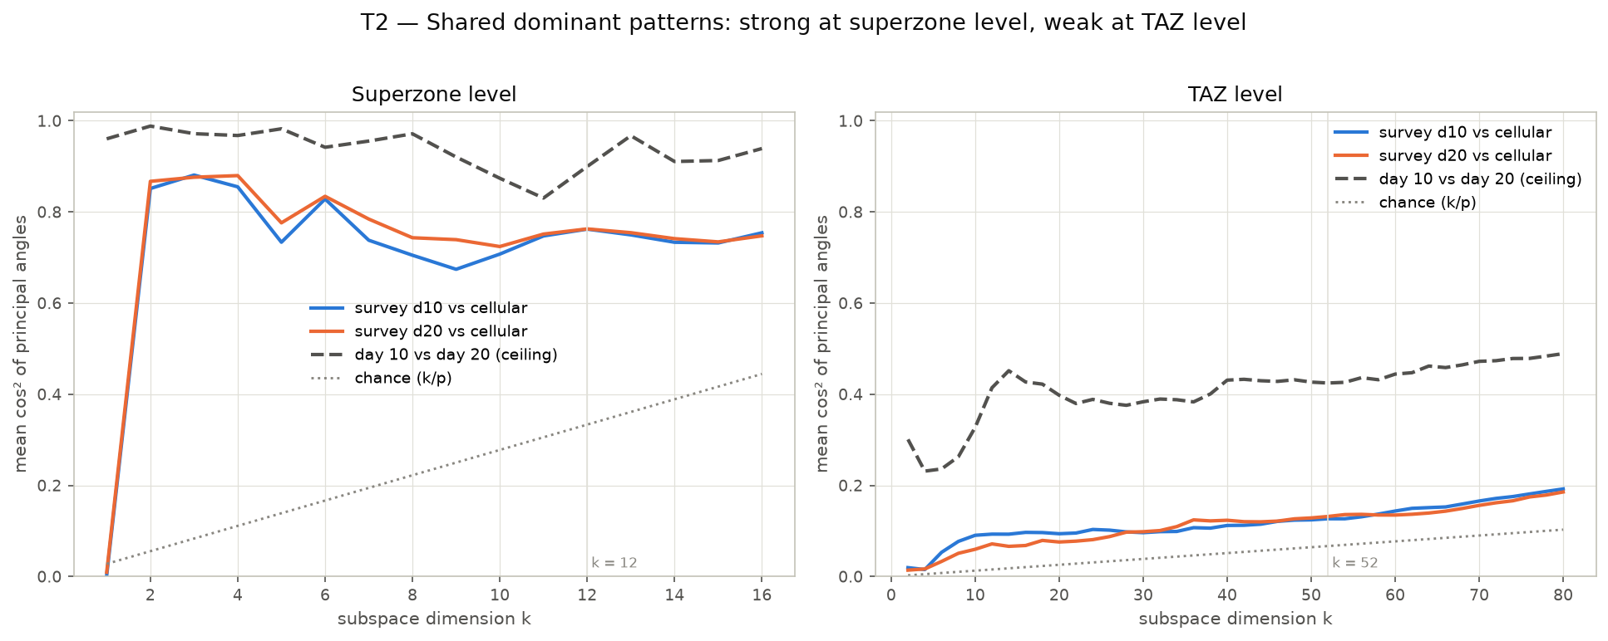
Figure 1. Subspace overlap (mean cos² of principal angles) between the survey's and cellular's top-k component subspaces, against the day 10 vs day 20 ceiling and chance. At superzone level the top-12 overlap is 0.76 (ceiling 0.90, chance 0.33); at TAZ level the survey cannot replicate even its own structure across days. Source: THS_2018_MTX_PCA_vs_cellular.ipynb.
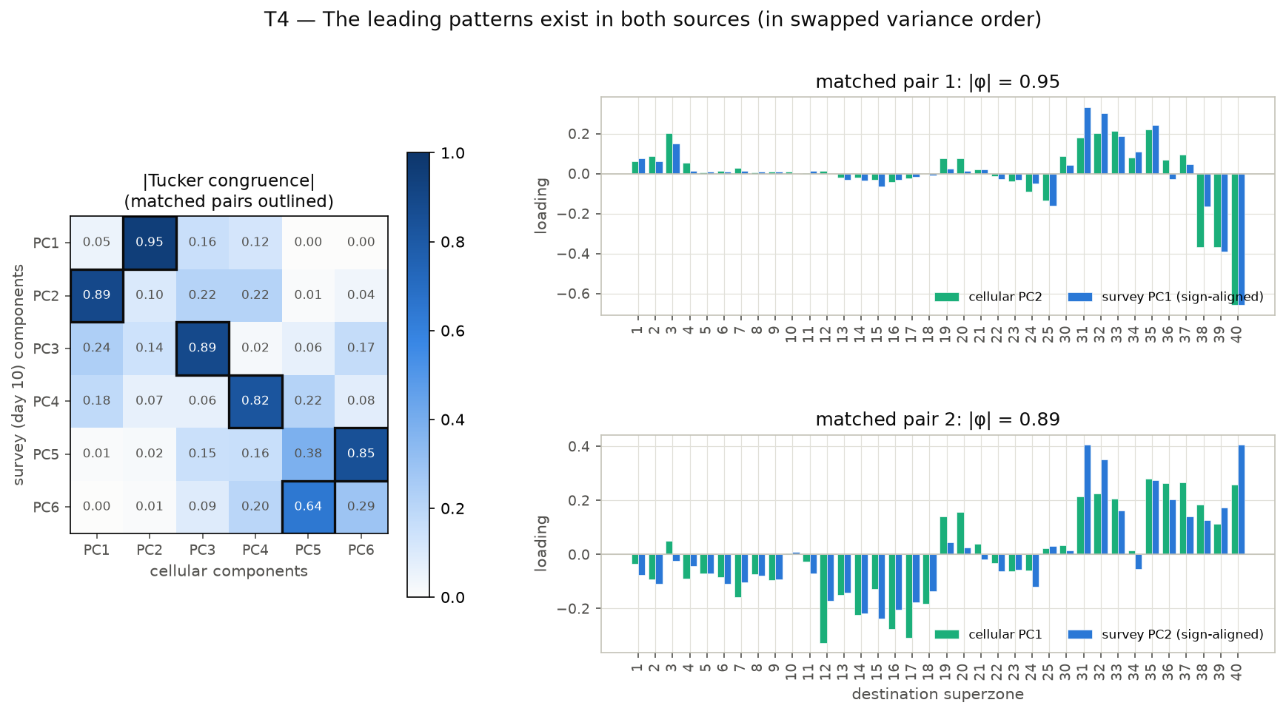
Figure 2. Hungarian-matched |Tucker congruence| between the top-6 survey and cellular components, with the two leading matched pairs as bars. Survey PC1 ↔ cellular PC2 (0.95) and survey PC2 ↔ cellular PC1 (0.89): the same two patterns in swapped variance order. Source: THS_2018_MTX_PCA_vs_cellular.ipynb. The eigenvector charts that follow replace these bars with maps.

4.2 The eigenvectors on the map
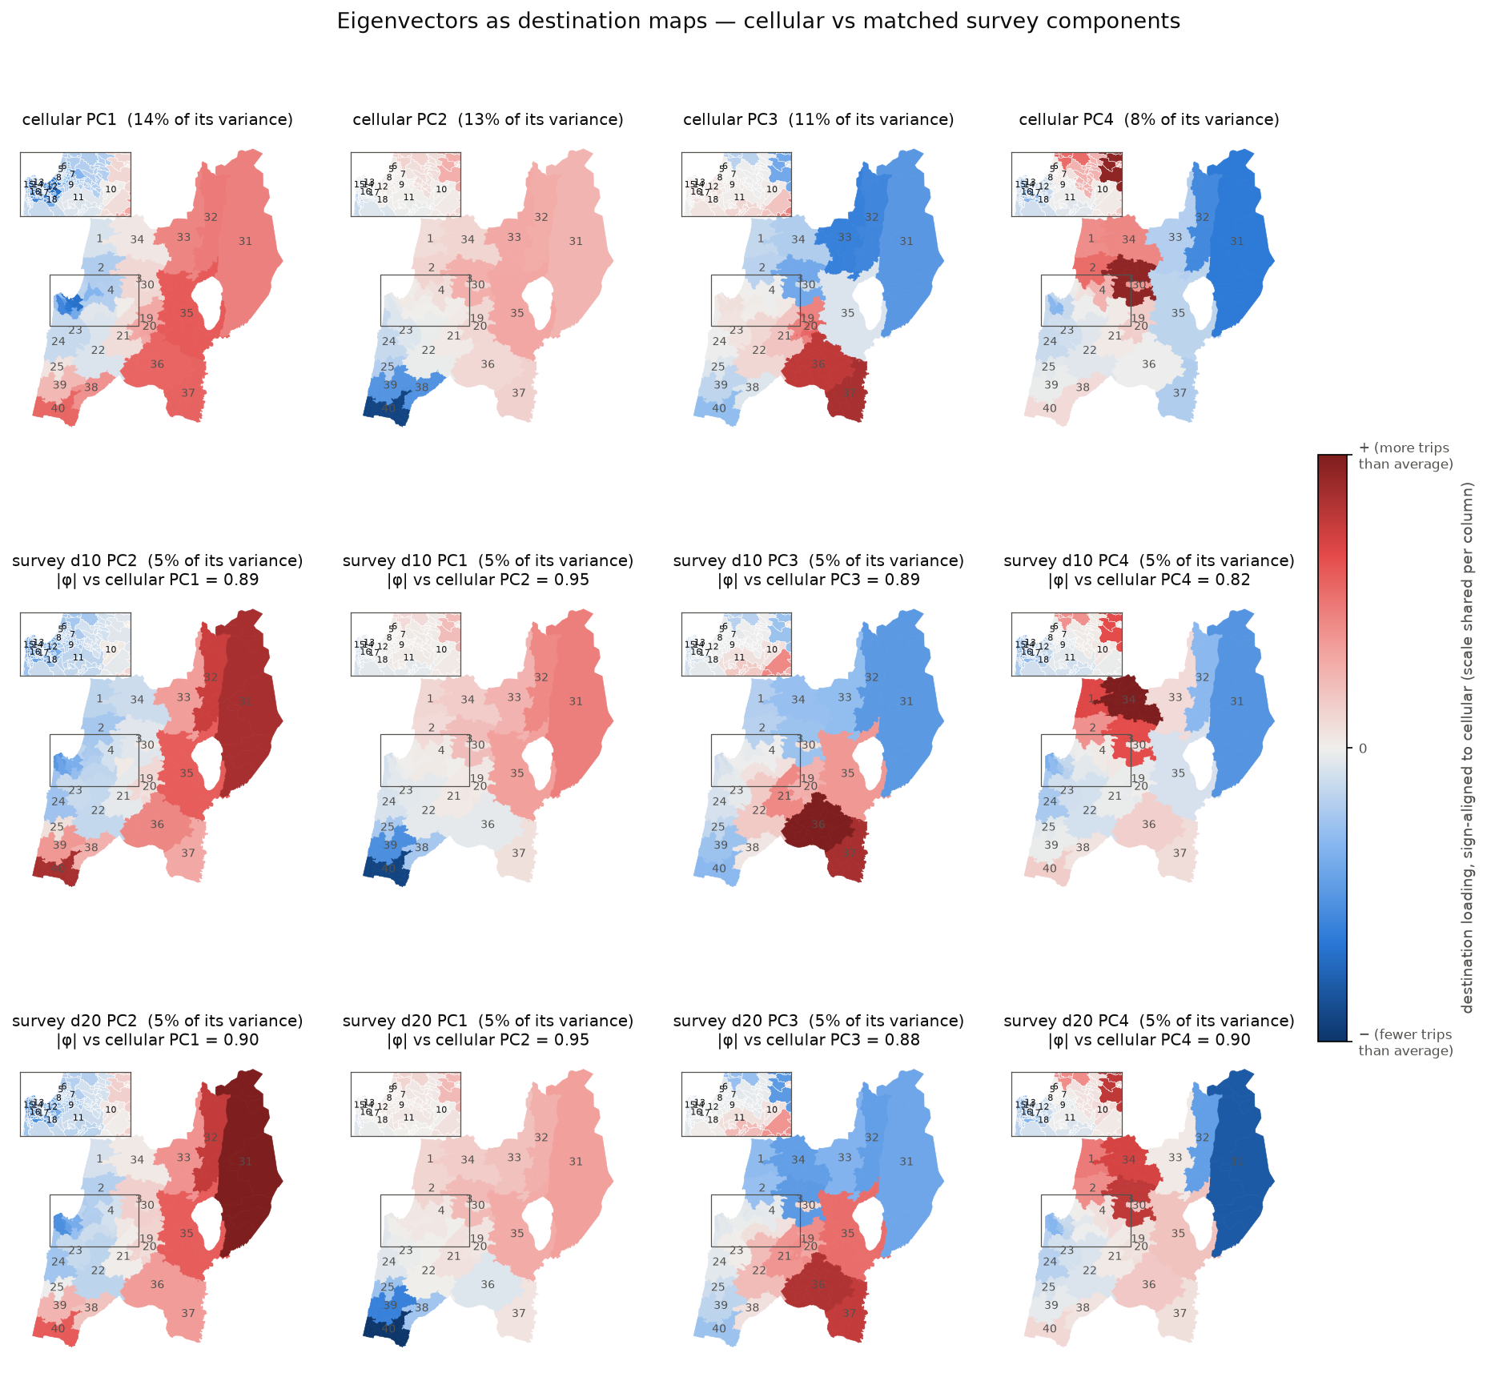
Figure 3. Eigenvectors as destination maps. Columns are cellular PC1–PC4; rows are cellular, survey day 10 and survey day 20, each survey component matched to the cellular one above it and sign-aligned. Red destinations carry positive loadings, blue negative; the colour scale is shared within a column. Inset: the Haifa-bay superzones 5–18. Titles give each source's own variance share and the congruence with cellular.
Read column by column, the four components are four regional contrasts:
Cellular PC | Variance (cellular / survey) | |φ| d10 / d20 / 2017 | Pattern
PC1 | 14 % / 5 % | 0.89 / 0.90 / 0.88 | Haifa core vs periphery. Negative on the metro core (12 Namal–Hamifrats, 17, 16, 14, 18, 7), positive on Kinneret, Yizre'el, Hadera, Upper Galilee and Golan (35, 37, 36, 40, 32, 31).
PC2 | 13 % / 5 % | 0.95 / 0.95 / 0.97 | North vs south. Hadera-side destinations (40, 38, 39, 25, 24) against the Galilee (35, 33, 32, 3, 31).
PC3 | 11 % / 5 % | 0.89 / 0.88 / 0.85 | Yizre'el / Nazareth (37, 36, 20, 19, 21, 22) vs Upper Galilee–Golan (33, 32, 31) and 3, 40.
PC4 | 8 % / 5 % | 0.82 / 0.90 / 0.91 | Western Galilee / Akko (3, 2, 34, 1, 30, 4) vs Golan (31, 32) and the Haifa core (17, 16, 14).
Table 3. The four leading cellular components, their matched survey components and the pattern each encodes. Survey variance shares are for day 10; day 20 and 2017 are within 0.5 pp.
The maps for day 10 and day 20 are near-identical for all four components, and within 0.01–0.08 in congruence with cellular. The survey's leading eigenvectors are therefore not sampling artefacts; the match only loosens at PC5–PC6 (0.64 / 0.56 and 0.85 / 0.78).
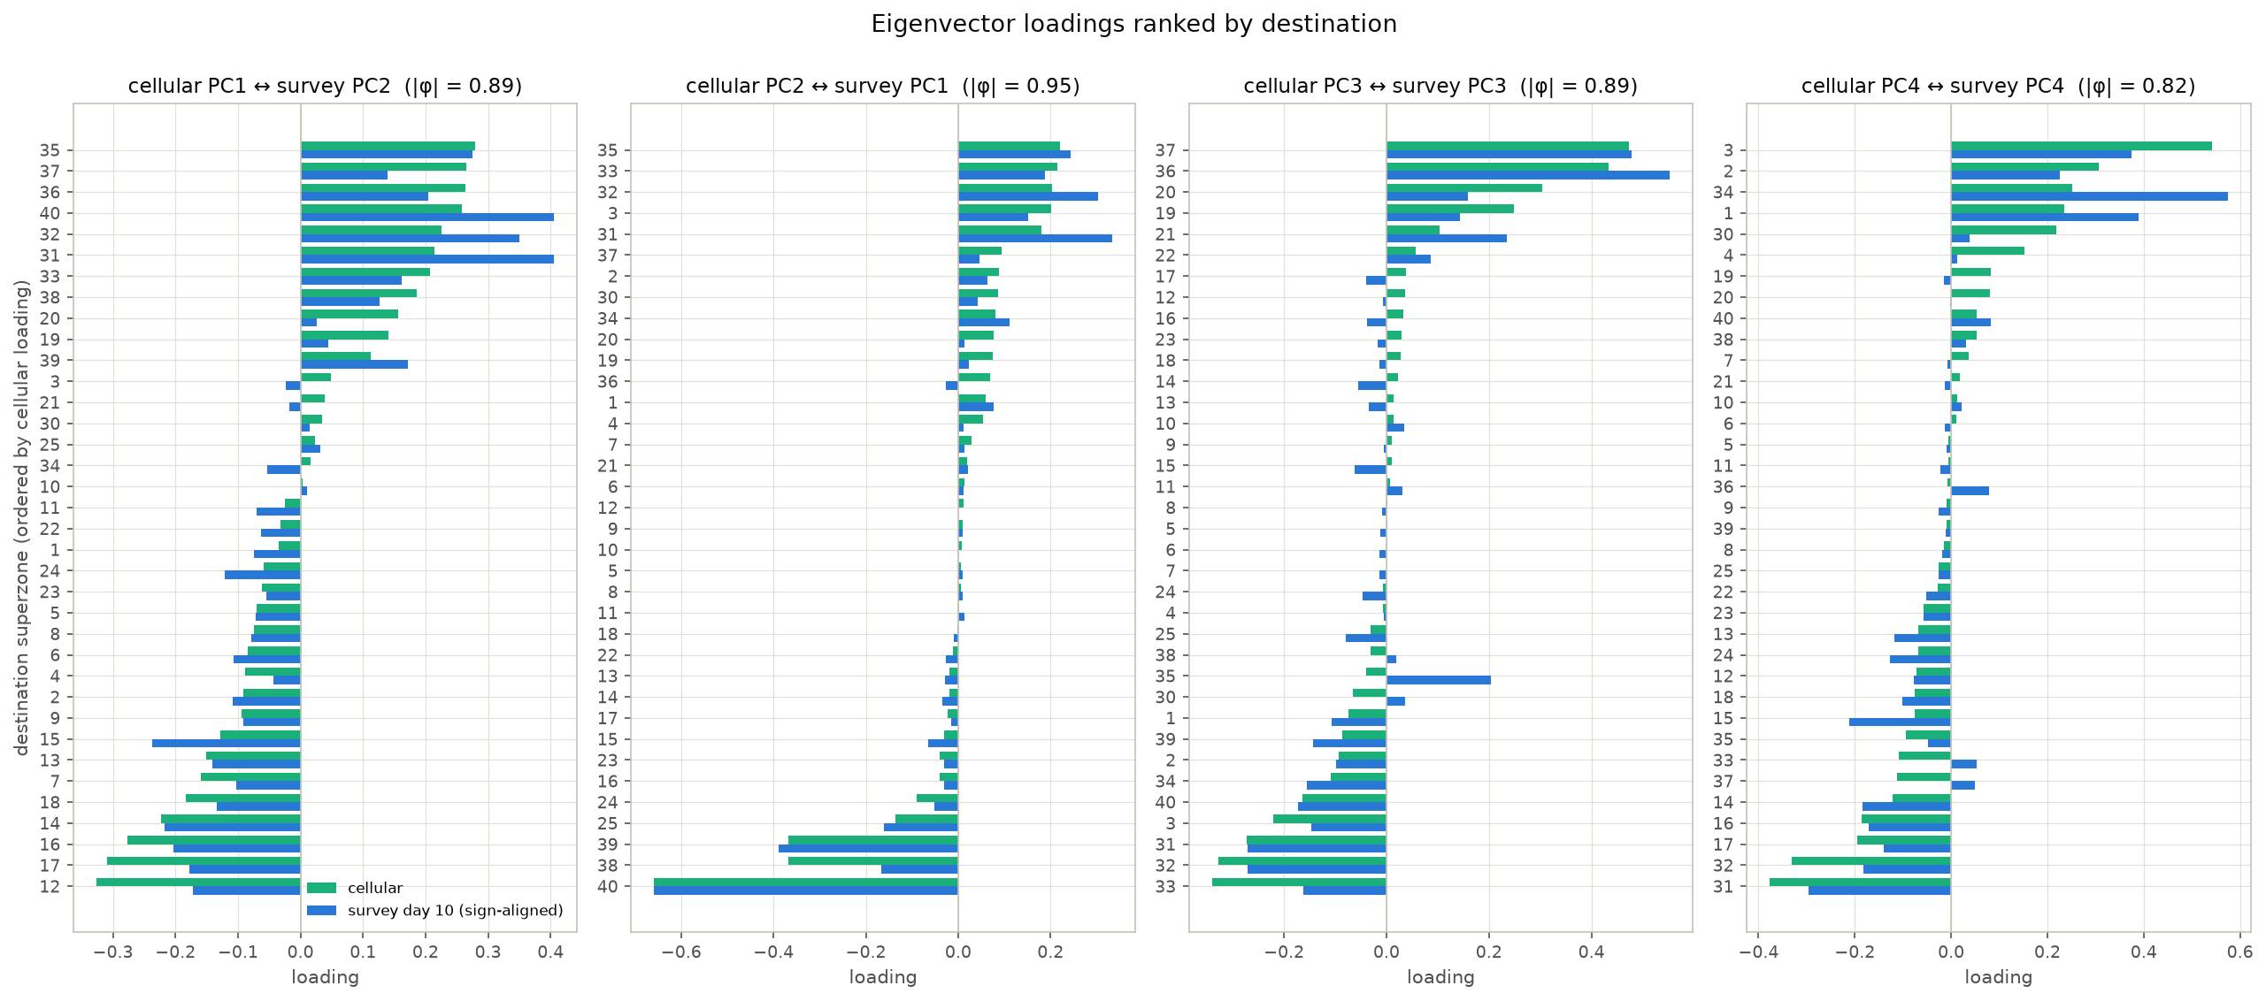
Figure 4. The same eigenvectors as ranked bars: destinations ordered by the cellular loading, with the sign-aligned survey day 10 loading alongside. The small Haifa-bay superzones become legible here. Two survey-specific accents are visible: on PC1 the survey weights the Golan and Upper Galilee (31, 32, 40) more heavily than cellular does, and on PC3 the survey attaches Kinneret (35) to the Yizre'el side (+0.20) where cellular does not (−0.05).

4.3 Which origins express each pattern
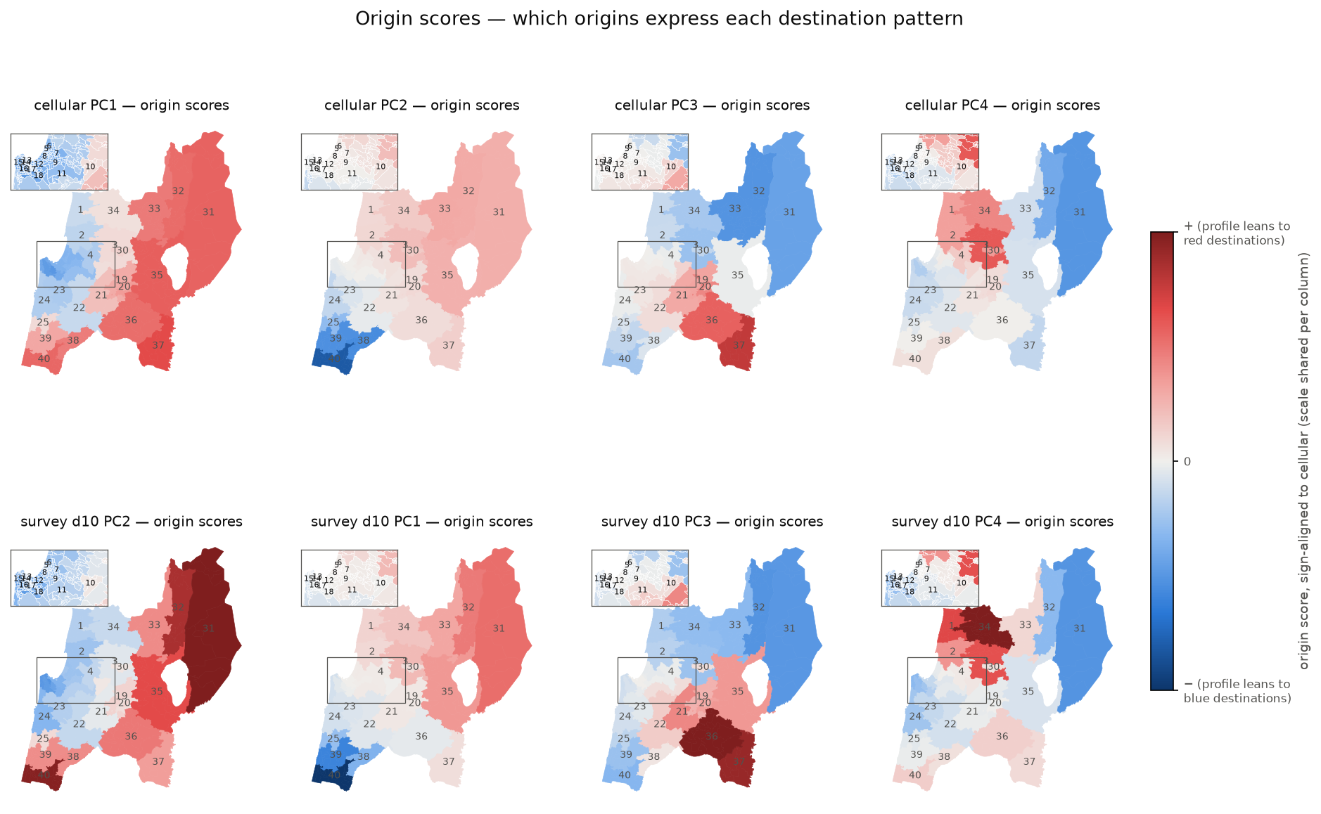
Figure 5. Origin scores for cellular and matched survey day 10 components. An origin coloured red projects positively on the component, i.e. its destination profile leans toward the red destinations of the corresponding loading map in Figure 3.
For PC1 the score map is essentially a map of the periphery: origins outside the Haifa metro score positively because their profiles lean toward their own region rather than the core. This is why the parent notebook found PC1 scores correlated with self-containment (r = +0.76): periphery and self-containment coincide. For PC2 the strongest origin in either source is superzone 40, the southernmost Hadera zone; the Galilee origins score mildly positive. PC3 and PC4 are expressed most strongly by the origins inside the regions they contrast (Yizre'el 36–37 and the Golan for PC3; Western Galilee 1–3, 34 and the Golan for PC4).
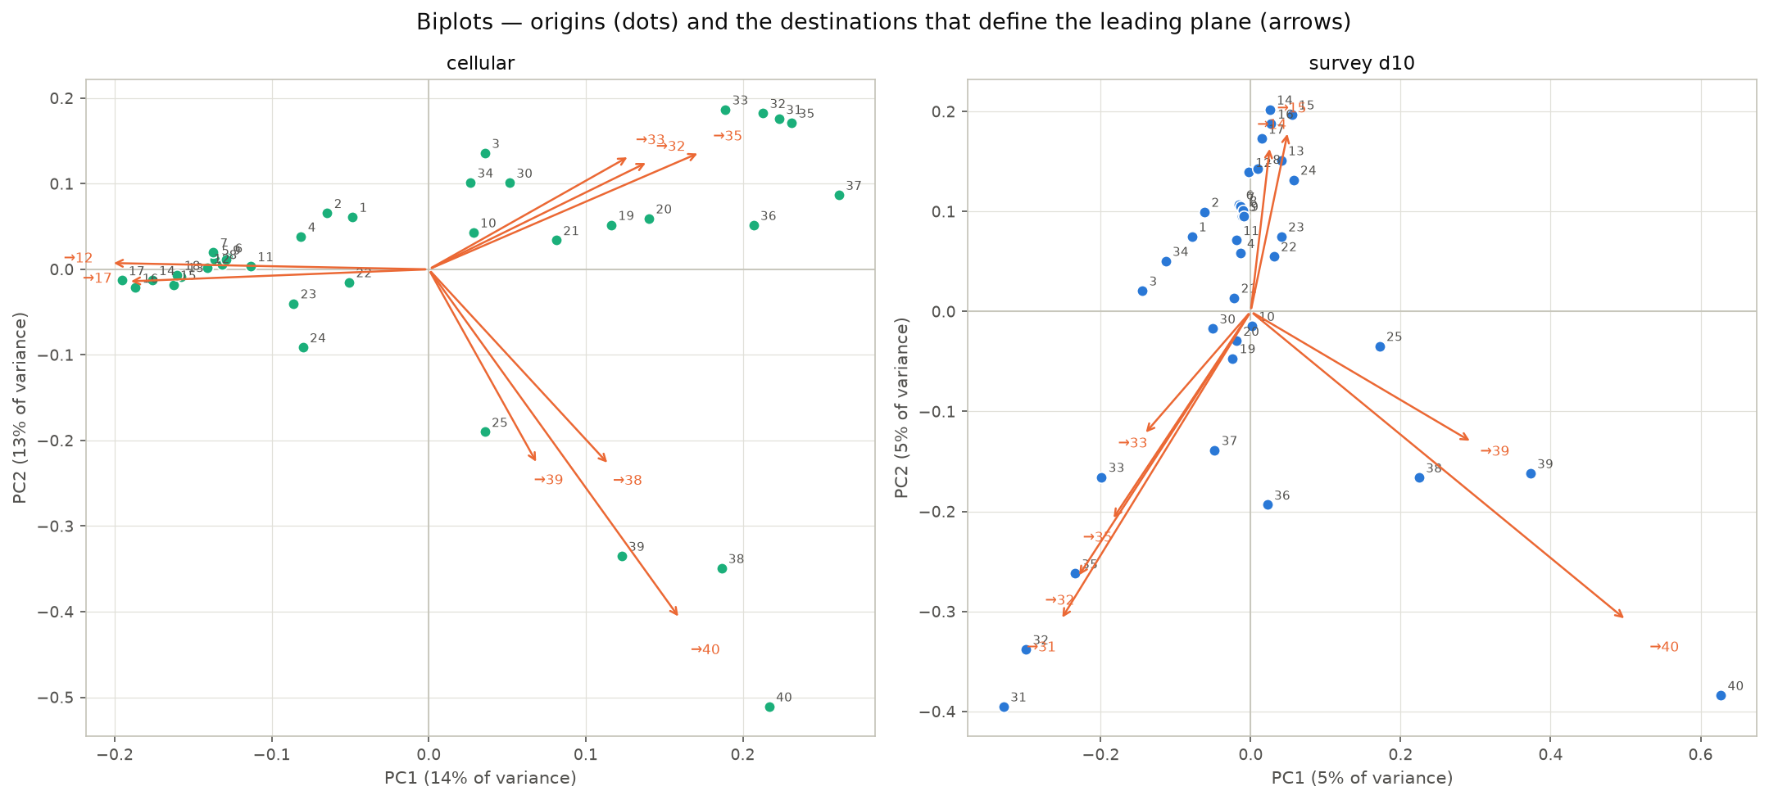
Figure 6. Biplots on the leading plane. Dots are origins (scores on PC1 and PC2); orange arrows are the eight destinations with the largest loadings on that plane, scaled to fit. In cellular the plane is spanned by the core-vs-periphery and north–south axes; the survey panel shows the same two patterns with PC1 and PC2 swapped, so it appears rotated by about 90°. The tight cluster of Haifa-bay origins (5–18) in both panels is the metro core, whose profiles are alike.

4.4 What the axes mean
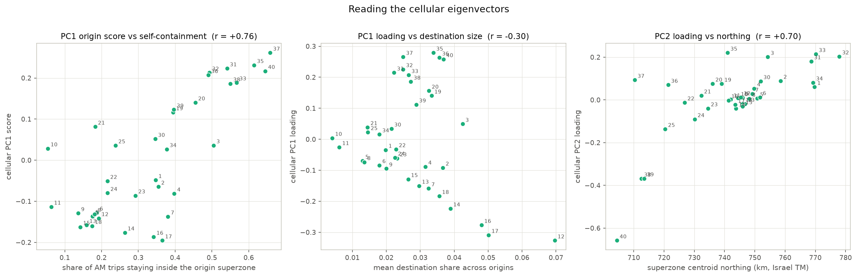
Figure 7. Three checks on the cellular eigenvectors. Left: PC1 origin score against self-containment (r = +0.76). Middle: PC1 loading against destination size (mean share across origins; r = −0.30) — PC1 is not a generic big-attractor axis, it singles out the Haifa metro attractors. Right: PC2 loading against the superzone's northing (r = +0.70): a north–south axis with the Hadera zones as its southern pole. The matched survey components give r = +0.76 and +0.74 for the same two checks.

4.5 How well the eigenvectors fit
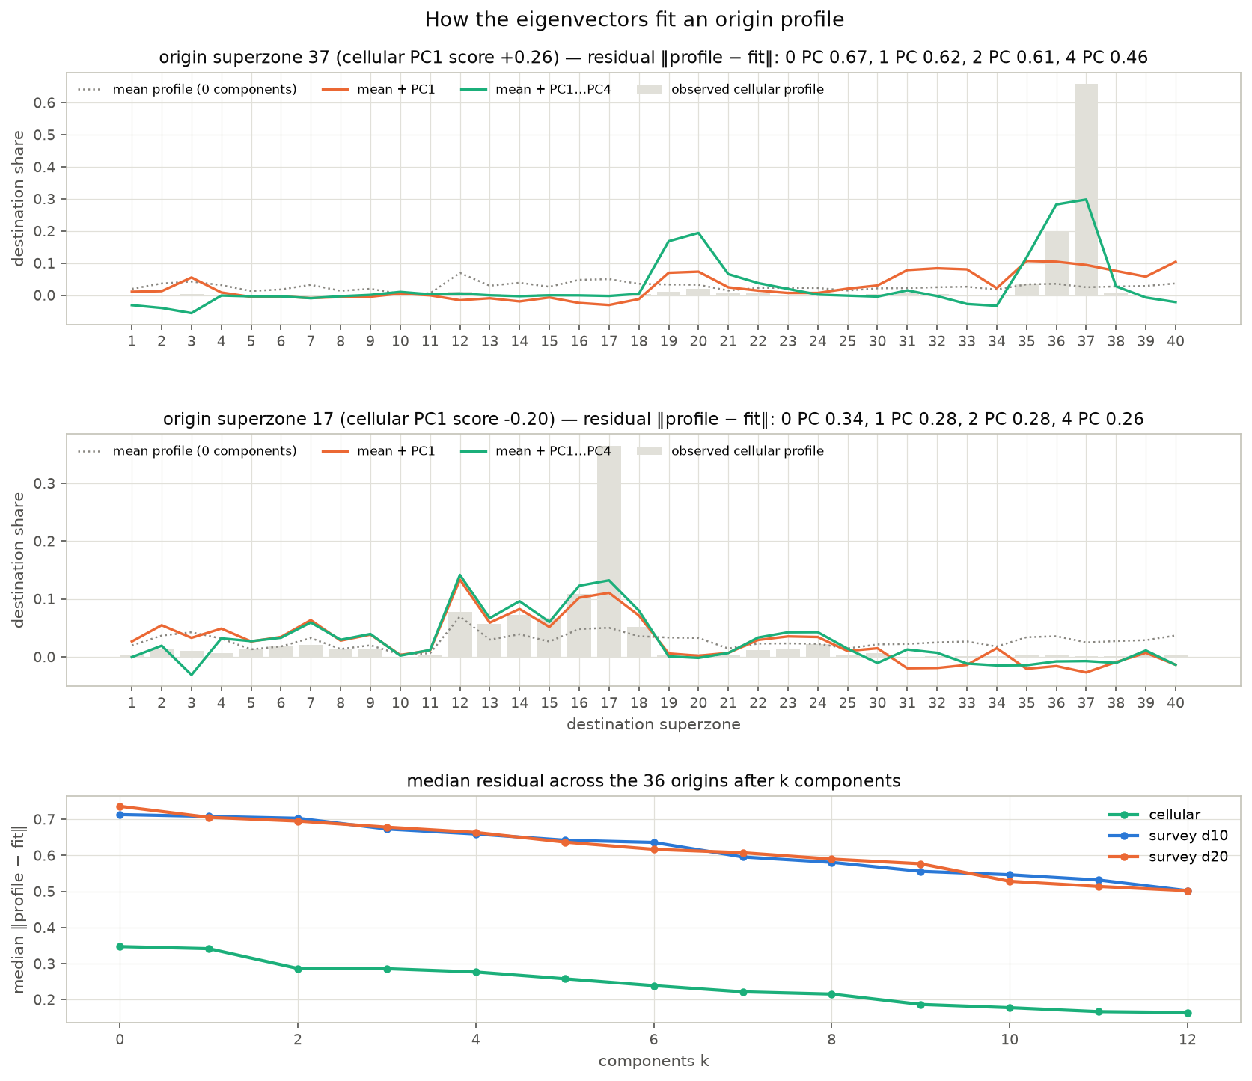
Figure 8. Reconstruction of two origin profiles (the two ends of cellular PC1) as mean + score × eigenvector with one and four components, over the observed profile; and the median residual across all 36 origins after k components, for cellular and both survey days.
The eigenvectors reproduce the shape of an origin's profile — which region it favours — but not the diagonal spike. For superzone 37, four components rebuild a self-share of 0.30 against an observed 0.66. The median residual across cellular origins falls from 0.35 with the mean alone to 0.28 with two components and 0.16 with twelve. Survey profiles start further from their mean (median residual 0.71) and stay above 0.50 even with twelve components, because the survey diagonal (≈ 72 % self-containment) dominates every row and is an origin-specific quantity that shared destination directions cannot absorb. This is the eigenvector view of the divergence result of the parent notebook: the sources share their off-diagonal patterns and differ on the diagonal.

4.6 Robustness — the 2017 trips-file survey
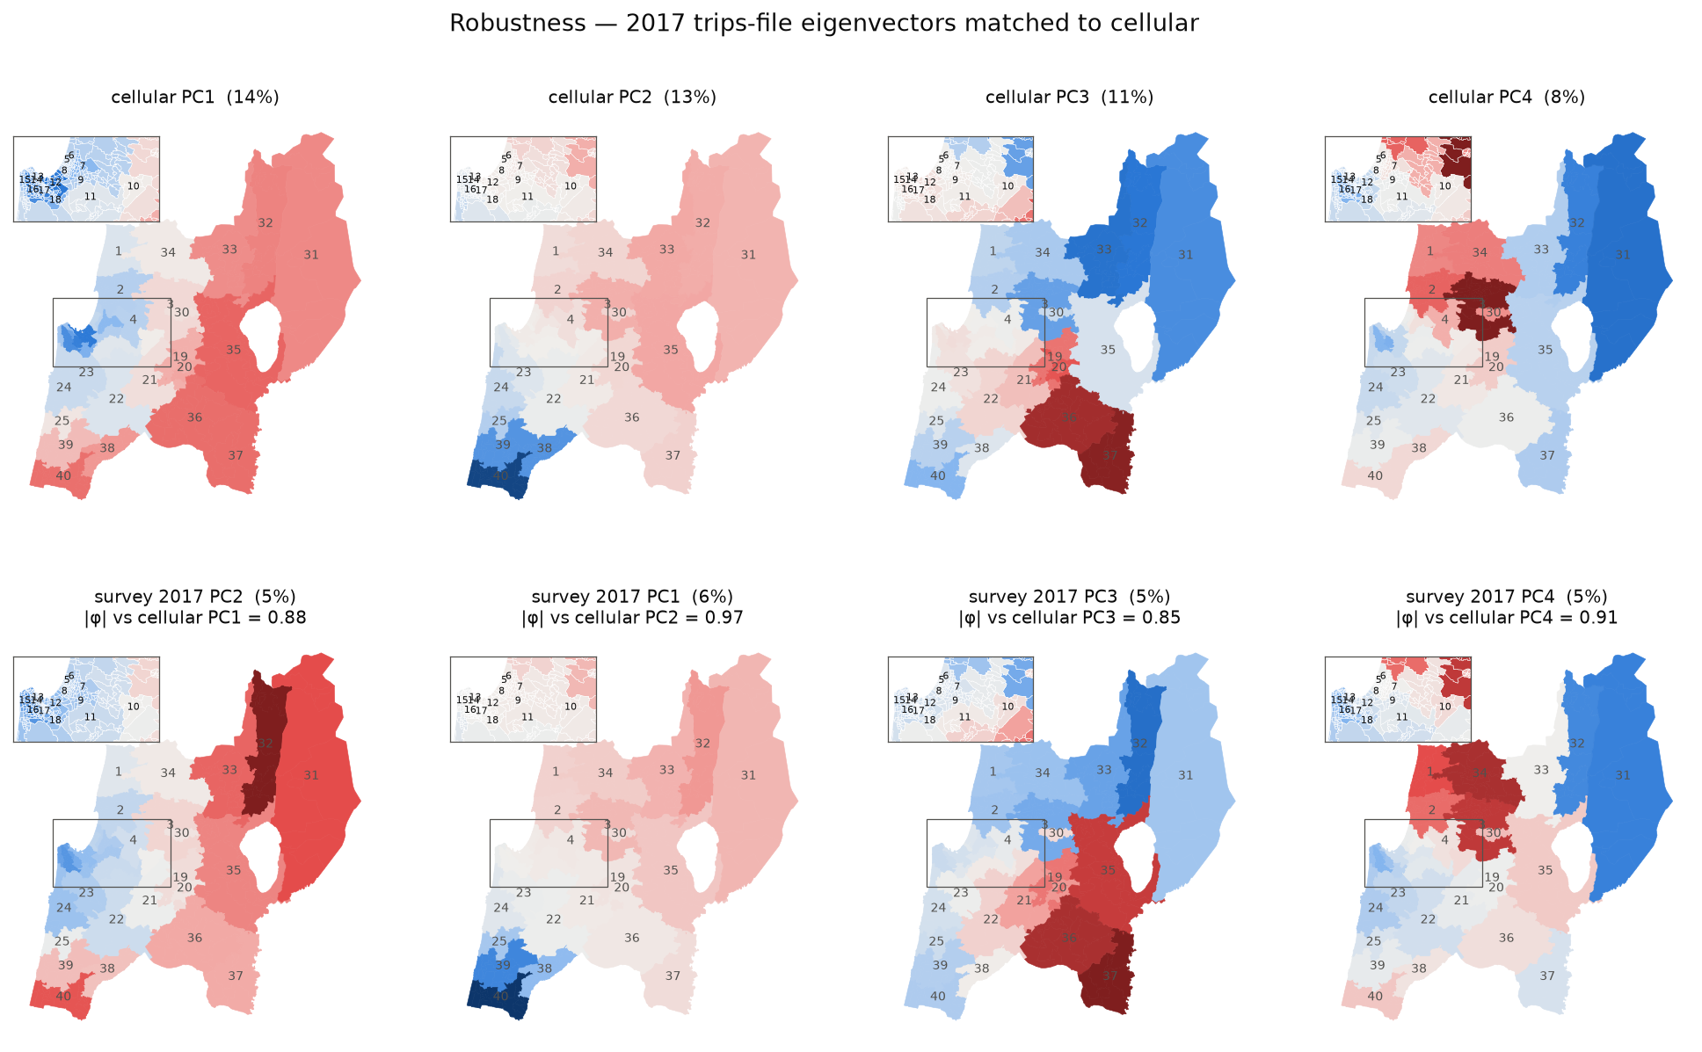
Figure 9. Eigenvector maps for the 2017 trips-file survey (the pipeline's primary fusion source), matched to the same cellular components. Congruences 0.88 / 0.97 / 0.85 / 0.91 on PC1–PC4; the maps are the same as for the 2018 activities source. The cellular matrix used here is prob_sz_cellular.csv; the 2017 notebook rebuilt its own with a slightly different TAZ-to-superzone key precedence, which moves a handful of cells by at most 0.07.

5. Outcome
- The shared structure has a geography. The four leading eigenvectors are four legible regional contrasts — Haifa core vs periphery, north vs south, Yizre'el/Nazareth vs Upper Galilee–Golan, Western Galilee/Akko vs Golan — and the parent notebook's "self-containment axis" is specifically a core-vs-periphery axis: its loading is only weakly related to destination size in general (r = −0.30) and singles out the Haifa metro attractors.
- Every pattern is present in both sources, in both survey days and in both survey vintages. Congruences with cellular are 0.82–0.97 for PC1–PC4 across survey day 10, day 20 and the 2017 trips file. The survey's eigenvectors are stable; what sampling noise changes is the eigenvalues — the same four patterns carry 14 / 13 / 11 / 8 % of cellular variance but a flat ≈ 5 % each of survey variance, which is the parent notebook's dimensionality finding made visible component by component.
- The eigenvectors fit the off-diagonal shape and leave the diagonal. Reconstruction reproduces which region an origin favours but not how much of its demand stays home; the survey profiles remain far from any low-rank fit because their diagonal dominates. This is exactly the term the pipeline's empirical-Bayes superzone correction factors act on.
- Implication for the pipeline. The eigenvector charts support the fusion design already adopted: cellular is the right spatial prior (its patterns are the survey's patterns, with far less noise), the survey's reliable contribution is the superzone diagonal, and there is no survey-specific destination pattern that the correction-factor approach would miss. The one survey accent worth noting — Kinneret grouped with Yizre'el on PC3 — is a single off-diagonal cell and does not change the picture.

6. Reproducibility
The charts and the numbers in this report are produced by THS_PCA_eigenvector_maps.ipynb, which reads only saved pipeline outputs and the study shapefile and writes:
- Output/figures/pca_eigenvector_maps.png, _loadings_ranked.png, _scores.png, _biplot.png, _meaning.png, _fit.png, _maps_2017.png — the seven charts;
- Output/pca_sz_eigenvectors.csv — the top-6 eigenvectors and origin scores of every source (864 rows: source, own PC, matched cellular PC, congruence, variance share, superzone, loading, origin score), matched to cellular and sign-aligned, for use in SQL or GIS.
Figures 1–2 are from THS_2018_MTX_PCA_vs_cellular.ipynb; the 2017 statistics quoted are consistent with THS_2017_PCA_vs_cellular.ipynb.

