Nofit LRT Extension — OD Demand Study
PCA Eigenvector Charts
Where the shared survey / cellular destination patterns sit on the map — and what that does and does not validate
Revision 2, after review · companion to THS_PCA_eigenvector_maps.ipynb and THS_PCA_review_tests.ipynb · September 2026

Summary
The Principal Component Analysis (PCA) notebooks of this study found that the household travel survey and the cellular-derived matrix share their dominant destination-choice patterns at superzone level. Revision 1 of this report drew those patterns — the eigenvectors — on the study geography. A review accepted the fusion approach but found the conclusions more confident than the evidence warranted, and asked for direct tests in five places. Revision 2 adds those tests and revises the conclusions accordingly.
What the evidence supports. At the 36-superzone level the two sources share a north–south destination pattern at the "equal" level of congruence (|φ| = 0.97) and related versions of a Haifa-core-vs-periphery pattern and two regional contrasts (|φ| 0.84–0.90, "fair similarity"). The survey's ≈ 68–72 % self-containment consists of real, short trips (median 0.7 km), which supports the rationale for correcting cellular's diagonal. The hybrid matrix is a defensible provisional base-year OD estimate for strategic screening.
What it does not support. The sources differ materially in where outbound trips go once a trip leaves its origin superzone — about 31 % of outbound trips would have to be moved to reconcile them, roughly 2.4 times what sampling noise would produce — so "the divergence is confined to the diagonal" is withdrawn. The hybrid resolves that difference by adopting the survey's pattern on every superzone pair, so its superzone-to-superzone structure is the survey's, not cellular's. The survey's flat eigenvalue spectrum is produced by its diagonal, not by sampling noise, as the reviewer suggested. PCA on row-normalised shares says nothing about absolute volumes, which rest entirely on the survey's expansion weights, and superzone agreement says nothing about the within-superzone allocation that governs 71 % of the corridor's own trips; a check at the survey's native zone resolution finds that allocation well matched in the Haifa inner-city superzones and poorly matched in Nazareth, Kiryat Eliezer / Carmel coast and Tirat Carmel.
Conclusion. The analysis supports the hybrid's structural plausibility at superzone level. Its absolute volumes, its within-superzone allocation outside the inner-city superzones, and its suitability for corridor demand remain to be validated against evidence that was not used in the correction. The intended-use table in section 6 sets out what the current evidence can carry.

1. Main goal
The OD demand pipeline fuses the household survey with the cellular matrix: cellular supplies the population-scale spatial prior, the survey supplies evidence at the scale where it is reliable (36 superzones). The PCA suite was built to test whether the two sources describe the same destination-choice structure and where they part ways; this report makes the eigenvectors visible so that each component can be read as a spatial pattern, and — in this revision — tests directly what the pattern agreement implies for the fused matrix.
Two limits of the method are stated up front, because revision 1 blurred them. PCA here works on row-normalised destination shares: it compares the variation of destination profiles across origins and is blind to trip totals, origin totals and destination totals. And the four charted components carry 46 % of cellular variance and 21 % of survey variance; their agreement describes the dominant patterns, not the bulk of either matrix.

2. Data
Input | Content | Role
Output/prob_sz_cellular.csv | Cellular AM-peak (6:00–9:00) OD probabilities, 36 × 36 superzones, rows sum to 1 | Population-scale reference (probabilities only)
Output/prob_sz_10_weighted.csv, prob_sz_20_weighted.csv | THS 2018 activities source, household-weighted (wf_new), survey day 10 and day 20 | Survey evidence; day 20 is the repeatability benchmark for day 10
Input/trips_ths_2017.xlsx | THS trips file: one row per activity per person per survey day, 5,108 households, with HHID3, SurveyDay, placeno, actTaz, Dep_h, TrvlDist, mainActivity, new_wf | Household bootstrap, diagonal audit, native-resolution within-superzone check; the same household panel as the 2018 file, extracted through a different chain
Output/ths2017/study_taz/hybrid_taz_trips.csv, hybrid_sz_prob.csv | The pipeline's primary hybrid (778 TAZs; 36 superzones) | What the hybrid actually carries; corridor exposure
Input/TAZ_North/TAZ_North.shp, Input/Submatrix_tazs.xlsx | 781 study TAZ polygons with SUPERZONE and ARZI_1270 fields; the 119 LRT-corridor TAZs | Geography, zone chain, corridor definition

The superzones are numbered rather than named; Table 2 gives each a reading aid (dominant sub-district, and the research areas it contains inside the LRT corridor). Corridor superzones in this report are those holding at least three corridor TAZs: 4, 7, 9, 12, 13, 14, 15, 17, 19, 20 and 24.
SZ | Sub-district | Corridor areas | SZ | Sub-district | Corridor areas
1 | Akko |  | 20 | Yizre'el | Nazareth Area
2 | Akko |  | 21 | Yizre'el | Tzipori
3 | Akko |  | 22 | Yizre'el
4 | Akko | Shefaram | 23 | Haifa
5 | Haifa | Kiryat Yam | 24 | Hadera | Tirat Carmel, Matam
6 | Haifa | Kiryat Motzkin–Bialik | 25 | Hadera
7 | Haifa | Kiryat Motzkin–Bialik, Kiryat Ata Center | 30 | Akko
8 | Haifa | Kiryat Motzkin–Bialik, Kiryat Yam | 31 | Golan
9 | Haifa | Kiryat Ata East / South | 32 | (Upper Galilee)
10 | Akko | Alon Hagalil | 33 | Tzfat
11 | Haifa | Adi, Kiryat Ata South | 34 | Akko
12 | Haifa | Namal, Hamifrats, Haifa Airport | 35 | Kinneret
13 | Haifa | Lower City, Hamoshava, Hadar Carmel | 36 | Yizre'el
14 | Haifa | Hadar Carmel | 37 | Yizre'el
15 | Haifa | Kiryat Eliezer, Neot Peres, Neve David | 38 | Hadera
16 | Haifa | (Carmel) | 39 | Hadera
17 | Haifa | Neve Yosef | 40 | Hadera
18 | Haifa | Nesher Lower, Hamifrats
19 | Yizre'el | Nazareth Area
Table 2. Superzone reading aid. Sub-district is the modal value over the superzone's TAZs; SZ 32 has no sub-district code in the source.

3. Method

3.1 PCA framing
Each origin superzone is an observation; its row-normalised destination-share profile (36 shares) is the feature vector. The 36 × 36 probability matrix is column-centred and decomposed by singular value decomposition. An eigenvector (loading vector) is a direction in destination space — one signed weight per destination superzone — drawn as a destination map; an origin score is the projection of an origin's profile on that direction, drawn as an origin map; the eigenvalue is the variance the component carries. An origin's profile equals the mean profile plus the sum of score × eigenvector over components, so origins coloured red on a score map send more trips than the average origin to destinations coloured red on the matching loading map.

3.2 Matching components across sources, and how to read a congruence
The top six components of each survey matrix are matched one-to-one to cellular's by the Hungarian algorithm on the absolute Tucker congruence |φ| (the dot product of unit-norm loading vectors), and each matched survey eigenvector is sign-aligned to its cellular partner. Revision 1 read |φ| ≥ 0.85 as "the same component". Following Lorenzo-Seva & ten Berge (2006), this revision reads |φ| ≥ 0.95 as components that can be considered equal and 0.85–0.94 as fair similarity; values below 0.85 are related patterns at most. These are interpretive guidelines from factor analysis, not transport-validation standards.

3.3 Benchmarks
No survey-vs-cellular statistic is read in isolation. Three benchmarks are used. (i) Survey day 20 next to day 10, and day 2 next to day 1 in the trips file: because both days come from the same households, this is a repeatability check under shared sampling and reporting biases, not independent evidence. (ii) A household bootstrap of the 2017 trips file (400 replicates, households resampled with both their days), which gives the sampling spread of every statistic given the survey design. (iii) A sampling-noise benchmark built on cellular: cellular resampled multinomially at the survey's per-origin sample sizes shows what pure noise at the survey's size does to a spectrum, a congruence or a distance, and cellular given the survey's diagonal (no noise) isolates the effect of the diagonal itself.

3.4 Direct tests added in this revision
- Conditional outbound distributions. For each origin i, q(j | i) = p_ij / (1 − p_ii), j ≠ i, is compared cell by cell between survey and cellular with the total-variation distance TV = ½ Σ |q_s − q_c| — the share of outbound trips that would have to be moved between destinations — against the day-to-day and sampling-noise benchmarks, for all origins, corridor origins, and origins with at least 100 sampled outbound trips.
- Spectrum decomposition. Cellular with the survey's diagonal (no noise), cellular resampled at the survey's sample sizes (noise only), and both, compared with the survey's observed spectrum and congruences.
- Diagonal audit. Intra-superzone AM-peak survey trips profiled by zone change at the survey's native 2636-zone resolution, reported distance, purpose pair and mode, against inter-superzone trips.
- Within-superzone check. Share of corridor trips that stay inside one superzone (hybrid), and, for each corridor superzone, the pooled intra-superzone destination distribution over the survey's native 1250-zones compared with cellular's. Below that resolution the survey is itself allocated by cellular shares and can check nothing.
- Scale. What the pipeline's absolute totals rest on, and which comparison is still open.

3.5 Geography and chart set
TAZ polygons are drawn in their superzone's colour on a diverging blue–grey–red scale centred on zero; superzone labels sit at the area-weighted centroid of the superzone's TAZs, and every map carries a zoom inset of the Haifa-bay superzones 5–18. Section 4 holds the eigenvector charts (Figures 3–9, preceded by two context figures from the parent notebook); section 5 holds the direct tests (Figures 10–12).

4. The eigenvectors on the map

4.1 Starting point — the parent notebook's evidence
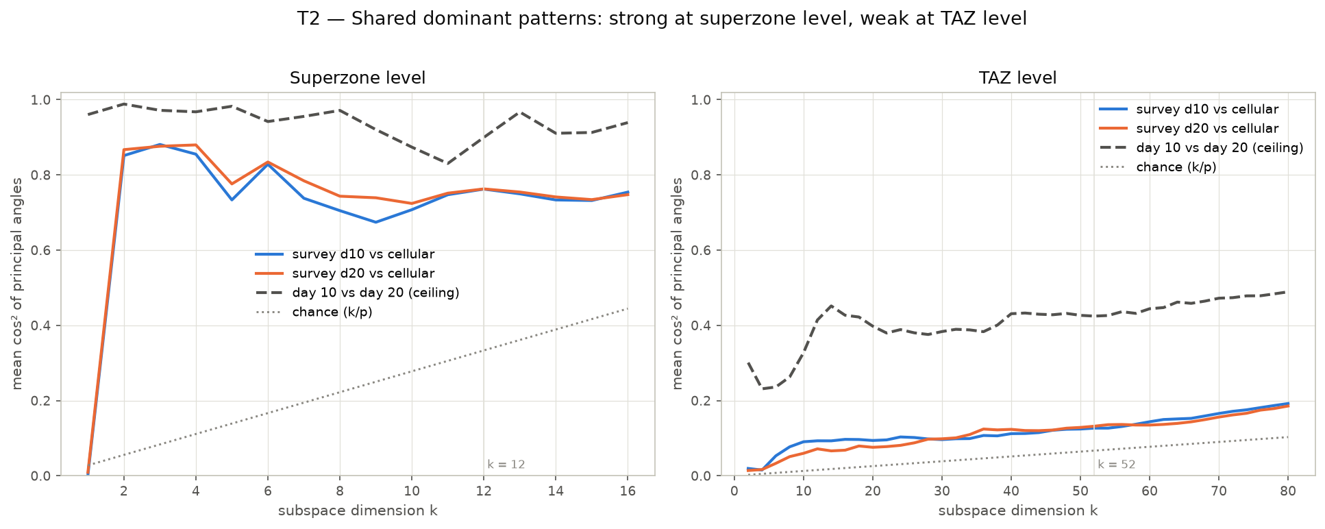
Figure 1. Subspace overlap (mean cos² of principal angles) between the survey's and cellular's top-k component subspaces, against the day 10 vs day 20 ceiling and chance. At superzone level the top-12 overlap is 0.76 (ceiling 0.90, chance 0.33); at TAZ level the survey cannot replicate even its own structure across days. Source: THS_2018_MTX_PCA_vs_cellular.ipynb.
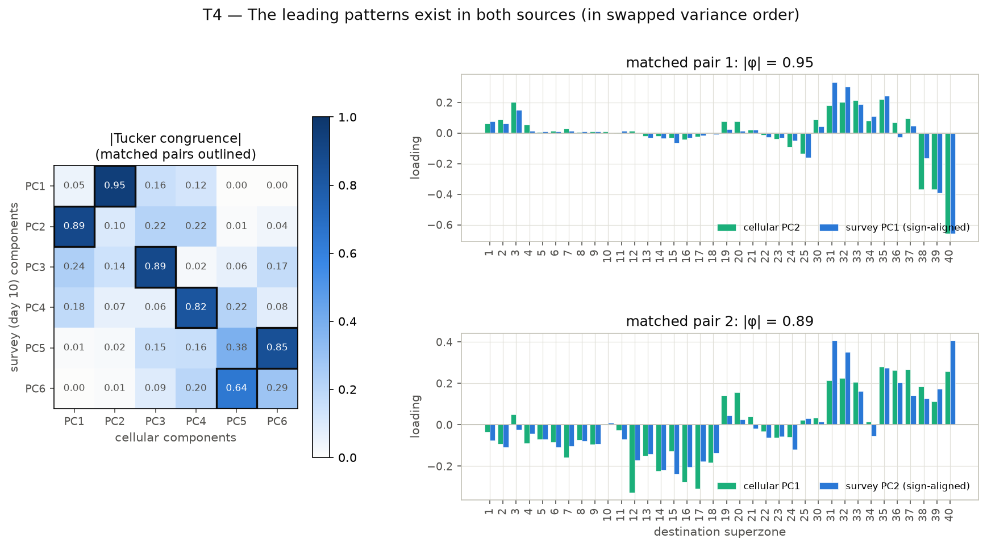
Figure 2. Hungarian-matched |Tucker congruence| between the top-6 survey and cellular components, with the two leading matched pairs as bars. Survey PC1 ↔ cellular PC2 (0.95) and survey PC2 ↔ cellular PC1 (0.89). Source: THS_2018_MTX_PCA_vs_cellular.ipynb.

4.2 Destination maps
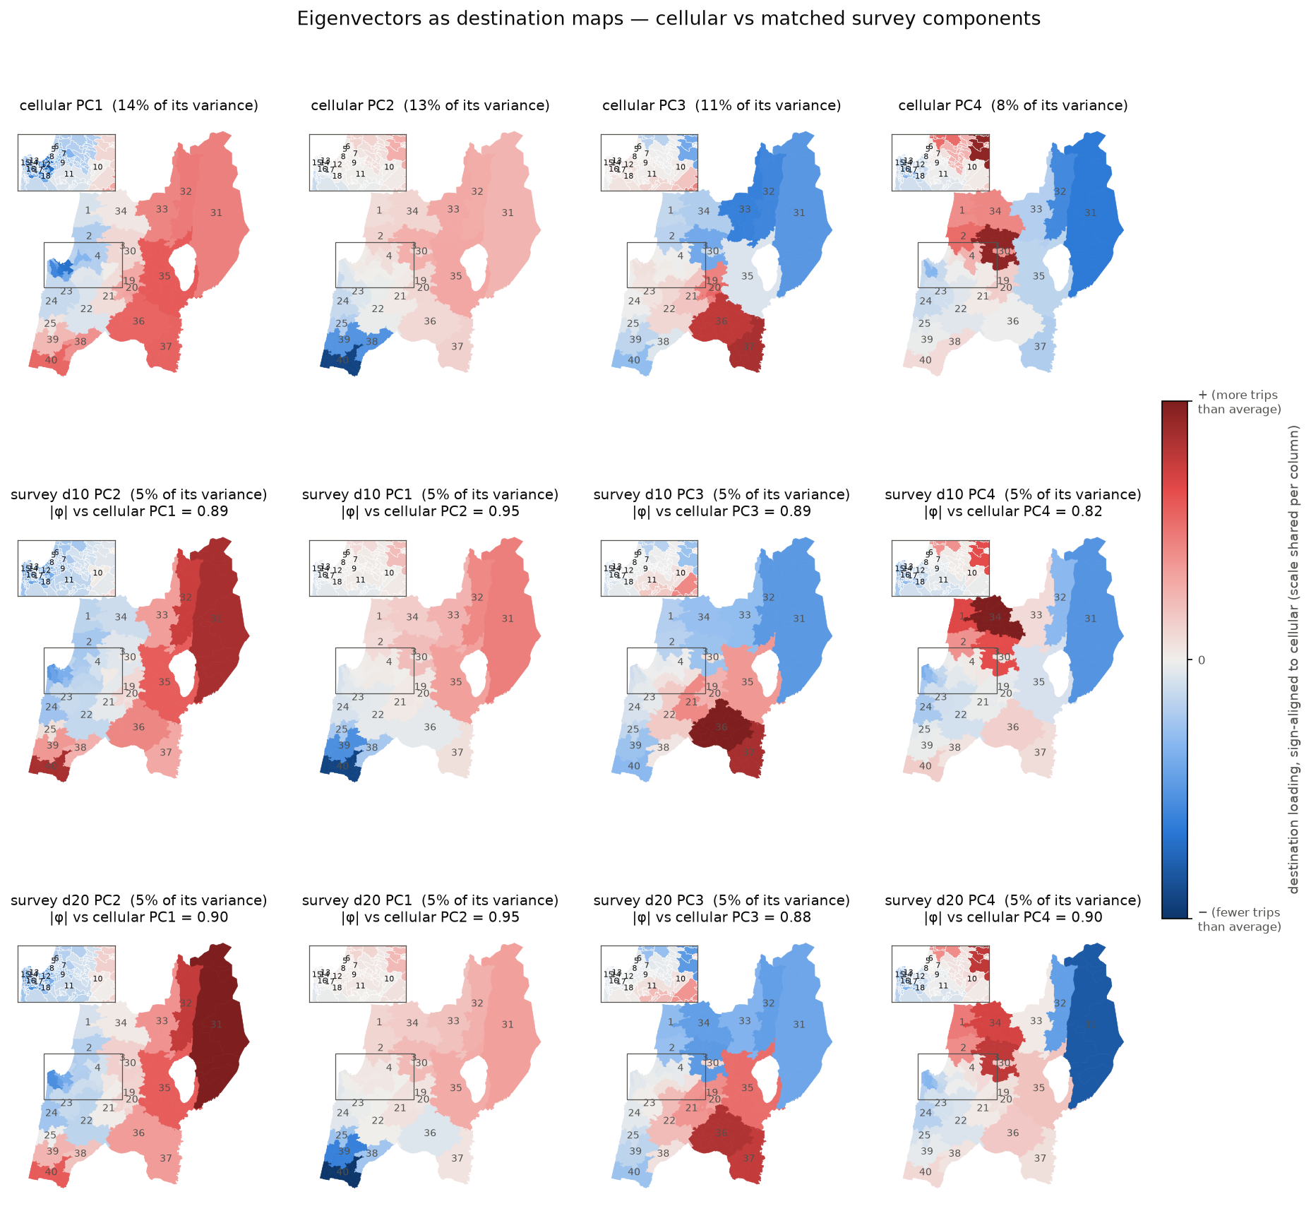
Figure 3. Eigenvectors as destination maps. Columns are cellular PC1–PC4; rows are cellular, survey day 10 and survey day 20, each survey component matched to the cellular one above it and sign-aligned. Red destinations carry positive loadings, blue negative; the colour scale is shared within a column. Inset: the Haifa-bay superzones 5–18.
Cellular PC | Variance (cellular / survey) | |φ| d10 / d20 / 2017 | Band (2017) | Pattern
PC1 | 14 % / 5 % | 0.89 / 0.90 / 0.88 | fair similarity | Haifa core vs periphery. Negative on the metro core (12 Namal–Hamifrats, 17, 16, 14, 18, 7), positive on Kinneret, Yizre'el, Hadera, Upper Galilee and Golan (35, 37, 36, 40, 32, 31).
PC2 | 13 % / 5 % | 0.95 / 0.95 / 0.97 | equal | North vs south. Hadera-side destinations (40, 38, 39, 25, 24) against the Galilee (35, 33, 32, 3, 31).
PC3 | 11 % / 5 % | 0.89 / 0.88 / 0.85 | fair / below | Yizre'el / Nazareth (37, 36, 20, 19, 21, 22) vs Upper Galilee–Golan (33, 32, 31) and 3, 40.
PC4 | 8 % / 5 % | 0.82 / 0.90 / 0.91 | fair similarity | Western Galilee / Akko (3, 2, 34, 1, 30, 4) vs Golan (31, 32) and the Haifa core (17, 16, 14).
Table 3. The four leading cellular components, their matched survey components and the pattern each encodes. Survey variance shares are for day 10. The 2017 congruences here are from the eigenvector notebook; the review-tests notebook, which rebuilds the 2017 matrix with a slightly different allocation of the 17 straddling zones, gives 0.87 / 0.97 / 0.84 / 0.90.
The maps for day 10 and day 20 are near-identical for all four components and within 0.01–0.08 in congruence with cellular: the survey's leading eigenvectors are reproducible across its two days. Being from the same households, that reproducibility is not independent confirmation; the household bootstrap in section 5.2 gives the sampling spread.
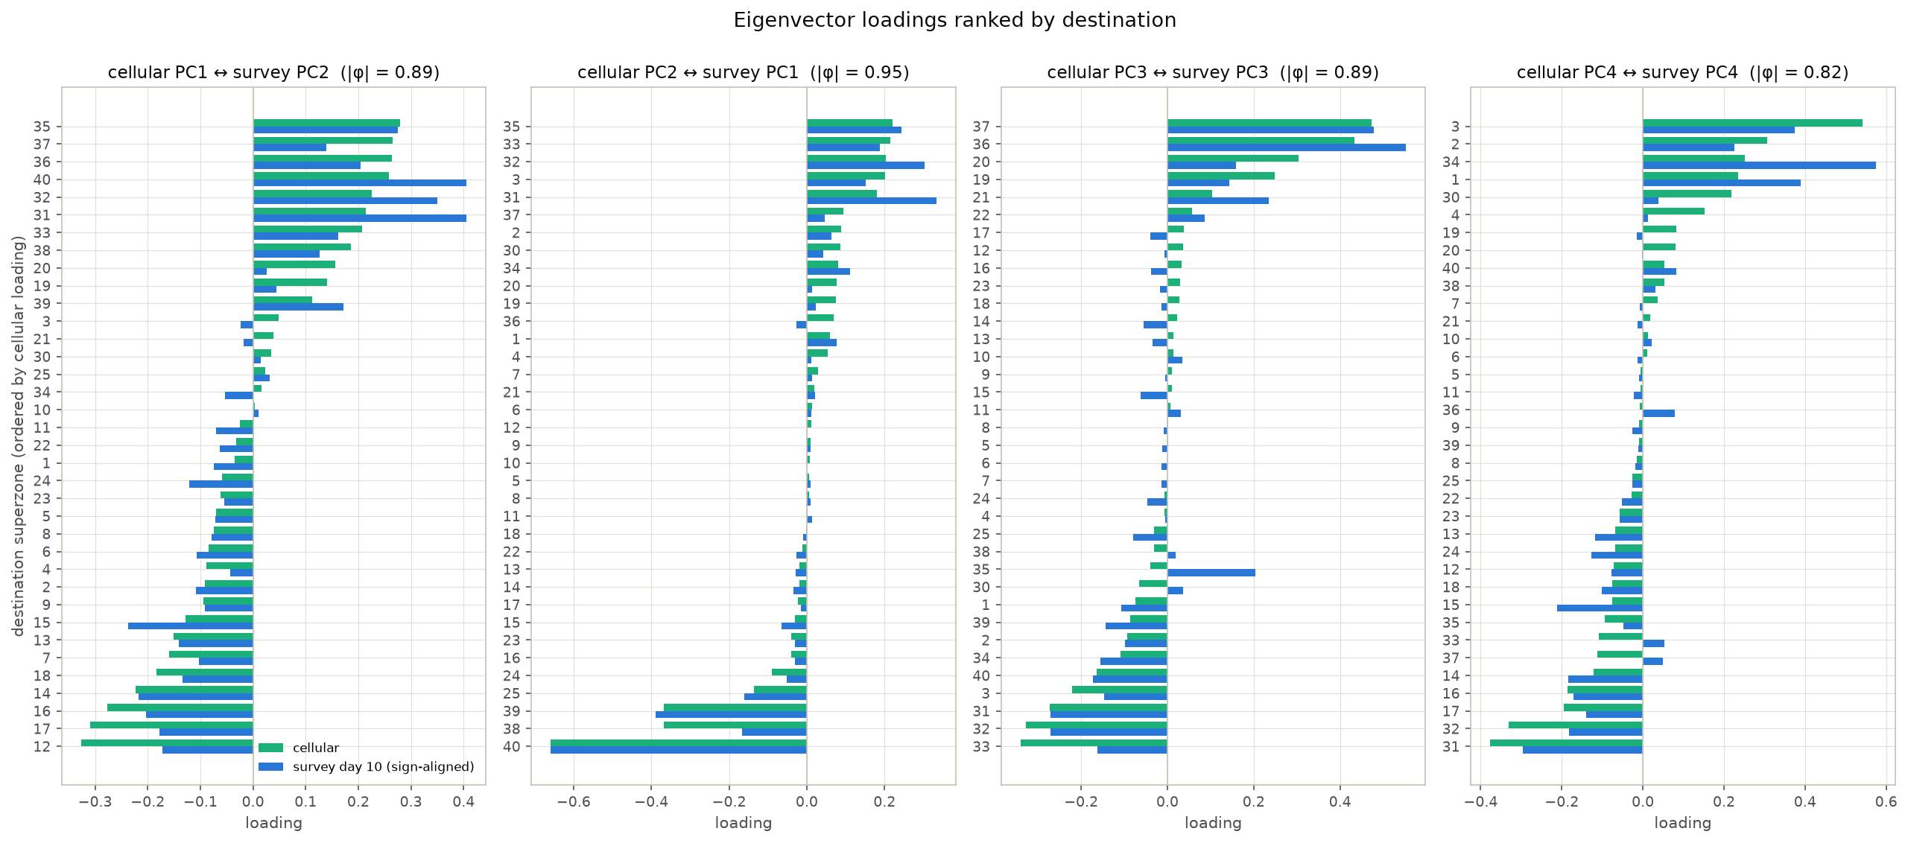
Figure 4. The same eigenvectors as ranked bars: destinations ordered by the cellular loading, with the sign-aligned survey day 10 loading alongside. The small Haifa-bay superzones become legible here. Two survey-specific accents are visible: on PC1 the survey weights the Golan and Upper Galilee (31, 32, 40) more heavily than cellular does, and on PC3 the survey attaches Kinneret (35) to the Yizre'el side (+0.20) where cellular does not (−0.05). A destination-loading difference of that kind shifts reconstructed flows to superzone 35 from every origin that scores on PC3; it is not a single OD cell.

4.3 Origin scores and biplots
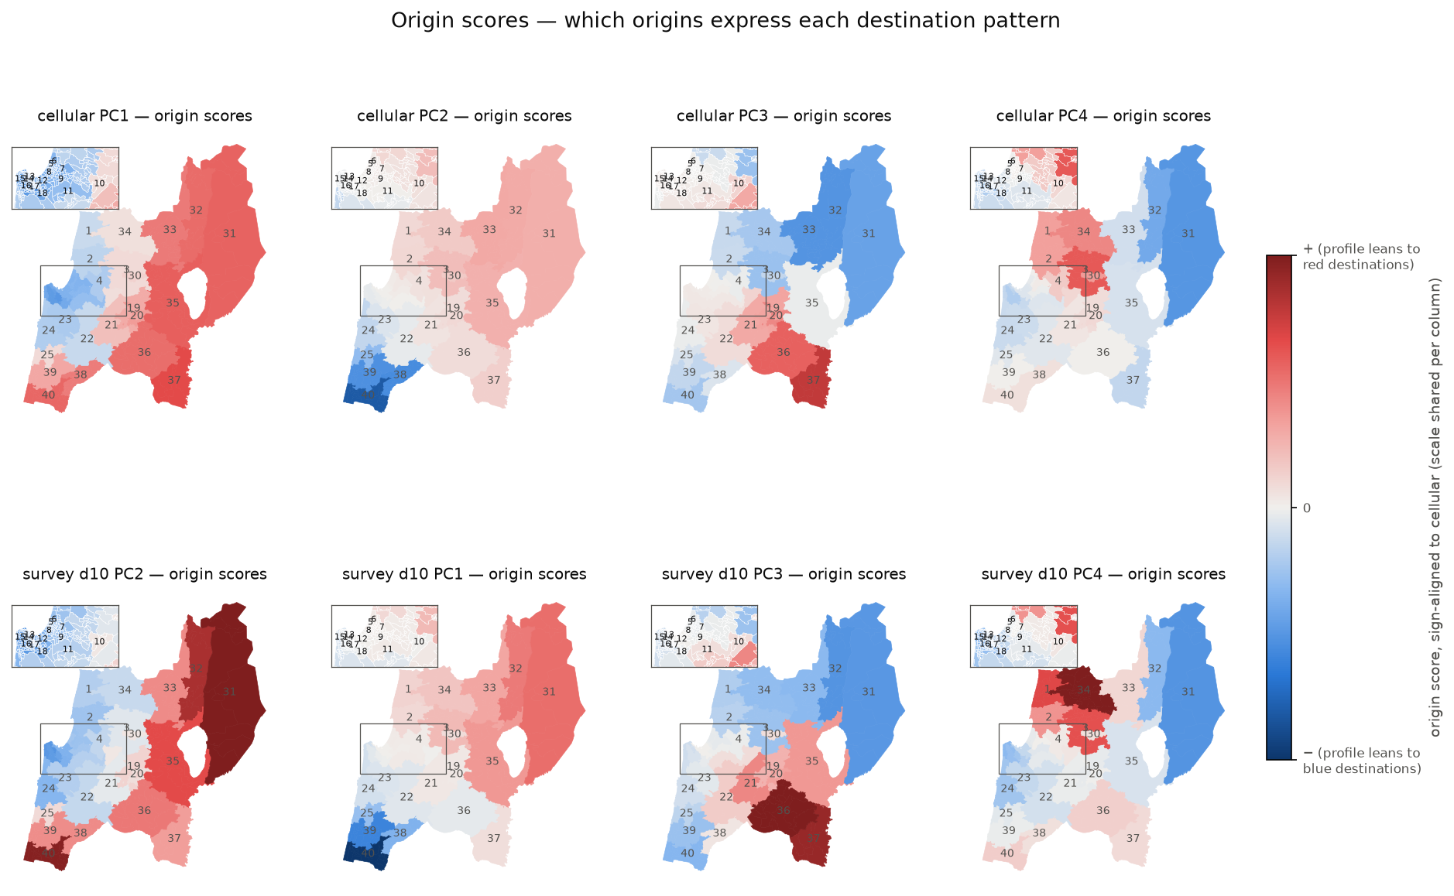
Figure 5. Origin scores for cellular and matched survey day 10 components. An origin coloured red projects positively on the component, i.e. its destination profile leans toward the red destinations of the corresponding loading map in Figure 3.
For PC1 the score map is a map of the periphery: origins outside the Haifa metro score positively because their profiles lean toward their own region rather than the core, which is why PC1 scores correlate with self-containment (r = +0.76). For PC2 the strongest origin in either source is superzone 40, the southernmost Hadera zone. PC3 and PC4 are expressed most strongly by origins inside the regions they contrast.
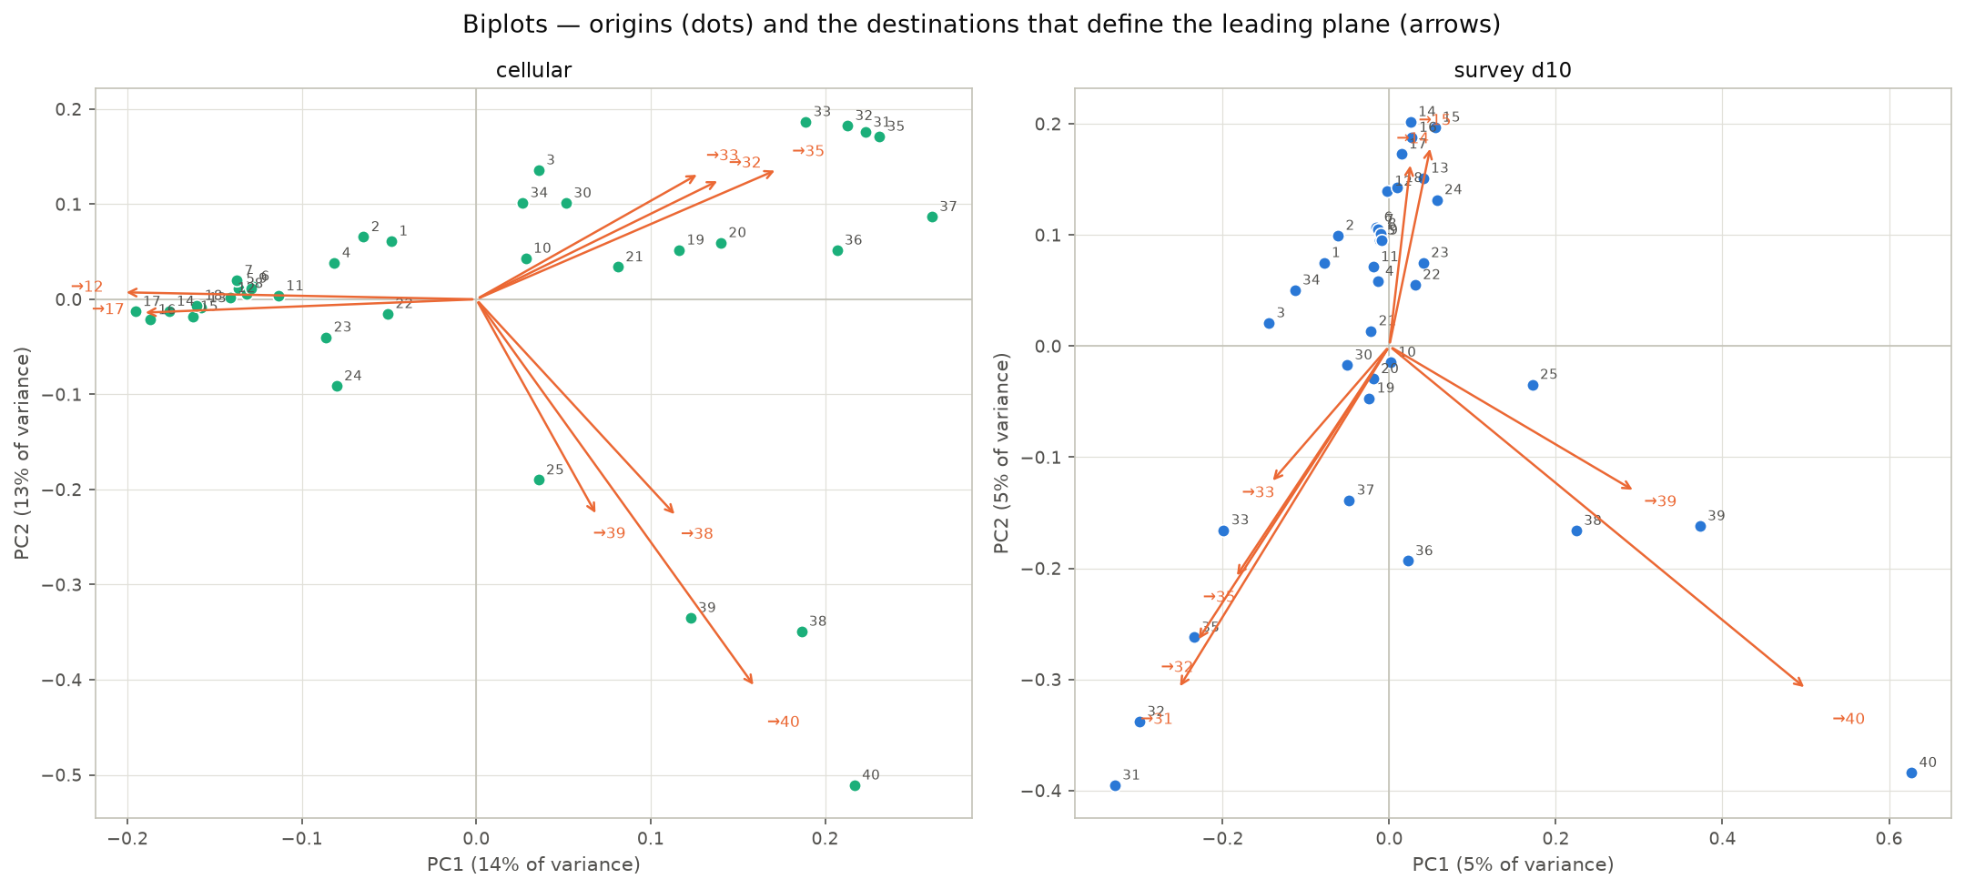
Figure 6. Biplots on the leading plane. Dots are origins (scores on PC1 and PC2); orange arrows are the eight destinations with the largest loadings on that plane, scaled to fit. The survey panel shows the same two patterns with PC1 and PC2 swapped, so it appears rotated by about 90°. The tight cluster of Haifa-bay origins (5–18) in both panels is the metro core, whose profiles are alike.

4.4 What the axes mean
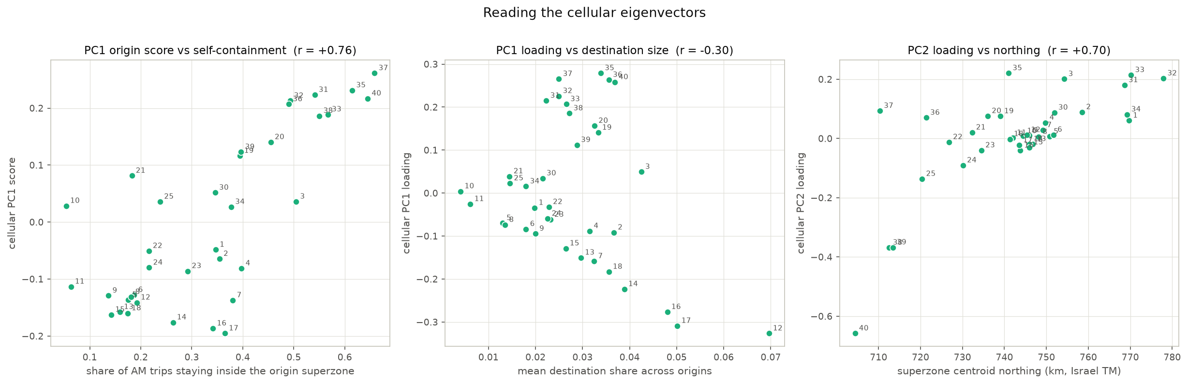
Figure 7. Three checks on the cellular eigenvectors. Left: PC1 origin score against self-containment (r = +0.76). Middle: PC1 loading against destination size (mean share across origins; r = −0.30) — PC1 is not a generic big-attractor axis, it singles out the Haifa metro attractors. Right: PC2 loading against the superzone's northing (r = +0.70). The matched survey components give r = +0.76 and +0.74 for the same two checks.

4.5 Low-rank fit
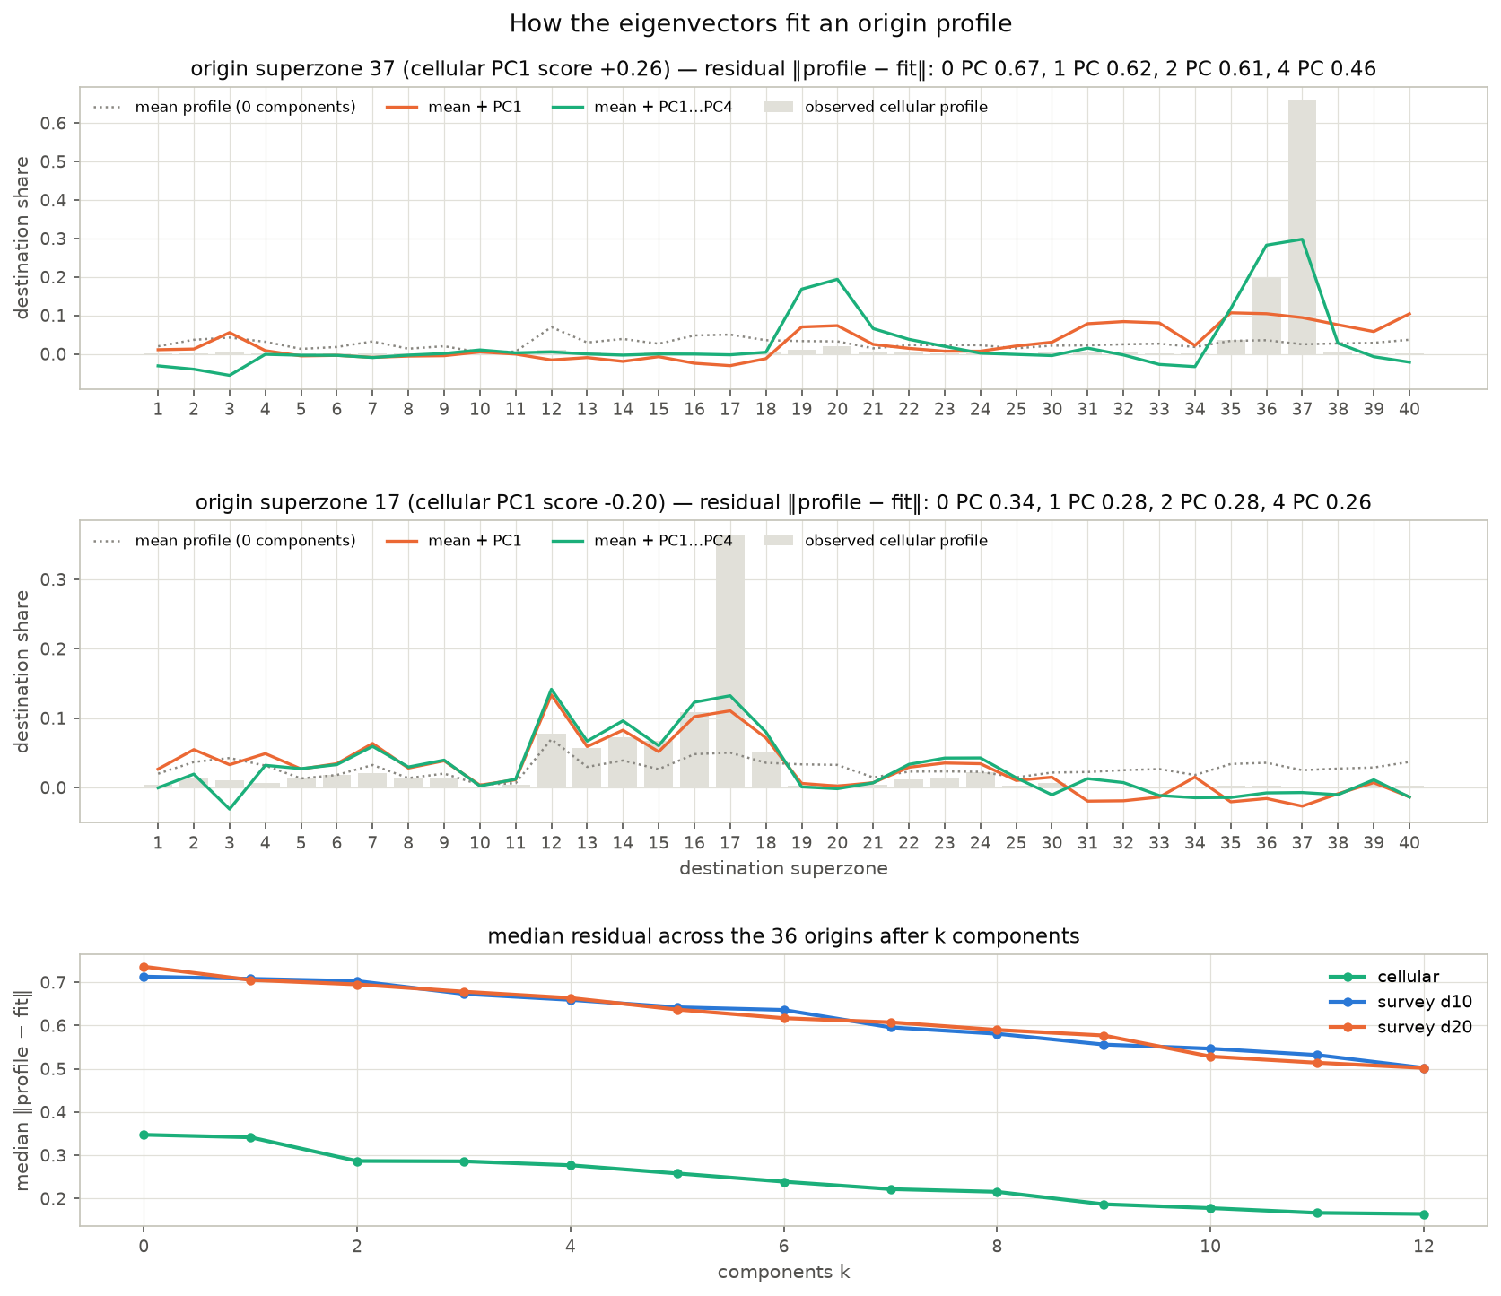
Figure 8. Reconstruction of two origin profiles (the two ends of cellular PC1) as mean + score × eigenvector with one and four components, over the observed profile; and the median residual across all 36 origins after k components, for cellular and both survey days.
The eigenvectors reproduce the shape of an origin's profile but not its diagonal spike (for superzone 37, four components rebuild a self-share of 0.30 against an observed 0.66); survey profiles stay above a residual of 0.50 even with twelve components because their diagonal dominates every row. As the review noted, this describes the limits of a low-rank representation of each source separately; it is not a test of where the two sources disagree. That test is in section 5.1.

4.6 The 2017 trips-file survey
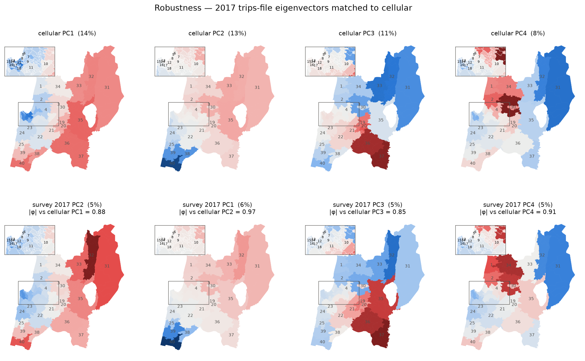
Figure 9. Eigenvector maps for the 2017 trips-file survey (the pipeline's primary fusion source), matched to the same cellular components. Congruences 0.88 / 0.97 / 0.85 / 0.91 on PC1–PC4. The 2017 and 2018 sources are the same household panel, so matching maps replicate the processing chain, not the sample. The cellular matrix used here is prob_sz_cellular.csv; the 2017 notebook rebuilt its own with a slightly different TAZ-to-superzone key precedence (a handful of cells differ by up to 0.07); resolving it needs the raw cellular file, which is held in Git LFS outside the working copy.

5. Direct tests

5.1 Where outbound trips go — conditional destination distributions
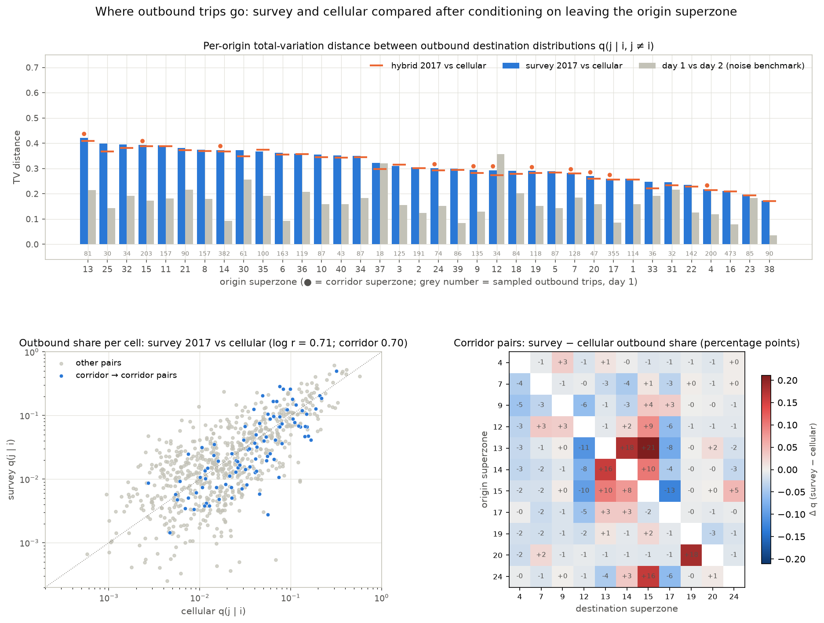
Figure 10. Top: per-origin total-variation distance between outbound destination distributions q(j | i, j ≠ i), survey 2017 vs cellular (blue), day 1 vs day 2 (grey, noise benchmark) and hybrid vs cellular (orange marks); corridor superzones dotted; grey numbers are sampled outbound trips on day 1. Bottom left: outbound share per cell, survey vs cellular, corridor-to-corridor pairs highlighted. Bottom right: survey minus cellular outbound share for the corridor superzone pairs, in percentage points.
Comparison | All origins | Corridor origins | Origins with ≥ 100 outbound samples
survey 2018 day 10 vs cellular | 0.34 | 0.35 | 0.34
survey 2018 day 20 vs cellular | 0.35 | 0.34 | 0.35
day 10 vs day 20 (repeatability) | 0.16 | 0.15 | 0.15
survey 2017 vs cellular | 0.31 | 0.31 | 0.31
day 1 vs day 2, 2017 (repeatability) | 0.17 | 0.17 | 0.14
pure sampling noise at survey size: one sample vs truth / two samples | 0.13 / 0.18 | — | —
hybrid 2017 vs cellular | 0.30 | 0.30 | 0.30
hybrid 2017 vs survey 2017 | 0.015 | 0.015 | 0.010
Table 4. Mean total-variation distance between outbound destination distributions (share of outbound trips that would have to move). Sampled outbound trips per origin on day 1 range from 18 to 473 (median 90).
The survey-to-cellular distance is about 2.4 times what sampling noise alone would produce and twice the day-to-day distance, for all origins, for corridor origins and for the best-sampled origins alike. Cell by cell, the log-share correlation is 0.71 (day-to-day 0.81). The two sources therefore disagree on where outbound trips go, not only on how many trips leave at all; the parent notebook's "88 % of squared divergence on the diagonal" is dominated by the diagonal's magnitude and does not carry the conclusion that revision 1 drew from it. In the corridor, the survey routes more of the Haifa inner-city exchange between superzones 13, 14 and 15 (+10 to +21 points of outbound share) and less to the port / Hamifrats superzone 12 (−6 to −11) and from 15 to 17 (−13) than cellular does.
What the hybrid keeps. The hybrid's outbound distributions sit 0.015 from the survey's and 0.30 from cellular's: with the cross-validated shrinkage constant k* = 5 the empirical-Bayes blend is slight, and the correction factors act on every superzone pair, so at superzone level the hybrid is the survey. Cellular's contribution is the allocation of trips to TAZs within each superzone pair. The validation question is therefore not whether the hybrid retains cellular's outbound structure — it does not — but whether the survey's superzone-to-superzone pattern, at 65–890 sampled trips per origin row, is the better estimate. The pipeline's day-held-out cross-validation says it is, but only against the survey itself.

5.2 Household bootstrap and what the congruences mean
Cellular PC | Cellular var. share | |φ| point (2017) | Bootstrap mean | Bootstrap 2.5–97.5 % | Band
PC1 | 0.14 | 0.87 | 0.83 | 0.70–0.93 | fair similarity
PC2 | 0.13 | 0.97 | 0.93 | 0.81–0.97 | equal
PC3 | 0.11 | 0.84 | 0.82 | 0.68–0.92 | below 0.85
PC4 | 0.09 | 0.90 | 0.85 | 0.71–0.92 | fair similarity
PC5 | 0.07 | 0.71 | 0.60 | 0.07–0.89 | below 0.85
PC6 | 0.06 | 0.46 | 0.49 | 0.04–0.83 | below 0.85
Table 5. Hungarian-matched congruence of the 2017 survey components with cellular's, with the household-bootstrap spread (400 replicates). A bootstrap replicate carries the original sample's noise plus resampling noise, so congruences shift downward under resampling; the interval width is the sampling-uncertainty message. Other bootstrap results: mean self-containment 0.683 (0.669–0.696); survey participation ratio 28.5 (27.6–28.9) against cellular's 13.1; top-4 variance share 0.21 (0.20–0.21).
Only the north–south component reaches the "equal" band. The core-vs-periphery and Western-Galilee components are fair similarity, the Yizre'el component falls just below, and the bootstrap spreads (about ±0.1) mean none of the four is established as identical. The next section places these values against the two synthetic benchmarks.

5.3 What flattens the survey's spectrum — the diagonal, not noise
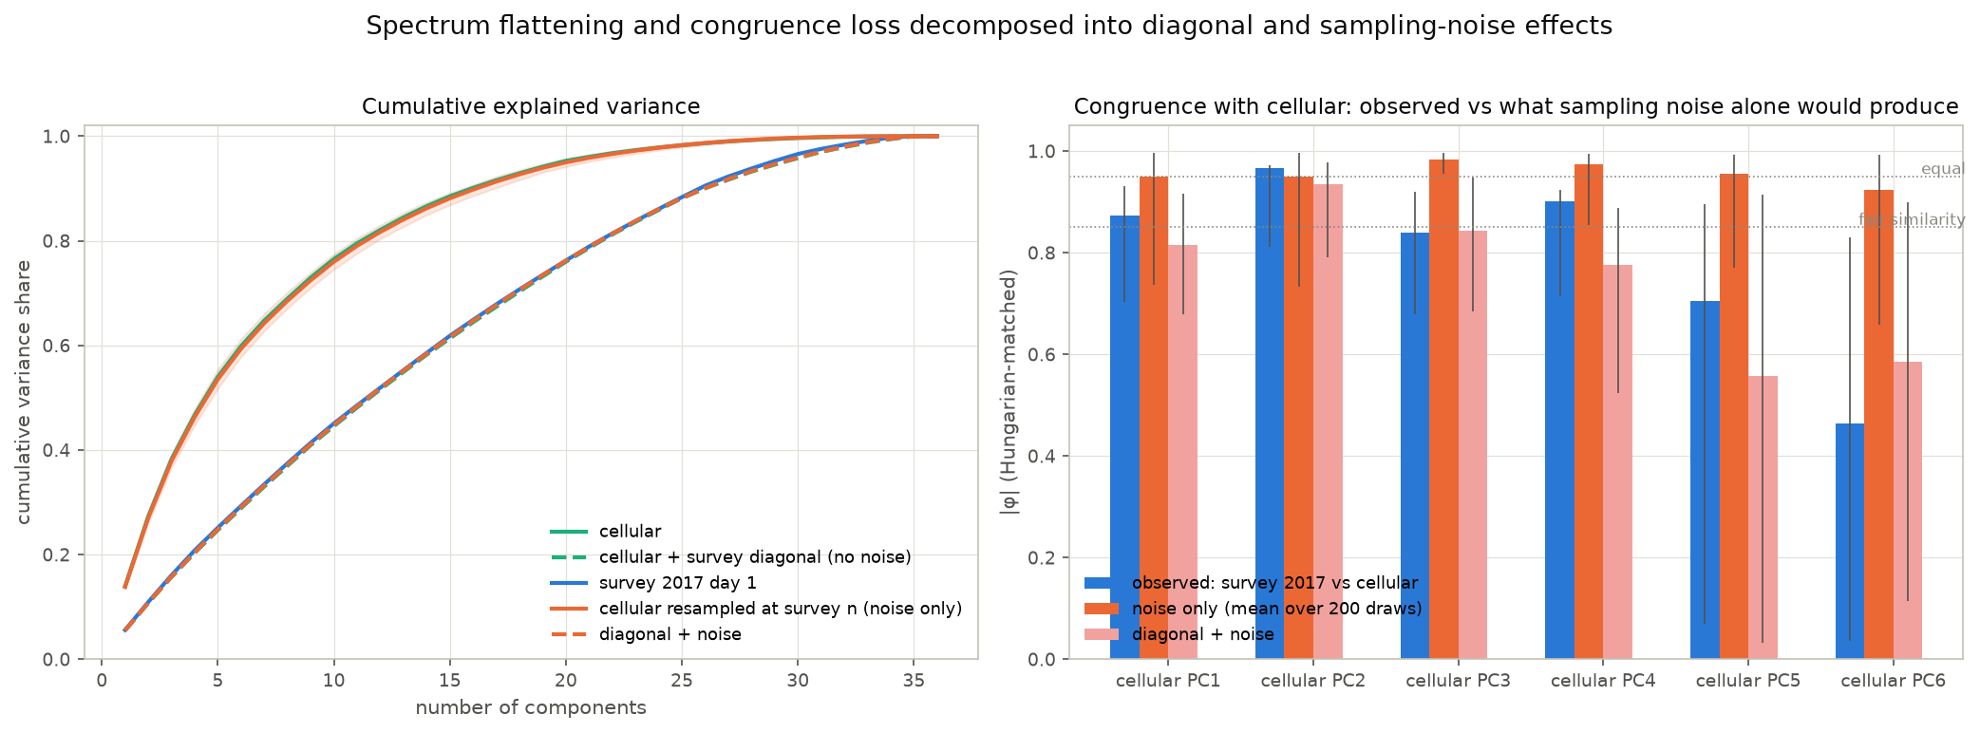
Figure 11. Left: cumulative explained variance for cellular, cellular given the survey's diagonal (no noise), cellular resampled at the survey's per-origin sample sizes (noise only, mean and 95 % band over 200 draws), both, and the observed survey. Right: congruence with cellular of the observed survey (blue, with bootstrap spread) against what noise alone (orange) and diagonal plus noise (pink) produce.
Matrix | Top-4 variance share | Participation ratio
cellular (observed) | 0.47 | 13.1
cellular + survey diagonal, no noise | 0.20 | 28.8
cellular resampled at survey sample sizes (noise only) | 0.46 | 13.3
diagonal + noise | 0.20 | 28.7
survey 2017 day 1 (observed) | 0.21 | 28.5
Table 6. Spectrum statistics of the synthetic and observed matrices.
Replacing cellular's self-shares by the survey's, with no noise at all, reproduces the survey's spectrum exactly; resampling cellular at the survey's sample sizes leaves the spectrum untouched. Revision 1 attributed the flattening to sampling noise; the reviewer's objection was correct and the claim is withdrawn. The congruence benchmarks say more: pure sampling noise at the survey's size would leave congruences at 0.95–0.98, so the observed 0.84–0.97 reflect structural differences; and cellular given the survey's diagonal plus noise lands at 0.82 / 0.93 / 0.84 / 0.78 — the same level as the survey. The leading eigenvectors are consistent with "cellular's regional patterns, re-weighted by a much larger diagonal, plus noise". That is a weaker statement than revision 1 made, and it is the one the evidence supports.

5.4 Diagonal audit — what an intra-superzone survey trip is
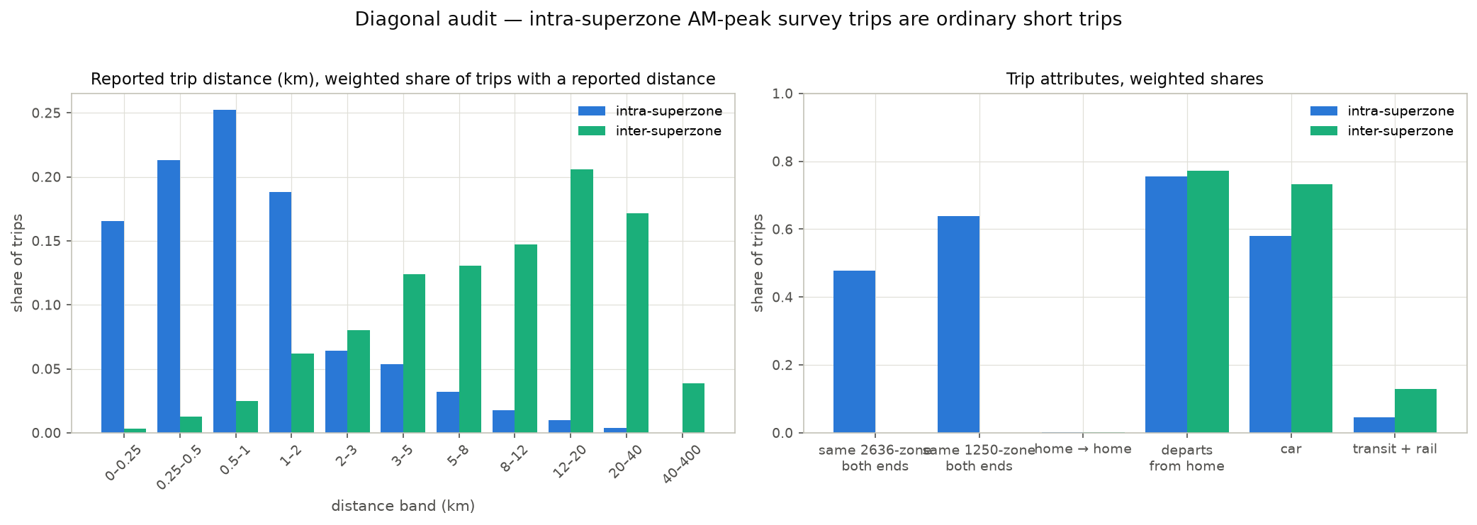
Figure 12. Intra-superzone versus inter-superzone AM-peak survey trips (2017 trips file, weighted). Left: reported trip distance. Right: share starting and ending in the same 2636-zone / 1250-zone, home → home pairs, departures from home, and mode.
Attribute (weighted) | Intra-superzone | Inter-superzone
share of AM-peak trips | 73.5 % | 26.5 %
sampled trips | 19,149 | 7,686
same 2636-zone at both ends | 48 % | 0 %
home → home | 0.2 % | 0.1 %
departs from home | 76 % | 77 %
median reported distance | 0.7 km | 9.5 km
reported distance < 0.5 km / ≥ 2 km | 38 % / 18 % | 2 % / 90 %
car / transit + rail | 58 % / 4.5 % | 73 % / 13 %
Table 7. Profile of intra- and inter-superzone survey trips. Purpose pairs (activity codes, 1 = Home): intra-superzone trips are dominated by 1 → 4 (39 %), 1 → 11 (15 %) and 1 → 2 (13 %); inter-superzone trips by 1 → 2 (43 %) and 1 → 4 (16 %). The codebook for codes 2, 4 and 11 is not in the repository; 2 behaving as the long-distance purpose and 4 as the short one is consistent with work and education but should be confirmed.
The diagonal is made of real trips: not stay-at-home records (0.2 % home → home, departures from home identical to inter-superzone trips), recorded at the survey's native zone resolution where half of them cross a 2636-zone boundary, with reported distances. They are short — median 0.7 km, more than a third under 0.5 km, fewer than a fifth of 2 km or more. This supports the rationale for correcting cellular's diagonal (cellular under-detects short trips) and bounds its relevance to the LRT: most of the trips the correction adds are below any plausible rail trip length, and it is the distance-band stratification of the mode-share step that keeps them out of the LRT market. Whether the correction's magnitude is right — whether cellular misses 70 % of these trips or the survey over-records them — cannot be settled from the survey alone; it needs the trip definitions, dwell-time and distance thresholds of the cellular product and, ideally, an independent count of short trips.

5.5 Within-superzone allocation — the corridor's main exposure
Of the hybrid's 94,610 AM-peak trips with both ends inside the LRT corridor (4.6 % of the study area), 71 % stay inside one superzone and 23 % inside one TAZ. Cellular's within-superzone allocation therefore governs most of the corridor's own demand, and superzone-level agreement says nothing about it. One check is possible: the survey records trip ends in the national 2636-zone system, mapped one-to-one to 1250-zones, and only the last link to study TAZs is a cellular-share allocation. At 1250-zone resolution the intra-superzone destination distribution of each corridor superzone, pooled over its origins, can be compared between the survey and cellular.
Superzone | 1250-zones | Sampled intra-SZ trips | TV survey vs cellular | r (destination shares)
13 Lower City / Hadar | 6 | 368 | 0.07 | 0.99
14 Hadar Carmel | 7 | 1,597 | 0.08 | 0.99
12 Namal / Hamifrats | 12 | 78 | 0.14 | 0.95
17 Neve Yosef | 11 | 831 | 0.18 | 0.87
4 Shefaram | 6 | 939 | 0.20 | 0.98
9 Kiryat Ata | 11 | 514 | 0.26 | 0.73
20 Nazareth Area | 6 | 191 | 0.27 | 0.89
24 Tirat Carmel / Matam | 14 | 257 | 0.29 | 0.69
7 Kiryat Motzkin–Bialik / Kiryat Ata | 9 | 315 | 0.31 | 0.88
19 Nazareth Area | 15 | 699 | 0.32 | 0.27
15 Kiryat Eliezer / Neot Peres / Neve David | 12 | 325 | 0.34 | 0.66
Table 8. Within-superzone destination check at 1250-zone resolution, corridor superzones with at least three native zones. Cellular at 1250-zone resolution is aggregated from the TAZ probability matrix with hybrid TAZ outflows as origin weights; the survey side is native. Mean TV 0.22, mean r 0.81.
The allocation agrees well in the Haifa inner-city and Carmel superzones (13, 14, 12, 4) and poorly in Nazareth (19), Kiryat Eliezer / Carmel coast (15), Tirat Carmel (24) and Kiryat Ata (9). Below 1250-zone resolution — i.e. at the TAZ level at which stations are placed — the survey can check nothing, and this exposure remains open.

5.6 Scale
Cellular enters the pipeline only as probabilities; every absolute number in the hybrid is the survey's expanded total (2.07 million study-area AM-peak trips on an average weekday; origin totals by superzone agree between the two survey days within a median 4 %, with one superzone at 31 %). The two extractions of the same panel agree within 0.5 % (2,196,813 vs 2,193,422 on day 1 / day 10), which is a consistency check on processing, not a validation of scale. The comparison that would validate scale — cellular's own AM-peak volumes, by origin and destination superzone, against these totals — has not been made in this repository, because the raw cellular file is held in Git LFS outside the working copy. It is the first open item in section 6.

6. Outcome

6.1 Revised conclusions
- Shared structure, at superzone level, with a geography. The sources share a north–south destination pattern at the "equal" level and related versions of a Haifa-core-vs-periphery pattern and two regional contrasts. That is the structural plausibility the reviewer accepted, and the eigenvector maps show what it consists of.
- Real disagreement on outbound destinations. About 31 % of outbound trips would have to be moved to reconcile the sources, 2.4 times the sampling-noise expectation; in the corridor the disagreement concentrates on the Haifa inner-city exchange and the port / Hamifrats superzone. The hybrid takes the survey's side on every superzone pair.
- The diagonal is real and short. Intra-superzone survey trips are genuine trips with a median reported distance of 0.7 km, which supports correcting cellular's diagonal in principle and limits the correction's bearing on rail-relevant demand; its magnitude is unvalidated.
- Three things the PCA evidence cannot carry. Absolute volumes (survey-expanded, uncompared with cellular volumes); within-superzone allocation outside the inner-city superzones, which governs 71 % of corridor trips; and the survey's spectrum reading, now corrected to a diagonal effect.

6.2 Intended use
Intended use | Supported by the current evidence?
Describe broad regional travel markets | Yes, provisionally
Screen corridors and identify potentially important OD pairs | Yes, with sensitivity testing on the survey correction
Estimate corridor demand volumes | Conditionally, after checking totals against cellular volumes and the corridor's within-superzone OD movements
Estimate additional LRT passengers | As a baseline input, with a separate mode-choice or diversion calculation
Produce station boardings or an investment-grade forecast | Not from this evidence alone
Table 9. Intended use of the hybrid matrix against the evidence in this report, following the reviewer's framing.

6.3 Open items before adoption as the central estimate
- Verify construction and scale. Compare the survey-expanded origin and destination totals with cellular's AM-peak volumes by superzone (needs the raw cellular file); obtain the cellular product's trip definition, dwell-time and minimum-distance thresholds and the activity codebook; resolve the TAZ-to-superzone key precedence between the 2017 and 2018 chains. Done here: the trip definitions and expansion of the survey side, the diagonal audit, and the exact form of the correction (survey pattern on every superzone pair, cellular within pairs).
- Demonstrate improvement against evidence not used in the correction. Candidates in the study's own inventory: the RavKav bus OD matrix and the 2019 rail smartcard OD, compared with the transit share of cellular-only and hybrid OD patterns for the same pairs; commuting OD evidence where available. Road counts require an explicit assignment link. Done here: the day-held-out cross-validation, which is against the survey itself.
- Test decision sensitivity. Vary the survey correction within the bootstrap spread (self-containment 0.67–0.70, outbound TV ±0.02) and under scenarios of systematic cellular short-trip under-detection, and examine corridor demand and alternative rankings. Not done here.

7. Reproducibility
The eigenvector charts and Table 3 are produced by THS_PCA_eigenvector_maps.ipynb; the direct tests, Figures 10–12 and Tables 4–8 by THS_PCA_review_tests.ipynb. Both read only saved pipeline outputs, the trips file and the study shapefile, and write Output/figures/pca_eigenvector_*.png, Output/figures/pca_review_*.png and Output/pca_sz_eigenvectors.csv (top-6 eigenvectors and origin scores per source, matched to cellular and sign-aligned). Figures 1–2 are from THS_2018_MTX_PCA_vs_cellular.ipynb. Reference: Lorenzo-Seva, U. & ten Berge, J.M.F. (2006), Tucker's congruence coefficient as a meaningful index of factor similarity, Methodology 2(2), 57–64.

