Nofit LRT — demand for the main route and the extension
Alternatives: (1) main route + extension as one through line; (2) extension only. Extension regimes: Prioritized (underground, step 25 calibrated times) and Unprioritized (at grade). Main route at its 80 km/h design speed. Scenario-years 2022, BU 2040, BU 2050, HS 2040, HS 2050; periods AM 06:00–09:00 and PM 16:00–19:00; TAZ level (174 corridor TAZs) aggregated to the 25 corridor areas; both directions of the line. Source: notebooks/current/LRT_alternatives_demand.ipynb (METHODOLOGY §6aq); produced 5 October 2026.

Assumptions stated
- Out-of-vehicle parameters: the central set of the OVT research — walk 2.0 × and wait 2.0 × in-vehicle time, bus ↔ LRT transfer 8 min, Metronit ↔ LRT 4 min, station access 1.5 min per underground end and 0.5 per surface end; wait = half the headway, capped at 10 min; walking 4.8 km/h on the straight line × 1.3.
- LRT premium: 5 generalized minutes over a bus-based alternative and 2.5 over a Metronit-based one (estimated from the calibrated models' in-vehicle multipliers, LRT 0.80–0.85 against BRT 0.90–0.95; range 1.5–3.5). Cost sensitivity λ = 0.03 per generalized minute, λ_T = 0.06 within the transit nest (step 31's central values).
- Main route stations: not in the delivery — taken at the route's network nodes at least 1 km apart (27 stations, 1.6 km mean spacing); to be replaced by the planned station list. Running time 80 km/h between stops + 10 s dwell per stop, at grade. One line through-runs at a 5-minute headway.
- Transit level of service: the GTFS bus and Metronit services of Tuesday 2 June 2026 in each period, with step 30's observed running times (May 2026 speeds); the car on the May 2026 speeds (07:00 / 17:00). Demand: step 31's incremental-logit pivot per TAZ pair on the observed 2022 shares.
- Base and forecast matrices: AM 2022 from step 22, PM 2022 from the wave-1b PM layers; forecast AM sets from step 23; forecast PM sets = the PM base grown at step 23's AM rates per TAZ pair (an approximation). Totals are for the three-hour periods on the corridor-internal TAZ pairs in different areas; taxi is carried unchanged; rail is inside the bus figure.

1. Matrices — car and transit
Every run's trip matrices are in Output/alternatives/: at TAZ level (174 × 174, *_taz.csv.gz) and on the 25 corridor areas (*_area_v2.csv), for the car, total transit, LRT, Metronit and bus after the LRT. The workbook Output/alternatives/LRT_alternatives_matrices.xlsx holds the 25 × 25 car and transit matrices of all 40 runs, one sheet per period × scenario × alternative × regime. The two matrices below are the central combination (main route + extension, Prioritized, BU 2040, AM), trips in the three hours, rows = origin area, columns = destination area (codes; names in the Areas sheet).
Car trips, BU 2040 AM, main route + extension, Prioritized
o \ d | 201 | 202 | 203 | 204 | 205 | 206 | 207 | 208 | 209 | 210 | 211 | 212 | 213 | 214 | 215 | 216 | 217 | 101 | 102 | 103 | 104 | 301 | 302 | 303 | 304
201 | 0 | 3063 | 0 | 0 | 450 | 1012 | 0 | 612 | 376 | 1011 | 0 | 1444 | 0 | 0 | 0 | 0 | 0 | 0 | 0 | 0 | 0 | 0 | 0 | 0 | 0
202 | 103 | 0 | 141 | 0 | 156 | 27 | 35 | 181 | 1 | 0 | 38 | 0 | 0 | 0 | 0 | 0 | 0 | 0 | 0 | 0 | 0 | 0 | 0 | 0 | 0
203 | 21 | 192 | 0 | 52 | 20 | 9 | 0 | 0 | 0 | 21 | 0 | 0 | 0 | 0 | 0 | 0 | 0 | 0 | 0 | 0 | 0 | 0 | 0 | 0 | 0
204 | 380 | 133 | 107 | 0 | 156 | 269 | 0 | 34 | 53 | 61 | 0 | 0 | 0 | 0 | 0 | 0 | 0 | 0 | 0 | 0 | 0 | 0 | 0 | 0 | 0
205 | 99 | 69 | 51 | 104 | 0 | 155 | 1402 | 191 | 17 | 0 | 0 | 0 | 0 | 0 | 0 | 0 | 0 | 0 | 0 | 0 | 0 | 0 | 0 | 0 | 21
206 | 352 | 327 | 18 | 276 | 0 | 0 | 306 | 259 | 40 | 166 | 26 | 0 | 0 | 0 | 0 | 0 | 208 | 0 | 0 | 0 | 20 | 0 | 0 | 0 | 18
207 | 5 | 322 | 0 | 0 | 0 | 2008 | 0 | 79 | 34 | 219 | 0 | 0 | 0 | 0 | 58 | 0 | 0 | 0 | 0 | 0 | 0 | 0 | 0 | 0 | 0
208 | 37 | 4 | 0 | 0 | 3 | 29 | 497 | 0 | 70 | 30 | 14 | 239 | 0 | 0 | 41 | 0 | 270 | 0 | 0 | 0 | 62 | 0 | 0 | 0 | 0
209 | 153 | 12 | 0 | 0 | 4 | 0 | 0 | 112 | 0 | 16 | 21 | 58 | 0 | 0 | 0 | 0 | 0 | 0 | 0 | 0 | 13 | 0 | 0 | 0 | 16
210 | 1 | 83 | 0 | 3 | 0 | 202 | 0 | 7 | 3 | 0 | 29 | 1 | 0 | 10 | 1 | 0 | 0 | 0 | 0 | 4 | 37 | 0 | 0 | 1 | 30
211 | 1 | 130 | 0 | 0 | 0 | 2 | 0 | 25 | 3 | 80 | 0 | 108 | 0 | 0 | 0 | 0 | 0 | 0 | 120 | 1 | 37 | 0 | 0 | 101 | 24
212 | 1 | 40 | 0 | 0 | 0 | 28 | 0 | 0 | 0 | 0 | 0 | 0 | 91 | 0 | 140 | 120 | 35 | 0 | 0 | 195 | 29 | 0 | 67 | 0 | 72
213 | 0 | 0 | 0 | 0 | 0 | 0 | 0 | 18 | 48 | 159 | 79 | 127 | 0 | 101 | 0 | 0 | 0 | 0 | 0 | 65 | 90 | 0 | 0 | 0 | 0
214 | 0 | 747 | 0 | 0 | 0 | 0 | 0 | 91 | 12 | 0 | 42 | 39 | 124 | 0 | 136 | 0 | 132 | 0 | 213 | 97 | 0 | 0 | 0 | 34 | 0
215 | 7 | 0 | 0 | 0 | 0 | 387 | 0 | 338 | 82 | 332 | 51 | 411 | 232 | 143 | 0 | 152 | 472 | 188 | 540 | 717 | 0 | 10 | 0 | 0 | 0
216 | 84 | 0 | 0 | 0 | 0 | 0 | 0 | 0 | 14 | 73 | 35 | 243 | 0 | 0 | 573 | 0 | 485 | 0 | 0 | 0 | 23 | 0 | 0 | 0 | 21
217 | 0 | 433 | 0 | 0 | 0 | 265 | 0 | 108 | 5 | 68 | 0 | 0 | 0 | 0 | 688 | 472 | 0 | 0 | 0 | 0 | 0 | 0 | 0 | 0 | 0
101 | 7 | 75 | 0 | 0 | 0 | 159 | 0 | 111 | 15 | 447 | 405 | 79 | 0 | 0 | 0 | 0 | 0 | 0 | 188 | 670 | 1142 | 401 | 167 | 824 | 84
102 | 4 | 144 | 0 | 0 | 0 | 0 | 0 | 126 | 167 | 0 | 155 | 286 | 223 | 0 | 0 | 0 | 261 | 1290 | 0 | 928 | 412 | 17 | 0 | 383 | 187
103 | 119 | 108 | 0 | 0 | 0 | 41 | 0 | 95 | 139 | 571 | 800 | 569 | 0 | 127 | 0 | 130 | 252 | 139 | 1124 | 0 | 4263 | 8 | 83 | 1202 | 281
104 | 42 | 173 | 0 | 0 | 0 | 891 | 0 | 255 | 57 | 888 | 377 | 630 | 0 | 0 | 0 | 0 | 0 | 51 | 610 | 1852 | 0 | 3 | 64 | 1111 | 931
301 | 2 | 136 | 0 | 0 | 0 | 76 | 0 | 53 | 7 | 153 | 130 | 38 | 0 | 0 | 0 | 0 | 0 | 1450 | 67 | 25 | 327 | 0 | 495 | 678 | 76
302 | 1 | 0 | 0 | 0 | 0 | 0 | 0 | 9 | 15 | 72 | 260 | 298 | 0 | 0 | 0 | 0 | 0 | 18 | 30 | 387 | 149 | 271 | 0 | 366 | 156
303 | 3 | 122 | 26 | 0 | 0 | 198 | 0 | 415 | 0 | 34 | 298 | 85 | 0 | 0 | 0 | 0 | 0 | 302 | 1469 | 1535 | 1022 | 137 | 457 | 0 | 580
304 | 25 | 49 | 6 | 0 | 0 | 297 | 0 | 77 | 35 | 138 | 310 | 145 | 0 | 0 | 0 | 0 | 0 | 35 | 321 | 177 | 836 | 2 | 30 | 1088 | 0
Transit trips (bus + Metronit + LRT), BU 2040 AM, main route + extension, Prioritized
o \ d | 201 | 202 | 203 | 204 | 205 | 206 | 207 | 208 | 209 | 210 | 211 | 212 | 213 | 214 | 215 | 216 | 217 | 101 | 102 | 103 | 104 | 301 | 302 | 303 | 304
201 | 0 | 666 | 71 | 91 | 29 | 610 | 62 | 214 | 98 | 120 | 44 | 55 | 2 | 1 | 0 | 0 | 3 | 12 | 16 | 19 | 25 | 1 | 1 | 19 | 12
202 | 65 | 0 | 12 | 14 | 5 | 86 | 19 | 53 | 23 | 26 | 10 | 14 | 5 | 1 | 0 | 0 | 1 | 3 | 5 | 5 | 8 | 0 | 0 | 9 | 4
203 | 43 | 77 | 0 | 12 | 4 | 57 | 11 | 35 | 15 | 19 | 7 | 10 | 4 | 1 | 0 | 0 | 1 | 2 | 3 | 3 | 5 | 0 | 0 | 6 | 3
204 | 138 | 197 | 25 | 0 | 10 | 190 | 33 | 102 | 45 | 54 | 19 | 28 | 10 | 2 | 0 | 0 | 3 | 6 | 9 | 10 | 16 | 0 | 0 | 18 | 9
205 | 68 | 113 | 14 | 17 | 0 | 106 | 24 | 62 | 25 | 30 | 11 | 16 | 6 | 1 | 0 | 0 | 2 | 3 | 5 | 5 | 9 | 0 | 0 | 10 | 5
206 | 162 | 232 | 26 | 38 | 11 | 0 | 53 | 142 | 55 | 66 | 27 | 34 | 12 | 3 | 0 | 0 | 4 | 8 | 11 | 12 | 19 | 0 | 0 | 22 | 11
207 | 20 | 66 | 7 | 8 | 3 | 68 | 0 | 116 | 42 | 29 | 10 | 11 | 1 | 0 | 0 | 0 | 9 | 3 | 4 | 4 | 4 | 0 | 0 | 3 | 2
208 | 23 | 65 | 8 | 9 | 3 | 60 | 45 | 0 | 48 | 31 | 12 | 13 | 1 | 0 | 0 | 0 | 11 | 3 | 4 | 5 | 5 | 0 | 0 | 3 | 2
209 | 37 | 74 | 8 | 11 | 4 | 68 | 40 | 125 | 0 | 34 | 13 | 15 | 2 | 0 | 1 | 0 | 11 | 3 | 6 | 5 | 6 | 0 | 0 | 5 | 3
210 | 45 | 102 | 12 | 14 | 5 | 104 | 30 | 92 | 35 | 0 | 0 | 8 | 10 | 2 | 3 | 2 | 15 | 4 | 10 | 7 | 8 | 1 | 1 | 6 | 2
211 | 7 | 16 | 2 | 2 | 1 | 14 | 4 | 14 | 5 | 0 | 0 | 2 | 2 | 0 | 0 | 0 | 2 | 1 | 2 | 1 | 1 | 0 | 0 | 1 | 0
212 | 10 | 22 | 2 | 3 | 1 | 22 | 6 | 20 | 8 | 3 | 1 | 0 | 5 | 1 | 1 | 0 | 4 | 2 | 4 | 3 | 3 | 0 | 0 | 2 | 1
213 | 8 | 29 | 3 | 4 | 2 | 28 | 9 | 28 | 20 | 87 | 37 | 101 | 0 | 21 | 1 | 0 | 2 | 12 | 27 | 21 | 37 | 1 | 2 | 38 | 17
214 | 5 | 30 | 2 | 3 | 1 | 18 | 6 | 18 | 12 | 50 | 29 | 55 | 52 | 0 | 0 | 0 | 1 | 8 | 21 | 14 | 22 | 1 | 1 | 25 | 11
215 | 3 | 8 | 1 | 1 | 0 | 11 | 8 | 47 | 28 | 180 | 53 | 77 | 9 | 2 | 0 | 0 | 17 | 8 | 11 | 13 | 11 | 0 | 0 | 4 | 6
216 | 0 | 0 | 0 | 0 | 0 | 0 | 0 | 0 | 0 | 0 | 0 | 0 | 0 | 0 | 0 | 0 | 1 | 0 | 0 | 1 | 0 | 0 | 0 | 0 | 0
217 | 1 | 2 | 0 | 0 | 0 | 4 | 24 | 75 | 35 | 85 | 31 | 33 | 1 | 0 | 9 | 14 | 0 | 13 | 56 | 29 | 28 | 0 | 0 | 0 | 3
101 | 40 | 49 | 5 | 7 | 2 | 47 | 30 | 99 | 46 | 124 | 43 | 57 | 12 | 3 | 1 | 0 | 8 | 0 | 279 | 179 | 175 | 8 | 12 | 54 | 17
102 | 37 | 56 | 6 | 8 | 3 | 51 | 33 | 113 | 51 | 121 | 46 | 63 | 14 | 3 | 1 | 0 | 8 | 94 | 0 | 177 | 171 | 9 | 14 | 58 | 18
103 | 70 | 118 | 10 | 13 | 4 | 84 | 56 | 179 | 87 | 221 | 78 | 106 | 22 | 6 | 2 | 0 | 15 | 165 | 487 | 0 | 309 | 15 | 23 | 99 | 31
104 | 50 | 107 | 11 | 14 | 5 | 104 | 46 | 148 | 72 | 185 | 64 | 86 | 20 | 5 | 1 | 0 | 8 | 105 | 259 | 189 | 0 | 16 | 25 | 123 | 38
301 | 9 | 24 | 3 | 3 | 1 | 23 | 7 | 22 | 18 | 101 | 38 | 50 | 14 | 3 | 0 | 0 | 2 | 30 | 57 | 50 | 49 | 0 | 44 | 103 | 11
302 | 8 | 21 | 2 | 3 | 1 | 21 | 6 | 20 | 16 | 91 | 34 | 49 | 13 | 3 | 0 | 0 | 2 | 27 | 52 | 45 | 44 | 26 | 0 | 94 | 10
303 | 39 | 103 | 12 | 15 | 5 | 103 | 30 | 103 | 54 | 213 | 80 | 105 | 26 | 6 | 0 | 0 | 5 | 60 | 120 | 101 | 137 | 48 | 74 | 0 | 50
304 | 30 | 83 | 9 | 11 | 4 | 90 | 22 | 75 | 36 | 98 | 35 | 46 | 9 | 2 | 0 | 0 | 2 | 25 | 54 | 44 | 80 | 14 | 22 | 120 | 0
of which LRT trips
o \ d | 201 | 202 | 203 | 204 | 205 | 206 | 207 | 208 | 209 | 210 | 211 | 212 | 213 | 214 | 215 | 216 | 217 | 101 | 102 | 103 | 104 | 301 | 302 | 303 | 304
201 | 0 | 328 | 44 | 52 | 11 | 378 | 42 | 138 | 69 | 62 | 23 | 24 | 2 | 0 | 0 | 0 | 3 | 5 | 6 | 7 | 9 | 0 | 1 | 11 | 6
202 | 29 | 0 | 6 | 6 | 2 | 34 | 8 | 21 | 10 | 7 | 3 | 4 | 2 | 1 | 0 | 0 | 1 | 0 | 1 | 1 | 1 | 0 | 0 | 3 | 1
203 | 28 | 42 | 0 | 6 | 2 | 31 | 7 | 20 | 10 | 12 | 4 | 6 | 3 | 1 | 0 | 0 | 1 | 1 | 2 | 2 | 3 | 0 | 0 | 4 | 2
204 | 82 | 97 | 12 | 0 | 2 | 86 | 17 | 50 | 24 | 32 | 12 | 18 | 8 | 2 | 0 | 0 | 2 | 3 | 5 | 5 | 8 | 0 | 0 | 10 | 5
205 | 26 | 40 | 6 | 4 | 0 | 33 | 8 | 20 | 10 | 12 | 5 | 7 | 4 | 1 | 0 | 0 | 1 | 1 | 1 | 2 | 2 | 0 | 0 | 4 | 2
206 | 88 | 103 | 13 | 17 | 4 | 0 | 28 | 64 | 28 | 35 | 14 | 19 | 8 | 3 | 0 | 0 | 4 | 3 | 5 | 5 | 8 | 0 | 0 | 13 | 6
207 | 12 | 30 | 4 | 4 | 1 | 31 | 0 | 54 | 22 | 16 | 6 | 5 | 0 | 0 | 0 | 0 | 8 | 1 | 2 | 2 | 2 | 0 | 0 | 2 | 1
208 | 14 | 29 | 4 | 4 | 1 | 26 | 21 | 0 | 22 | 15 | 6 | 6 | 0 | 0 | 0 | 0 | 9 | 1 | 2 | 2 | 2 | 0 | 0 | 2 | 1
209 | 22 | 33 | 4 | 5 | 1 | 29 | 19 | 48 | 0 | 17 | 6 | 7 | 1 | 0 | 0 | 0 | 9 | 1 | 2 | 2 | 2 | 0 | 0 | 2 | 1
210 | 21 | 26 | 6 | 9 | 2 | 60 | 18 | 48 | 18 | 0 | 0 | 6 | 6 | 2 | 2 | 1 | 12 | 1 | 4 | 3 | 3 | 0 | 0 | 2 | 1
211 | 3 | 3 | 1 | 1 | 0 | 7 | 2 | 6 | 2 | 0 | 0 | 1 | 1 | 0 | 0 | 0 | 2 | 0 | 0 | 0 | 0 | 0 | 0 | 0 | 0
212 | 3 | 4 | 1 | 2 | 0 | 10 | 3 | 8 | 3 | 2 | 1 | 0 | 3 | 1 | 0 | 0 | 3 | 0 | 1 | 1 | 1 | 0 | 0 | 1 | 0
213 | 6 | 15 | 3 | 4 | 1 | 19 | 6 | 17 | 12 | 55 | 18 | 59 | 0 | 13 | 0 | 0 | 1 | 5 | 12 | 10 | 12 | 1 | 1 | 20 | 9
214 | 4 | 20 | 2 | 2 | 1 | 16 | 5 | 16 | 11 | 40 | 22 | 41 | 29 | 0 | 0 | 0 | 1 | 3 | 8 | 6 | 12 | 1 | 1 | 18 | 8
215 | 3 | 4 | 1 | 1 | 0 | 8 | 6 | 39 | 22 | 131 | 35 | 47 | 5 | 1 | 0 | 0 | 11 | 2 | 3 | 4 | 4 | 0 | 0 | 3 | 4
216 | 0 | 0 | 0 | 0 | 0 | 0 | 0 | 0 | 0 | 0 | 0 | 0 | 0 | 0 | 0 | 0 | 1 | 0 | 0 | 0 | 0 | 0 | 0 | 0 | 0
217 | 1 | 2 | 0 | 0 | 0 | 3 | 21 | 63 | 30 | 73 | 27 | 28 | 1 | 0 | 5 | 12 | 0 | 7 | 32 | 21 | 23 | 0 | 0 | 0 | 2
101 | 12 | 7 | 2 | 3 | 1 | 20 | 13 | 33 | 15 | 46 | 0 | 12 | 5 | 1 | 0 | 0 | 4 | 0 | 0 | 0 | 1 | 0 | 0 | 0 | 0
102 | 11 | 8 | 2 | 4 | 1 | 22 | 14 | 38 | 17 | 45 | 0 | 13 | 6 | 1 | 0 | 0 | 3 | 0 | 0 | 0 | 1 | 0 | 0 | 0 | 1
103 | 20 | 17 | 4 | 6 | 1 | 36 | 24 | 60 | 28 | 82 | 0 | 21 | 9 | 2 | 0 | 0 | 7 | 0 | 0 | 0 | 2 | 0 | 0 | 0 | 1
104 | 14 | 15 | 4 | 6 | 1 | 43 | 20 | 50 | 24 | 69 | 0 | 17 | 7 | 2 | 0 | 0 | 4 | 0 | 1 | 0 | 0 | 0 | 0 | 0 | 1
301 | 4 | 6 | 2 | 2 | 0 | 13 | 4 | 12 | 7 | 37 | 0 | 15 | 7 | 2 | 0 | 0 | 2 | 0 | 0 | 0 | 0 | 0 | 0 | 0 | 0
302 | 4 | 6 | 1 | 2 | 0 | 12 | 4 | 11 | 7 | 34 | 0 | 14 | 6 | 2 | 0 | 0 | 2 | 0 | 0 | 0 | 0 | 0 | 0 | 0 | 0
303 | 19 | 27 | 7 | 9 | 2 | 60 | 19 | 55 | 22 | 79 | 0 | 21 | 11 | 4 | 0 | 0 | 4 | 0 | 0 | 0 | 1 | 0 | 0 | 0 | 1
304 | 14 | 22 | 5 | 7 | 2 | 52 | 14 | 40 | 14 | 36 | 0 | 10 | 4 | 2 | 0 | 0 | 2 | 0 | 0 | 0 | 0 | 0 | 0 | 0 | 0
Area totals of the same run (origins), all four alternative × regime combinations, AM and PM:
area | AM Main route + extension Prioritized | AM Main route + extension Unprioritized | AM Extension only Prioritized | AM Extension only Unprioritized | PM Main route + extension Prioritized | PM Main route + extension Unprioritized | PM Extension only Prioritized | PM Extension only Unprioritized
201 TiratCarmel | 1,222 | 886 | 1,196 | 872 | 503 | 380 | 493 | 374
202 Matam-NeotPeres | 141 | 101 | 133 | 97 | 845 | 684 | 823 | 673
203 HofCarmel-NeveDavid | 186 | 156 | 179 | 150 | 192 | 163 | 188 | 160
204 Hecht-Shprintzak | 483 | 398 | 464 | 380 | 192 | 160 | 188 | 157
205 EinHayam | 191 | 151 | 180 | 143 | 100 | 77 | 97 | 75
206 BatGalim-KiryatEliezer | 465 | 374 | 440 | 353 | 592 | 453 | 576 | 440
207 Hamoshava | 204 | 182 | 194 | 172 | 216 | 178 | 193 | 158
208 LowerCity | 165 | 142 | 153 | 131 | 787 | 638 | 684 | 549
209 Namal-Giborim | 215 | 180 | 201 | 167 | 223 | 184 | 192 | 156
210 Hamifrats | 252 | 200 | 200 | 149 | 641 | 604 | 268 | 232
211 Bazan-Hutsot | 31 | 23 | 18 | 12 | 135 | 117 | 32 | 21
212 TsometKiryatAta | 49 | 38 | 24 | 16 | 372 | 348 | 132 | 114
213 KiryatAta North | 297 | 280 | 41 | 29 | 104 | 101 | 28 | 25
214 KiryatAta North-East | 267 | 254 | 34 | 26 | 26 | 25 | 3 | 2
215 Shefaram | 334 | 325 | 55 | 50 | 12 | 12 | 1 | 0
216 Hamovil | 2 | 2 | 0 | 0 | 3 | 3 | 0 | 0
217 Nazareth | 352 | 347 | 69 | 63 | 104 | 104 | 8 | 8
101 TsurShalom | 174 | 146 | 89 | 66 | 71 | 52 | 32 | 16
102 Kiryon | 187 | 155 | 98 | 73 | 107 | 88 | 34 | 18
103 KiryatBialik Center | 322 | 267 | 165 | 121 | 104 | 82 | 37 | 19
104 KiryatHaim | 281 | 230 | 148 | 108 | 104 | 86 | 48 | 33
301 SavyoneyYam | 115 | 103 | 45 | 34 | 20 | 18 | 5 | 4
302 KiryatYam A | 105 | 94 | 42 | 32 | 17 | 15 | 4 | 3
303 KiryatYam B+C | 341 | 285 | 192 | 143 | 75 | 69 | 24 | 18
304 KiryatHaim West | 225 | 177 | 146 | 106 | 62 | 56 | 21 | 16

2. Time on route — LRT, Metronit, train, car
End-to-end and segment times. LRT from the station time matrices (symmetric); Metronit line 1 from its scheduled trips of the period, first to last study-area stop, with step 30's observed ÷ scheduled ratio; train from the day's Israel Railways trips; car on the May 2026 speeds between the corridor areas' points plus a 3-minute terminal.
mode | period | direction | from | to | stops | minutes (scheduled / design) | observed (min)
Metronit line 1 (83001) | AM | 0 | ת. מרכזית חוף הכרמל/רציפים עירוני | מרכזית הקריות/הורדה מטרונית | 42.0 | 65.0 | 57.2
Metronit line 1 (83001) | AM | 1 | מרכזית הקריות/איסוף מטרונית | ת. מרכזית חוף הכרמל/הורדה מטרונית | 41.0 | 65.0 | 57.2
Train (Israel Railways, study-area stations) | AM | 0 | בנימינה | נהריה | 9.0 | 65.0
Train (Israel Railways, study-area stations) | AM | 1 | נהריה | בנימינה | 9.0 | 68.0
Metronit line 1 (83001) | PM | 0 | ת. מרכזית חוף הכרמל/רציפים עירוני | מרכזית הקריות/הורדה מטרונית | 42.0 | 65.0 | 57.2
Metronit line 1 (83001) | PM | 1 | מרכזית הקריות/איסוף מטרונית | ת. מרכזית חוף הכרמל/הורדה מטרונית | 41.0 | 65.0 | 57.2
Train (Israel Railways, study-area stations) | PM | 0 | בנימינה | נהריה | 9.0 | 65.0
Train (Israel Railways, study-area stations) | PM | 1 | נהריה | בנימינה | 9.0 | 68.0
Train (Israel Railways, corridor segment) | AM | חוף הכרמל → קרית מוצקין | חוף הכרמל | קרית מוצקין |  | 30.0
Train (Israel Railways, corridor segment) | AM | קרית מוצקין → חוף הכרמל | קרית מוצקין | חוף הכרמל |  | 31.0
Train (Israel Railways, corridor segment) | PM | חוף הכרמל → קרית מוצקין | חוף הכרמל | קרית מוצקין |  | 30.0
Train (Israel Railways, corridor segment) | PM | קרית מוצקין → חוף הכרמל | קרית מוצקין | חוף הכרמל |  | 31.0
LRT — Main route + extension, Prioritized (extension underground) | all | both (symmetric) | Tirat Carmel (S01) | Hamifrats (S24) | 50.0 | 40.6
LRT — Main route + extension, Prioritized (extension underground) | all | both (symmetric) | Hamifrats (S24) | Nazareth (M27) | 50.0 | 34.9
LRT — Main route + extension, Prioritized (extension underground) | all | both (symmetric) | Tirat Carmel (S01) | Nazareth (M27) | 50.0 | 75.5
LRT — Main route + extension, Unprioritized (extension at grade) | all | both (symmetric) | Tirat Carmel (S01) | Hamifrats (S24) | 50.0 | 65.8
LRT — Main route + extension, Unprioritized (extension at grade) | all | both (symmetric) | Hamifrats (S24) | Nazareth (M27) | 50.0 | 34.9
LRT — Main route + extension, Unprioritized (extension at grade) | all | both (symmetric) | Tirat Carmel (S01) | Nazareth (M27) | 50.0 | 100.7
LRT — Extension only, Prioritized (extension underground) | all | both (symmetric) | Tirat Carmel (S01) | Hamifrats (S24) | 24.0 | 40.6
LRT — Extension only, Unprioritized (extension at grade) | all | both (symmetric) | Tirat Carmel (S01) | Hamifrats (S24) | 24.0 | 65.8
Car (May 2026 speeds, 07:00) | AM | forward | TiratCarmel | Hamifrats |  | 32.5
Car (May 2026 speeds, 07:00) | AM | reverse | Hamifrats | TiratCarmel |  | 20.8
Car (May 2026 speeds, 07:00) | AM | forward | Hamifrats | Nazareth |  | 45.8
Car (May 2026 speeds, 07:00) | AM | reverse | Nazareth | Hamifrats |  | 41.9
Car (May 2026 speeds, 07:00) | AM | forward | TiratCarmel | Nazareth |  | 64.6
Car (May 2026 speeds, 07:00) | AM | reverse | Nazareth | TiratCarmel |  | 58.9
Car (May 2026 speeds, 17:00) | PM | forward | TiratCarmel | Hamifrats |  | 32.0
Car (May 2026 speeds, 17:00) | PM | reverse | Hamifrats | TiratCarmel |  | 21.2
Car (May 2026 speeds, 17:00) | PM | forward | Hamifrats | Nazareth |  | 46.5
Car (May 2026 speeds, 17:00) | PM | reverse | Nazareth | Hamifrats |  | 40.9
Car (May 2026 speeds, 17:00) | PM | forward | TiratCarmel | Nazareth |  | 64.9
Car (May 2026 speeds, 17:00) | PM | reverse | Nazareth | TiratCarmel |  | 58.3

3. Total demand — car, Metronit, LRT, total transit, AM and PM
Trips in the three-hour period on the corridor-internal TAZ pairs (TAZs in different corridor areas), after the LRT. Total transit = bus + Metronit + LRT (rail inside the bus figure). "Busiest segment" is the largest three-hour load on one station-to-station segment in one direction.
AM (06:00–09:00)
scenario | alternative | regime | car | bus | Metronit | LRT | total transit | LRT from car | busiest segment
2022 | Main route + extension | Prioritized | 55,838 | 3,706 | 5,620 | 5,414 | 14,740 | 326 | 1,943
2022 | Main route + extension | Unprioritized | 55,929 | 3,900 | 6,148 | 4,601 | 14,649 | 260 | 1,662
2022 | Extension only | Prioritized | 56,069 | 4,546 | 6,376 | 3,588 | 14,509 | 178 | 1,124
2022 | Extension only | Unprioritized | 56,143 | 4,739 | 6,844 | 2,852 | 14,435 | 128 | 829
BU_2040 | Main route + extension | Prioritized | 73,926 | 5,311 | 7,146 | 6,607 | 19,065 | 395 | 2,239
BU_2040 | Main route + extension | Unprioritized | 74,062 | 5,610 | 7,820 | 5,499 | 18,929 | 297 | 1,884
BU_2040 | Extension only | Prioritized | 74,196 | 6,225 | 8,065 | 4,505 | 18,795 | 226 | 1,346
BU_2040 | Extension only | Unprioritized | 74,311 | 6,525 | 8,658 | 3,497 | 18,680 | 147 | 954
BU_2050 | Main route + extension | Prioritized | 84,912 | 6,224 | 8,133 | 7,799 | 22,157 | 878 | 2,497
BU_2050 | Main route + extension | Unprioritized | 85,318 | 6,545 | 8,898 | 6,308 | 21,751 | 548 | 2,073
BU_2050 | Extension only | Prioritized | 85,232 | 7,179 | 9,148 | 5,510 | 21,837 | 674 | 1,837
BU_2050 | Extension only | Unprioritized | 85,599 | 7,500 | 9,819 | 4,150 | 21,470 | 381 | 1,271
HS_2040 | Main route + extension | Prioritized | 76,589 | 5,220 | 7,262 | 7,744 | 20,226 | 901 | 2,632
HS_2040 | Main route + extension | Unprioritized | 76,832 | 5,470 | 7,998 | 6,514 | 19,983 | 701 | 2,186
HS_2040 | Extension only | Prioritized | 77,236 | 6,366 | 8,262 | 4,950 | 19,578 | 425 | 1,506
HS_2040 | Extension only | Unprioritized | 77,434 | 6,615 | 8,914 | 3,852 | 19,381 | 274 | 1,093
HS_2050 | Main route + extension | Prioritized | 87,461 | 5,611 | 8,172 | 9,548 | 23,331 | 1,348 | 3,210
HS_2050 | Main route + extension | Unprioritized | 87,830 | 5,900 | 9,052 | 8,010 | 22,962 | 1,036 | 2,645
HS_2050 | Extension only | Prioritized | 88,399 | 6,968 | 9,339 | 6,086 | 22,393 | 643 | 1,828
HS_2050 | Extension only | Unprioritized | 88,701 | 7,255 | 10,118 | 4,718 | 22,091 | 406 | 1,327
PM (16:00–19:00)
scenario | alternative | regime | car | bus | Metronit | LRT | total transit | LRT from car | busiest segment
2022 | Main route + extension | Prioritized | 65,938 | 2,672 | 5,254 | 4,260 | 12,186 | 287 | 998
2022 | Main route + extension | Unprioritized | 66,019 | 2,811 | 5,669 | 3,625 | 12,104 | 227 | 869
2022 | Extension only | Prioritized | 66,081 | 3,075 | 5,890 | 3,078 | 12,043 | 212 | 770
2022 | Extension only | Unprioritized | 66,156 | 3,213 | 6,264 | 2,490 | 11,968 | 158 | 627
BU_2040 | Main route + extension | Prioritized | 85,741 | 3,959 | 6,754 | 5,606 | 16,320 | 351 | 1,343
BU_2040 | Main route + extension | Unprioritized | 85,852 | 4,206 | 7,303 | 4,699 | 16,209 | 270 | 1,163
BU_2040 | Extension only | Prioritized | 85,911 | 4,500 | 7,539 | 4,112 | 16,150 | 262 | 1,284
BU_2040 | Extension only | Unprioritized | 86,013 | 4,746 | 8,030 | 3,271 | 16,048 | 189 | 969
BU_2050 | Main route + extension | Prioritized | 99,809 | 4,537 | 7,642 | 6,428 | 18,608 | 394 | 1,768
BU_2050 | Main route + extension | Unprioritized | 99,938 | 4,834 | 8,283 | 5,361 | 18,478 | 298 | 1,326
BU_2050 | Extension only | Prioritized | 99,990 | 5,128 | 8,508 | 4,790 | 18,426 | 300 | 1,730
BU_2050 | Extension only | Unprioritized | 100,111 | 5,423 | 9,083 | 3,799 | 18,306 | 213 | 1,310
HS_2040 | Main route + extension | Prioritized | 87,820 | 4,046 | 6,713 | 5,808 | 16,566 | 432 | 1,471
HS_2040 | Main route + extension | Unprioritized | 87,947 | 4,246 | 7,278 | 4,916 | 16,439 | 334 | 1,255
HS_2040 | Extension only | Prioritized | 87,983 | 4,571 | 7,486 | 4,346 | 16,403 | 346 | 1,144
HS_2040 | Extension only | Unprioritized | 88,101 | 4,770 | 7,997 | 3,518 | 16,285 | 257 | 915
HS_2050 | Main route + extension | Prioritized | 95,816 | 4,008 | 7,064 | 6,165 | 17,237 | 475 | 1,466
HS_2050 | Main route + extension | Unprioritized | 95,960 | 4,220 | 7,665 | 5,209 | 17,094 | 365 | 1,246
HS_2050 | Extension only | Prioritized | 95,991 | 4,551 | 7,861 | 4,651 | 17,063 | 380 | 1,165
HS_2050 | Extension only | Unprioritized | 96,124 | 4,762 | 8,405 | 3,763 | 16,930 | 280 | 934

Figures
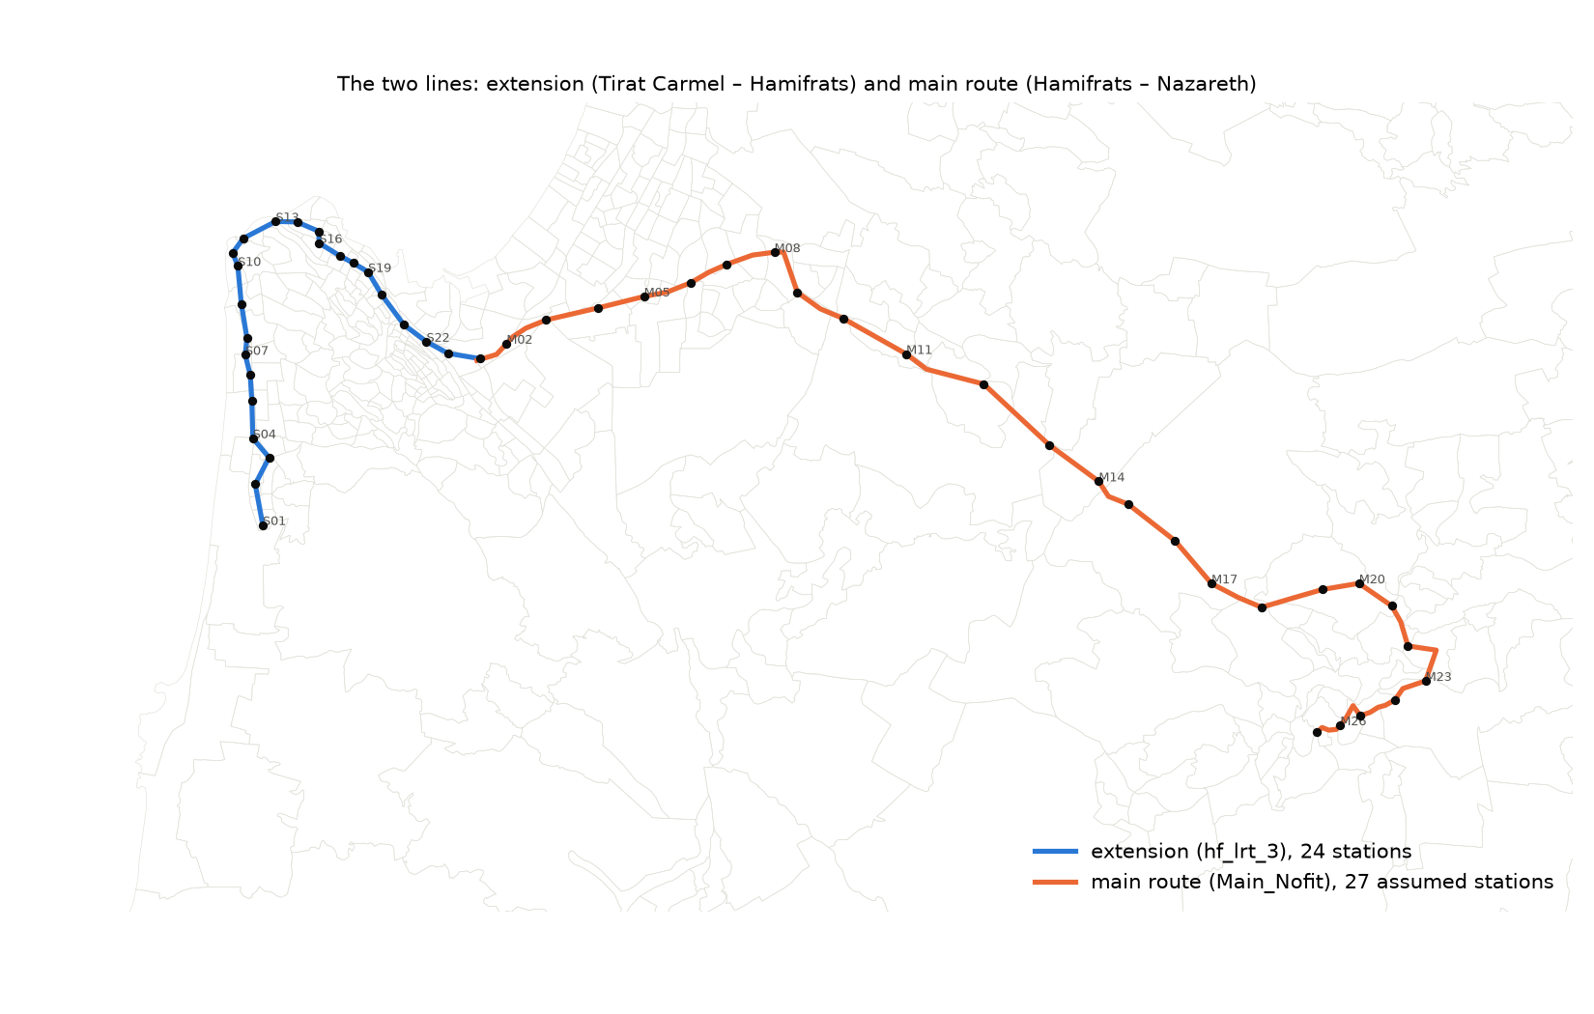
The two lines and their stations.
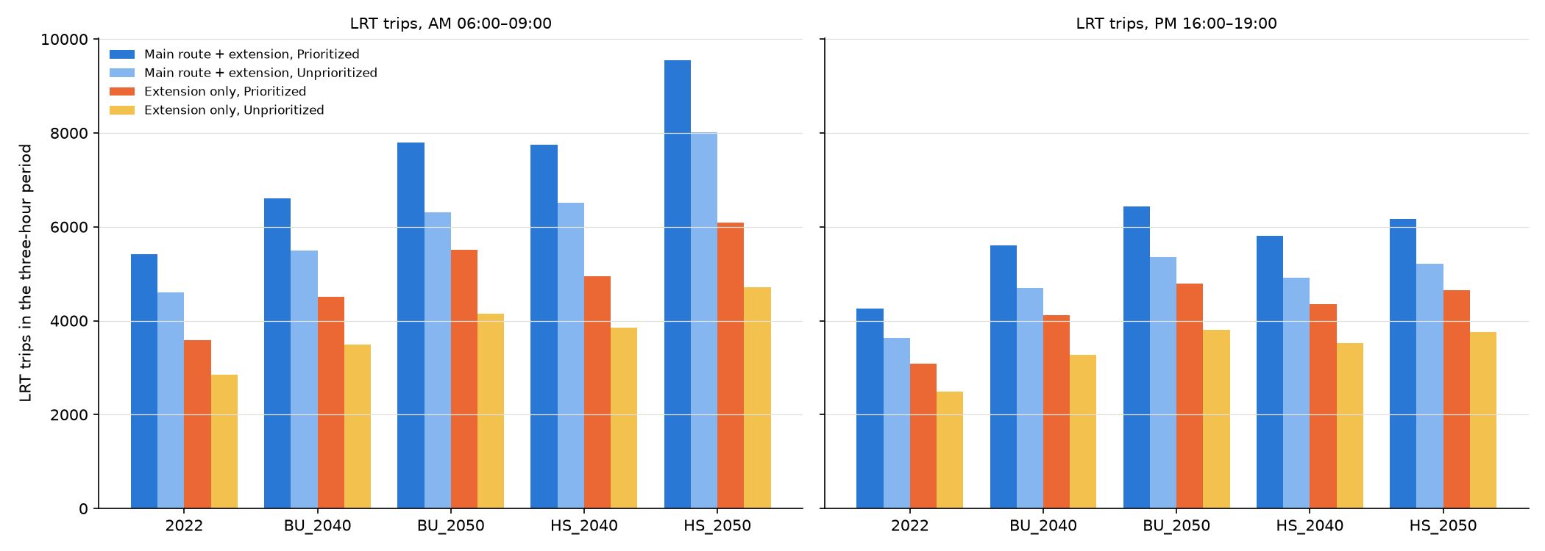
LRT trips by scenario-year, alternative and regime, AM and PM.
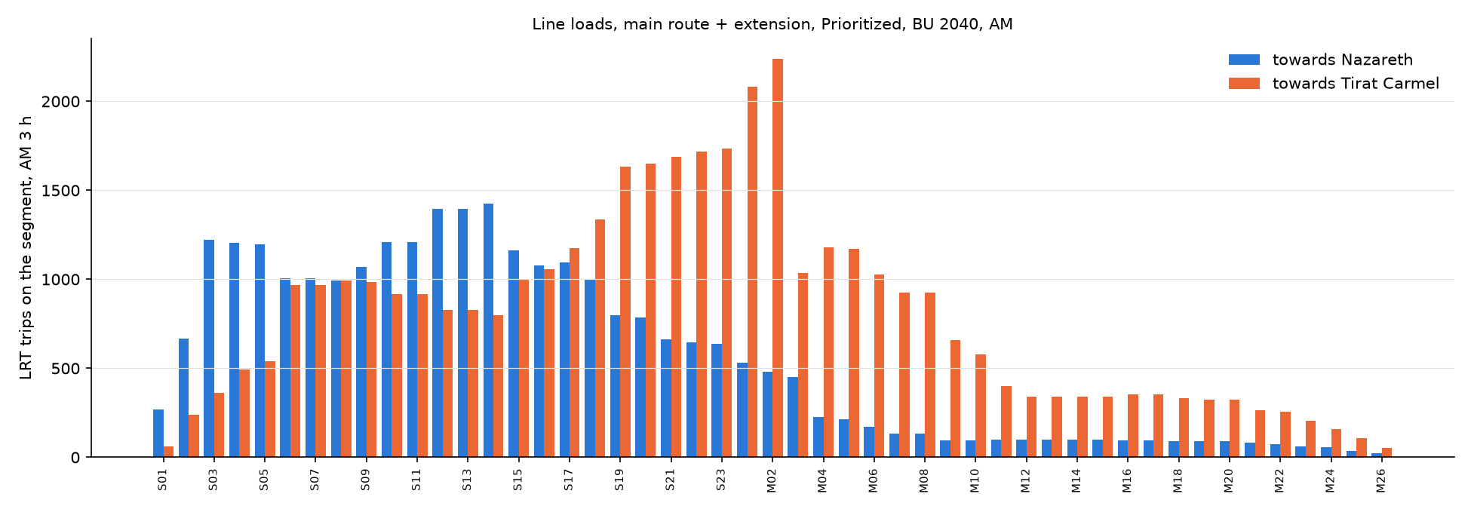
Line loads by segment and direction, main route + extension, Prioritized, BU 2040, AM.

Limits
The main route's stations are assumed; its demand moves with the real station list and with any feeder restructuring in Kiryat Ata and Nazareth. The forecast PM sets are grown at the AM rates. The LRT premium over the Metronit is an estimate, not an estimated parameter. The pivot's induced car trips depend on the aggregation level (METHODOLOGY caveat 27). No capacity, no route choice against parallel bus services, no fare, no park-and-ride. The level of service is a single best path per TAZ pair at the line's own headway (caveat 26).

