Nofit LRT Extension
The Corridor on the V2 Aggregation, the LRT Line’s Travel Times and the Generalized-Cost Inputs
Findings, and what the matrices can and cannot be used for — revision 1.3
Date: 22 September 2026. Companion to the Survey Matrices report (revision 2.1, 21 September 2026), which remains the account of how the 2022 base was built and tested; this report covers the work done on the new inputs delivered on 22 September and states the usability of every matrix product now in the repository. Revision 1.1 (same day) corrects the LRT travel times — the calibration report’s 500 m section assumption was checked against the Red Line’s own timetable and found to halve the underground speed — and adds the bus level of service per TAZ from the national GTFS, the Metronit tagging, and the check of the bus timetable against what surveyed bus users report. Revision 1.2 adds the observed bus running times: every timetable trip routed over the measured May 2026 bus link speeds. Revision 1.3 (same day) records three decisions of the study team — money out of the comparison (a flat, integrated fare with a daily cap), the LRT valued as a premium mode (five generalized minutes), and free LRT–Metronit transfers — and adds the complete skim set per mode, the first flow comparison, and — with the zonal forecast files now pulled and the four 2040 / 2050 sets produced — the same capture on the forecast matrices (Part E).
Notebooks: Corridor_peak_hour_V2_routes, Corridor_flow_profile_V2_routes, Corridor_profile_V2_survey_vs_ticketing, LRT_line_stations_travel_time, GTFS_bus_LOS_TAZ, GTFS_bus_observed_times, GC_data_inventory_and_skims, Mode_skims_and_flow_comparison (all under notebooks/current/); THS_2017_PCA_car_vs_transit (diagnostics). Methodology sections 6s, 6v–6ac of METHODOLOGY.md.
Outputs: Output/corridor_v2/, Output/lrt_v2/, Output/gtfs/, Output/gc/, Output/skims/, Output/figures/.

1. Summary
Four new inputs arrived on 22 September 2026: a new corridor aggregation (V2 — 25 areas built from 174 traffic analysis zones, arranged as three routes on a common trunk), the planned LRT alignment with its stations, a street network carrying measured bus speeds for May 2026, and the national GTFS timetable of 22 May 2026. Alongside them came a calibrated stop-to-stop travel-time function for the Tel Aviv Red Line, with separate coefficients for underground and ground-level running. This report explains what was done with them and what the results say, in plain language, and then answers the question a user of the repository needs answered before quoting any number from it: which matrix is fit for which purpose.
Six pieces of work are covered:
- The corridor on the V2 aggregation. The 2022 demand layers laid along each of the three routes and along the whole tree network, as three-hour and peak-hour potential movements, with peak-hour factors re-estimated on the new route sequences.
- The survey against ticketing on the new geography. The comparison of the calibrated-survey transit profile with the ticketing-based one, repeated route by route.
- The LRT line. The 46 platform points turned into 24 stations with chainage, and station-to-station in-vehicle times under two scenarios — every station underground, every station at ground level — using the calibrated function.
- The bus network today. A level of service for every TAZ from the national timetable — stops, lines, peak-hour departures, headway grade, direct reach — for all buses and for the Metronit lines separately; a timetable-based in-vehicle time and headway between the 25 areas; and the same trips routed over the measured bus link speeds for an observed running time.
- The generalized-cost inputs. Component by component and mode by mode, what exists, what could be derived, what had to be assumed, and what is missing; a first fill of the car, bus, Metronit and LRT matrices on the 25 areas; and the bus timetable checked against what surveyed bus users report.
- A check. The car-versus-transit destination-structure test repeated on the V2 areas.

The main numbers
Quantity (2022 layers, 06:00–09:00 unless stated) | Value
V2 aggregation | 25 areas, 174 TAZs, 492,000 residents and 221,000 jobs (2020); 184,106 trips with both ends in the areas (car 156,944, bus 18,788, taxi-type 8,323, rail 51)
Route-internal trips (all layers / transit) | T1 Nazareth 123,906 / 12,546; T2 Krayot 73,964 / 7,711; T3 Kiryat Yam 55,519 / 7,054
Busiest transit link on every route, three hours (peak hour) | Away from Tirat Carmel: Ein Hayam – Bat Galim, 1,379–1,437 (814–848). Towards Tirat Carmel: Matam – Hof Carmel, 1,410–1,629 (833–961)
Busiest single link of any route | Kiryat Haim – Kiryat Bialik Center (T2), 10,144 towards Haifa in three hours (5,812 in the peak hour), transit share 10 %
Busiest trunk link on the tree network, towards Haifa | Bazan-Hutsot – Tsomet Kiryat Ata: 16,231 all layers / 2,898 transit in three hours; 8,792 / 1,710 in the peak hour
Peak-hour share of the three hours (car, by route) | 0.62–0.65 away from Tirat Carmel, 0.57–0.58 towards it; 0.56 / 0.52 on the whole network (bus 0.59, taxi-type 0.58 unchanged)
Calibrated survey ÷ ticketing transit, Haifa segment | Away from Tirat Carmel 0.78–0.83 on every route; towards it T2 0.92, T3 0.73, T1 0.66
LRT line hf_lrt_3 | 24 stations, 18.74 km between the end stations, mean spacing 815 m; serves the ten trunk areas Tirat Carmel – Hamifrats only
End-to-end in-vehicle time, all underground / all ground | 40.7 min (27.6 km/h) / 65.8 min (17.1 km/h) with the calibrated function transferred through the Red Line’s actual station spacing; underground saves 38 %. (Revision 1’s 73.5 / 89.7 min read the function over a nominal 500 m spacing and is superseded)
Bus level of service from the GTFS (Tuesday 2 June 2026) | 719 of 781 TAZs served in the peak hour; on the best single line 215 TAZs grade A, 239 B, 106 C, 97 D, 61 E; 60 TAZs with a Metronit stop, 41 of them in 20 of the 25 V2 areas
Direct bus services between the trunk areas (timetable) | 82 of 90 pairs (72 by Metronit); scheduled in-vehicle time 13 min median at a 1.7-minute combined headway; Metronit 10 min at 6 min
Observed bus running time (trips routed over the measured link speeds) against the timetable | Per trip 1.09 × (Metronit 0.87); hops under 500 m on schedule, hops over 2 km 1.4 × slower; trunk pairs 14.4 min observed against 10.4 scheduled, demand-weighted
Generalized-cost first fill, trunk pairs, trip-weighted | Car door-to-door 14.5 min. Bus, observed: in-vehicle 14.4, walk 4.7, wait 1.6 min (partial cost 27.0). LRT: in-vehicle 11.7 (underground) / 18.9 (ground) min, walk 13.6, wait 2.5 at a 5-minute headway (partial cost 43.9 / 51.1)
GTFS-based bus door-to-door against the survey, same pairs | 24.3 min against 31.8 reported (× 1.3): a fixed overhead of about 7 minutes, 1.9 × on pairs under 3 km, 1.1–1.5 × at 3–20 km, parity beyond

The main findings
- The Haifa trunk looks the same on every route; the branches do not. Between Tirat Carmel and Hamifrats the three routes share their busiest transit links and their values (within a few per cent of the earlier 18-area line). Beyond Tsomet Kiryat Ata the Nazareth branch is one-directional in the morning (5,809 towards Haifa against 785 away, transit share 20–23 % — the highest in the set), the Krayot branch holds the busiest link of any route (10,144 towards Haifa, but only 10 % transit), and the Kiryat Yam branch peaks at 4,896.
- The eastern trunk fills up only when the branches are added together. Loading every pair of the 25 areas on its unique path over the tree, Bazan-Hutsot – Tsomet Kiryat Ata carries 16,231 potential movements towards Haifa in three hours (2,898 transit) — three times what the Nazareth route alone puts there. The 14,688 trips between two different branches load the branch links, not the trunk.
- Peak-hour factors estimated on the new routes are lower in the Haifa-bound direction. Car trips from Nazareth and the Krayot start earlier and spread their departures, so the towards-Haifa factor is 0.57–0.58 per route and 0.52 on the whole network, against 0.63 on the earlier line. Peak-hour values fell by 5–17 % from the first pass. Bus and taxi-type samples are still too thin for route-specific factors.
- The survey and the ticketing data agree away from Tirat Carmel and disagree towards it, route by route. On the Krayot route the two frames nearly match in both directions; on the Nazareth route the ticketing set carries about 2.3 times the survey’s transit towards Haifa beyond Hamifrats. The cause is the one found before: journeys ticketed from Nazareth land at trunk-route alighting stops in Bat Galim, Lower City and Hecht-Shprintzak, where the survey places them by employment share. A Nazareth-branch market should be quoted as a range.
- The LRT function was being read too slowly, and the fix came from the Red Line’s own timetable. The calibration report converts its per-section times to speeds by assuming 500 m between stops. The Red Line’s timetable in the GTFS shows its underground sections average 970 m and its surface sections 577 m, so 1.96 minutes per underground section is a 30 km/h section, not a 15 km/h one. Fitting running time and a stop penalty on the Red Line’s scheduled sections and levelling to the calibration gives 46 km/h plus 49 seconds per stop underground and 31 km/h plus 74 seconds at the surface. On this line’s 815 m spacing that is 40.7 minutes end to end underground (27.6 km/h) and 65.8 at ground level (17.1 km/h); going underground saves 38 %.
- The buses run slower than their timetable where the demand is, and the LRT would be faster in the vehicle. Every morning-peak timetable trip was routed stop by stop over the measured bus link speeds. Short hops match the schedule to the minute, so the link speeds include the dwell at stops; hops over a kilometre — the arterial stretches — run 1.25 to 1.4 times slower than scheduled in the 07:00–08:00 hour, and the Metronit runs faster than its timetable (0.87). Demand-weighted on the trunk pairs the observed bus in-vehicle time is 14.4 minutes against 10.4 scheduled, and the underground LRT’s 11.7 minutes is now three minutes below it.
- What the LRT loses on is station access. 24 stations against 12,845 stops means 13.6 minutes of walking against 4.7, and with walking weighted twice the LRT’s partial generalized cost (43.9 underground, 51.1 at ground level, with a 5-minute headway) is above the bus’s 27.0 on every trunk pair. Door to door the underground LRT (28 min) equals what bus users report today (27 min). The open question on the LRT side is no longer its speed but its access: feeder buses, the walking network and park-and-ride.
- The GTFS-based door-to-door time is below what bus users report, by a fixed seven minutes. On the same area pairs the best direct service — observed in-vehicle time plus walk to the nearest stop plus half the pooled headway — gives 24 minutes door to door; surveyed bus users report 32. The ratio is 1.9 on pairs under 3 km and shrinks towards parity beyond 20 km, so it is an overhead (the transfer, the wait for the line actually needed), not a speed error: the running time itself is now observed. It is the calibration margin for the bus generalized cost.
- The Metronit codes needed correcting. Of the five codes supplied, only 83001 (line 1) is a Metronit route in the feed; 83003 and 83005 belong to local lines elsewhere and 83002 / 83004 do not exist. The lines in the feed are 83001, 67002 (line 2), 67003 (line 3), 62004 (line 4) and 52005 (line 5). 60 TAZs have a Metronit stop; Tirat Carmel, Shefaram, Hamovil, Nazareth and Kiryat Ata North-East have none.
- The line as drawn serves ten of the 25 areas. Bazan-Hutsot, Tsomet Kiryat Ata and the three branches have no station on the supplied alignment, so no LRT time exists for them yet.
- The destination-structure check adds nothing at this geography. On the V2 areas the car-versus-transit overlap sits at or just below transit’s own day-to-day repeatability, depending on which handful of origins has enough transit trips. The superzone-level finding — transit is less local and more Haifa-bound than car, so it cannot be read off the car pattern — stands.
Revision 1.3 — the skims and the first flow comparison. Each mode now has a complete 25 × 25 skim (car, bus, Metronit, LRT underground and LRT ground); the LRT reaches the fifteen areas off the drawn line through a feeder leg to the cheapest gateway station — the Metronit, with a free transfer, on 378 of those 510 pairs. Set against the observed 2022 flows the skims cannot calibrate the cost sensitivity: the transit share is highest exactly where the bus is worst placed, which is car availability, not cost. With the sensitivity assumed (0.03 per generalized minute), the LRT valued five minutes above the bus and money out of the comparison, the underground line would take 3,332 of the 11,664 transit trips made between the 25 areas in the three morning hours of 2022 (2,544 at ground level), a third to 45 % of today’s bus movements on the trunk links, most of it boarding at Hamifrats and Namal-Giborim where the Krayot feeders arrive. Across the ranges of the three assumptions the figure moves between 2,357 and 4,855 — wider than the difference between the two alignments.

2. What arrived, and what was made of it
Input | What it is | How it is used here
Corridor_TAZ_Agg_V2.xlsx | 25 areas (codes 201–217 trunk and Nazareth branch, 101–104 Krayot branch, 301–304 Kiryat Yam branch), each a list of TAZs; three route orders T1 / T2 / T3 sharing the twelve trunk areas 201–212 | The reporting geography of everything in this report. 143 of its TAZs were in the earlier 28-area set; 62 old TAZs are dropped (Hadar Carmel, Neve Yosef, Kiryat Ata East, the influence areas …) and 31 added (all of Nazareth city, Shefaram, Neot Peres). TAZ 1509, where station S13 falls, is not listed.
hf_lrt_3.shp and station_hf_lrt_3.geojson | One 18.94 km polyline from Hamifrats to Tirat Carmel; 46 platform points | Projected to the Israel grid; the points paired into 24 stations by chainage; each station located in its TAZ and area.
BusSpeedData: Streets.shp and std_202605.csv | 161,534 street links nationally, with bus speeds per weekday, hour and direction for May 2026; 54,507 links in the study area, 48,092 of them with a Tuesday 07:00–08:00 bus speed | A bus-served street graph on which the fastest path between area centroids gives a running-time floor for bus in-vehicle time.
Transit travel-time calibration report (operator 22, the Tel Aviv Red Line) | 26,653 clean journeys over 132 Thursdays, 2023–2026: 1.961 min per underground section, 2.393 min per surface section, dwell included; speeds quoted under a 500 m spacing assumption | The station-to-station time function of Part B, transferred to Haifa’s spacing through the Red Line’s actual section lengths.
israel-public-transportation.zip (national GTFS, 22 May 2026) | 12,845 stops in the study area, 33,499 trips calling at them on the representative Tuesday (2 June 2026), 955 MB of stop times | The bus level of service per TAZ and the Metronit tagging (Part D); the direct-service in-vehicle time and headway between areas that the generalized cost now uses; the Red Line’s section lengths for the LRT function.

Direction convention throughout: “up” means away from Tirat Carmel towards the end of a branch (the old “1 → 23”); “down” means towards Tirat Carmel, which for every branch is the direction into Haifa in the morning.

3. Part A — the corridor on the V2 aggregation

3.1 Routes, and the tree network
The V2 file gives three route orders. All three start at Tirat Carmel and run through the same twelve trunk areas to Tsomet Kiryat Ata; there they branch. T1 continues through Kiryat Ata North, Kiryat Ata North-East, Shefaram and Hamovil to Nazareth (17 areas). T2 turns to Kiryat Haim, Kiryat Bialik Center, Kiryon and Tsur Shalom (16 areas). T3 turns to Kiryat Haim West, Kiryat Yam B+C, Kiryat Yam A and Savyoney Yam (16 areas).
The 2022 layers of the survey base (car, bus, taxi-type, rail, at TAZ level) were added up into 25 × 25 area matrices. For each route, every pair of areas with both ends on the route is assigned to every link between them, in its direction of travel — exactly the construction of the earlier corridor profiles. A route profile therefore counts only trips with both ends on that route. A fourth view treats the three routes as one tree: every pair of the 25 areas has a single path over the trunk and the branches, and the trunk links carry the trips of all three branches at once. That view is the one to use for the trunk; the route views are the ones to use for each branch.
What the values are. Each value is the number of morning-peak trips between line areas that could traverse a link if every such trip used the line: a potential movement, over three hours or in the peak departure hour. It is not a passenger load — there is no station access, no choice between the line and parallel buses, and no trip with one end off the line.

3.2 Results per route
Route | Route-internal trips (all / transit) | Busiest trunk link, transit, up (3 h → peak hour) | Busiest trunk link, transit, down | Busiest branch link, all layers, down (3 h → peak hour) | Transit share on the branch, down
T1 Nazareth | 123,906 / 12,546 | Ein Hayam – Bat Galim 1,379 → 814 | Matam – Hof Carmel 1,489 → 879 | Tsomet Kiryat Ata – Kiryat Ata North 5,809 → 3,372 | 20–23 %
T2 Krayot | 73,964 / 7,711 | Ein Hayam – Bat Galim 1,391 → 821 | Matam – Hof Carmel 1,629 → 961 | Kiryat Haim – Kiryat Bialik Center 10,144 → 5,812 | 8–14 %
T3 Kiryat Yam | 55,519 / 7,054 | Ein Hayam – Bat Galim 1,437 → 848 | Matam – Hof Carmel 1,410 → 833 | Tsomet Kiryat Ata – Kiryat Haim West 4,896 → 2,817 | 15–19 %
Tree network | 184,106 / 18,839 | Ein Hayam – Bat Galim 1,518 → 896 | Bazan-Hutsot – Tsomet Kiryat Ata 2,898 → 1,710 | Kiryat Haim – Kiryat Bialik Center 13,592 → 7,272 | —

Three things stand out. First, the Haifa segment is the same on every route: the same busiest links, values within a few per cent of each other and of the earlier 18-area profile (1,661 / 1,650 there against 1,379–1,437 / 1,410–1,629 here, the difference being the reaggregation — Bat Galim and Kiryat Eliezer are one area now, so are Matam and Neot Peres). Second, the branches differ in kind. The Nazareth branch is one-directional in the morning and carries the highest transit shares in the whole set; the Krayot branch carries more people than any trunk link but almost all of them in cars; the Kiryat Yam branch sits between. Third, down dominates every link east of Bat Galim in the morning and up dominates only Tirat Carmel – Ein Hayam, where Tirat Carmel’s residents head into the city.
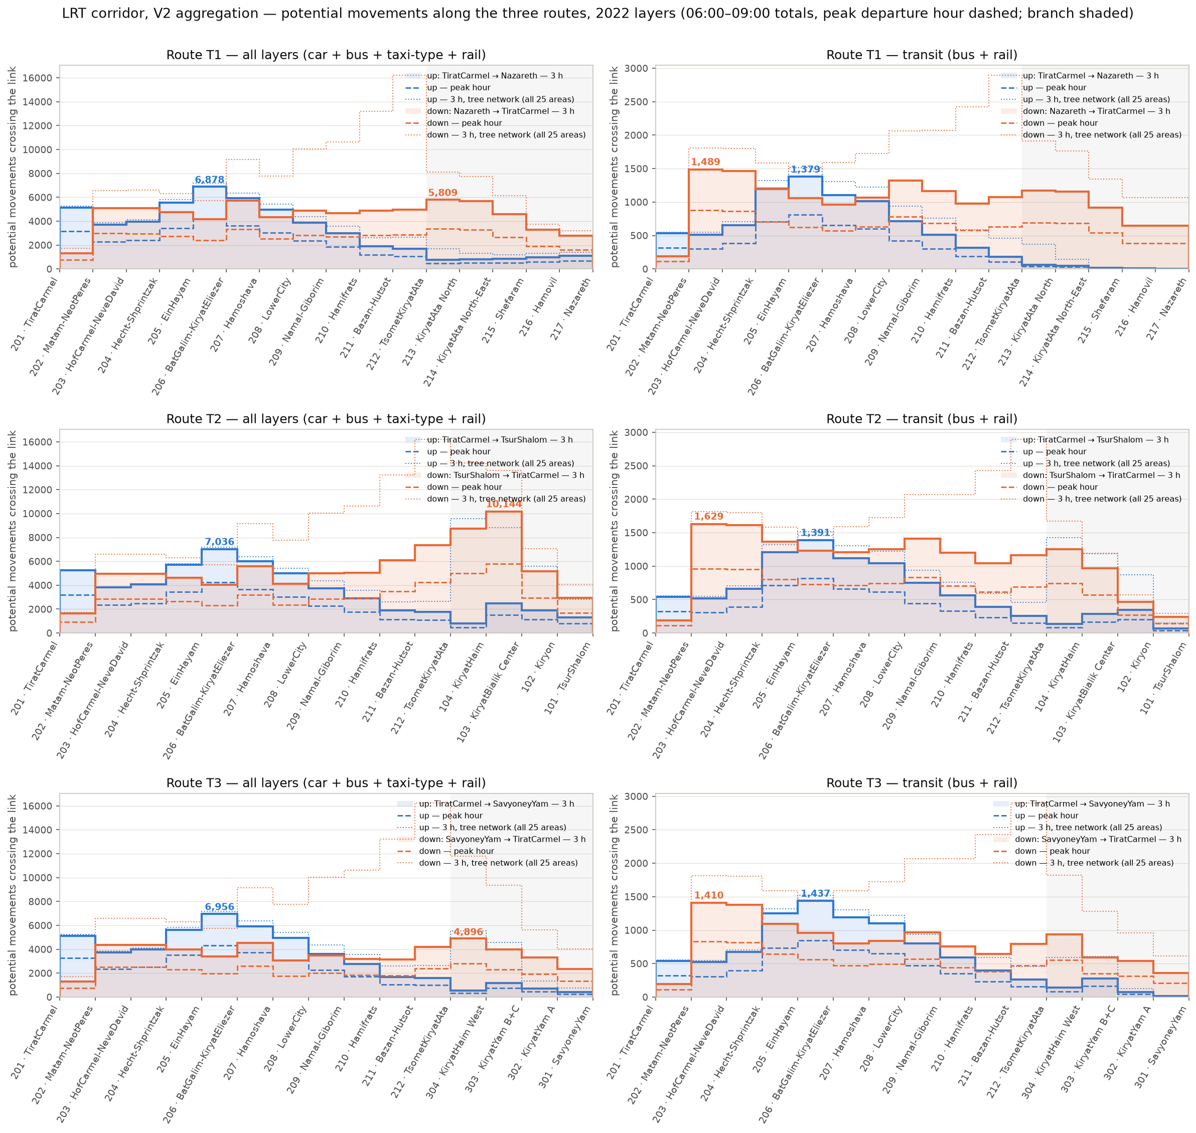
Figure 1. Potential movements along the three routes (three-hour totals filled, peak hour dashed, tree network dotted; branch shaded). All layers on the left, transit on the right.

3.3 The peak hour on the V2 routes
The earlier peak-hour factors were estimated on the trips between the 18 areas of the old line. They were re-estimated on the V2 route sequences from the survey’s minute-level departure times, per route, direction and layer, with the same rules as before: a factor is applied per direction where at least 100 sampled trips support it, otherwise the layer’s study-area factor; 200 household resamples give the range.
Scope | Car, up | Car, down | Sampled car trips (up / down) | Bus | Taxi-type
T1 Nazareth | 0.626 (07:15–08:15) | 0.578 (07:00–08:00) | 203 / 240 | 0.590 * | 0.580 *
T2 Krayot | 0.619 (07:15–08:15) | 0.569 (07:15–08:15) | 332 / 447 | 0.590 * | 0.580 *
T3 Kiryat Yam | 0.652 (07:15–08:15) | 0.569 (07:00–08:00) | 241 / 299 | 0.590 * | 0.580 *
Tree network | 0.556 (07:15–08:15) | 0.522 (07:00–08:00) | 777 / 1,001 | 0.590 * | 0.580 *
Earlier 18-area line | 0.661 | 0.626 | 194 / 236 | 0.590 * | 0.580 *
* study-area factor: no route-direction bus sample exceeds 58 trips (96 on the network), no taxi-type sample 48; the route values scatter around the study-area ones within their ranges. Peak hour in brackets; factors are the share of the three hours in the busiest 60 minutes (an average hour is 0.333).
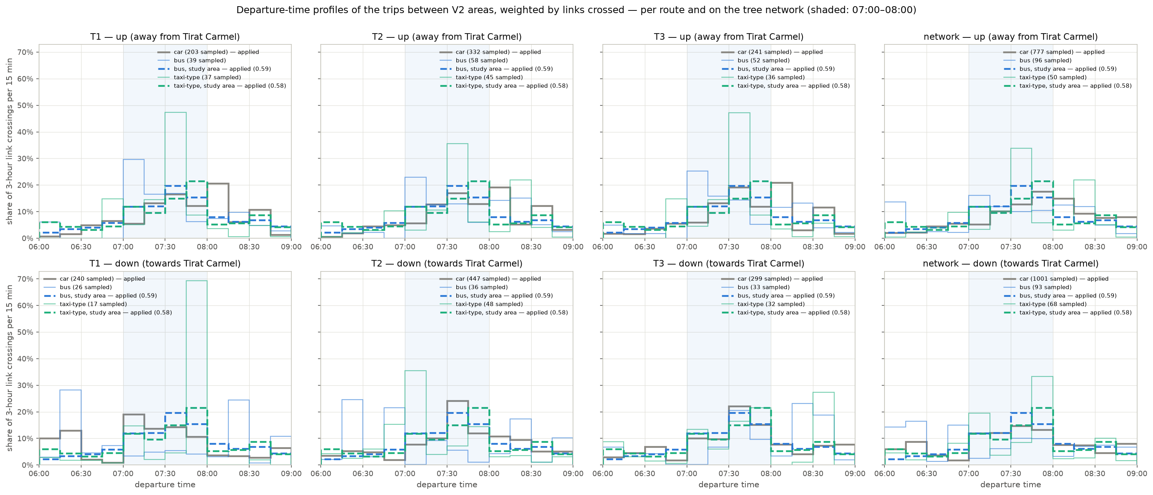
Figure 2. Departure-time profiles of the trips between V2 areas, weighted by links crossed, per route and on the tree network; the applied factor is the solid line where the route sample supports it, the dashed study-area profile otherwise.
The up factors are within a few per cent of the earlier ones. The down factors are 8–9 % lower per route and 16–17 % lower on the network: trips into Haifa from Nazareth and the Krayot start earlier and spread over 06:00–08:00, so the pooled Haifa-bound profile is flatter than any single route’s. The peak-hour values in this report use the new factors; against the first pass that used the old ones, peak-hour car and total values are 5–17 % lower (the network trunk link 8,792 instead of 9,956).

3.4 The calibrated survey against the ticketing data, route by route
The earlier comparison of the two transit frames — the calibrated survey (residents from their doorstep) and the ticketing data (every rider from the boarding stop) — was repeated on the V2 routes from the TAZ-level products, so that no earlier aggregation is involved. In the 25 areas the survey set holds 18,839 transit trips and the ticketing set 16,363, yet the survey sits below the ticketing profile on almost every link: its transit is more local, in short pairs that cross few links; the ticketing’s is more corridor-long.
Scope | Haifa segment, up (survey ÷ ticketing) | Haifa segment, down | Beyond Hamifrats, up | Beyond Hamifrats, down | Ticketing peak link, down (3 h)
T1 Nazareth | 0.83 | 0.66 | 1.08 | 0.43 | Lower City – Namal-Giborim 2,903
T2 Krayot | 0.78 | 0.92 | 0.58 | 0.79 | Lower City – Namal-Giborim 2,073
T3 Kiryat Yam | 0.82 | 0.73 | 0.57 | 0.79 | Lower City – Namal-Giborim 1,920
Tree network | 0.82 | 0.63 | 0.74 | 0.65 | Bazan-Hutsot – Tsomet Kiryat Ata 4,476 (survey 2,898)

Away from Tirat Carmel the two frames agree as they did before, with the same peak link. Towards Tirat Carmel the disagreement is route-specific: the Krayot route nearly matches, the Nazareth route does not. The pairs that drive the gap are the ones found before, now named on the V2 areas: Nazareth as origin (1,070 survey against 2,402 ticketed corridor-bound trips), above all Nazareth to Bat Galim-Kiryat Eliezer (87 against 521), to Hecht-Shprintzak (22 against 271) and to Lower City (132 against 431); then Kiryat Yam B+C, Tsur Shalom and the Hamifrats hub as origins. By destination the ticketing set lands far more at Bat Galim-Kiryat Eliezer, Lower City and Hecht-Shprintzak — trunk-route alighting stops — while the survey places its trips by employment share. The survey is the higher of the two from Kiryat Bialik Center, Ein Hayam and Hecht-Shprintzak, and to Kiryat Ata North and Kiryat Yam B+C.
The reading is unchanged: the gap is about where Nazareth’s trips are allocated inside Haifa and about the alighting frame, not about ticketing coverage. For any market figure on the Nazareth branch, both frames should be carried as a range until that allocation is settled.
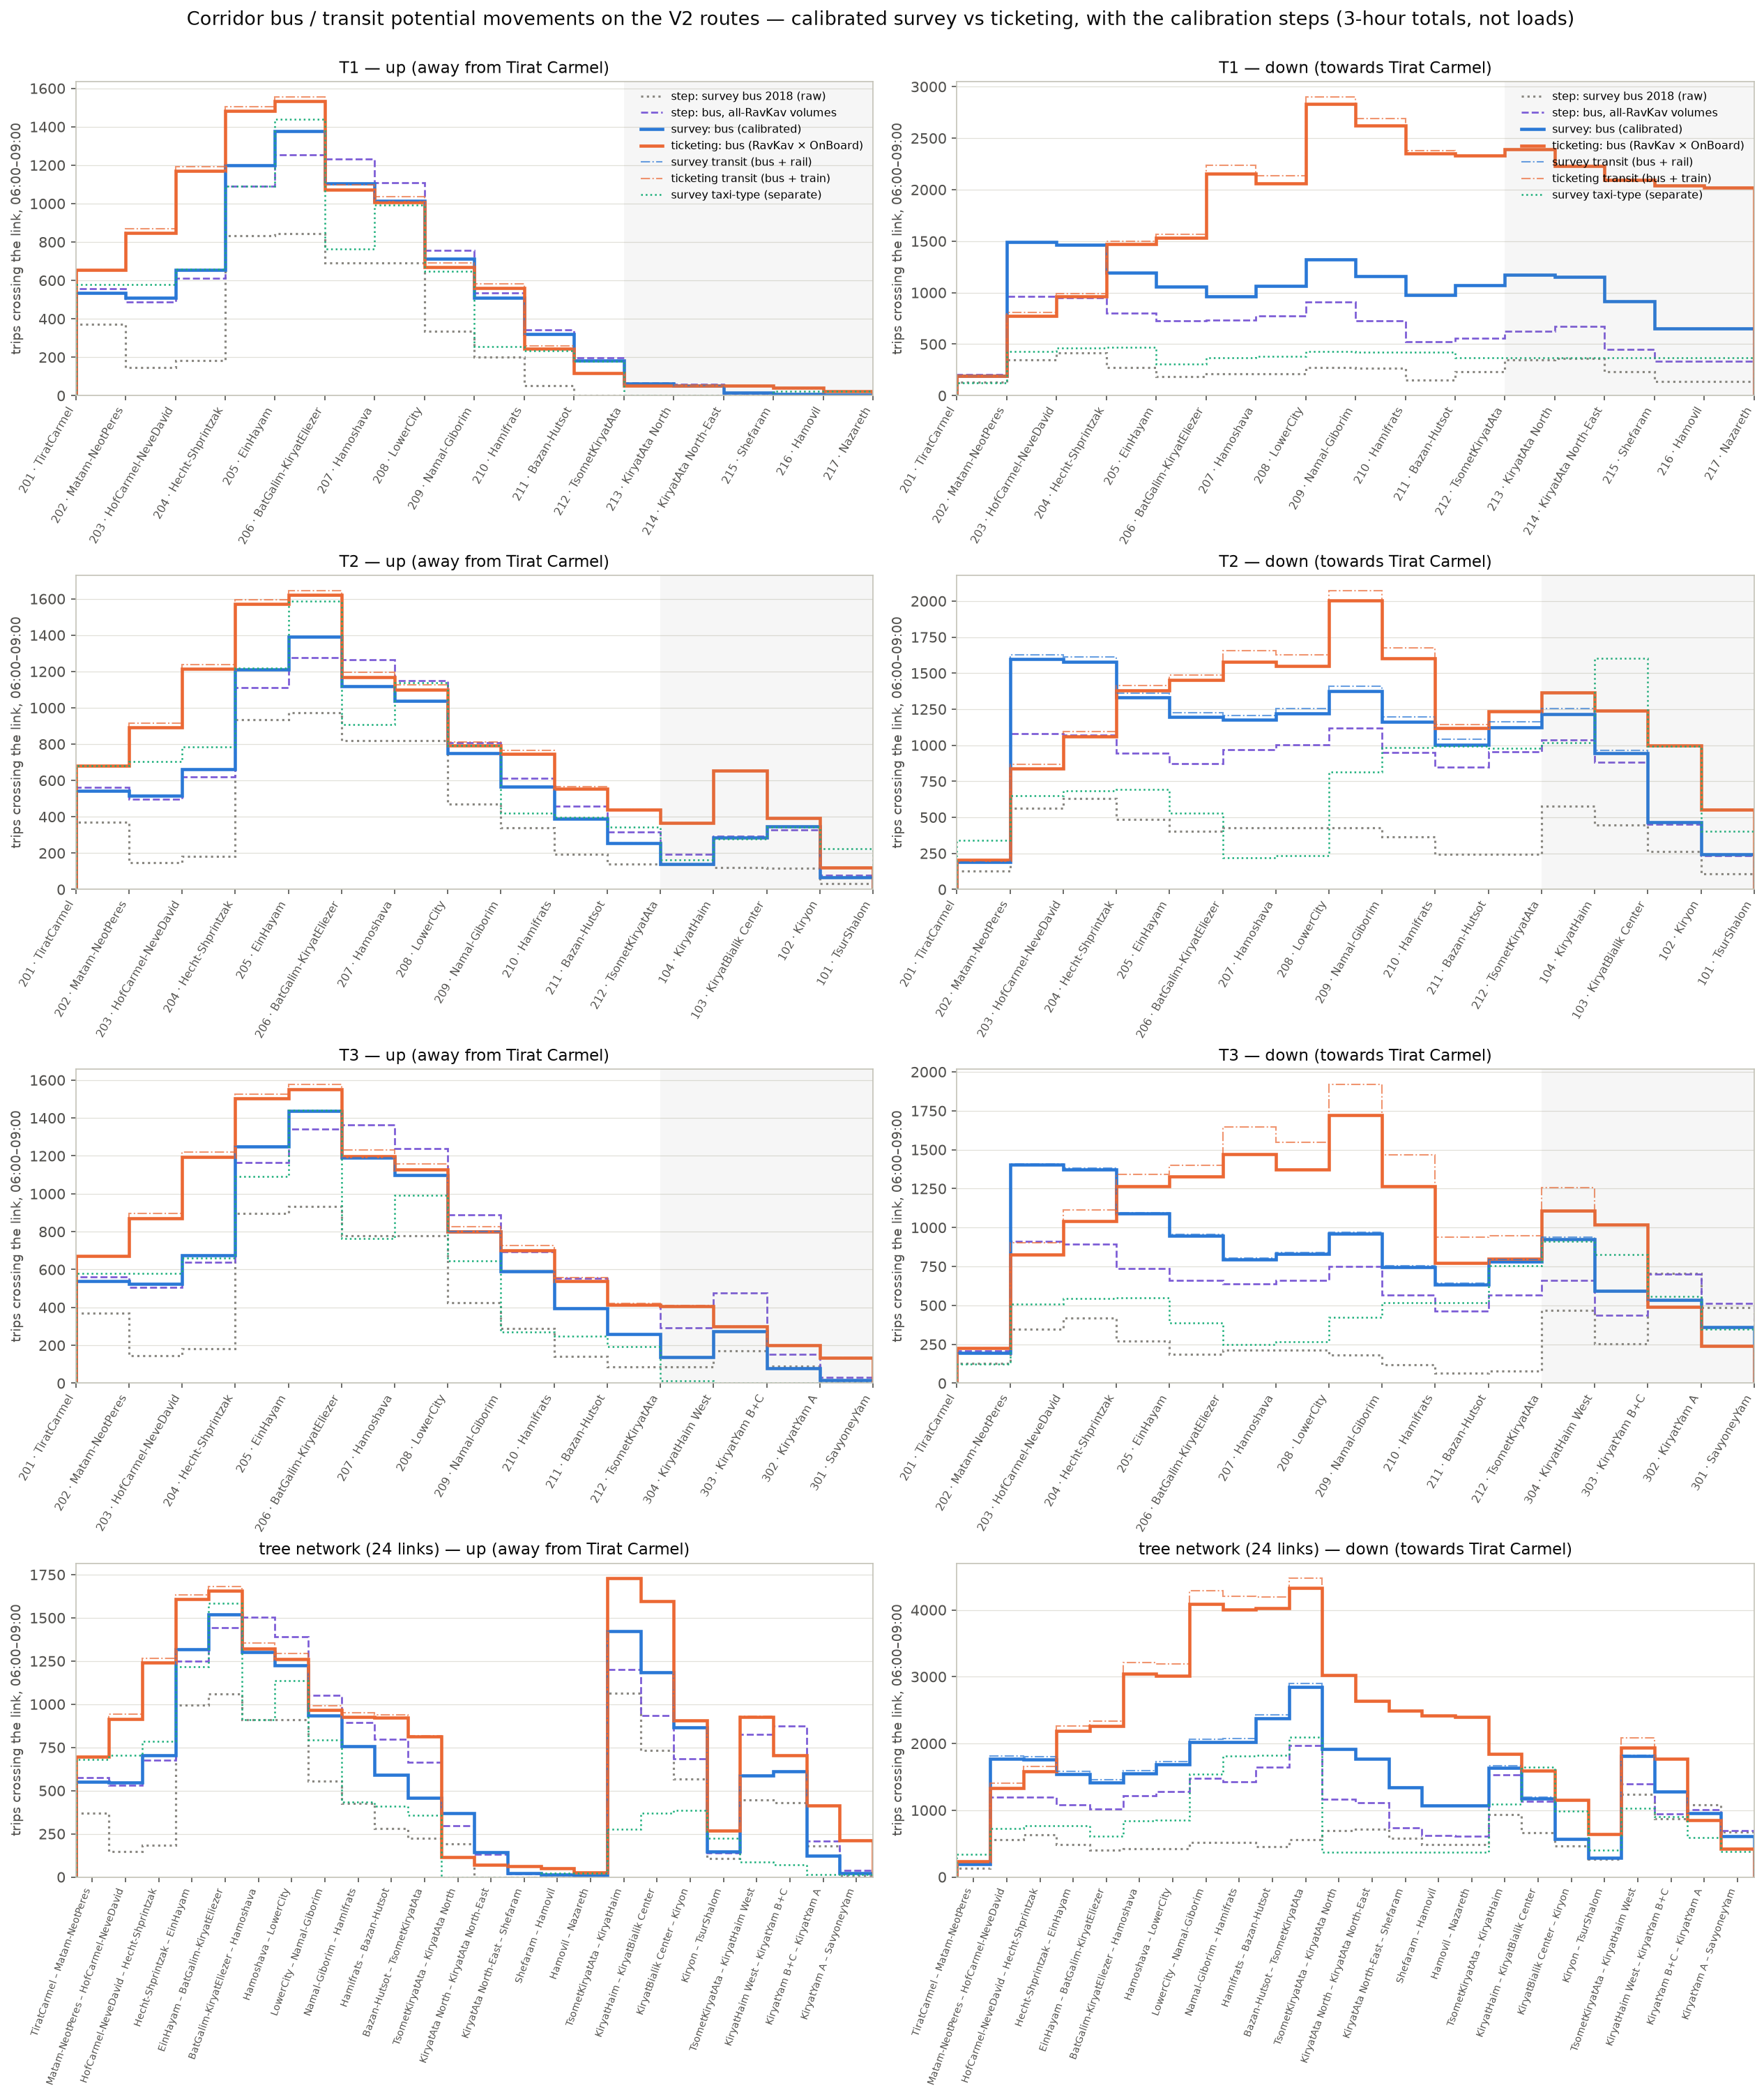
Figure 3. Bus and transit potential movements on the V2 routes and the tree network: calibrated survey (blue) against ticketing (orange), with the calibration’s intermediate steps (grey dotted, purple dashed) and taxi-type (green dotted).

3.5 Car versus transit at the V2 areas
The test of whether car and transit trips share the same destination structure — the reason the base keeps a transit-specific destination pattern rather than a scaled car matrix — was repeated with the V2 areas as the geography. With the 14 areas that have at least ten sampled transit trips as origins, the car-versus-transit overlap is 0.55 against transit’s own day-to-day repeatability of 0.76; with the seven best-sampled origins it is 0.76 against 0.80. Which side of the noise floor it lands on depends on which handful of origins is in, which is what sample-limited means. The level adds no conclusion; the superzone and TAZ-by-superzone evidence stands. The same pull towards Haifa shows per origin: Kiryon sends 35 % of its transit trips to the Haifa trunk areas against 6 % of its car trips, Kiryat Bialik Center 30 % against 6 %, Kiryat Yam B+C 31 % against 8 %. Nazareth (83 sampled transit trips) is 90 % self-contained in transit and 96 % in car — its corridor-bound transit is a thin slice of a large local market.

4. Part B — the LRT line and its station-to-station times

4.1 The geometry
The supplied alignment is one 18.94 km line from Hamifrats to Tirat Carmel. Its 46 platform points all lie within 80 m of the line and pair up into 24 stations (22 platform pairs and two single points at the Hamifrats end), S01 at the Tirat Carmel end to S24 at Hamifrats, 18.74 km apart. Spacing runs from 354 m to 1,396 m, 815 m on average — 1.6 times the 500 m at which the travel-time function was calibrated. Every station was located in its TAZ and V2 area; station S13, between Ein Hayam and Bat Galim, falls in TAZ 1509, which the V2 file does not list. The line serves the ten trunk areas from Tirat Carmel to Hamifrats and nothing beyond: Bazan-Hutsot, Tsomet Kiryat Ata and all three branches have no station on this geometry.

4.2 The calibrated function, the 500 m assumption, and the two scenarios
The function is T = 1.961 × (underground sections) + 2.393 × (other sections), in minutes per section, dwell included; a section counts as underground only when both its stations are. The two scenarios asked for are the two pure regimes: every section underground, or every section at ground level.
Revision 1 of this report read the coefficients as the calibration report does, over a nominal 500 m section, and got 73.5 and 89.7 minutes end to end. That was too slow, and the Red Line’s own timetable — in the same national GTFS, routes 34447 and 34448, 32 stops over 21.4 km in 70.6 scheduled minutes — shows why: its underground sections average 970 m and its surface sections 577 m. The calibrated 1.961 minutes per underground section is therefore a 30 km/h section. Fitting the scheduled section time against distance on the Red Line’s 14,477 scheduled sections separates running time from the stop penalty per regime, and levelling each regime to the calibration’s observed mean (0.94 underground, 1.02 surface) keeps the observed level:
Regime | Red Line mean section | Running speed | Stop penalty | Section time at Haifa’s 815 m spacing
Underground | 970 m | 46 km/h | 49 s | 1.77 min (27.6 km/h)
Ground level | 577 m | 31 km/h | 74 s | 2.86 min (17.1 km/h)
A third scenario was added at the study team’s request: a specified design regime of 50 km/h between stops with 10 seconds per stop, at the same 5-minute headway. It runs end to end in 26.3 minutes (42.7 km/h), 35 % below the calibrated underground case, because the specification carries no acceleration or braking — the calibrated forms put 49 to 74 seconds per stop into the stop penalty, where dwell, acceleration and deceleration all sit. It should be read as the ceiling of the alignment, beside the two calibrated scenarios rather than as a third observed regime.

Scenario | End to end S01 → S24 (18.74 km, 23 sections), decomposed form (the estimate) | Section form (one calibrated section per link, fast bound) | Nominal 500 m form (revision 1, superseded)
All stations underground | 40.7 min (27.6 km/h) | 45.1 min (24.9 km/h) | 73.5 min (15.3 km/h)
All stations at ground level | 65.8 min (17.1 km/h) | 55.0 min (20.4 km/h) | 89.7 min (12.5 km/h)
Specified design regime: 50 km/h + 10 s per stop (third scenario) | 26.3 min (42.7 km/h) | — | —
Saving from going underground | 25.1 min, 38 % | 9.9 min, 18 % | 16.2 min, 18 %

The decomposed form is the estimate carried into the generalized cost. The section form is kept as a bound: it is right for the underground where Haifa’s spacing is close to the Red Line’s, and too fast at the surface, where Haifa’s sections are 40 % longer than the Red Line’s. The saving from going underground is larger than the 18 % per section because the two coefficients embed different section lengths. The earlier capture-model assumption of 22–26 km/h sits inside the underground range.
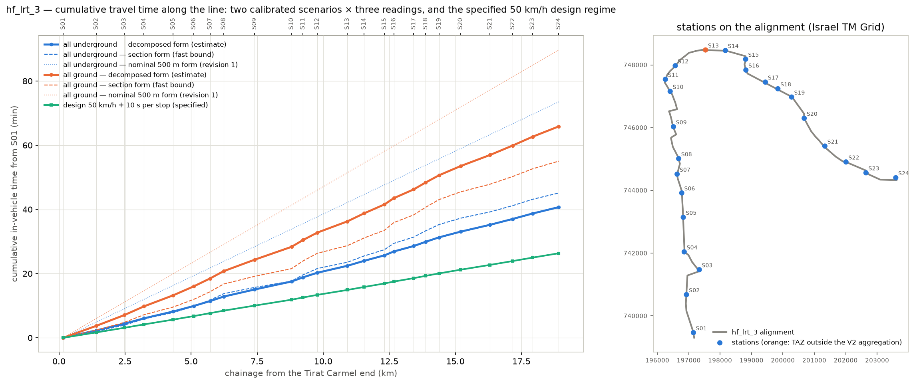
Figure 4. Cumulative in-vehicle time from S01 under the two scenarios: the decomposed form (solid, the estimate), the section form (dashed) and the superseded nominal 500 m form (dotted); the stations on the alignment (right; the orange station is the one whose TAZ is missing from the V2 file).
Station | Chainage from Tirat Carmel end | Area | Cumulative min, underground (decomposed / section form) | Cumulative min, ground (decomposed / section form)
S01 | 0.16 km | Tirat Carmel | 0.0 / 0.0 | 0.0 / 0.0
S04 | 3.22 km | Tirat Carmel | 6.1 / 5.9 | 9.8 / 7.2
S06 | 5.10 km | Matam-Neot Peres | 9.9 / 9.8 | 16.0 / 12.0
S09 | 7.40 km | Hof Carmel-Neve David | 15.0 / 15.7 | 24.3 / 19.1
S12 | 9.77 km | Ein Hayam | 20.3 / 21.6 | 32.8 / 26.3
S15 | 12.32 km | Bat Galim-Kiryat Eliezer | 25.7 / 27.4 | 41.5 / 33.5
S17 | 13.43 km | Hamoshava | 28.6 / 31.4 | 46.2 / 38.3
S19 | 14.39 km | Lower City | 31.3 / 35.3 | 50.6 / 43.1
S21 | 16.31 km | Namal-Giborim | 35.2 / 39.2 | 57.0 / 47.9
S24 | 18.91 km | Hamifrats | 40.7 / 45.1 | 65.8 / 55.0
The stations listed are the representative station of each served area (nearest its population- and employment-weighted centroid) plus S01; the full 24-station table is Output/lrt_v2/lrt_line_profile.csv.

5. Part C — the generalized-cost inputs: what exists, what is missing

5.1 The formula and the inventory
The capture model planned for the study compares modes on generalized cost in minutes: in-vehicle time, plus twice the walking time, plus twice the waiting time, plus eight minutes per transfer. Fares and parking were in the formula until revision 1.3; they are now out of the comparison by decision (Part E). Every component was inventoried for car, bus and LRT on the 25 V2 areas and given one of four statuses: measured (observed for that cell), derived (computed from data by a stated rule), assumed (a stated default to be replaced), or missing (a placeholder written so that the matrix is complete, and flagged).
Component | Car | Bus | LRT
In-vehicle time | Derived: survey door-to-door times (2017/18) per area pair, smoothed with a time = 7.0 + 1.85 × km fit where fewer than ten trips were sampled | Derived: observed running time of the direct GTFS services routed over the measured link speeds, on the 422 of 600 pairs that have one (82 of 90 trunk pairs); the scheduled time kept alongside; elsewhere the fastest path on the speed network scaled by 1.12 | Derived on the ten trunk areas from Part B (decomposed form); missing for the other 15
Walk (access + egress) | Included in the door-to-door time | Derived: TAZ centroid to the nearest served GTFS stop, weighted by residents and jobs | Derived: TAZ centroid to nearest station, 3–12 min per area, weighted by residents (access) and jobs (egress)
Wait | — | Derived: half the combined 07:00–08:00 headway of the direct services, capped at 10 min; a placeholder where no direct service | Assumed: half a 5-minute headway (12 departures an hour)
Transfers | — | 0 where a direct service exists; missing on the 178 pairs without one (path building needed) | Assumed 0 on the trunk; undefined for the branches
Fare / operating cost | Constant by decision (out of the comparison) | Constant by decision (flat integrated fare with a daily cap) | Constant by decision (the same fare as the bus)
Parking | Excluded by the same decision | — | —
Value of time, weights | Missing: to be taken from נוהל פר"ת; the walk / wait / transfer weights are the plan’s defaults

5.2 The first fill
With what exists, the trip-weighted values on the 90 pairs of trunk areas are:
Mode | In-vehicle time | Walk | Wait | Partial generalized cost (IVT + 2·walk + 2·wait) | Note
Car | 14.5 min (door to door) | — | — | 14.5 | 2017/18 vintage; no 2026 congestion uplift
Bus (observed running time) | 14.4 min (direct services over the measured link speeds; the timetable says 10.4, the speed-network floor 12.5) | 4.7 min | 1.6 min | 27.0 | Bus users in the survey report 27.1 min door to door on the same pairs
Metronit (on its 72 trunk pairs) | 8.6 min (scheduled 7.8) | 4.4 min | 2.4 min | 22.1 | Level with all-bus on the same pairs (20.2), which already includes it
LRT, all underground | 11.7 min (decomposed form; section form 13.3) | 13.6 min | 2.5 min | 43.9 | Dearer than the bus on every trunk pair, by 4–31 (median 17)
LRT, all ground | 18.9 min (section form 16.2) | 13.6 min | 2.5 min | 51.1
Money components are constant by decision and enter at zero. Bus values on the eight trunk pairs without a direct service are placeholders.
Two of the LRT’s minutes are structural rather than uncertain. Twenty-four stations over 18.7 km put the average trunk resident 6.8 minutes from a station against 2.4 minutes from a bus stop; with walking weighted twice, that alone is 18 generalized minutes, the whole of the LRT’s median disadvantage against the bus.
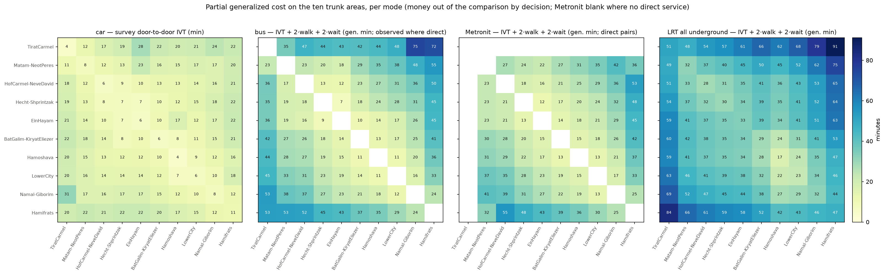
Figure 5. The first fill on the ten trunk areas: car door-to-door time, the bus partial generalized cost from the timetable, and the LRT partial generalized cost (all underground), in generalized minutes.

5.3 Observed running times, and the bus against what bus users report
Every morning-peak timetable trip was routed, stop by stop, over the street network with the measured May 2026 bus link speeds (weekday 3, 07:00–08:00): 7,324 trips, 15,929 distinct stop-to-stop segments routed once each by shortest path, 94 % of the routed length on links with a measured speed, 2 % of segments falling back to the schedule. Per trip the observed in-vehicle time is 1.09 times the scheduled one (Metronit 0.87, ordinary buses 1.10). The pattern by hop length says what the speeds contain: hops under 500 m, two thirds of all hops, take exactly the scheduled time, so the link speeds include the dwell at stops; hops of 1–2 km run 1.25 times slower than scheduled and hops over 2 km 1.4 times, which is the peak-hour congestion on the arterials that the timetable pads only partly. Demand-weighted on the trunk pairs the observed in-vehicle time is 14.4 minutes against 10.4 scheduled. The long interurban timetables are padded (observed 0.88 of schedule on pairs over 30 scheduled minutes), except from Nazareth, where the observed times to the Haifa trunk run 8–9 minutes above the schedule.
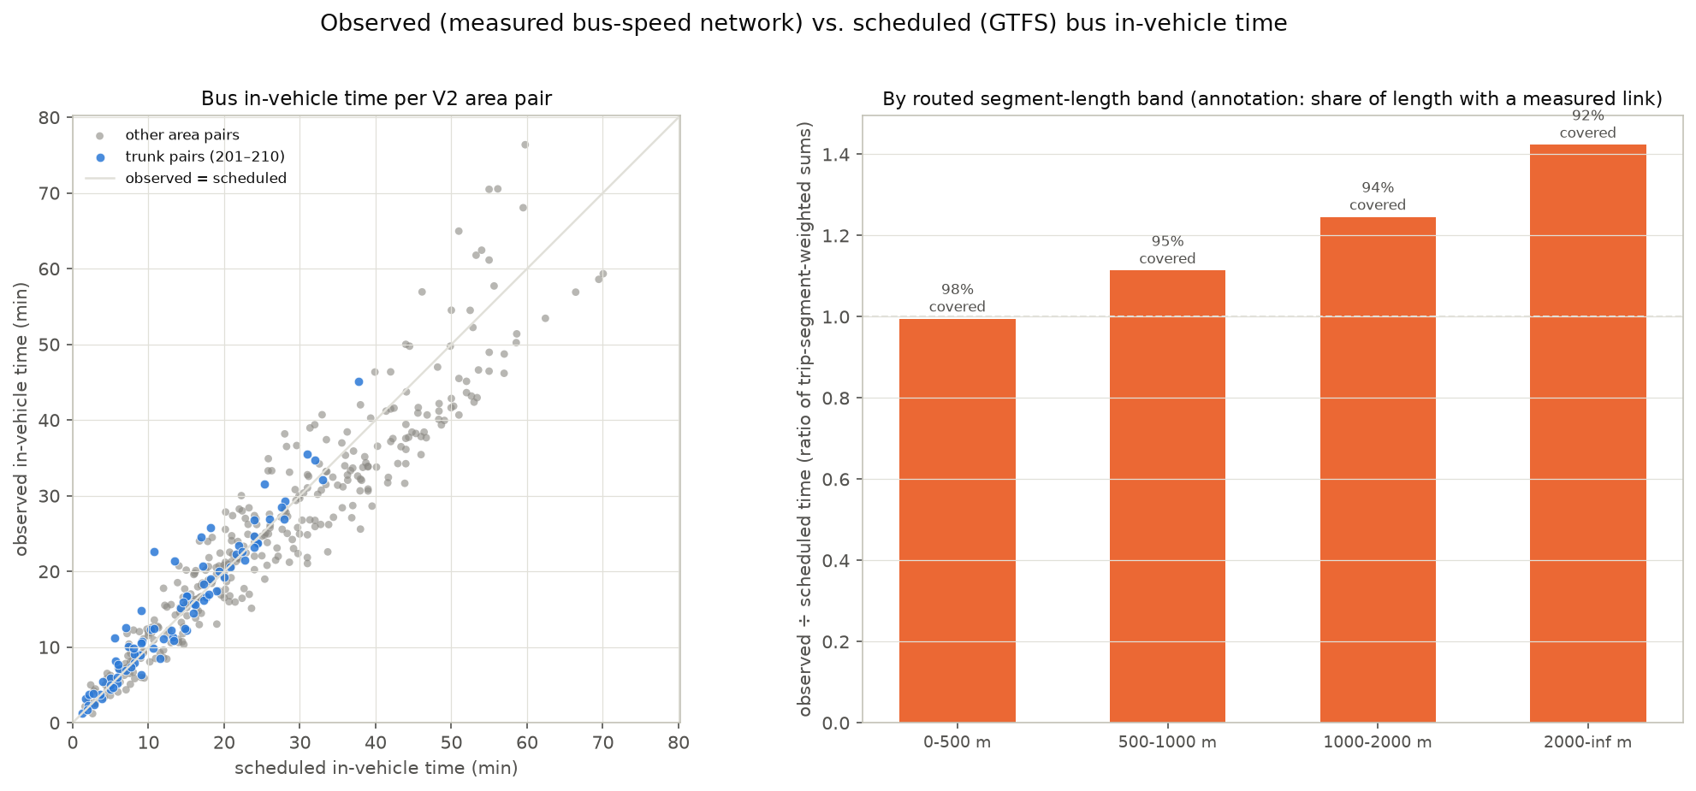
Figure 6. Observed against scheduled bus in-vehicle time per area pair (left) and the observed-to-scheduled ratio by hop length with the measured-link coverage (right).
The surveyed bus trips of 2b were then compared, pair by pair, with the GTFS-based door-to-door time for their area pair: observed in-vehicle time plus walking to the nearest served stop plus half the pooled headway. On the pairs with a direct service, which carry 97 % of the surveyed bus trips, this gives 24.3 minutes (in-vehicle 17.1, walk 5.3, wait 1.9) against 31.8 reported. The ratio is not constant:
Area pairs | Sampled bus trips | Survey door-to-door (min) | GTFS observed in-vehicle (min) | GTFS door-to-door (min) | Survey ÷ GTFS
All with a direct service | 99 | 31.8 | 17.1 | 24.3 | 1.3
Trunk to trunk | 36 | 26.8 | 14.1 | 20.0 | 1.3
Under 3 km apart | 57 | 25.6 | 7.8 | 13.7 | 1.9
3–6 km | 24 | 28.9 | 18.7 | 25.6 | 1.1
6–20 km | 14 | 50.2 | 27.3 | 36.9 | 1.4
20–60 km | 3 | 54.3 | 55.9 | 70.4 | 0.8

The gap is an overhead of about seven minutes rather than a proportional error: large on short pairs, gone on the longest. With the running time now observed, it is what a best direct service does not carry — the transfer that a share of bus journeys involve and the wait for the line actually needed rather than the pooled headway of everything that passes. Only three pairs hold three or more sampled trips, so this is a trip-level comparison by distance band, not a pair-level fit. For the capture model it is the calibration margin for the bus generalized cost: either add the overhead, or replace the pooled wait by the headway of the route actually used.
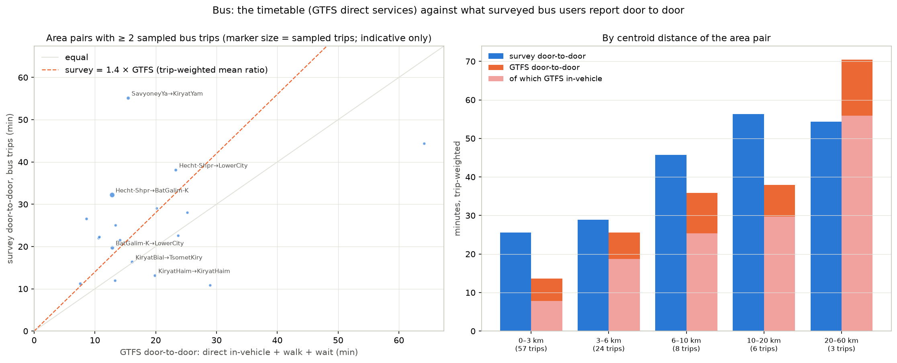
Figure 7. Bus: the GTFS-based door-to-door time (observed in-vehicle time, walk and wait) against what surveyed bus users report — by area pair (left, indicative) and by distance band (right).

5.4 What decides the answer now
Revision 1 said the LRT speed was the decisive input. With the function transferred through the Red Line’s actual spacing and the bus running times observed rather than scheduled, it no longer is: the LRT’s in-vehicle time on the trunk pairs is three minutes below the buses’ observed running time underground and four minutes above it at ground level. What separates the LRT from the bus in this first fill is station access, and that is a matter of the access model — feeder buses to the stations, the walking network instead of a straight-line detour factor, park-and-ride where the station plan allows — and of the station plan itself, not of the travel-time function. The two inputs to obtain first are therefore the alignment and stations beyond Hamifrats and on the three branches, without which 15 of the 25 areas have no LRT time at all, and an access treatment for the LRT. The money components are out of the comparison by decision: the flat, integrated fare with a daily cap is the same for every transit mode and every pair, and against the car it is a constant per trip that the pivot on the observed shares absorbs.

6. Part D — the bus network today: level of service per TAZ from the GTFS
The national timetable of 22 May 2026 was reduced to the study area on its representative Tuesday, 2 June 2026: 12,845 stops in 730 of the 781 TAZs, 33,499 trips calling at them on the day, 7,324 of them departing a study-area stop between 06:00 and 09:00. For every TAZ, for all buses and for the Metronit separately, the table Output/gtfs/bus_los_taz.csv gives the served stops, the lines, the departures in the three hours and in the peak hour, the combined headway of everything that passes, the headway of the best single line, the number of TAZs reachable without a transfer (and within 30 scheduled minutes), the distance from the TAZ centroid to the nearest stop, and a frequency grade in the TCQSM classes (A ≤ 10 min, B ≤ 15, C ≤ 20, D ≤ 30, E ≤ 60). The grade on the best single line is the informative one; the combined headway grades almost every TAZ A because some bus passes every few minutes.
The Metronit was tagged by its route codes in the feed. The five codes supplied with the request were checked: only 83001 (line 1) is a Metronit route; 83003 and 83005 belong to local lines in Kiryat Malachi and Arara BaNegev, and 83002 and 83004 do not exist. The lines in the feed, all under Superbus, are 83001 (line 1, Hof HaCarmel – Krayot), 67002 (line 2, Bat Galim – Kiryat Ata), 67003 (line 3, Krayot loop), 62004 (line 4, via the Carmel tunnels) and 52005 (line 5, Yagur). The notebook prints every matched route so the tagging can be audited.
V2 area | TAZs (unserved in the peak hour) | Lines | Best-line headway (min, median TAZ) | TAZs reachable without transfer in 30 min | TAZs with a Metronit stop
Hamifrats | 6 (1) | 97 | 4 | 58 | 2
Bat Galim-Kiryat Eliezer | 10 (2) | 52 | 6 | 38 | 4
Lower City | 7 (1) | 36 | 6 | 71 | 4
Tsomet Kiryat Ata | 3 (0) | 44 | 9 | 91 | 1
Kiryat Haim | 5 (1) | 31 | 6 | 72 | 3
Kiryat Bialik Center | 9 (2) | 29 | 12 | 35 | 1
Kiryat Yam B+C | 6 (1) | 30 | 3 | 44 | 3
Tirat Carmel | 14 (0) | 8 | 12 | 22 | 0
Kiryat Ata North | 7 (3) | 17 | 18 | 10 | 2
Kiryat Ata North-East | 7 (2) | 17 | 20 | 10 | 0
Shefaram | 10 (0) | 25 | 20 | 54 | 0
Hamovil | 3 (0) | 30 | 30 | 84 | 0
Nazareth | 38 (0) | 48 | 12 | 48 | 0
A selection of the 25 areas; the full table is in the notebook. 719 of the 781 TAZs have a peak-hour departure; the 62 without are mostly zones with no stop at all (Bazan, the port, the Matam fringe, Kiryat Ata industry).
The Haifa trunk is A to B on the best line and reaches 40 to 100 TAZs without a transfer within half an hour. The branches are weaker in kind: the Kiryat Ata branch has 18 to 20 minute best-line headways, five of its fourteen TAZs unserved in the peak hour and a direct reach of ten TAZs; Shefaram and Hamovil 20 and 30 minutes; Nazareth is dense (2,438 peak-hour departures across its 38 TAZs) but local. Sixty TAZs have a Metronit stop, 41 of them in twenty of the 25 V2 areas; Tirat Carmel, Shefaram, Hamovil, Nazareth and Kiryat Ata North-East have none.
Between the 25 areas, 422 of the 600 ordered pairs have a direct bus service in the morning peak and 278 a direct Metronit service; on the trunk 82 of 90 pairs (72 by Metronit). The eight trunk pairs without one are Tirat Carmel to and from Bat Galim, Hamoshava, Lower City and Hamifrats, which need a change at Hof HaCarmel. The scheduled in-vehicle time of these direct services, their number in the peak hour and the implied headway are the bus skim of Part C.
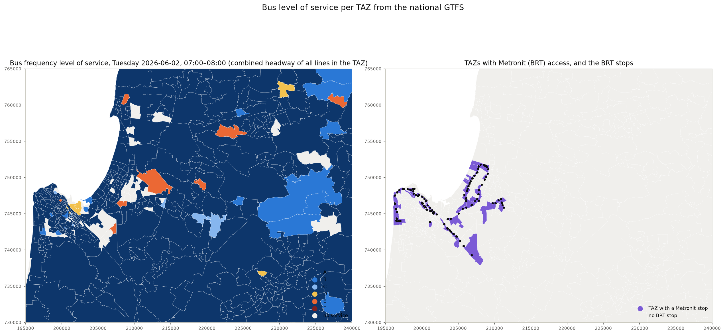
Figure 8. Left: bus frequency grade per TAZ on the combined peak-hour headway (Tuesday 2 June 2026, 07:00–08:00). Right: the TAZs with a Metronit stop and the Metronit stops.

7. Part E — the complete skims and the first flow comparison

7.1 One skim set per mode
The components of Part C were assembled into one complete 25 × 25 skim per mode — in-vehicle time, walk, wait, transfers, partial generalized cost and a status for every cell — for car, bus, Metronit, LRT all underground and LRT all ground (Output/skims/skims_area_v2.xlsx, one sheet per mode and component, and the same as CSV). Car is full from the survey; bus is the observed running time of the direct services on 422 pairs and a scaled fastest-path floor with one transfer on the other 178; the Metronit is a direct-service skim on 278 pairs and not available elsewhere. The LRT, which the drawn line serves on ten areas only, is extended to all 25 through a feeder leg: from an area off the line the traveller rides to the cheapest gateway station and transfers. The feeder is the bus, with the eight-minute transfer penalty, or — where a direct Metronit service reaches the gateway — the Metronit, with the LRT–Metronit transfer free by decision; both ends off the line combine two such legs. The gateway and the feeder modes are recorded per pair. Money is out of the comparison by decision: the transit fare in the area is flat and integrated with a daily cap, the same for bus, Metronit and LRT and for every pair, and against the car a constant per trip.
Mode | Pairs skimmed | Trunk pairs: IVT | walk | wait | GC | All pairs: GC
Car | 600 | 14.7 | — | — | 14.7 | 20.2
Bus | 598 | 14.9 | 4.8 | 1.4 | 27.8 | 38.5
Metronit | 278 | 11.2 | 4.7 | 2.5 | 25.6 | 31.0 (its pairs)
LRT all underground | 600 | 12.6 | 13.2 | 2.5 | 44.0 | 64.6
LRT all ground | 600 | 20.4 | 13.2 | 2.5 | 51.8 | 70.0
LRT design 50 km/h + 10 s (specified) | 600 | 8.0 | 13.2 | 2.5 | 39.4 | 61.1
Minutes, weighted by the 2022 transit trips of each pair; the trunk pairs are the 90 pairs among the ten station areas. GC = IVT + 2 × walk + 2 × wait + 8 × penalised transfers, in generalized minutes; the LRT premium is not in the skim.
On physical cost the LRT is dearer than the bus on 560 of the 598 pairs — on the trunk by 4 to 28 generalized minutes, median 15 — and what makes it dearer on the trunk is station access: 13.2 minutes of walking against 4.8 to the nearest bus stop, weighted twice. Off the line it is the feeder ride. With the five-minute premium the LRT is the cheaper transit mode on 96 pairs carrying 441 of the transit trips.

7.2 The 2022 flows do not calibrate the cost sensitivity
The plan was to read the cost sensitivity off revealed behaviour: the observed 2022 transit share of each pair against the bus’s cost handicap over the car. On 573 pairs and 67,700 car and transit trips the fit returns the wrong sign, and no sensitivity at all once a constant per distance band is allowed. The transit share is 0.11 under three kilometres, 0.25 at three to six, 0.16 to 0.17 at six to twenty and 0.41 beyond twenty (Nazareth, Shefaram), while the bus’s handicap grows steadily from 11 to 28 generalized minutes over the same bands: the pairs where the bus is worst placed are those whose travellers are least car-available, and car availability is not in the skims. The cross-section identifies car availability, not cost. The sensitivity is therefore assumed — 0.03 per generalized minute, a range of 0.02 to 0.05, twice that within the transit nest — with the observed shares entering only as the pivot; fitting it properly needs a segmented estimation on the survey’s person records.
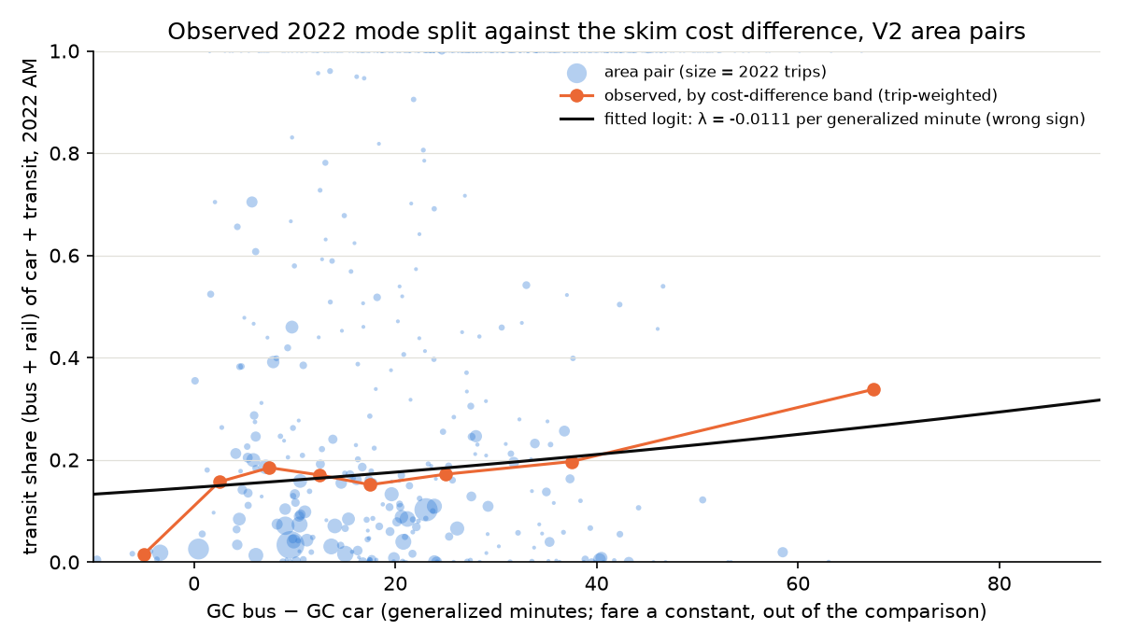
Figure 9. The observed 2022 transit share of each pair against the skim cost difference (bus minus car); the orange line is the trip-weighted share by band, the black line the fitted logit, whose slope has the wrong sign.

7.3 What the LRT would take, on the 2022 market between the 25 areas
A nested incremental logit pivoted on the observed trips of each pair — with the LRT removed it returns 2022 exactly — splits the transit trips between bus and LRT on the cost difference less the premium, and lets the improved transit nest draw a little from the car. The market is the 11,664 bus and rail trips and 56,445 car trips made between the 25 areas in the three morning hours of 2022; nothing from outside the areas, no growth to 2040, no capacity, no route choice against the buses that remain.
Scenario and case | LRT trips 06:00–09:00 | from bus | from car | share of transit | trunk pairs: share of transit
Underground, central (λ 0.03, premium 5, free LRT–Metronit transfer) | 3,332 | 3,037 | 295 | 27 % | 34 %
Underground, λ 0.02 / 0.05 | 4,855 / 2,357 |  |  | 36 % / 19 % | 42 % / 25 %
Underground, premium 0 / 10 | 2,658 / 4,122 |  |  | 22 % / 32 % | 28 % / 41 %
Ground, central | 2,544 | 2,375 | 169 | 21 % | 25 %
Ground, λ 0.02 / 0.05 | 4,277 / 1,472 |  |  | 32 % / 12 % | 36 % / 14 %
Ground, premium 0 / 10 | 1,999 / 3,200 |  |  | 16 % / 26 % | 20 % / 31 %
Design 50 km/h + 10 s, central | 3,970 | 3,534 | 437 | 31 % | 40 %
Design 50 km/h + 10 s, λ 0.02 / 0.05 | 5,272 / 3,227 |  |  | 38 % / 26 % | 45 % / 35 %
Two of the three assumptions each add about a fifth to the central figure: without the premium the underground line takes 2,658 trips, some 400 of which the free Metronit transfer brings in from the Krayot; with a ten-minute premium 4,122. The range across the cost sensitivity, 2,357 to 4,855, is wider than the difference between the two alignments. In the specified design regime the line draws 3,970 trips, a fifth more than underground — what the ceiling of the alignment is worth, and less than the range across λ. The trips board mostly at the two Krayot-facing ends — Hamifrats 995 and Namal-Giborim 747, where the Metronit feeders arrive — then Hecht-Shprintzak 391 and Bat Galim 353; the largest single flows run to the Matam employment end from Bat Galim (122), Hecht-Shprintzak (116) and Tirat Carmel (104), then Nazareth to the Lower City (75) by feeder bus.
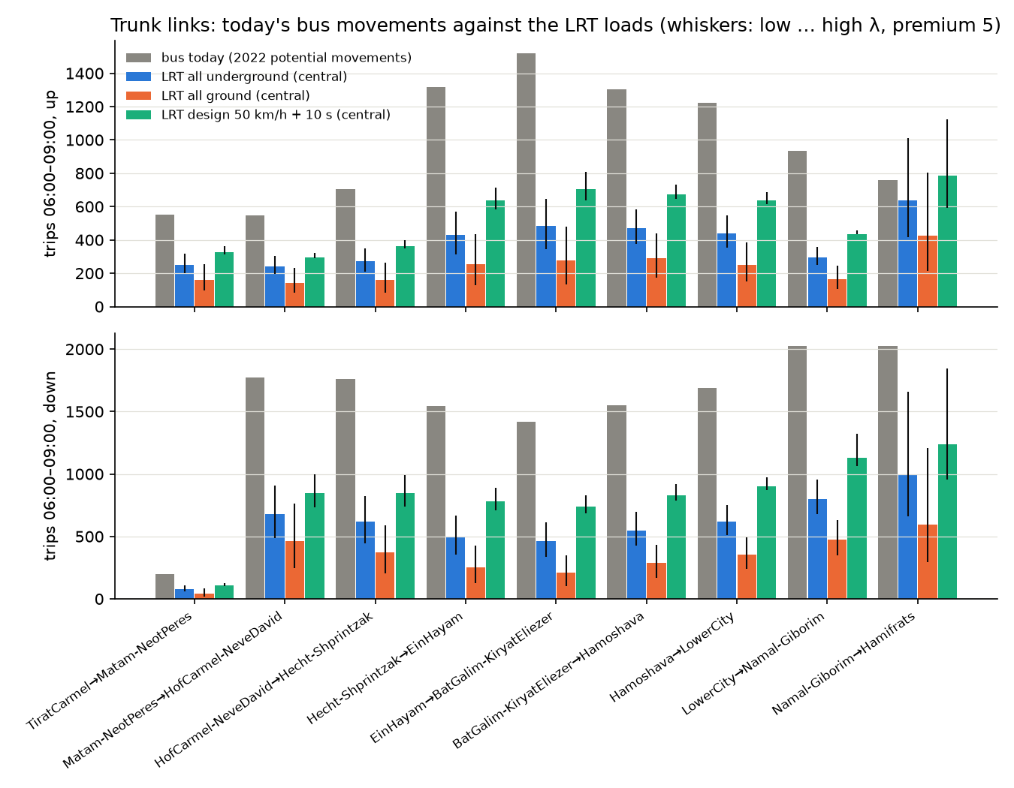
Figure 10. The nine trunk links, both directions: today’s bus movements (grey) against the LRT loads of the central case, underground (blue) and ground (orange); the whiskers span the cost-sensitivity range.
On the trunk links the underground line carries 79 to 995 trips per link and direction over the three hours (47 to 588 in the peak hour), a third to 45 % of the bus movements on the same links today and 84 % on Namal-Giborim to Hamifrats towards the Krayot, where the feeder trips concentrate; the ground scenario carries 44 to 595. These are the loads of the corridor-internal 2022 market only; the external trips would add to them, the buses that keep running in parallel would take from them.

7.4 The same capture on the 2040 / 2050 matrices
With the zonal forecast files pulled, the four demographic-reference sets of the forecast step (BU and HS, 2040 and 2050) were produced at TAZ level and aggregated to the 25 areas: transit trips between the areas grow from 11,664 to 14,836 and 16,369 under BU and to 16,076 and 18,291 under HS, car trips a little faster, so the no-build transit share stays at 0.16–0.17 by construction. The capture applied to them, with the skims held at today’s conditions, gives 4,114 and 4,498 LRT trips underground under BU and 4,520 and 5,354 under HS (ground level 3,105 / 3,386 and 3,430 / 4,047): the capture rate is the same as in 2022 — 28 to 29 % of the transit trips underground — because nothing in the skims changes with the year; what changes is the market and where it grows. BU grows Tirat Carmel and the Krayot branch, HS the Carmel coast (Matam, Hof Carmel, Bat Galim) and the western Krayot, and the boardings follow: Hamifrats stays the largest station area in every scenario (995 today, 1,717 by HS 2050), Tirat Carmel more than doubles under BU, Bat Galim and Matam under HS. The busiest trunk link, Namal-Giborim to Hamifrats towards the Krayot, goes from 995 trips in the three hours today to 1,367 (BU 2050) and 1,717 (HS 2050) — about 1,000 in the peak hour by HS 2050; in the design regime 6,432 trips by HS 2050 and 2,104 on that link, about 1,250 in the peak hour.

8. Part F — what each matrix can be used for
Every product in the repository is fit for some questions and not for others. The table states, for each, what it is, what it can be used for and what it must not be used for. The general rule that applies to all of them: they support relative questions — ranking routes, segments and branches, sizing the market between line areas, locating demand, and scaling to a design hour — and they do not support passenger loads, capacity or frequency decisions, ridership forecasts or appraisal.
Product (Output/…) | What it is | Fit for | Not fit for
final_2022/{car, transit, total}_2022_taz.csv | The deliverable 778 × 778 matrices, 2022, 06:00–09:00, residents with both trip ends in the study area; transit = calibrated bus + rail; taxi-type as a variant; long format for SQL | Any aggregation to superzones or areas; relative comparisons; margins for growth; the base of everything else | TAZ-level statements about transit (the TAZ detail is a population / employment split, not observed); loads; appraisal
corridor_v2/{car, bus, taxi, rail, transit, total}_2022_area_v2.csv | The same layers summed to the 25 V2 areas | Market sizing between line areas per route or on the network; the geography of the capture model | Comparing totals one-to-one with the earlier 28-area products (different TAZ sets); intra-area cells (no within-area treatment yet)
corridor_v2/corridor_v2_link_flows_long.csv, corridor_v2_network_link_flows.csv | Potential movements per link, route, direction and layer; three-hour and peak-hour | Ranking links, segments and branches; where demand concentrates; the design-hour scale (1.6–1.8 × an average hour) | Loads, capacity or frequency; trips with one end off the line; link-crossing hour (the factors are on departure time)
corridor_v2/peak_hour_factors_v2*.csv | Peak-hour factors per route / network, direction and layer, with ranges | Car by route and direction (± 0.1 range); bus and taxi-type as study-area factors | Route-specific bus or taxi-type factors; per-link factors
corridor_v2/corridor_v2_survey_vs_ticketing*.csv | The two transit frames on the V2 routes, link by link and pair by pair | A range for the transit market: survey (residents, doorstep) to ticketing (all riders, boarding stop) — needed on the Nazareth branch | Choosing one frame as “the” transit demand; adding the two
lrt_v2/lrt_station_times_{all_underground, all_ground, design_50kmh}.csv (+ …_section_form, …_nominal500m_form) | Station-to-station in-vehicle times, 24 stations, two scenarios; the decomposed form is the estimate, the other two are bounds | LRT skims for the ten trunk areas (40.7 / 65.8 min end to end); the 38 % underground saving | The nominal 500 m form (revision 1, superseded); any area beyond Hamifrats or on the branches
gtfs/bus_los_taz.csv | Bus and Metronit level of service per TAZ from the timetable of 22 May 2026 (Tuesday 2 June) | Ranking TAZs and areas by service; the BRT-access flag; catchment and station-area work | Observed operations (it is the schedule); the combined-headway grade as a measure of service to one destination
gtfs/bus_direct_skim_area_v2.csv, gtfs/bus_observed_skim_area_v2.csv | Scheduled and observed in-vehicle time, trips and headway of the direct services between the 25 areas, bus and Metronit | The bus in-vehicle time (observed), wait and transfer count of the generalized cost on the 422 pairs with a direct service | Pairs without a direct service (transfer paths not built); door-to-door time without the seven-minute overhead of 5.3
gc/gc_components_area_v2_long.csv, gc_area_v2_*.csv (car, bus, brt, lrt), gc_data_inventory.csv | Every generalized-cost component per cell with its status; partial GC per mode including the Metronit; the gap table | Seeing what exists and what is missing; the structure of the capture model; tracking the gaps as they close | Running the capture model or calibrating its sensitivity; quoting a mode’s generalized cost as complete (LRT access by straight-line walk; the LRT off the line only through a feeder)
skims/skims_area_v2.xlsx, skim_{mode}_{component}.csv, skims_area_v2_long.csv | One complete 25 × 25 skim set per mode — car, bus, Metronit, LRT underground, LRT ground — with in-vehicle time, walk, wait, transfers, partial generalized cost and a status per cell; the LRT off the line through a feeder (bus, or Metronit with a free transfer) to the cheapest gateway station, recorded per pair | Running the capture model; comparing modes pair by pair; feeding any assignment or appraisal that works on the 25 areas | Intra-area cells (not skimmed); TAZ-level questions; the 178 bus pairs without a direct service (a scaled floor with one transfer assumed)
skims/lrt_capture_scenarios.csv, lrt_trips_2022_*_central.csv, trunk_link_flows_bus_vs_lrt.csv, lrt_boardings_by_station_area_central.csv | The LRT trips per pair, by scenario and case, and their loads on the nine trunk links against today’s bus movements; boardings by station area | The order of magnitude of the corridor-internal market the LRT would take in 2022 conditions and where it loads; sensitivity to the three assumptions | A ridership forecast: no external trips, no forecast-year growth, no capacity, no route choice against the buses that remain; the sensitivity is assumed, not estimated
forecast_taz/{BU_2040, BU_2050, HS_2040, HS_2050}/ | The four demographic-reference matrix sets at TAZ level (car, transit, taxi-type, total), grown from the final 2022 layers on the zonal forecasts; dry_run/ keeps the mechanics test | Market growth by scenario and where it falls; the no-build input to the capture | A forecast of mode choice or destination choice (both held at 2022); taxi-type row margins (unconverged to 10–15 %)
skims/forecast/ | The forecast sets on the 25 areas and the step 31 capture run on each: LRT trips per pair, boardings, trunk-link loads by scenario-year | The order of magnitude and growth of the LRT’s corridor-internal market to 2040 / 2050; the tilt of the trunk loads by reference | A ridership forecast: today’s skims, no external trips, no capacity, assumptions not estimates
ths2017/study_taz/hybrid_*, historical/*, transit/*, forecast/* | The survey × cellular hybrids and the 25-area composite | The record of how the work evolved | Anything current — superseded; the TAZ hybrids do not reproduce their superzone totals

Practical notes for a user of the matrices
- Rows are origins, columns destinations, values are expanded trips in the three morning hours; the long-format file final_2022_long.csv.gz carries the same cells as (origin, destination, car, bus, rail, taxi_type, transit, total) for SQL work.
- The V2 area codes are those of Corridor_TAZ_Agg_V2.xlsx; the TAZ-to-area key has 174 rows and one TAZ (1509, station S13) should be added to it before the next run.
- Peak-hour values are departure-hour quantities: a trip leaving at 07:30 crosses a link ten to forty minutes later. A link-crossing hour would be later and slightly flatter.
- Bus in the survey base means public bus and Matronit; the taxi-type layer (special and group taxi) is never inside transit. The ticketing frame counts every rider and every journey that begins with a transfer at a hub.
- When a number from this report is quoted, its frame should go with it: three-hour or peak-hour; route or network; survey or ticketing; for the LRT, the decomposed form unless a bound is meant.

9. What to keep in mind
- The base is unvalidated externally. No screenline count has yet been set against the car layer, and the bus total depends on a coverage threshold. The corridor numbers are as good as the base.
- Below the superzone the survey’s TAZ detail is an allocation by residents and jobs. Area-level results are fair; TAZ-level transit statements are not.
- The Nazareth branch is where the two transit frames disagree by a factor of two or more towards Haifa. Carry both.
- The LRT function was calibrated on the Red Line and transferred to Haifa’s spacing through the Red Line’s scheduled running time and stop penalty. The level is the calibration’s; the split between running and dwell is the schedule’s. A regime per section of the actual design would replace the two pure scenarios.
- The bus generalized cost is the best direct service at its observed running time. Bus users report seven minutes more door to door; the 178 area pairs without a direct service, eight of them on the trunk, have no transfer path yet. The observed times route each trip by shortest path between its stops, and 13.5 % of the hops needed link direction ignored to route plausibly.
- The LRT’s access is a straight-line walk from TAZ centroids to 24 stations, the bus’s to the nearest of 12,845 stops. The comparison between them is dominated by that difference until feeder access is modelled.
- Money is out of the comparison by decision (the flat, integrated fare with a daily cap). The cost sensitivity, the LRT premium and the free LRT–Metronit transfer are assumptions, not estimates; the capture numbers move by a third across their ranges.
- The 2040 / 2050 matrices are a demographic reference: margins grown from the zonal forecasts, destination choice and mode split at 2022. The capture on them (Part E) applies today’s skims unchanged.

10. What is needed next
In the order that changes the answer most (task list section E in the repository):
- LRT geometry beyond the trunk. Alignment and stations from Hamifrats to Tsomet Kiryat Ata and for the three branches; the planned headway per branch and the through-running pattern.
- LRT access. Feeder-bus access to the stations from the GTFS, a walking network instead of the straight-line detour factor, and park-and-ride where the station plan allows. This is what the generalized-cost comparison now turns on.
- Bus transfer paths. The 178 area pairs without a direct service, and the wait set to the headway of the route actually used.
- The cost sensitivity. A segmented mode-choice estimation on the survey’s person records (car availability, purpose), or a value transferred from the national model with its source; confirm the walk / wait / transfer weights, the LRT premium and the free LRT–Metronit transfer against נוהל פר"ת.
- Car skim vintage. A small sample of current travel times (about 40 pairs, Tuesday 07:30) to bring the 2017/18 survey times to 2026.
- Housekeeping. Add TAZ 1509 to the V2 aggregation; settle the Nazareth allocation (tasks A1, B1c, B2) so the branch market can be quoted as one number; a regime (underground / ground) per section of the actual LRT design.

11. Files
Folder | Contents
Output/corridor_v2/ | area_legend_v2.csv; the six area matrices; corridor_v2_link_flows_long.csv and _wide.csv; corridor_v2_network_link_flows.csv; corridor_v2_route_summary.csv; corridor_v2_vs_earlier_profile.csv; peak_hour_factors_v2.csv and _applied.csv; corridor_v2_survey_vs_ticketing.csv, _summary.csv, _pairs.csv
Output/lrt_v2/ | lrt_stations_hf_lrt_3.csv and .geojson; lrt_calibration_redline_spacing_check.csv; lrt_station_distances_km.csv; lrt_station_times_{all_underground, all_ground}.csv (decomposed form) with _section_form and _nominal500m_form; lrt_end_to_end_summary.csv; lrt_line_profile.csv; lrt_area_representative_station.csv; lrt_area_ivt_*.csv
Output/gtfs/ | bus_los_taz.csv (781 TAZs, bus and Metronit metrics, grades, BRT access); bus_direct_skim_area_v2.csv (422 area pairs, scheduled); bus_observed_skim_area_v2.csv (observed), bus_segments_observed.csv, bus_trips_observed.csv.gz; the stop and stop-time intermediates; dry_run/ (the synthetic mechanics test)
Output/gc/ | car_ivt_survey_area_v2.csv (+ n_sampled, distances); bus_ivt_network_area_v2.csv; bus_path_km_area_v2.csv; bus_survey_vs_network_check.csv; bus_gtfs_vs_survey_summary.csv and _pairs.csv; lrt_access_taz_v2.csv, lrt_access_area_v2.csv; gc_components_area_v2_long.csv; gc_area_v2_{car, bus, brt, lrt_all_underground, lrt_all_ground}.csv; gc_cell_status_area_v2.csv; gc_trunk_pairs_comparison.csv; gc_data_inventory.csv
Output/ths2017/tests/ | pca_car_vs_transit_levels.csv (V2 rows added); pca_car_vs_transit_by_area_v2.csv
Output/figures/ | corridor_v2_route_profiles_2022.png; corridor_v2_peak_hour_profiles.png; corridor_v2_survey_vs_ticketing.png; lrt_line_profile_hf_lrt_3.png; gc_first_fill_trunk_v2.png; gtfs_bus_observed_vs_scheduled.png; gc_bus_gtfs_vs_survey.png; gtfs_bus_los_taz.png
docs/ | Transit_Travel_Time_Calibration_Report_Operator22.md (the calibrated function); LRT_CAPTURE_PLAN.md and CORRIDOR_DEMAND_TASKS.md (section E) updated

