Dashboard 1 — Executive Portfolio Decision View
PPM Decision Intelligence | Dashboard Specification & QA Record
Purpose. Provide executives with a portfolio-level view of financial exposure, delivery performance, resource-capacity pressure, and projects requiring prioritized intervention.
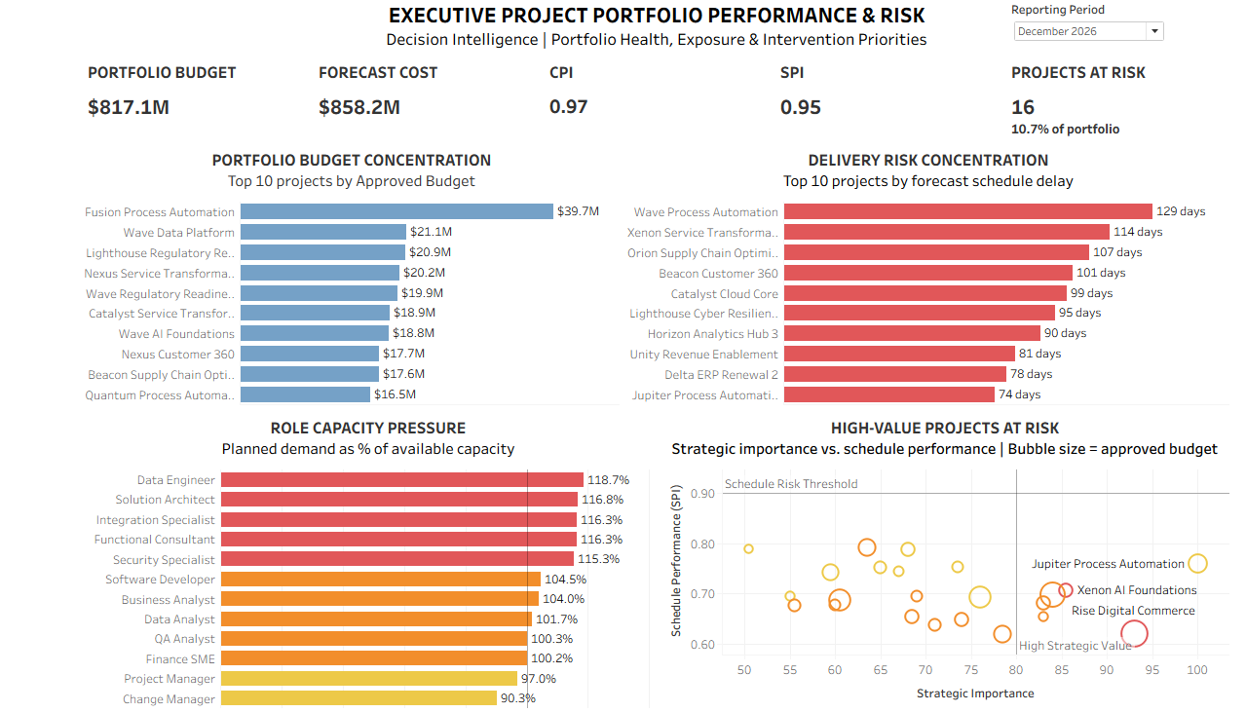
Figure 1. Certified December 2026 executive dashboard.

1. Dashboard Components
Component | Business purpose
Portfolio Budget | Quantify total approved investment exposure.
Forecast Cost | Show expected portfolio financial outcome.
CPI | Assess portfolio cost efficiency.
SPI | Assess portfolio schedule efficiency.
Projects at Risk | Quantify the At Risk/Critical project population.
Portfolio Budget Concentration | Identify the largest financial exposures.
Delivery Risk Concentration | Identify projects with the greatest forecast schedule delay.
Role Capacity Pressure | Identify constrained delivery capabilities.
High-Value Projects at Risk | Prioritize strategically important projects with schedule underperformance and material financial exposure.

2. Analytical Data Sources & Grain
Project Performance — one row per Project × Reporting Month. Drives KPI 01–05 and VIZ 01, VIZ 02, and VIZ 04.
Resource Capacity — one row per Resource Role × Reporting Month. Drives VIZ 03.
Modeling decision. The sources are not physically joined. Their grains are different, and a direct join without a valid project-role allocation key could create many-to-many duplication. A common reporting-period field synchronizes the dashboard while preserving each dataset's analytical grain.

3. Tableau Business Logic
Projects at Risk — Counts distinct projects whose overall health is At Risk or Critical.
COUNTD(
IF [Health Status] = "At Risk"
OR [Health Status] = "Critical"
THEN [Project Id]
END
)
Executive Zone Label — Labels projects in the defined executive-attention zone.
IF [Strategic Importance Score] >= 80
AND [Spi] < 0.90
THEN [Project Name]
END
Forecast Overrun — Optional supporting calculation for forecast-versus-approved-budget analysis.
SUM([Forecast Cost]) - SUM([Approved Budget])

4. Reporting-Period Filter Architecture
Visible control: Reporting Period (Single Value Dropdown).
Primary field: Period Start Date.
Scope: all worksheets using related data sources.
One visible control synchronizes Project Performance and Resource Capacity without physically joining the two datasets.
QA defect caught during testing: VIZ 03 initially retained an obsolete December-only local filter. When cross-data-source filtering was enabled, the two filters conflicted and blanked the resource-capacity view for other months. Removing the redundant local filter restored synchronized behavior.

5. December 2026 Regression Controls
Control | Certified value
Portfolio Budget | $817.1M
Forecast Cost | $858.2M
Average CPI | 0.97
Average SPI | 0.95
Projects At Risk | 16 (10.7% of portfolio)
Largest Budget Exposure | Fusion Process Automation — ~$39.7M
Largest Schedule Delay | Wave Process Automation — 129 days
Highest Role Utilization | Data Engineer — 118.7%
Executive Attention Zone | Rise Digital Commerce

6. QA Certification
Test | Validation | Result
QA-01 | Reporting-period synchronization | PASS
QA-02 | KPI reconciliation | PASS
QA-03 | Budget ranking | PASS
QA-04 | Delivery-risk ranking | PASS
QA-05 | Capacity integrity | PASS
QA-06 | Executive-priority logic | PASS
QA-07 | Interaction / edge-case stress test | PASS
Certification result: 7/7 tests passed.

7. Executive Findings
- Financial: forecast cost exceeds approved portfolio budget.
- Delivery: schedule performance is weaker than cost performance in the December 2026 snapshot.
- Risk: 16 of 150 projects are At Risk/Critical.
- Capacity: multiple specialized delivery roles operate above available capacity.
- Prioritization: Rise Digital Commerce occupies the defined high-strategic-value / low-SPI intervention zone and carries meaningful financial exposure.
- Interpretive boundary: portfolio-level capacity pressure coincides with concentrated delivery risk, but the current data grain does not establish project-level resource causality.

8. Design Decisions
- Fixed 1200 × 800 dashboard designed for practical laptop viewing.
- Five-card KPI strip plus four analytical views; no additional insight panel was added because available real estate was intentionally protected for readability.
- Color is semantic rather than decorative: neutral information, attention, and intervention states are visually distinguished.
- Dashboard 1 is frozen after QA certification; future changes should be regression-tested against the December 2026 controls above.

