PPM DECISION INTELLIGENCE

Dashboard 2 — Portfolio Risk & Intervention
Specification & QA Record
Decision Intelligence | Risk Severity, Concentration, Drivers & Intervention Priorities
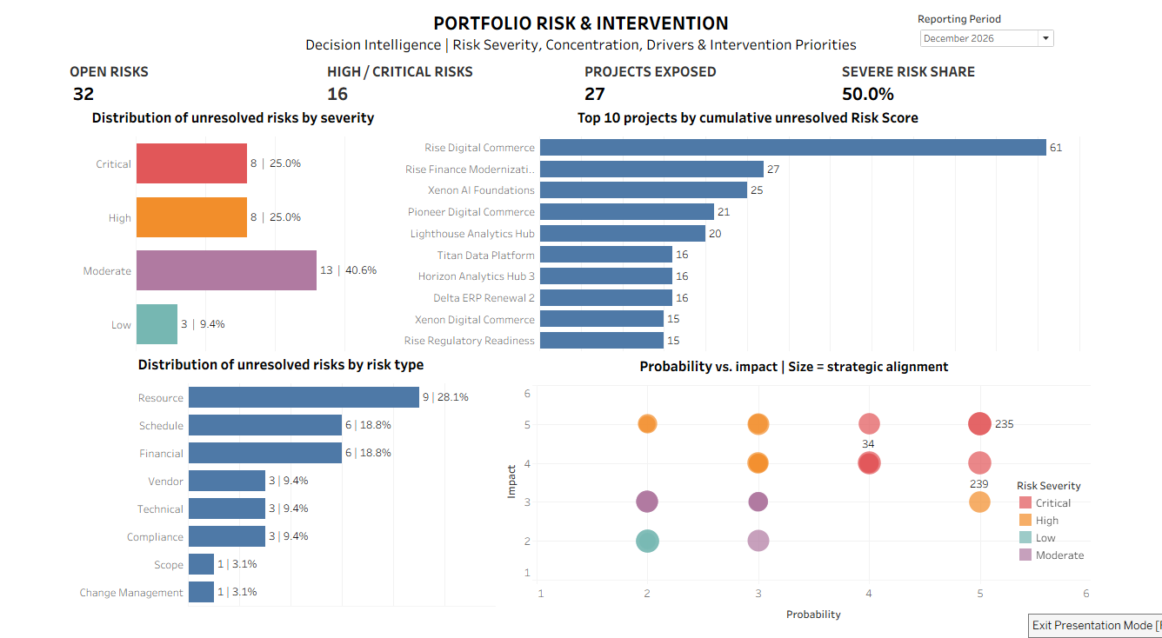
Certified reference state: Reporting Period = December 2026.

1. Purpose and Executive Decision
Dashboard 2 converts portfolio risk records into an executive intervention view. It answers: What unresolved risks exist, how severe are they, where are they concentrated, what types of risk are driving exposure, and which individual risks merit intervention?
Narrative flow: Scale → Severity → Concentration → Drivers → Intervention. The dashboard is intentionally complementary to Dashboard 1: Dashboard 1 identifies where leadership should pay attention; Dashboard 2 explains the risk exposure behind that attention.

2. Data Scope and Grain
Item | Specification
Primary source | tableau_risk_analysis.csv
Source grain | One row per individual risk item
Reporting coverage | January 2025 through December 2026
December 2026 source population | 44 risk items across 37 represented projects
Unresolved definition | Risk Status = Open or Mitigating; Closed is excluded
Unresolved December population | 32 risk items across 27 exposed projects
Core scoring model: Probability Score × Impact Score = Risk Score. Probability and Impact use a 1–5 scoring system. Risk Score is semi-quantitative and is not a monetary exposure measure.

3. Certified KPI Strip — December 2026
KPI | Certified Value | Business Meaning
Open Risks | 32 | Distinct unresolved risk items (Open + Mitigating).
High / Critical Risks | 16 | Distinct unresolved risks with High or Critical severity.
Projects Exposed | 27 | Distinct projects with at least one unresolved risk.
Severe Risk Share | 50.0% | High/Critical unresolved risks as a share of all unresolved risks.

4. Tableau KPI Logic
KPI 06 — Open Risks: COUNTD(IF [Risk Status] <> "Closed" THEN [Risk Id] END)
KPI 07 — High / Critical Risks: COUNTD(IF [Risk Status] <> "Closed" AND ([Risk Severity] = "High" OR [Risk Severity] = "Critical") THEN [Risk Id] END)
KPI 08 — Projects Exposed: COUNTD(IF [Risk Status] <> "Closed" THEN [Project Id] END)
KPI 09 — Severe Risk Share: COUNTD(IF [Risk Status] <> "Closed" AND ([Risk Severity] = "High" OR [Risk Severity] = "Critical") THEN [Risk Id] END) / COUNTD(IF [Risk Status] <> "Closed" THEN [Risk Id] END)

5. Visualization Specifications

VIZ 05 — Distribution of Unresolved Risks by Severity
Purpose: establish the severity profile of unresolved exposure. Horizontal bars use semantic severity colors and display both count and share. December 2026 controls: Critical 8 (25.0%), High 8 (25.0%), Moderate 13 (40.6%), Low 3 (9.4%). Counts reconcile to 32; Critical + High reconcile to 16 and 50.0%.
Share calculation: COUNTD([Risk Id]) / TOTAL(COUNTD([Risk Id]))

VIZ 06 — Top 10 Projects by Cumulative Unresolved Risk Score
Purpose: prioritize projects carrying the greatest cumulative unresolved risk burden. Bar length represents Open Risk Burden; color represents Max Open Risk Score. December 2026 leader: Rise Digital Commerce = 61, with 3 unresolved risks and a maximum individual Risk Score of 25.
Open Risk Burden: SUM(IF [Risk Status] <> "Closed" THEN [Risk Score] END)
Interpretive boundary: Open Risk Burden is a prioritization index created by summing semi-quantitative Risk Scores. It must not be described as monetary risk exposure.
Top-N implementation: Risk Status and Risk Analysis Period Start Date are context filters. Project Name is then filtered to Top 10 by SUM(Risk Score). Raw Risk Status/Severity must not be placed on Marks in a way that changes the view grain; the certified view is one bar per project.

VIZ 07 — Distribution of Unresolved Risks by Risk Type
Purpose: reveal the principal drivers of unresolved risk. December 2026: Resource 9 (28.1%), Schedule 6 (18.8%), Financial 6 (18.8%), Vendor 3 (9.4%), Technical 3 (9.4%), Compliance 3 (9.4%), Scope 1 (3.1%), Change Management 1 (3.1%). Counts reconcile to 32.

VIZ 08 — Priority Risk Intervention Matrix
Purpose: locate individual unresolved risks by Probability × Impact while preserving executive context. Risk Id is on Detail, producing one underlying mark per unresolved risk. Risk Severity controls color; Strategic Alignment Score controls bubble size. Risks with Risk Score ≥ 20 receive a visible Risk Id label.
Stack Marks is OFF. Turning stacking on numerically displaced marks and distorted the Impact axis. Exact Probability/Impact coordinates take precedence over visually separating overlapping risks. Overlaps remain discoverable through hover.
Axis treatment: the underlying scoring model remains 1–5. The displayed range includes boundary padding (the certified screenshot shows space through 6) so bubbles centered at score 5 are not clipped. This padding is a rendering choice, not an additional score value.

6. Reporting-Period and Filter Architecture
Dashboard 2 is governed exclusively by Risk Analysis. A single Reporting Period control, built from Risk Analysis → Period Start Date, applies to all Dashboard 2 worksheets using that data source. The certified architecture does not use Project Performance as a date source and does not rely on ‘All Using Related Data Sources’ for Dashboard 2.

7. Defect Record — Cross-Data-Source Filter Contamination
Stage | Record
Observed defect | After period switching and return to Dec 2026: 32 | 328 | 146 | 55.8% instead of 32 | 16 | 27 | 50.0%.
Root cause | A Project Performance Period Start Date filter had contaminated Risk Analysis worksheets.
Diagnostic evidence | Tableau warned that Project Performance fields could not be used because there was no relationship to the primary data source.
Repair | Removed foreign date filters; added Risk Analysis Period Start Date to every Dashboard 2 worksheet; rebuilt the dashboard control from Risk Analysis.
Regression control | Switch across multiple periods and return to Dec 2026; certified values must restore exactly.
Lesson | A visually similar date field is not sufficient. Data-source lineage must be verified explicitly in multi-source Tableau workbooks.

8. QA Certification Record
Test | Result | Acceptance Evidence
11.1 KPI Regression | PASS | Dec 2026 = 32 | 16 | 27 | 50.0%.
11.2 Severity Reconciliation | PASS | 8 + 8 + 13 + 3 = 32; severe = 16 = 50.0%.
11.3 Category Reconciliation | PASS | Category counts total 32; Resource = 9 / 32 = 28.1%.
11.4 Top-N Integrity | PASS | 10 project bars; Rise Digital Commerce = 61; one mark per project.
11.5 Intervention Matrix | PASS | 32 underlying unresolved-risk marks; 1–5 score geometry preserved; Stack Marks Off.
11.6 Period Stress Test | PASS | KPIs and VIZ 05–08 respond correctly across multiple reporting periods.
11.7 Return-to-December | PASS | Certified December state restores exactly after period switching.
11.8 Interaction Test | PASS | Selections/hover do not introduce unintended population changes.
11.9 Presentation Test | PASS | Full dashboard remains usable on 1200×800 laptop-first canvas without scrolling.

9. Design Decisions
The dashboard uses a fixed 1200 × 800 laptop-first canvas. Generic ‘VIZ’ headers were removed to reclaim vertical space; descriptive chart titles carry the semantic burden instead. No narrative insight box or additional KPIs/charts were added. The severity legend is kept compact within the matrix area.
The layout deliberately supports a left-to-right executive scan: severity profile and risk drivers explain the portfolio population, project burden identifies concentration, and the intervention matrix brings the reader down to individual risks requiring attention.

10. Executive Findings — Certified December 2026 View
- Half of unresolved portfolio risks are High or Critical (16 of 32).
- Resource risk is the largest unresolved category, representing 9 of 32 risks (28.1%).
- Rise Digital Commerce carries the highest cumulative unresolved Risk Score at 61 and includes an individual risk scored at 25.
- Twenty-seven projects are exposed to at least one unresolved risk, showing that risk is distributed broadly even though burden is concentrated in a smaller set of projects.

11. Interpretation and Governance Boundary
The dashboard supports prioritization and intervention; it does not prove causality. For example, resource capacity pressure elsewhere in the portfolio may corroborate Resource-category risks, but the dashboard does not establish that capacity pressure caused a specific risk. Professional judgment and underlying risk records remain necessary before management action.

12. Certification Status
STATUS: CERTIFIED AND FROZEN — 9/9 QA TESTS PASSED
Canonical screenshot: dashboard_02_portfolio_risk_intervention.png
Recommended repository locations:
• assets/dashboards/dashboard_02_portfolio_risk_intervention.png
• docs/dashboard-specs/dashboard_02_portfolio_risk_intervention_spec.docx

