PPM DECISION INTELLIGENCE

Dashboard 3 — Resource Capacity & Delivery Readiness
Specification & QA Record
Decision Intelligence | Demand, Capacity, Constraints & Delivery Pressure
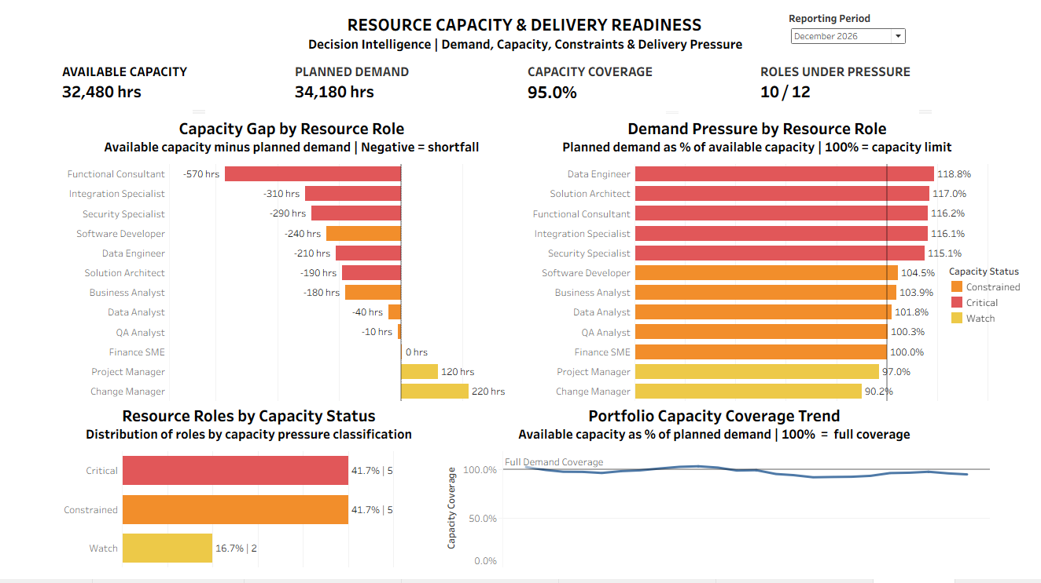
Certified reference state: Reporting Period = December 2026.

1. Purpose and Executive Decision
Dashboard 3 evaluates whether portfolio resource capacity is sufficient to support planned demand and identifies the roles creating the greatest delivery pressure. It answers four executive questions: Is planned demand within available capacity? How large is the shortfall? Which roles are most constrained? Is capacity pressure improving or deteriorating over time?
Narrative flow: Capacity → Shortfall → Intensity → Breadth → Trend.

2. Data Scope and Grain
Item | Specification
Primary source | tableau_resource_capacity.csv
Source grain | Resource Role × Reporting Month
Reporting coverage | January 2025 through December 2026 (24 months)
Roles per reporting month | 12
Project linkage | None in this extract; project-level resource exposure is therefore not inferred
Key measures | Available Capacity Hours, Planned Demand Hours, Actual Allocated Hours, Open Demand Hours, Capacity Status
The absence of Project ID/Project Name is an explicit analytical boundary: this dashboard identifies portfolio- and role-level capacity pressure, not which individual projects are caused or affected by it.

3. Certified KPI Strip — December 2026
KPI | Certified Value | Meaning
Available Capacity | 32,480 hrs | Total available resource capacity across the 12 roles.
Planned Demand | 34,180 hrs | Total planned resource demand across the 12 roles.
Capacity Coverage | 95.0% | Available capacity as a percentage of planned demand.
Roles Under Pressure | 10 / 12 | Roles classified Critical or Constrained by the governed source logic.
Portfolio capacity shortfall: 32,480 − 34,180 = −1,700 hours.

4. Tableau KPI Logic
KPI 10 — Available Capacity: SUM([Available Capacity Hours])
KPI 11 — Planned Demand: SUM([Planned Demand Hours])
KPI 12 — Capacity Coverage: SUM([Available Capacity Hours]) / SUM([Planned Demand Hours])
KPI 13 — Roles Under Pressure: COUNTD(IF [Capacity Pressure Flag] = 1 THEN [Role Name] END)
Total Resource Roles: COUNTD([Role Name])
Capacity Coverage is a ratio of totals, not an average of role-level percentages. It is also distinct from utilization: December planned demand exceeds capacity even though actual allocation need not equal planned demand.

5. Visualization Specifications

VIZ 09 — Capacity Gap by Resource Role
Purpose: show absolute capacity shortage or headroom by role. Capacity Gap = Available Capacity − Planned Demand; negative values indicate shortfall. December's five largest shortages are Functional Consultant −570 hrs, Integration Specialist −310 hrs, Security Specialist −290 hrs, Software Developer −240 hrs, and Data Engineer −210 hrs. All role gaps reconcile to the portfolio shortfall of −1,700 hrs.
Capacity Gap Hours: SUM([Available Capacity Hours]) - SUM([Planned Demand Hours])

VIZ 10 — Demand Pressure by Resource Role
Purpose: show proportional demand pressure relative to each role's available capacity. December leader: Data Engineer ≈118.8%, followed by Solution Architect ≈117.0%, Functional Consultant ≈116.2%, Integration Specialist ≈116.1%, and Security Specialist ≈115.1%. A 100% reference line marks nominal full capacity.
Demand to Capacity %: SUM([Planned Demand Hours]) / SUM([Available Capacity Hours])
VIZ 09 and VIZ 10 intentionally produce different rankings: absolute-hour shortage and proportional pressure answer different management questions.

VIZ 11 — Resource Roles by Capacity Status
Purpose: show how broadly capacity pressure is distributed. December 2026: Critical 5 (41.7%), Constrained 5 (41.7%), Watch 2 (16.7%), Healthy 0. Critical + Constrained = 10 of 12 roles (83.3%), reconciling directly to KPI 13. The dashboard consumes the governed Capacity Status classification rather than creating a competing threshold.

VIZ 12 — Portfolio Capacity Coverage Trend
Purpose: show direction of travel. Capacity Coverage declines from 102.5% in January 2025 to 95.0% in December 2026, a 7.5 percentage-point deterioration. Coverage remains below 100% continuously from December 2025 through December 2026 (13 consecutive reporting months).
Interpretation: planned demand exceeded available capacity throughout that 13-month period. The trend does not by itself prove that capacity pressure caused schedule delay or project failure.

6. Reporting-Period Parameter Architecture
QA exposed a temporal-design problem in the first dashboard assembly: the snapshot worksheets could show an earlier selected month while VIZ 12 continued through December 2026, effectively displaying 'future' periods relative to the selected reporting date. The architecture was replaced with a single Selected Reporting Period parameter.
Selected Period Only: [Period Start Date] = [Selected Reporting Period]
Show Through Selected Period: [Period Start Date] <= [Selected Reporting Period]
Target worksheets | Behavior
KPI 10–13 + VIZ 09–11 | Selected Period Only = True; show the chosen monthly snapshot.
VIZ 12 | Show Through Selected Period = True; show history from Jan 2025 through the chosen period.
This creates one user control with two intentional temporal behaviors: snapshot equality and historical upper-bound filtering.

7. Interaction Defect and Repair
Stage | Record
Observed defect | Selecting a point in VIZ 12 caused VIZ 09–11 to go blank until the point was clicked again.
Cause | VIZ 12 was acting as a dashboard filter / participating in an unintended filter action.
Repair | Disabled the unintended Use as Filter/filter-action behavior for VIZ 12.
Acceptance | Trend points may highlight when selected, but other executive views remain populated and unchanged.
Lesson | Mark selection and cross-filtering are different behaviors; dashboard actions must be intentional and QA-tested.

8. QA Certification Record
Test | Result | Acceptance evidence
15.1 KPI Regression | PASS | 32,480 hrs | 34,180 hrs | 95.0% | 10/12.
15.2 Absolute Gap Reconciliation | PASS | 12 roles; role gaps total −1,700 hrs; Functional Consultant = −570 hrs.
15.3 Relative Pressure | PASS | Data Engineer ≈118.8%; 100% threshold correctly positioned.
15.4 Status Reconciliation | PASS | 5 Critical + 5 Constrained + 2 Watch = 12; 10/12 under pressure.
15.5 Historical Integrity | PASS | 24-month history; 102.5% Jan 2025 → 95.0% Dec 2026; 13 months below 100%.
15.6 Period Stress Test | PASS | Snapshot views respond correctly across multiple periods.
15.7 Return-to-December | PASS | Certified December controls restore exactly.
15.8 Trend Architecture | PASS — repaired | Trend now ends at selected reporting period; no future-period ambiguity.
15.9 Interaction Test | PASS — repaired | Selecting VIZ 12 marks no longer blanks other visualizations.
15.10 Presentation Test | PASS | 1200×800 laptop-first view is readable without scrolling.

9. Executive Findings — December 2026
- Planned demand exceeds available capacity by 1,700 hours; portfolio Capacity Coverage is 95.0%.
- Capacity pressure is broad: 10 of 12 roles (83.3%) are Critical or Constrained.
- Functional Consultant has the largest absolute shortfall (−570 hrs), while Data Engineer has the highest proportional pressure (≈118.8%).
- Capacity Coverage deteriorated from 102.5% in January 2025 to 95.0% in December 2026 and remained below full coverage for 13 consecutive months from December 2025.

10. Design and Governance Decisions
The dashboard uses a fixed 1200 × 800 laptop-first canvas with four KPIs and four visualizations. Redundant Tableau field labels and development annotations were removed, one compact Capacity Status legend is retained, and the trend uses a 100% Full Demand Coverage reference line. No project-level resource claims are made because the source extract does not contain project linkage.

11. Certification Status
STATUS: CERTIFIED AND FROZEN — 10/10 QA TESTS PASSED
Canonical screenshot: dashboard_03_resource_capacity_delivery_readiness.png
Recommended repository locations:
• assets/dashboards/dashboard_03_resource_capacity_delivery_readiness.png
• docs/dashboard-specs/dashboard_03_resource_capacity_delivery_readiness_spec.docx

