Mini-Project: The bioinformatic detective

Sequence similarity search
The given amino acid sequence was used to perform a sequence similarity search by BLASTP on the swissprot database. The swissprot database was chosen as it has only verified sequences on it which means we are sure that the quality of the sequences is good.
Here are the top hits that were recorded afterwards.
protein/gene name | organism | % identity | E-value | query coverage
Sensor protein VanS | Enterococcus faecium | 100.00 | 0.0 | 100
Sensor protein VanSC | Enterococcus gallinarum | 39.61 | 1e-67 | 79
Sensor histidine protein kinase/phosphatase WalK | Streptococcus pneumoniae D39 | 32.77 | 5e-27 | 58
Sensor protein kinase WalK | Staphylococcus epidermidis RP62A | 28.51 | 9e-27 | 58
Sensor protein kinase WalK | Staphylococcus saprophyticus subsp. saprophyticus ATCC 15305 = NCTC 7292 | 28.51 | 1e-26 | 58
Alkaline phosphatase synthesis sensor protein PhoR | Bacillus subtilis subsp. subtilis str. 168 | 33.19 | 2e-26 | 59
Sensor protein kinase WalK | Staphylococcus aureus | 28.07 | 2e-26 | 58
Signal transduction histidine-protein kinase BaeS | Escherichia coli K-12 | 28.08 | 2e-26 | 66

The top hits do not come from the same organisms. The top hit (100% identity, E-value 0.0) is from Enterococcus faecium. The second hit is from Enterococcus gallinarum, which is also the only other Enterococcus species entry in the top hits. All remaining hits come from phylogenetically distinct organisms: Streptococcus, Staphylococcus (three different species), Bacillus, and E. coli.
It does not appear to be well conserved. The protein seems to be highly species-specific at the sequence level. There is a sharp drop from 100% (self-hit) to around 40% (closest relative) and then to 28–33% for all remaining hits. This indicates that VanS does not have close homologs even within Gram-positive bacteria.
VanS is a relatively isolated, recently acquired resistance protein that is highly conserved.

Gene and protein characterization

Gene
Full gene name: Vancomycin resistance histidine kinase VanS-M
Organism: Enterococcus faecium
Genomic location: locus E6A31_RS13940 on plasmid pSRR24
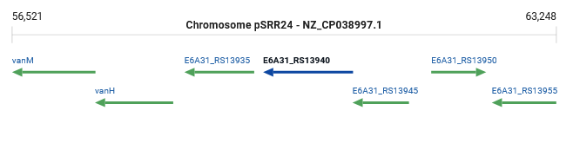
NZ_CP038997.1:59624-60736 (-)
Gene type: protein coding
Associated disease or biological relevance:

Protein
Name: Sensor protein VanS
Length: 384 amino acids
Mass: 43,916 Da
Localization: Membrane protein
Function:
- is the sensor component of a two-part regulatory system (VanS/VanR)
- detects vancomycin (and other glycopeptides) in the environment
- autophosphorylates a histidine residue on the glycopeptide
- transphosphorylates VanR which in turn activates it
- VanR, when activated, acts as a transcription factor to upregulate vanHAX, enabling resistance.
Functional domains: Histidine kinase (161-376 aa)

Literature search
On the PubMed database there are 24 published papers about the Vancomycin resistance histidine kinase VanS gene and protein.
The paper “The VanS sensor histidine kinase from type-B vancomycin-resistant enterococci recognizes vancomycin directly” published in the Journal of biological chemistry in 2025 was selected for this review as it shows the importance of studying VanS. This paper was written by Maciunas L. J., Rotsides P., D'Lauro E. J., Brady S., Beld J., and Loll P. J.

Clinical Urgency
Vancomycin-resistant enterococci are high-priority targets for new therapeutic development, and VRE are among the pathogens that are the leading causes of hospital-acquired infections for which few therapeutic options remain. VanS sits at the very top of the resistance signaling cascade, making it a critical target.

The Master Switch for Resistance
VanS is a transmembrane sensor histidine kinase that detects the antibiotic and transduces the signal to the VanR transcription factor, which then initiates transcription of the resistance genes. Without VanS functioning, the entire resistance machinery (VanHAX) remains silent. It is therefore the master switch of the resistance phenotype.

Resolving a Fundamental Question
The largest gap in understanding vancomycin resistance centered on how VanS recognizes vancomycin: whether directly via a physical interaction, or indirectly by sensing a downstream consequence of vancomycin's action. This paper provides the first definitive answer for a VanS protein from a human pathogen, demonstrating direct binding.

First Direct Binding Proof in a Human Pathogen
This represents the first time that a direct sensing mechanism has been confirmed for any VanS protein from a human pathogen. Previous work on type-A VRE and non-enterococcal organisms had been inconclusive, and the full-length type-B VanS protein had not been well characterized prior to this work.

Therapeutic Implications
The confirmation of direct binding between vancomycin and VanS rationalizes why type-B VRE are resistant only to vancomycin and not to related glycopeptide antibiotics that share vancomycin's mechanism of action but differ in structure. This opens the possibility of generating new antibiotics which would be vancomycin derivatives not recognized by VanS.

Homolog collection
For the homolog collection, the 8 proteins obtained by BLASTP were used. The labels present on the figures in the following section are shown as well.
Label | Protein | Organism
BAES_ECOLI | Sensor kinase BaeS | Escherichia coli
WALK_STRP2 | Sensor kinase WalK | Streptococcus pneumoniae
WALK_STAAU | Sensor kinase WalK | Staphylococcus aureus
WALK_STAEQ | Sensor kinase WalK | Staphylococcus epidermidis
WALK_STAS1 | Sensor kinase WalK | Staphylococcus sp.
VANS_ENTFC | Sensor kinase VanS | Enterococcus faecium
VANSC_ENTGA | Sensor kinase VanC | Enterococcus gallinarum
PHOR_BACSU | Sensor kinase PhoR | Bacillus subtilis

Multiple Sequence Alignment
To do the multiple sequence alignment on the homolog collection, the program MAFFT was used in the version (Galaxy Version 7.526+galaxy2). G-INS-1 was selected as the MAFFT flavor because it is progressive and creates a more accurate guide tree even though it is slower. However, since we are aligning less than 200 sequences, it does not present any problems.

Conserved regions
1. DHp Region— H-box (the phosphorylatable histidine)
This is the most functionally critical block and it is well conserved, being present in all 8 sequences. It is visible in the alignment around the segment: VANVSHELRTPLT / VANVSHELKTPIT (residues 432 to 443) which can be seen below.
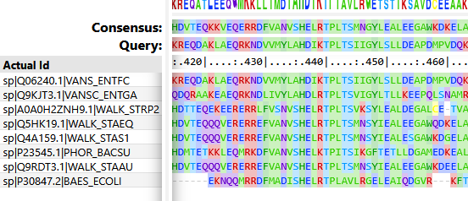
It is the primary autophosphorylation site: the H-box contains the conserved phosphoryl-accepting histidine residue in the DHp domain. The consensus motifs are H in xHELR or xHDxTP. The Histidine residue is located at position 436.
Another motif we see in this invariant sequence is the TPLT/TPIT segment that immediately follows the Histidine residue at 440–444. It is part of the conserved DHp helix that forms the dimerization interface.
2. HATPase_c Region — G1- and G2-boxes (ATP binding)
Toward the C-terminal region of the alignment, a highly conserved block is visible: GGTGLGLAI (...) K (...) I, pictured below. This region spans residues 605 to 630. This region is conserved well, which underscores its important catalytic role.
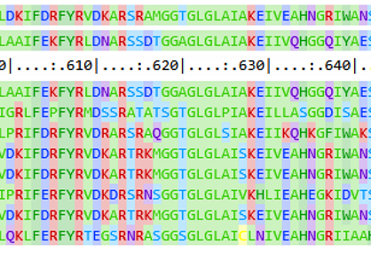
The CA subdomain includes four distinct sequence motifs: the N-, G1-, F-, and G2-boxes, which are involved in ATP binding.
The N-box serves as the Mg²⁺ coordination for catalysis.
The GLGL core (621–624) is the G1-box, critical for positioning the ATP γ-phosphate for transfer. The downstream conserved Lysine residue (K) contacts the ATP phosphate groups directly. It is found at position 628.
The F-box is FYR preceded by K, R or P, that is found around 10 aa upstream of the G1-box. It plays a role in conformational coupling. The FYR motif is found at positions 605–608.

Variable regions
1. N-terminal sensor / transmembrane domain
The first 200 aligned residues are very variable. The beginning of the alignment is dominated by gaps and divergent sequences.
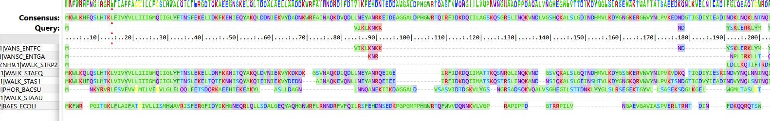
This is where the sensing domain and transmembrane helices reside:
- WALK_STAEQ and WALK_STAS1 have long N-terminal extracellular domains
- VANS_ENTFC and VANSC_ENTGA have short segments that are very divergent, reflecting their plasmid-encoded vancomycin-sensing role
- PHOR_BACSU and BAES_ECOLI have completely different N-terminal architectures

Phylogenetic tree
This phylogenetic tree was obtained by running FASTTREE with ML Model Jones-Taylor-Thorton, CAT approximation with 20 rate categories and using BLOSUM45 as the amino acid distance matrix.Additionally, Newick Display was used to output a PNG image of the tree and visualize branch length.
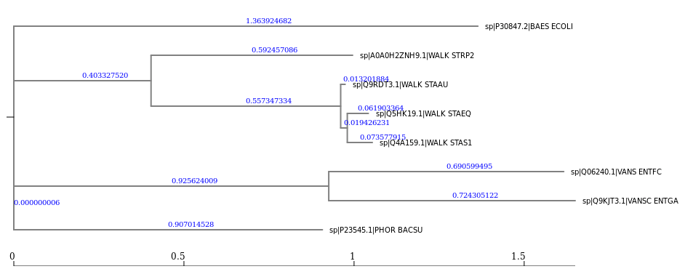

Clustering Patterns
Looking at the phylogenetic tree produced by FASTTREE, we can observe 2 clusters and some outliers which are separated from the other sequences by long branches.
Cluster 1 — WalK Staphylococci:
The three Staphylococcus WalK proteins (STAAU, STAEQ, STAS1) form a very tight cluster. They are separated by very short branch lengths (from 0.013 to 0.073). This indicates they are nearly identical. The S. pneumoniae WalK has a slightly longer distance from the others as we can see that it is more separated since it is on its own branch.
This observation is consistent with all these organisms being Firmicutes with conserved WalK cell-wall sensing functions.
Cluster 2 — VanS Enterococci:
The second cluster is made up of VANS_ENTFC and VANSC_ENTGA. They cluster together with branch lengths of 0.69 and 0.72 respectively. This also makes sense as both are vancomycin-resistance sensor kinases in Enterococcus species, and both organisms are Firmicutes within Enterococcaceae.
The outliers:
- BaeS (E. coli) sits on an extremely long branch of length 1.36. This reflects its evolutionary distance since it is a Gram-negative proteobacterium. Structurally it has a sensor kinase, but one that is very divergent in terms of sequence.
- PhoR (B. subtilis) also branches alone on a branch of length 0.907. This is consistent with it being a phosphate-sensing kinase rather than a cell-wall/vancomycin sensor. It is functionally distinct from the others.
We observe a surprising grouping as Bacillus and Enterococcus are both Firmicutes (Bacillota) and we might expect to see them cluster closer together than either does with the Staphylococcal/Streptococcal clade. The tree does not cleanly reflect the Firmicutes monophyly that exists in real life.

Taxonomy vs. Function
The clustering we observe on this tree is more consistent with protein function than with taxonomy:
- The WalK proteins cluster tightly regardless of whether the host is Streptococcus or Staphylococcus
- The VanS proteins cluster together by function (vancomycin sensing) and notably vanS in E. faecium is plasmid/transposon-encoded, suggesting this gene has spread by horizontal gene transfer rather than vertical descent.
- PhoR, though from a Firmicute (Bacillus), diverges because it serves a completely different sensing function (phosphate limitation instead of vancomycin). Therefore, its kinase domain evolved under different selective pressures and its sequence is different.

Galaxy workflow
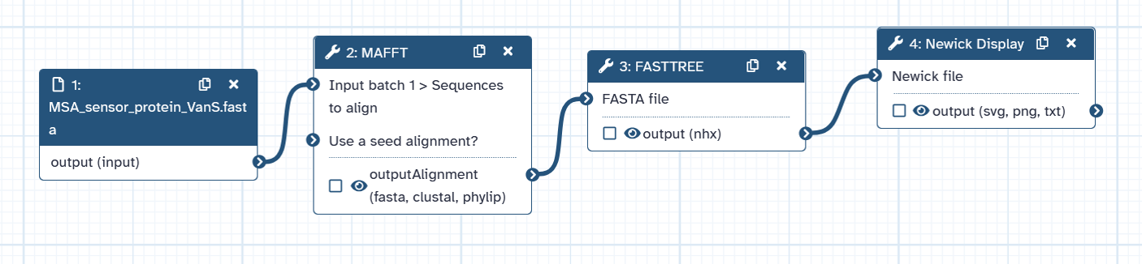
Step 1: import multiFASTA file to Galaxy
Step 2: run MAFFT with G-INS-1
Step 3: run FASTTREE with ML Model Jones-Taylor-Thorton, CAT approximation with 20 rate categories and amino acid distances by BLOSUM45
Step 4: run Newick Display to output PNG image of the tree and visualize branch length

Bibliography
Arthur, M et al. “The VanS sensor negatively controls VanR-mediated transcriptional activation of glycopeptide resistance genes of Tn1546 and related elements in the absence of induction.” Journal of bacteriology vol. 179,1 (1997): 97-106. doi:10.1128/jb.179.1.97-106.1997
Grasty, Kimberly C et al. “Structure of VanS from vancomycin-resistant enterococci: A sensor kinase with weak ATP binding.” The Journal of biological chemistry vol. 299,3 (2023): 103001. doi:10.1016/j.jbc.2023.103001
Maciunas, Lina J et al. “The VanS sensor histidine kinase from type-B vancomycin-resistant enterococci recognizes vancomycin directly.” The Journal of biological chemistry vol. 301,6 (2025): 110276. doi:10.1016/j.jbc.2025.110276
Papon, Nicolas, and Ann M Stock. “What do archaeal and eukaryotic histidine kinases sense?” F1000Research vol. 8 F1000 Faculty Rev-2145. 27 Dec. 2019, doi:10.12688/f1000research.20094.1
NCBI Genbank, “E6A31_RS13940 - vancomycin resistance histidine kinase VanS-M” https://www.ncbi.nlm.nih.gov/datasets/gene/66455786/
https://www.ncbi.nlm.nih.gov/protein/Q06240.1?report=genbank&log$=prottop&blast_rank=1&RID=3U46T4SC016

