חלופה מערכות הגנת סייבר במקצוע "תכנון ותכנות מערכות" - הערכה לעבודת גמר 5) יחידות לימוד( – תשפ"ו

33162937 | מספר ת.ז. | אוהד בכור | שם התלמיד
SkyVault |  |  | נושא העבודה
25.05.2026 | תאריך ההגשה | נטליה ששוב | שם המנחה

Revision History

Ed. Id | Date | Reason for Change
1 | 29/09/2025 | Baseline
2 | 20/11/2025 | Adding authentication system

Contents

Introduction
Cloud storage is one of most known ways to store your data without scarifying your device’s storage and a way to share files between people all around the world. Furthermore, the files in the Cloud are encrypted, so no one can access your personal data easily. This project is a secure cloud solution called “Sky Vault”. In this cloud service, you’ll able to store and menage your personal files with high security. This cloud service offers a variety of things you can do such as saving your files to your local machine, deleting them, uploading a new file and even creating a link to share the file from the web so people would access your desired file. There are few reasons why I chose to develop a cloud storage solution. In the first place, I have never built a cloud storage solution before. So, for me is a new and exciting way to way to know ho to deal with a new type of field in software engineering and in Computer Science. Moreover, my project may be challenging. I must mind a few things, for example, efficiency because python isn’t the most efficient programming language and sending big files might slow down the application and reduce the user experience. The user’s max storage should be considered as well. Since the server is built to run on one of the school’s desktops, I don’t have unlimited storage to store all the files of all the clients, so I’d have to limit the storage capacity to 1 GB to each client. This kind of project isn’t something new, a lot of people and companies are doing similar things for example the most known cloud storage services are “Google Drive” by Google and “OneDrive” by Microsoft. Both Microsoft and Google have a budget of billions of dollars, so they can maintain huge data centers all around the world and store trillions of data every day.

System Overview
The software would allow to a user/client to connect via the Ip address and PORT number to the server and mange its own files and will give the client the following abilities:
- Delete file – The client can select a file from the files table and press the “Delete File” and the server will get a “DELETE” request with the file’s id to delete the file.
- Upload File – Once the client pressed the Upload File” button, a Windows explorer tab will open to select a file of any type to upload (of course, if the client has enough storage to upload the selected file).
- Save File – The client has the option to save any file he wants. He can save the file by pressing “Save File”.
- Create share link – The client can also create a share link to his desired file. The server will create a share link using the API. In the link the user can download the file to his device even if he’s not connected to any user, Internet connection is enough.
- Web Application – All the features that are available in the Graphical User Interface, will have web version as well for making the product easier to access if people don’t want to install the software and access their files from their mobile device so it makes the final product Universal for any device.
System examinations are important as well. Of course, to maintain and test large amount of code, I should use the Debug tool in the IDE. This ensures that I know what happens in every line/block of code. But debug cannot do anything. So, I can use the software called “Wireshark” to know that the data transfers correctly across the network.
There’s no such a thing without risks. Sending data across the internet may be dangerous. so, using encryption before sending the data is very important. Also, when sending a file or data via socket the file size is unknown, this can be solved by sending the file size first, then the encrypted file itself.
But nothing will not work as expected if I don’t have good time management, I should strive to complete at least on part of the software once a week and spending one day a week to fix bugs.

software or hardware
Operating systems

End-user characteristics
….

General Constraints
- Hardware or software environment
- End-user environment
- Interface/protocol requirements
- Data repository and distribution requirements
- Security requirements (or other such regulations)
- Memory and other capacity limitations
- Performance requirements
- Network communications
- Verification and validation requirements (testing)

System Architecture - Functionality

Presentation layer
Business Layer Logic Layer
Communication Layer…
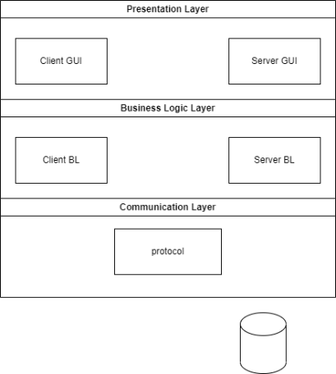

Subsystem Architecture

Use Case – 1st…
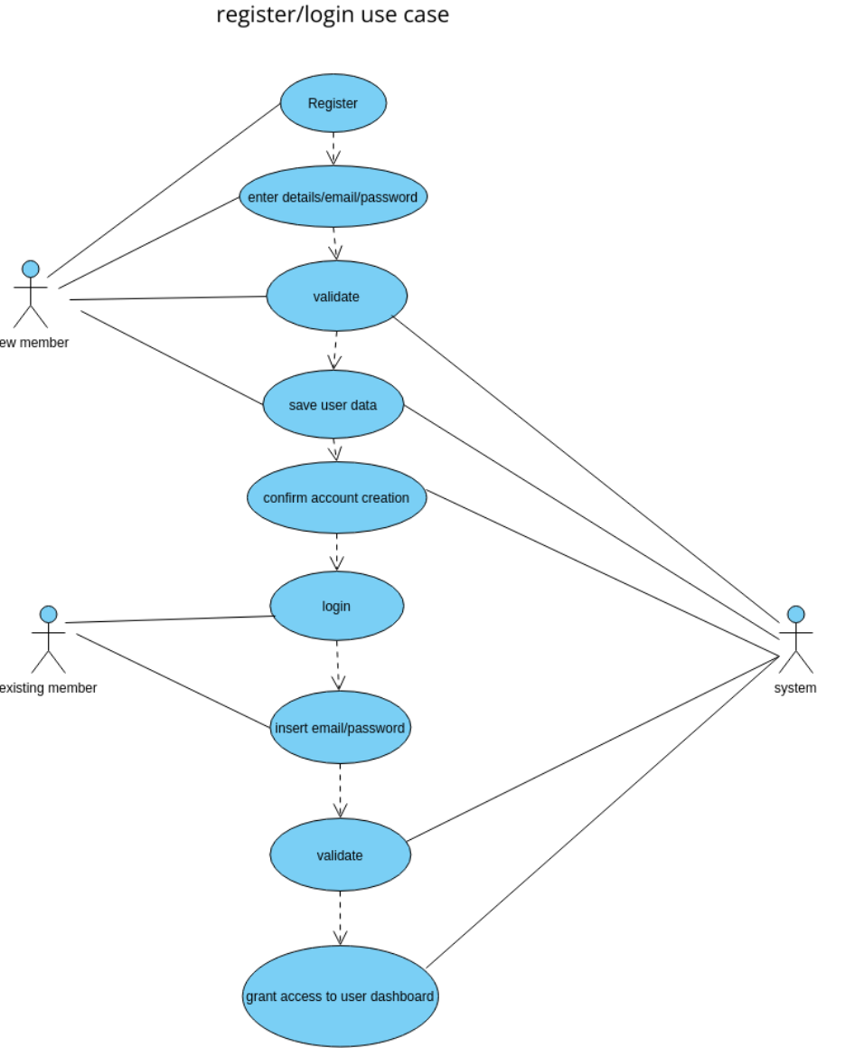

Use Case – 2nd….
…

Sequence diagram – 1st…

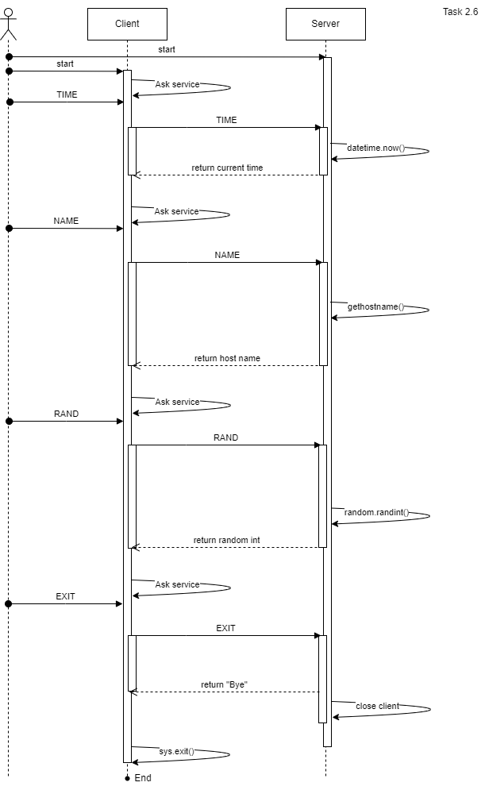

Sequence diagram – 2nd…
…

DB tables
…
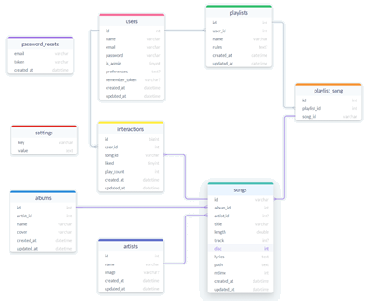

Protocol
This section explaining the protocol of the project. Meaning how client sending requests and receiving responses from the server. The structure of the requests is in Json format, the 8 firsts bytes containing the message length, and after the message itself. Also, the request contains: request type (in "cmd") and arguments. The response format its also in Json format. The first 8 bytes are the message length, and the message after them. The response returns two values; "status" containing a Boolean value representing if the client's request's handled correctly and also response message to display In the Client GUI. Here you can see examples for both requests & responses:
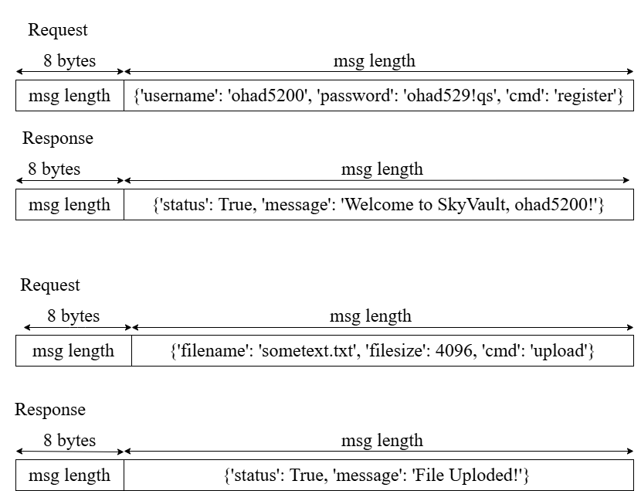

Encryption
…

Classes
…
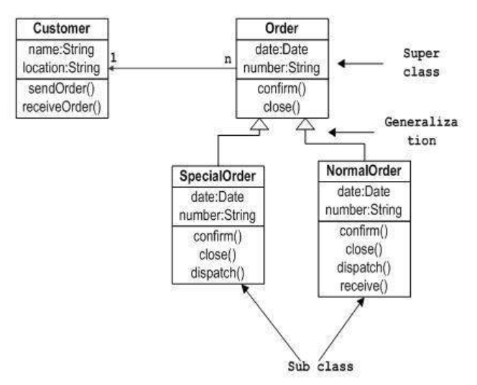…

System Architecture - Presentation Layer
…

Forms workflow
…
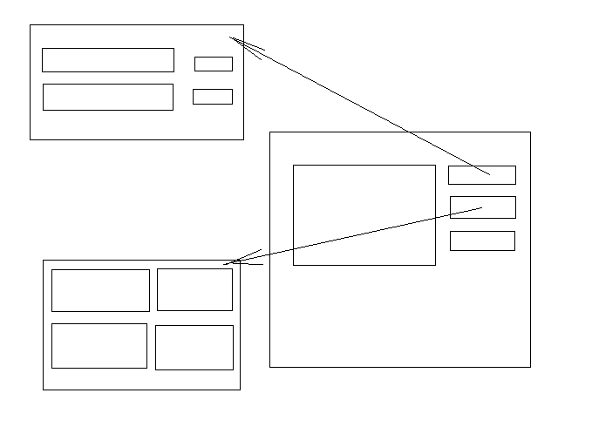…

Source Code
…

SW Test plan
…

Test scenarios
…

Test Results
…

Bibliography

