Terraform exercise



**GENERAL**in this exercise you will create AWS ngnix EC2 instance using terraform.  
  
Scripts content can be found in this URL:  
<https://github.com/eli2983/lectures/blob/master/Terraform_excersize>

**PREREQUISITED**

OS: Ubuntu

AWS Account

1. **Create Terraform files (inside a dedicated folder)**
   1. **Alter the terraform variable file (/home/ubuntu/terraform.tfvars)**

replace key_name with your own credentials:

…

***key_name="Student_name"***

* 1. **create terraform file (terraform.tf)**

***variable "aws_access_key" {}***

***variable "aws_secret_key" {}***

***variable "private_key_path" {}***

***variable "public_key_path" {}***

***variable "key_name" {}***

***provider "aws" {***

***access_key = "${var.aws_access_key}"***

***secret_key = "${var.aws_secret_key}"***

***region = "eu-central-1"***

***}***

***resource "aws_key_pair" "default_keypair" {***

***key_name = "${var.key_name}"***

***public_key = "${file(var.public_key_path)}"***

***}***

***resource "aws_instance" "nginx" {***

***ami= "ami-9a91b371"***

***instance_type = "t2.micro"***

***key_name ="${var.key_name}"***

***connection {***

***user = "ec2-user"***

***private_key = "${file(var.private_key_path)}"***

***}***

***provisioner "remote-exec" {***

***inline = [***

***"sudo yum install nginx -y",***

***"sudo service nginx start"***

***]***

***}***

***depends_on = ["aws_key_pair.default_keypair"]***

***}***

***output "aws_instance_public_dns" {***

***value = "${aws_instance.nginx.public_dns}"***

***}***

1. Run “terraform init”

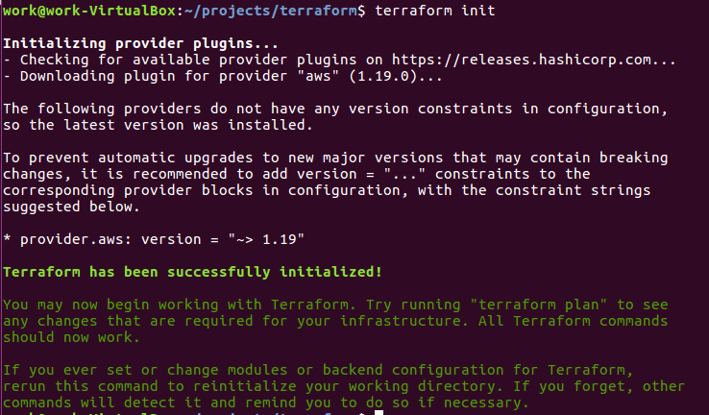

1. Run “terraform plan” command and check the output



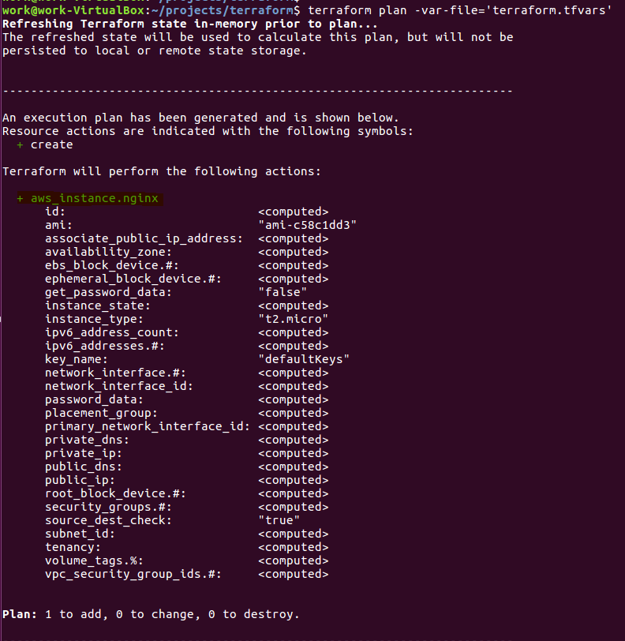

1. Run “terraform apply” command and wait for “Outputs”  
     
     
     
   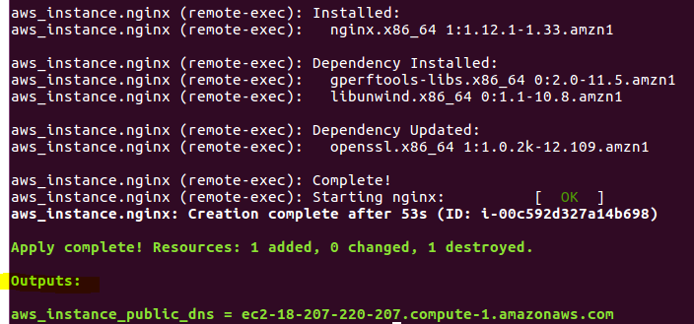
2. Browse to the new “ngnix” instance  
     
   