## Problem 3.47: Pre-emphasis or De- emphasis?

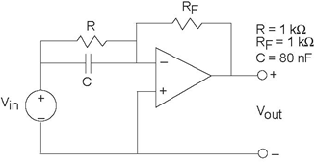

In audio applications, prior to analog-to-digital conversion signals are passed through what is known as a **pre-emphasis circuit** that leaves the low frequencies alone but provides increasing gain at increasingly higher frequencies beyond some frequency ***f***0. **De- emphasis circuits** do the opposite and are applied after digital-to- analog conversion. After pre-emphasis, digitization, conversion back to analog and de-emphasis, the signal's spectrum should be what it was.

The op-amp circuit here (Figure 3.88) has been designed for pre- emphasis or de-emphasis (Samantha can't recall which).

**Figure 3.88 Pre-emphasis or De-emphasis?**

1. Is this a pre-emphasis or de-emphasis circuit? Find the frequency f0 that defines the transition from low to high frequencies.
2. What is the circuit's output when the input voltage is **sin *(2πft)***, with ***f = 4kHz***?
3. What circuit could perform the opposite function to your answer for the first part?