## Problem 4.8: Spectra of Pulse Sequences

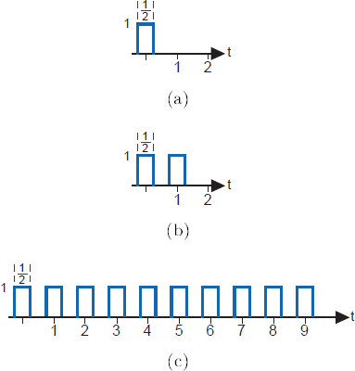

Pulse sequences occur often in digital communication and in other fields as well. What are their spectral properties?

* 1. Calculate the Fourier transform of the single pulse shown below (Figure 4.24(a)).
  2. Calculate the Fourier transform of the two-pulse sequence shown below (Figure 4.24(b)).
  3. Calculate the Fourier transform for the ten-pulse sequence shown in below (Figure 4.24(c)). You should look for a general expression that holds for sequences of any length.
  4. Using Matlab, plot the magnitudes of the three spectra. Describe how the spectra change as the number of repeated pulses increases.

**Figure 4.24 Spectra of Digital Communication Signals 1**

One way to represent bits with signals is shown in Figure 4.25. If the value of a bit is a "1", it is represented by a positive pulse of duration

***T***. If it is a "0", it is represented by a negative pulse of the same duration. To represent a sequence of bits, the appropriately chosen pulses are placed one after the other.