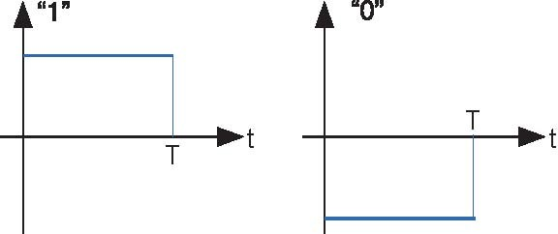

**Figure 4.25 Spectra of Digital Communication Signals 2**

1. What is the spectrum of the waveform that represents the alternating bit sequence "...01010101..."?
2. This signal's bandwidth is defined to be the frequency range over which 90% of the power is contained. What is this signal's bandwidth?
3. Suppose the bit sequence becomes "...00110011..." Now what is the bandwidth?



. Derive an expression for the filter's output to this pulse.

1. Noting that the square wave is a superposition of a sequence of these pulses, what is the filter's response to the square wave?
2. The nature of this response should change as the relation between the square wave's period and the filter's cutoff frequency change. How long must the period be so that the response does **not** achieve a relatively constant value between transitions in the square wave? What is the relation of the filter's cutoff frequency to

the square wave's spectrum in this case?

Let a square wave (period ***T*** ) serve as the input to a first-order lowpass system constructed as a RC filter. We want to derive an expression for the time-domain response of the filter to this input.

1. First, consider the response of the filter to a simple pulse, having unit amplitude and width

**Problem 4.10: Lowpass Filtering a Square Wave**

**Problem 4.11: Mathematics with Circuits**

Simple circuits can implement simple mathematical operations, such as integration and differentiation. We want to develop an active circuit (it contains an op-amp) having an output that is proportional to the integral of its input. For example, you could use an integrator in a car to determine distance traveled from the speedometer.

1. What is the transfer function of an integrator?
2. Find an op-amp circuit so that its voltage output is proportional to the integral of its input for all signals.