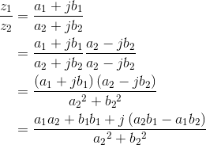

What is the product of a complex number and its conjugate? Division requires mathematical manipulation. We convert the division problem into a multiplication problem by multiplying both the numerator and denominator by the conjugate of the denominator.

**Exercise 2.1.3**

Because the fnal result is so complicated, it's best to remember **how** to perform division multiplying numerator and denominator by the complex conjugate of the denominator than trying to remember the fnal result.

The properties of the exponential make calculating the product and ratio of two complex numbers much simpler when the numbers are expressed in polar form.



To multiply, the radius equals the product of the radii and the angle the sum of the angles. To divide, the radius equals the ratio of the radii and the angle the diference of the angles. When the original complex numbers are in Cartesian form, it's usually worth translating into polar form, then performing the multiplication or division (especially in the case of the latter). Addition and subtraction of polar forms amounts to converting to Cartesian form, performing the arithmetic operation, and converting back to polar form.