this notation for a complex number represents vector addition, but it provides a convenient notation when we perform arithmetic manipulations.

Some obvious terminology. The **real part** of the complex number *z = a + jb*, written as Re (*z*), equals a. We consider the **real part** as a function that works by selecting that component of a complex number not multiplied by *j.* The **imaginary part** of *z*, **Im** (*z*), equals b: that part of a complex number that is multiplied by *j*. Again, both the real and imaginary parts of a complex number are real-valued.

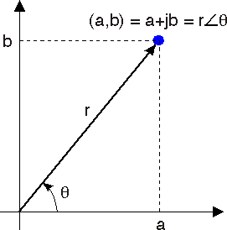

**Figure 2.1 The Complex Plane** A complex number is an ordered pair (a,b) that can be regarded as coordinates in the plane. Complex numbers can also be expressed in polar coordinates as r∠θ.

The **complex conjugate** of z, written as z *, has the same real part as z but an imaginary part of the opposite sign.



Using Cartesian notation, the following properties easily follow.

* If we add two complex numbers, the real part of the result equals the sum of the real parts and the imaginary part equals the sum of the imaginary parts. This property follows from the laws of vector addition.



In this way, the real and imaginary parts remain separate.

* The product of *j* and a real number is an imaginary number: *ja*. The product of *j*

and an imaginary number is a real number: *j (jb)= −b* because *j2 = −1*.