## Problem 3.26: More Circuit Detective Work

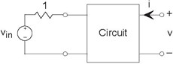

The left terminal pair of a two terminal-pair circuit is attached to a testing circuit. The test source vin (t) equals sin (t) (Figure 3.69).

**Figure 3.69 More Circuit Detective Work**

We make the following measurements.

* With nothing attached to the terminals on the right, the voltage v

(t) equals

.

* When a wire is placed across the terminals on the right, the current ***i***(***t***) was **−(sin**(***t***)**)**.

1. What is the impedance "seen" from the terminals on the right?
2. Find the voltage v (t) if a current source is attached to the terminals on the right so that i(t) = sin(t).