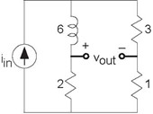

**Figure 3.76 An Interesting Circuit**

1. For the circuit shown in Figure 3.76, find the transfer function.
2. What is the output voltage when the input has the form ***i*in** = **5sin (2000π*t*)**?

**Problem3.34: An Interesting Circuit**

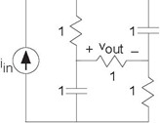

**Figure 3.77 A Simple Circuit**

1. What is the transfer function between the source and the output voltage?
2. What will the voltage be when the source equals sin (t)?
3. Many function generators produce a constant offset in addition to

a sinusoid. If the source equals **1 + sin(*t*)**, what is the output voltage?

You are given the depicted circuit (Figure 3.77).

**Problem 3.35: A Simple Circuit**