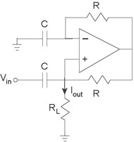

**Figure 3.84 Op-Amp Circuit**

1. What is the transfer function relating the complex amplitude of the output signal, the current ***I*out**, to the complex amplitude of the input, the voltage ***V***in?
2. What equivalent circuit does the load resistor **RL** see?
3. Find the output current when

.

The following circuit (Figure 3.84) is claimed to serve a useful

purpose.

**Problem 3.43: Op-Amp Circuit**