## Problem 3.50: Optical Receivers

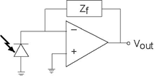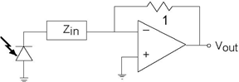

In your optical telephone, the receiver circuit had the form shown (Figure 3.91).

**Figure 3.91 Optical Receivers**

This circuit served as a transducer, converting light energy into a voltage ***v***out. The photodiode acts as a current source, producing a current proportional to the light intensity falling upon it. As is often the case in this crucial stage, the signals are small and noise can be a problem. Thus, the op-amp stage serves to boost the signal and to filter out-of-band noise.

1. Find the transfer function relating light intensity to vout.
2. What should the circuit realizing the feedback impedance ***Zf*** be so that the transducer acts as a 5 kHz lowpass filter?
3. A clever engineer suggests an alternative circuit (Figure 3.92) to accomplish the same task. Determine whether the idea works or not. If it does, find the impedance ***Zin*** that accomplishes the lowpass filtering task. If not, show why it does not work.

**Figure 3.92 an alternative circuit**