Baklay Cebu: Online Hiking & Trekking Bookings
(Manual Instructions)

MILDRED CORNELIO

BSIT - 1B

Introduction
A Baklay Cebu: Online Hiking & Trekking Booking is a computer program intended to simplify and automate the outdoor adventure booking and management process. It enables customers to view available treks, book reservations, and track their itinerary status, while allowing guides to monitor assigned bookings and update trek status, and enabling administrators to track guide availability, manage trek schedules, and process account approvals effectively.
Benefactors:
- Admin/Manager:
- Benefit from a user-friendly online trek scheduling and approval system, reducing manual data entry and enhancing overall guide and trek management efficiency.
2. Trail Guides :
- Gain quick access to assigned customer information and trek availability/status, allowing for better service preparation and efficient group management on the trail.
- Experience reduced administrative burdens related to manually checking trek rosters or updating trip statuses, enabling them to focus more on customer safety and support.
3. Customers :
- Benefit from streamlined trek booking, payment tracking, and status updates, leading to improved communication and a reliable pre-trip experience.
- Have access to valuable trek details, guide assignments, and personal booking history, enabling informed decision-making when selecting an adventure and better personal planning.

A. ERD (Entity Relationship Diagram)
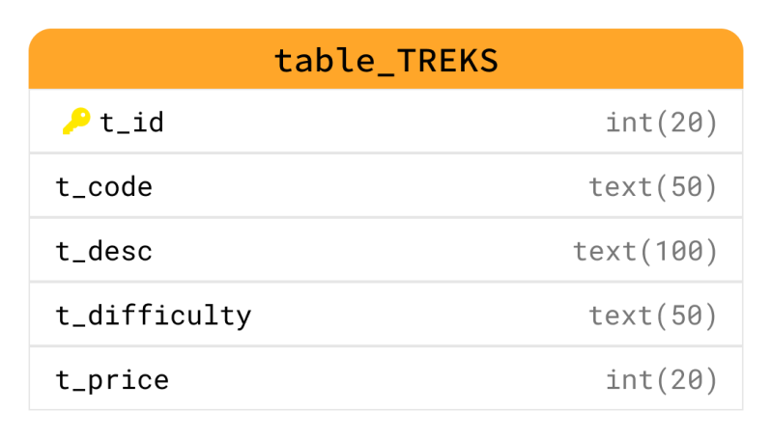
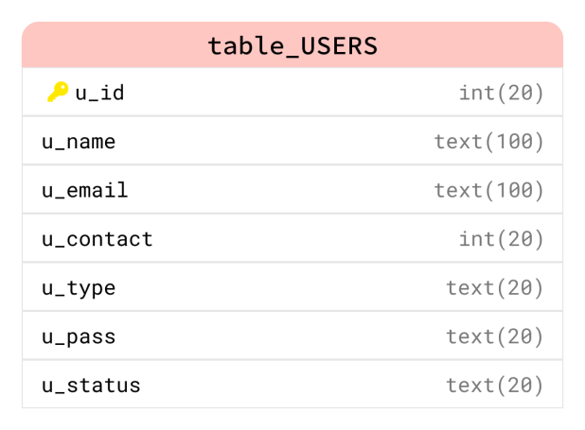

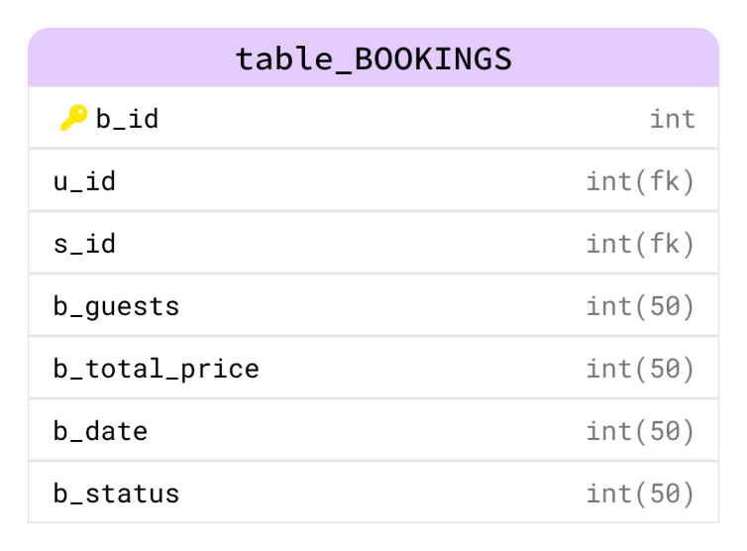

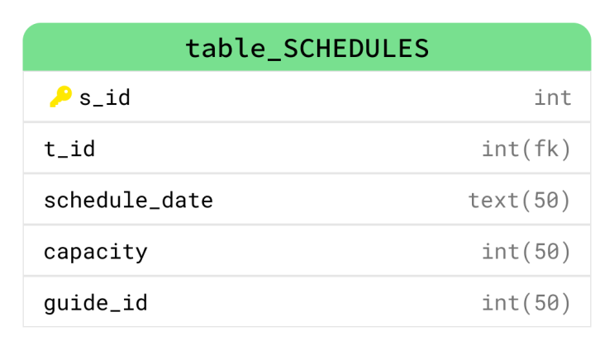

B. Data Dictionary

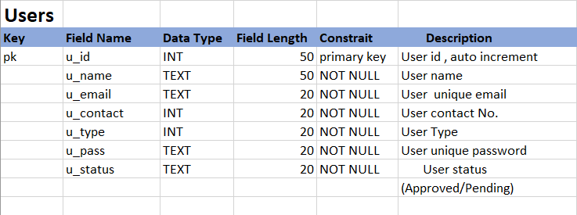

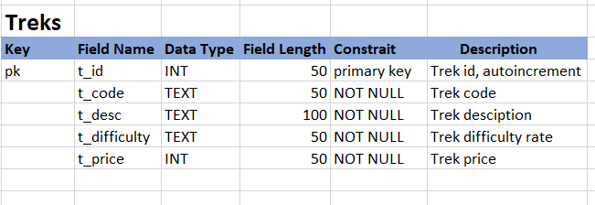

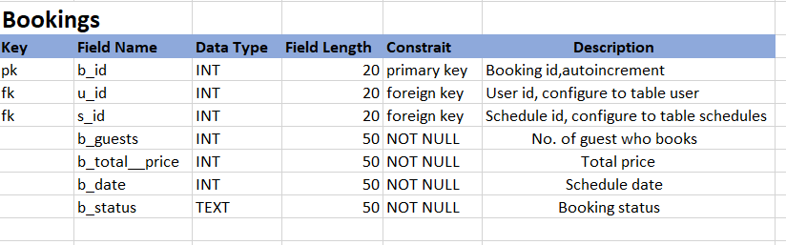

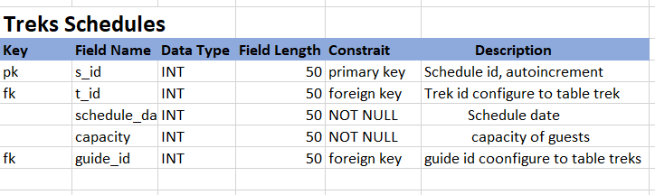

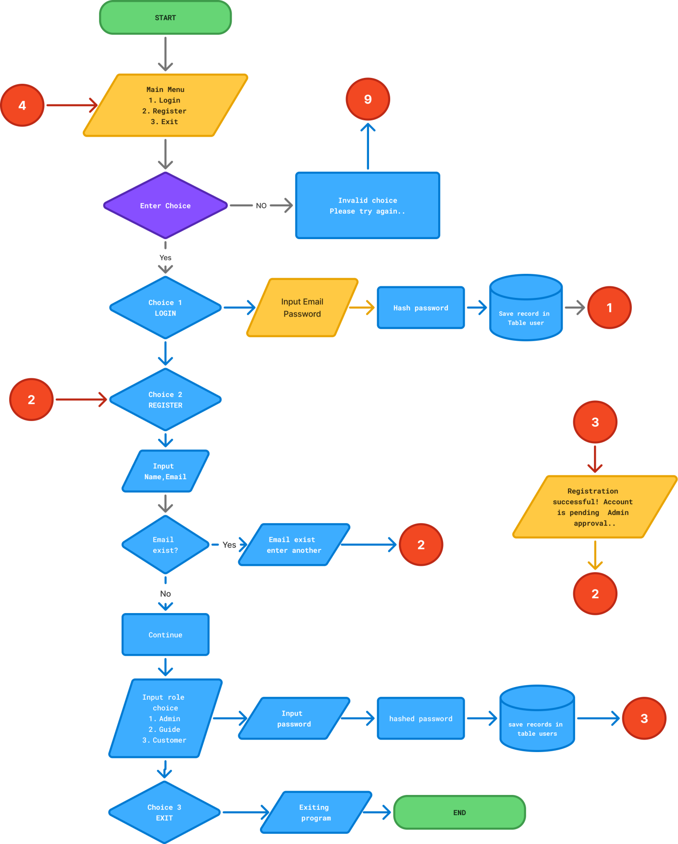
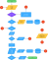

C. FLOWCHART
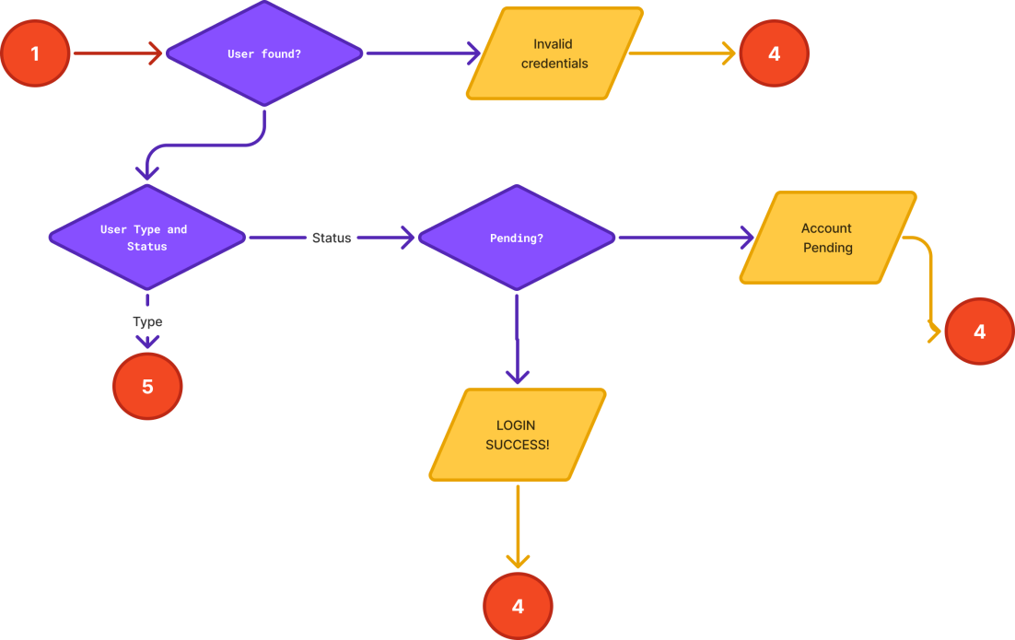

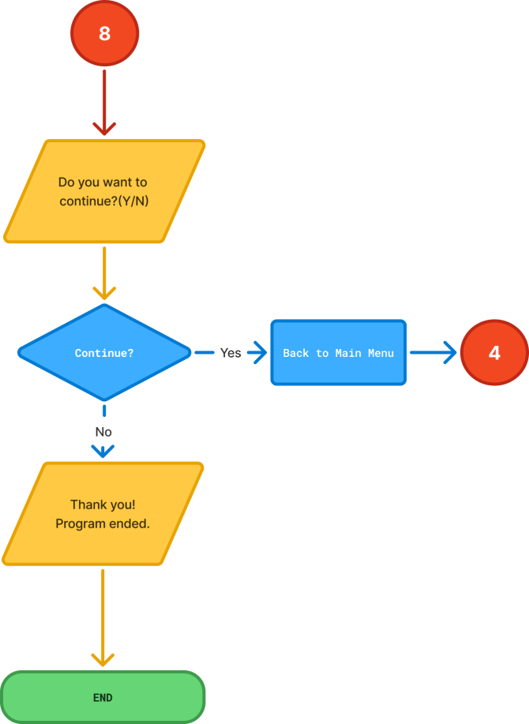

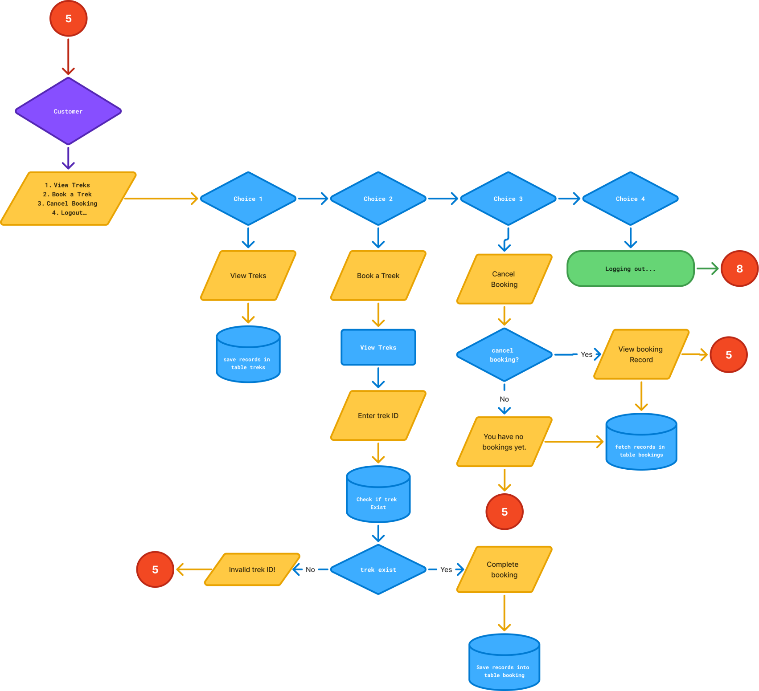

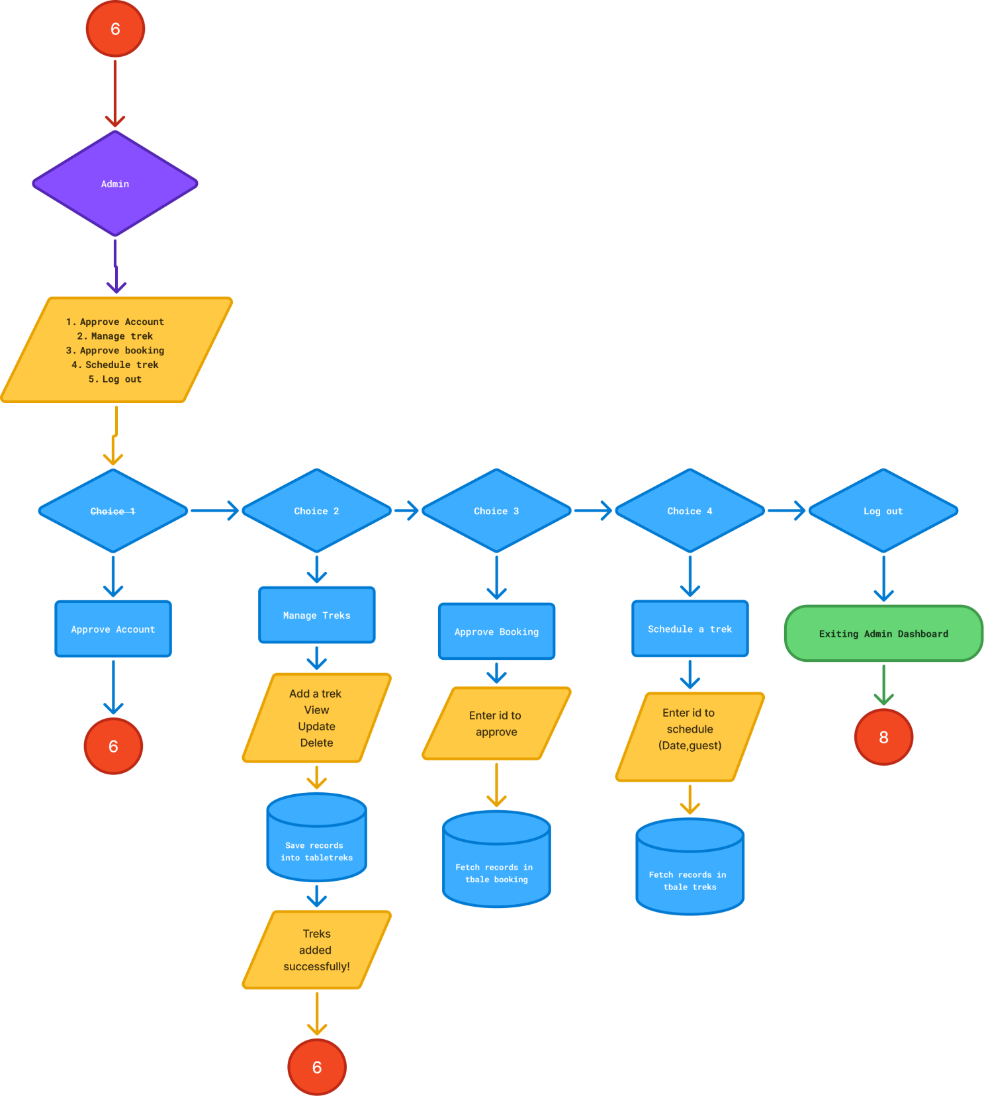

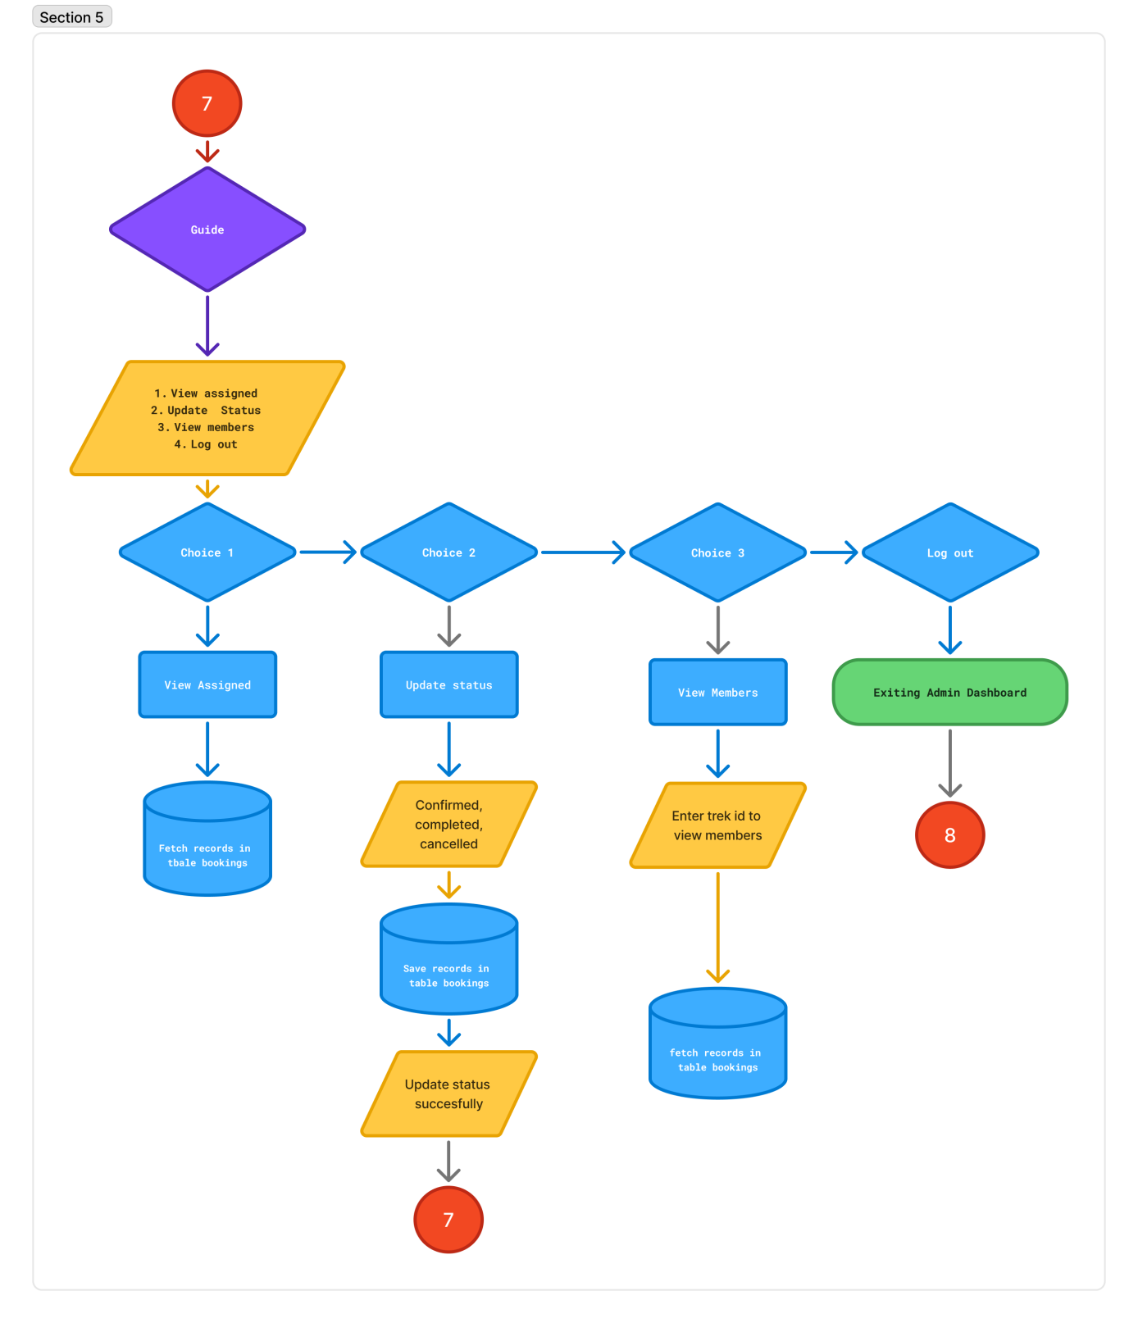

D. User Manual

How to Use the Program
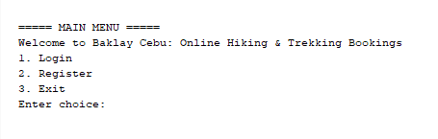

A. MAIN MENU
Upon running the program, you will be presented with the main menu, which offers
several options:

Select an option by entering the corresponding number.
* the system will notify the user if the entered number exceeds the maximum capacity. (LIMIT 3 )

Main Menu Options Summary
- LOG IN – Log in existing account.
- REGISTER – Register account wait for approval of the admin (Approved/Pending).
- EXIT - Exit the program.

1. Log in
* when you log in the system will notify if the account exist then it directly log in according to type (Admin, Guide, Customer) you registered.
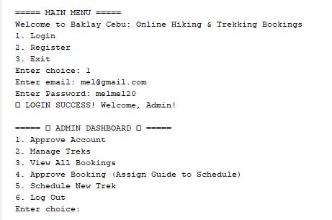
To register a new Account:
- Select option 2 from the main menu.
- Enter user name, contact, email, type and password.
* the system will record your registration and its status is pending await the admin to approved it .
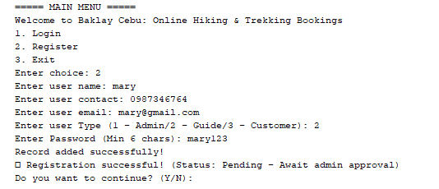

- For each user, you will be prompted to enter the following information:
    - User Name
    - User Contact(must be digits)
    - User Email ("your name@gmail.com) follow this pattern
    - User type (must be digit between 1 - 3)
    - User password(min of 6 char)
* the system will notify the user if the entered correct format if not it will not proceed
- After entering the details, it successfully recorded and wait the admin to approved it.
- If your account is already approved you can now log in according what type are you either (Admin , Guide , or Customer).
- The system will ask “Do you want to continue? (y/n): ”for the user to proceed to the next feature.

2. Login in Admin DashBoard
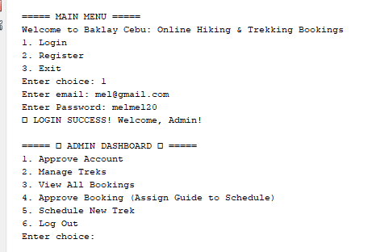

* the system will show you the 5 options

To Approved Account:
- Select option 1 from the admin dashboard.
- The program will display a list of all registered patients, showing their ID, Name, Contact , Email , Type , and password.
- The system will display “Enter ID to Approved? (y/n): and the account is now fully registered the user can already log in.
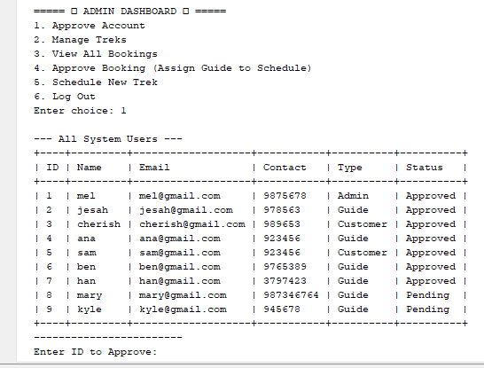

To Manage Treks :

- Select option 2 from the admin dashboard.
- Enter Trek code, description, difficulty and price and it directly recorded.

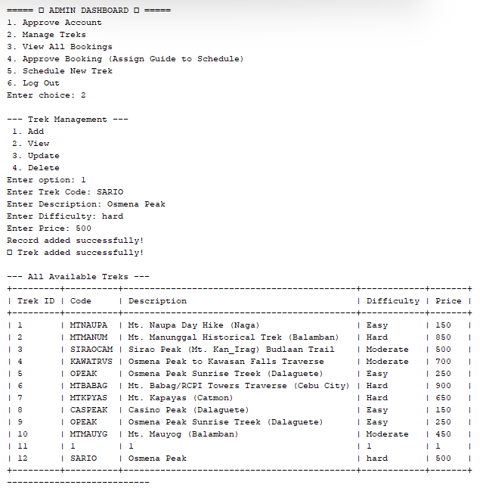

View All Bookings

- Select option 3 from the admin dashboard.
* the system will view the list of all bookings

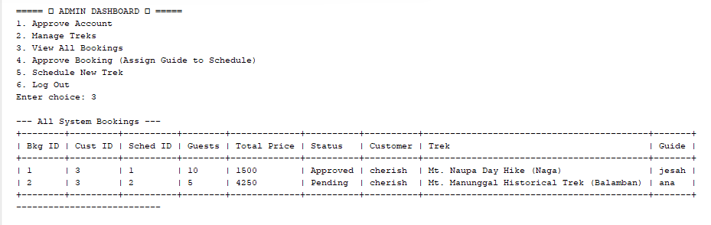
Approved Booking( Assign Guide to Schedule)
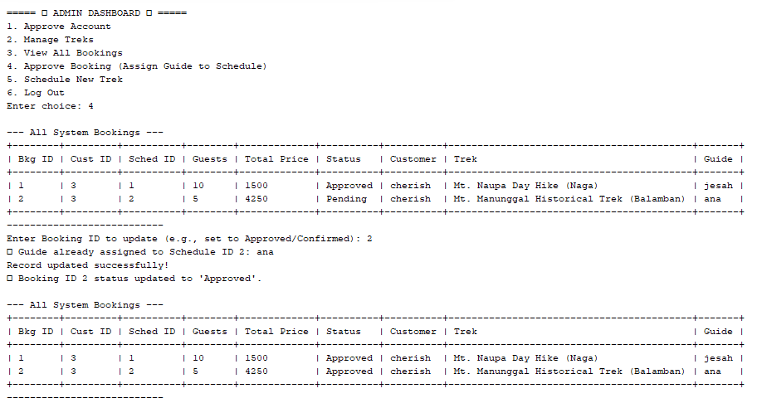

- Select option 4 from the main menu.
- Enter booking ID to approved.
  - the system will directly approved it when the admin enterthe booking id and its already recorded.

Schedule a New Trek :

a. Select option 5 from the admin dashboard.
b. Enter option 1 to add new schedule
  - the system will ask you to enter different details to add a new schedule.
c. Enter id trek schedule, hike date , and capacity o f guests.
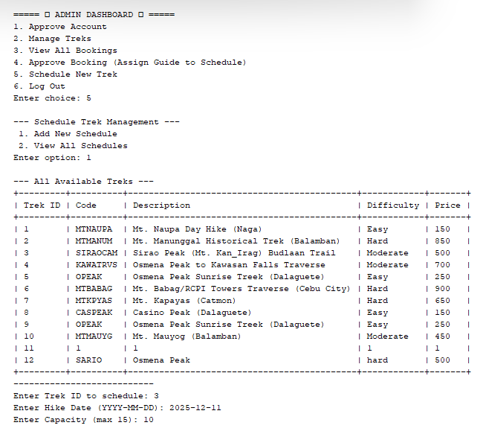

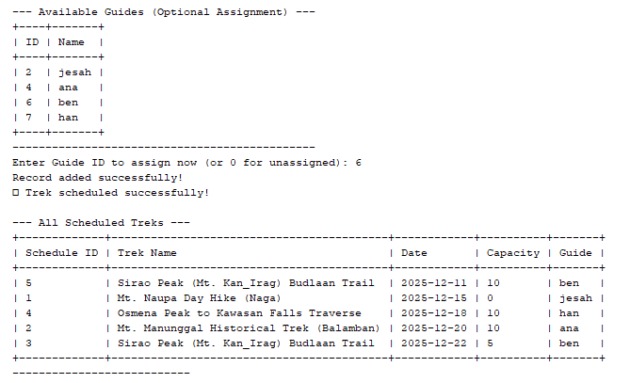
*the system admin will assign the guide in that trek by entering guide id.
d. It recorded successfully

Log out
* the system will notify log out and back to main menu
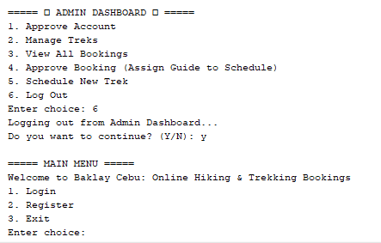

3 . Login in Guide DashBoard

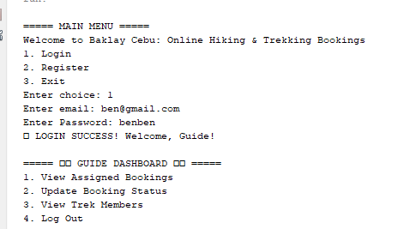

- Select option 1 from the guide dashboard.
- The guide will view their assigned bookings.

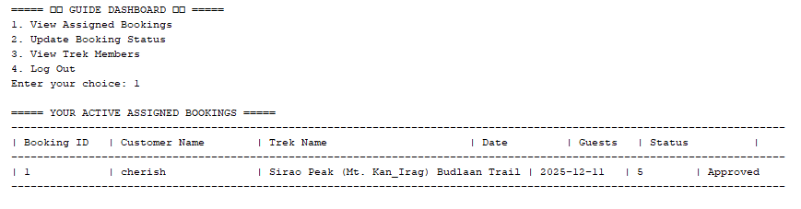

To update booking status :
- Select option 2 from the guide dashboard.
- The user will enter the booking ID to update and prompt either (confirmed, complete or cancelled).
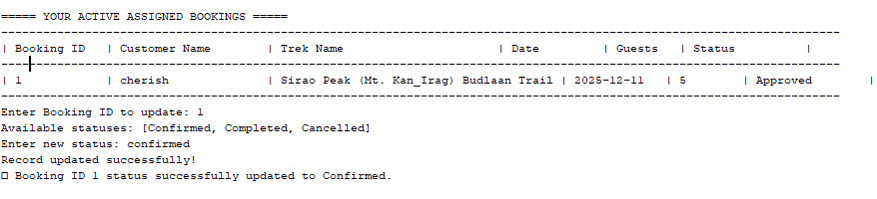
* the system will update your assigned bookings

- The system will ask “Do you want to continue? (y/n): ”for the user to proceed to the next feature.
- Select option 4 to log out and it will back to main menu.
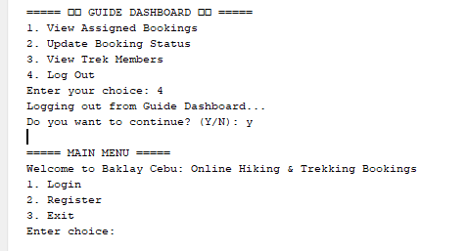

4. Login in Customer Dashboard
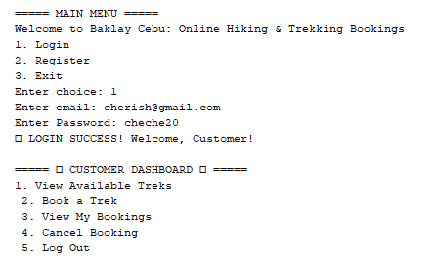

View Available Treks :
- Select option 1 from the Customer dashboard.
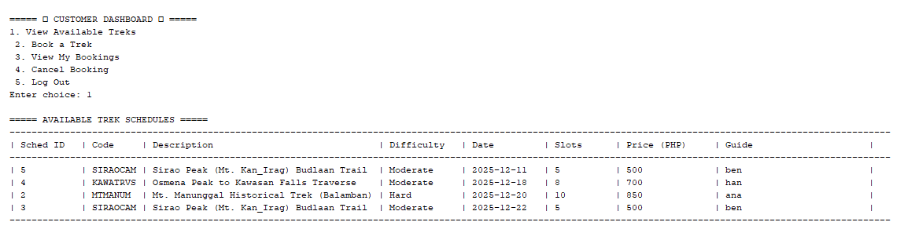
* the system will view the available treks to books.
Book a Trek :
- Select option 2 from the customer dashboard.
b. The customer will enter ID and number of guests
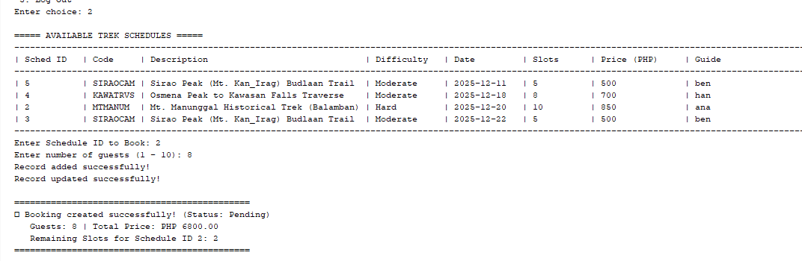
*the system will record the details into table bookings.
View my Bookings:
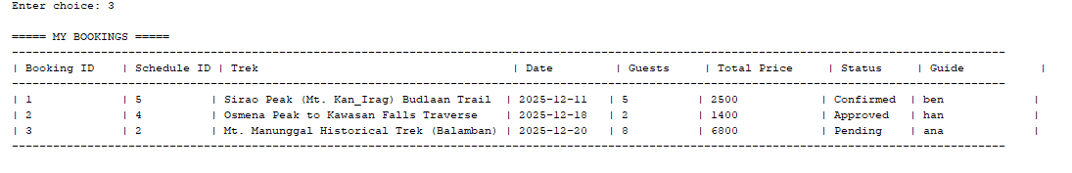
c. Select option 3 in the Customer dashboard.

Cancel a Booking :
- Select option 4 from the customer dashboard.
- The user will enter booking ID to cancel booking.
* the system will directly change in cancelled booking.
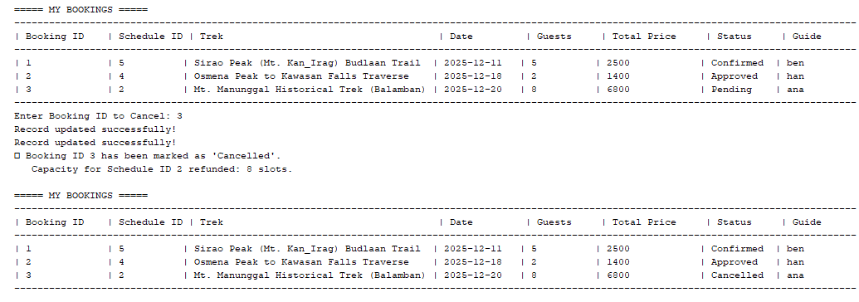
c. The system will ask “Do you want to continue? (y/n): ”for the user to proceed to the next feature.
Log out in customer dashboard
- Select option 5 from the customer dashboard.
* the system will log out in customer dashboard and back to main menu.
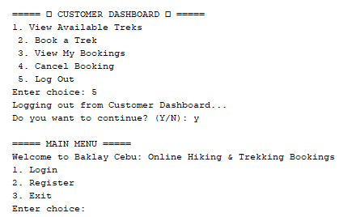

The program will ended.

