**Introduction**

Foal Naming Contest

**Introduction**

We thought we would introduce subjects of interest in the Equine world. To begin, especially since we are having a “Foal Naming Contest,” you might like to know the thinking behind how to achieve a certain breed.

**How To Achieve A Certain Breed**

When people want to create a breed of horse for a certain purpose, either for an activity or to have a particular appearance, they basically mate together mares and stallions, which possess at least some of the characteristics they want.

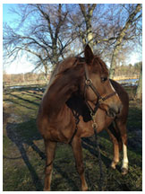Sometimes, an animal is strongly dominant in breeding, i.e. it passes on to its offspring most of its own characteristics, good and bad. Such animals are good for breeding as they reliably produce offspring like themselves. Dominant (called “prepotent”) animals can be mares or stallions, but dominant stallions have more influence on a breed.

The modern competition warmblood was created initially by continental European nations to have “elastic,” scopy gaits and a powerful jump–– their aim was to produce world-class dressage and show (stadium) jumping horses.

But, this was not the case with Fyra.

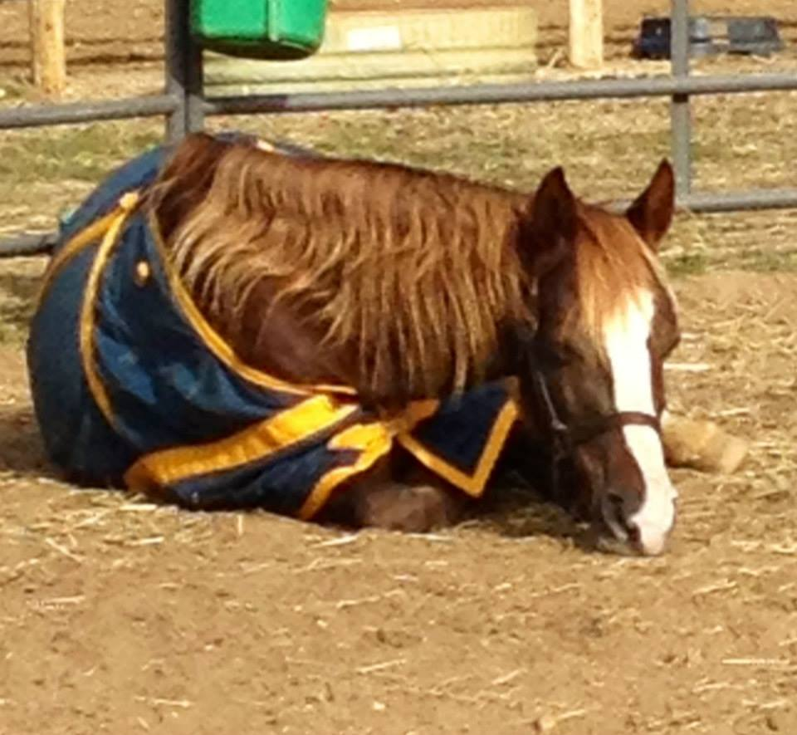Fyra was rescued on October 23, 2013. At the time, we knew that she was pregnant, but we didn’t know how far along she was. A horse is pregnant for approximately eleven months. The story goes, so we’ve been told, like this: Fyra the proud mom-to-be, was in the paddock when the stallion jumped the fence, and the rest is history! We know the foal has good lineage and we just want it to be born healthy! Now, as we wait for this foul to be born, our thoughts turn to a name.

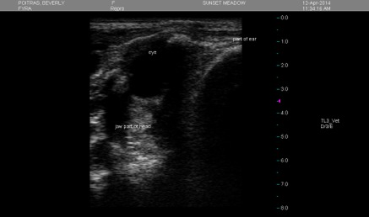Fyra means, “fire blaze” in Danish, because she looks like fire. Her show name is Van de Fyra, which means “of the fire blaze.”

Fyra went to the birthing farm on April 11, 2014. On April 12, Dr. Denise Newsome, the veterinarian, came to give Fyra an ultra-sound. It was so exciting to see the foal. Dr. Denise told us that the foal will have Fyra’s height and other characteristics, which we were so pleased to hear, but she is not due until the end of May or early June. And now we anxiously await the birth of the foal! We hope to have video to share with you leading up to the big event!

**Foal Naming Contest**

What’s in a name? Everything. So enter as many times as you like, but think about the name. Enter for a boy, and/or a girl; please be creative, and unique. Will it stand out in the show arena, and in everyday interaction?

Because we are a certified 501(c)(3) non-profit, the prize will be recognition of name chosen and photo on website, Facebook, and in our monthly newsletter. Donations are welcome but not necessary to participate in our Contest. Have fun!

**Share With A Friend**

Know someone who might be interested in receiving this Newsletter? Why not share it with them!