“true lid” at 256*H_t

t = 10800s

sigma = 0.5, 1, 2, 4, 8, 16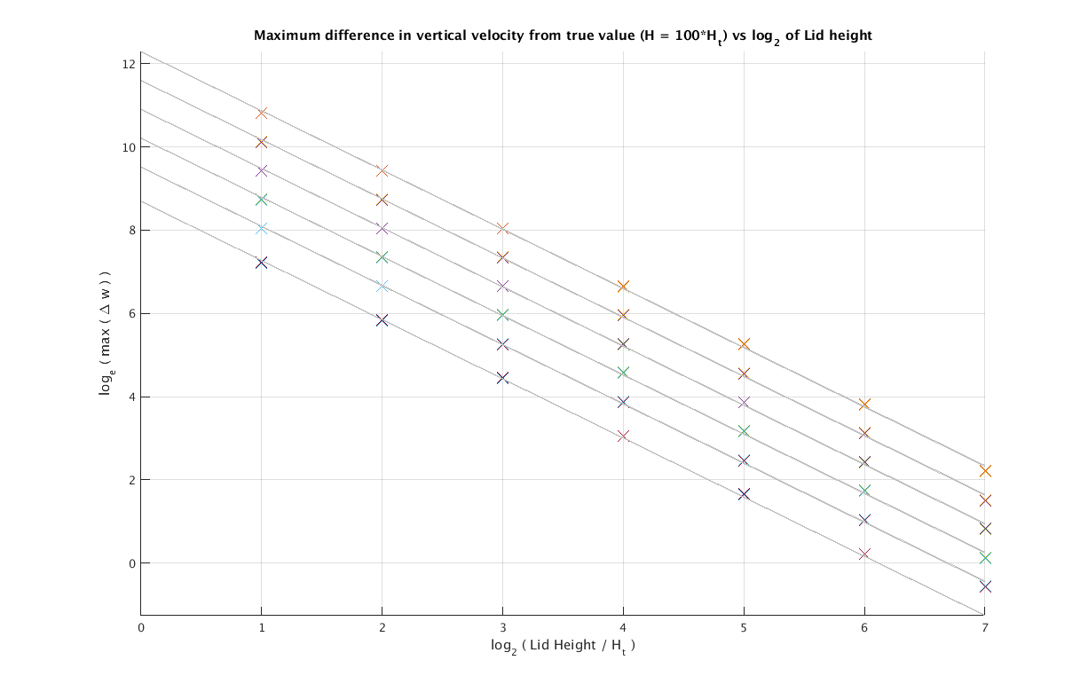

t = 1800s

sigma = 0.5, 1, 2, 4, 8, 16

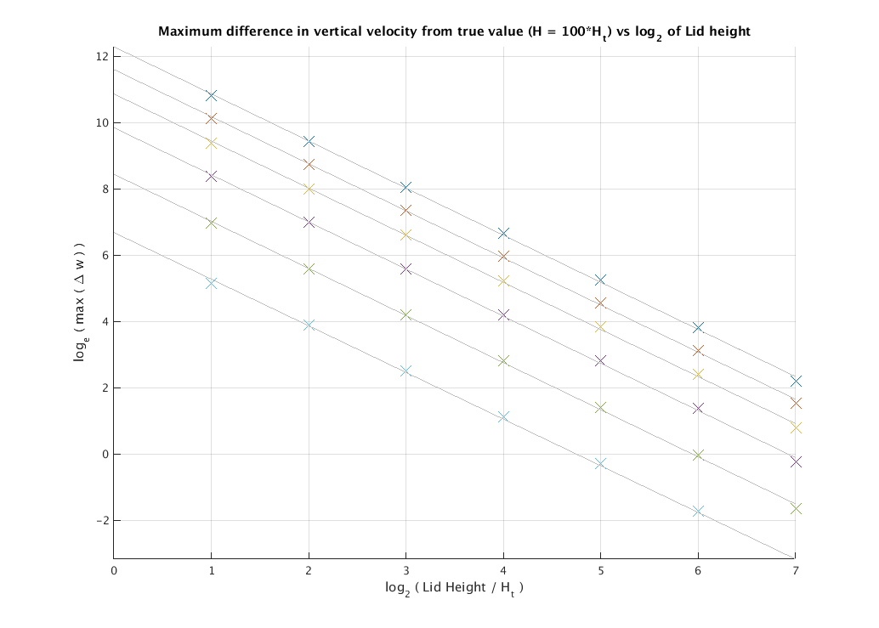

t = 1800s

sigma = 0.5, 1, 2, 4, 8, 16

