Exercise: ML-Training – Ch. 1

Expected Output

- What is the output for the given code?
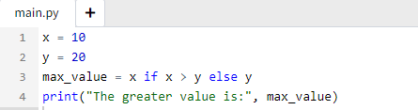

- What is the output for the given code?
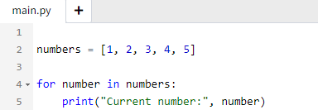

- What is the output for the given code?

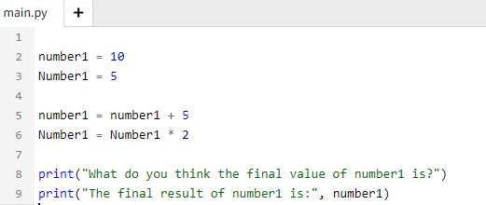

Correct the Error
- Please fix the syntax error here (hint: one syntax error exists).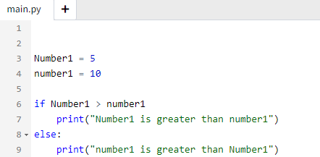

Write the complete Python code to solve the given problem

- Write a Python program that checks if employees are eligible for a bonus based on their yearly performance scores. The bonus eligibility is determined by a score of 80 or higher.
Your program should:
- Use a predefined list of performance scores (e.g., [85, 75, 90, 65]).
- For each score:
  - Print "Eligible for bonus" if the score is 80 or higher.
  - Print "Not eligible for bonus" if the score is less than 80.
- Count and display how many employees are eligible for the bonus and how many are not.
An example of the output for the given list. The program should be dynamic, meaning the list can be changed to any suitable one based on my preference
Score 85 is eligible for bonus
Score 75 is not eligible for bonus
Score 90 is eligible for bonus
Score 65 is not eligible for bonus
Total eligible for bonus: 2
Total not eligible for bonus: 2

Good Luck

