Ohana IOT - low budget home automation

Until recently only big companies have offered home automation systems like remote controlled light, temperature, window blinds… As the technology got cheaper, new products have emerged at low price. In my attempt to improve my life style with home automation in mind, I have encountered problems which I will describe in the following text.
In order to interconnect multiple devices, only wireless inter connectivity is acceptable. We all carry smart phones, so using one to control home appliances is only practical. This means using either Bluetooth or WiFi. I have personally had a lot of problems with bluetooth, especially if it needs to connect to a PC, so my only choice is WiFi network as it has proven sufficiently reliable.
The cheapest available solutions I have found are WiFi enabled LED light bulbs. The lowest price I found on www.aliexpress.com was 13 euros. A WiFi thermostat was about 20 euros. Each of these devices is from a different manufacturer and requires a dedicated WiFi application. Their application programming interface (API) is closed source, so there is no way to unify the control for all devices.
A more practical solution comes from Philips. They offer LED light bulbs, smart plugs and other devices. The communication is based on Zigbee network, so you also need a central hub which is WiFi connectable. The next thing you need is an android application to interface the central hub. The lowest prices I have so far found on sale are 11euros for a light bulb, 50 euros for the central hub, 50 euros for a smart wall plug.
While these prices sound acceptable for a lot of people in developed countries, there is still a large percentage of people to who these prices sound too steep when trying to control more than 3 or 4 devices. Also these solutions only cover a small range of devices that can be controlled remotely. These solutions offer a large degree of protection, a remote access via internet and a wide range of features like connecting to Amazon Alexa or Google Assistant, but for most common users, this is too complex to setup, create accounts, pay for account maintenance…

Common requirements
I have build for my own use WiFi controlled LED lamps, timers, thermostats, thermometers, RFID locks, NTP clock (automatically adjusted via internet), relays and also a device that acts as a router so I can access all my devices via internet from outside my home network.
Lets assume that we are going to use a WiFi module which has input output pins that can drive a simple LED, so 3,3V maximum input or output voltage and up to 10mA output current.
To build a WiFi lamp, we need something that gives more light than a simple LED. The cheapest solution is a 4 to 10W LED strip or a module. These usually work on 12V, so we need an external transistor to boost the output current and a 12V DC voltage source. Our WiFi chip works on 3.3V so we also need a 3.3V DC/DC drop down voltage converter.
To build a thermometer, we need a digital temperature probe, so for a thermostat we would also need to activate a relay that can drive a heater.
If we want to control an automated window blinds system, we could use relays to bypass the control switches.
Add a few resistors and diodes to get the whole circuit working properly and we can see that there is some considerable soldering to do.
I have tried to share my ideas with my colleagues, but most of them are not skillful with soldering, so they can not build these devices on their own. This led me to a cheap and multipurpose solution which requires very little or no soldering skills, but simply enough knowledge to connect a home light like any electrician should be able to do. It contains all the necessary hardware already connected, leaving for the user to just connect it to the system intended for wireless control.
The universal WiFi controller
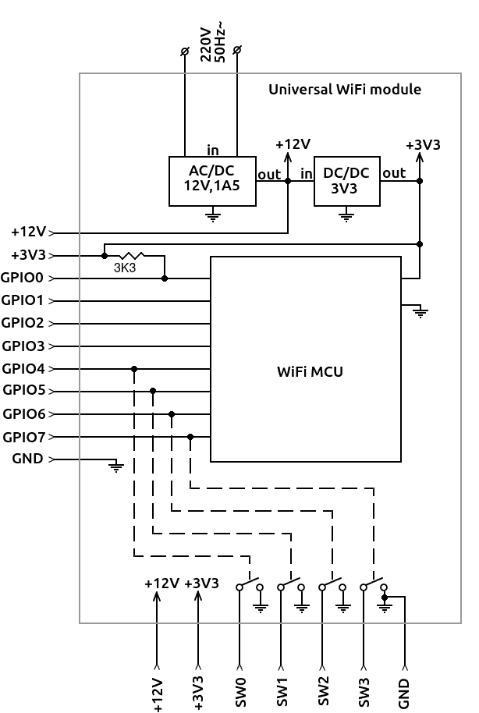

It has it’s own web interface that can be used for controlling and configuring the device. If unconfigured, it provides it’s own WiFi hotspot, so you can connect to it using any WiFi enabled device (smart phone or PC). Once you connect to it you can configure it to connect to your home network, so further communication is via home WiFi network. In case the home network is unavailable, the device will again provide the hotspot until the configured WiFi network is available again. It’s IP address can be either left unconfigured, in which case I have provided an Android application to detect and list all such devices on the network, or it can be configured as a static IP address. If so, you can just type the IP address in your web browser and access the device. Also by using browser bookmark, you can always have an easy access.
An Application Programming Interface is implemented, documented and made available for download, so anyone with some programming skills can interface the device and design their own automation systems. The main control interface is through a web browser, but the device can be controlled and configured via other network protocols (UDP broadcast, websockets and TCP messages) which allows for automation without a web browser or a screen (embedded linux devices, Arduino projects, PC software,…)
Over The Air update is implemented, so with a dedicated PC application downloadable from our website and by choosing an appropriate firmware, the user can update the firmware on the device and change it’s purpose via WiFi network. The firmware update application is as simple as possible so it can be easy to use for anyone. It automatically detects and lists devices available on the network and displays their current firmware version and purpose. It offers a dialog to browse for a new firmware and a simple button to initiate the upload.
Each device is standalone so no central hub is required and no additional costs for setting up only one device.
Available controller firmware types
To turn it into a WiFi lamp, one needs to connect an LED strip or a module to a switched output and upload the WiFi lamp firmware. The device will provide a web interface similar to the following for a simple LED or an RGB LED strip:

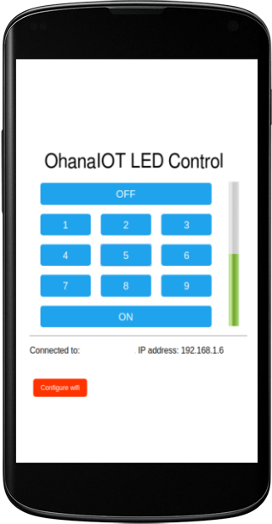
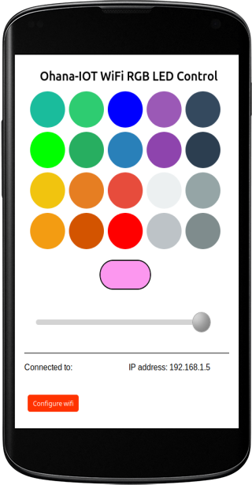

A relay can also be attached to control an additional light bulb of any type, so this can be built into the regular ceiling mounted light to provide an additional functionality.

Some of input devices that the Universal WiFi Module can directly interface are:
- low temperature digital probe like DS18B20 for temperatures below 90 degrees Celsius,
- high temperature thermocouple module using MAX6675 for temperatures up to 600 degrees Celsius,
- a MFRC522 RFID module for reading electric lock tags
- a simple metal surface about 2 square cm in diameter as a touch sensor
Some of output devices to be used directly can be:
- an LED strip or a module
- a relay, for activating any 200V home appliance or overriding any switches.

I have developed a firmware to be used with the Universal WiFi Controller and enable it to act as a central hub to be accessed from the internet. This can give you external access to all your home automation devices.

The current project status
So far I have tested individual devices at some point. I have made a lot of improvements and most of my projects are very stable, but need some more adjustments to address branding, configuration and usability for non technical people like creating an application for easy firmware update and a dedicated website for technical support. The cost of building one Universal WiFi Controller is less than 7 euros, using components from www.Aliexpress.com. I assume that in a large scale production, this can be less. My goal is to provide a low cost home automation tool, so I would finish all the code and test everything, but I am a software developer and am looking for someone to invest money and time to manage the patenting, production, marketing and sales of the project. I only require a small percentage from the sale of the product or a suitable compensation during the development and improvements of the product.

