

CSF3133 WEB-BASED INTERFACE DESIGN (K4)
LAB MODULE 4
SEMESTER III 2025/2026

PREPARED BY:
AIDA HUSNA BINTI MUHAMAD ZAIDI

NO MATRIK:
S76103

LECTURER:
TS. DR. WAN NURAL JAWAHIR BINTI HJ WAN YUSOF

LAB MODERATOR:
PN. WAN FATIN FATIHAH BINTI YAHYA

5.3 inline CSS
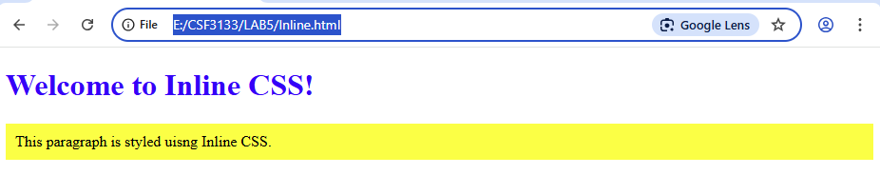
5.4 Internal Class
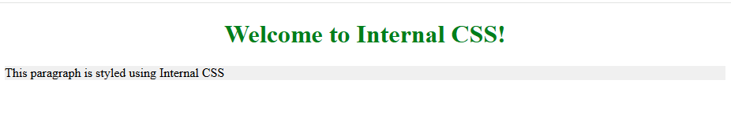
5.5 External CSS
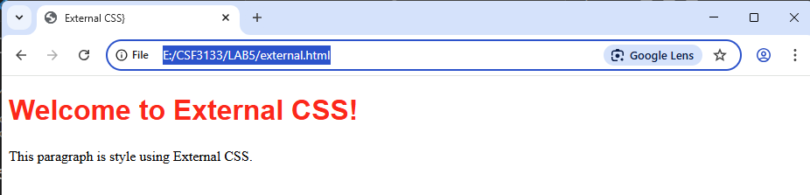

5.6 Link to file CSS (from another website)
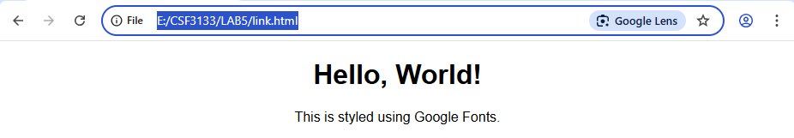
<!DOCTYPE html>
<html>
<head>
<title>Google Fonts Example</title>
<link href="https://fonts.googleapis.com/css2?family=Crimson+Pro" rel="stylesheet">
<style>
body{
font-family: 'Crimson Pro', serif;
text-align: center;
}
</style>
</head>
<body>
<h1>Hello, World!</h1>
<p>This is styled using Google Fonts.</p>
</body>
</html>
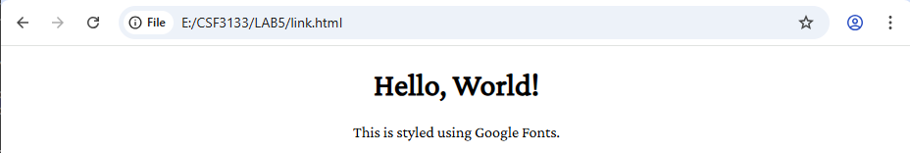

5.7 CSS Backgrounds
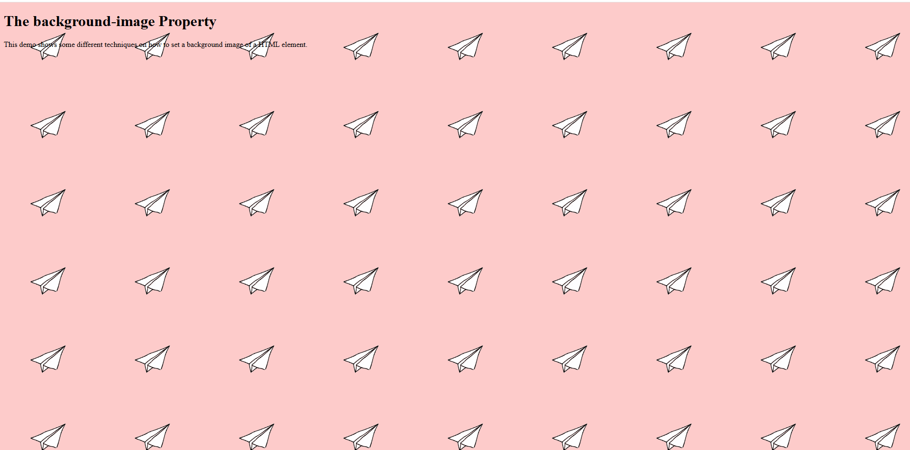
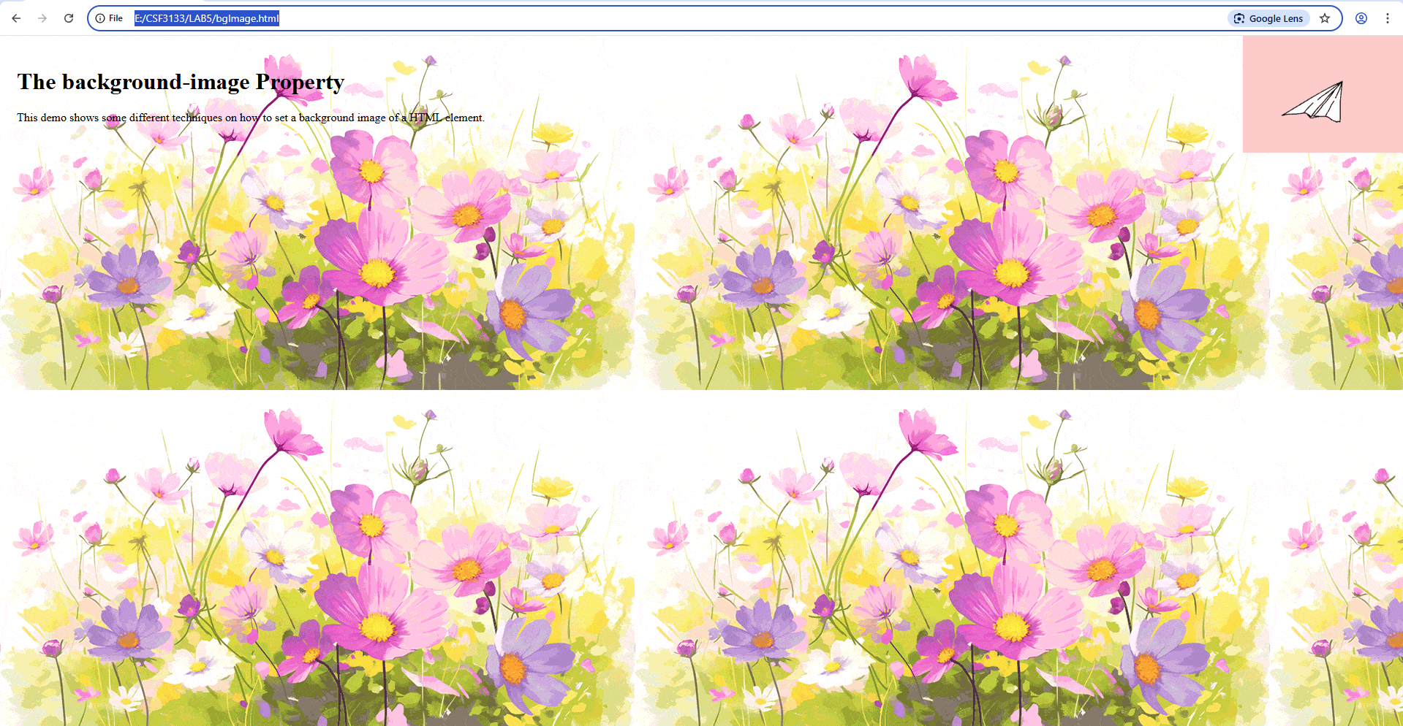

5.8 CSS Table
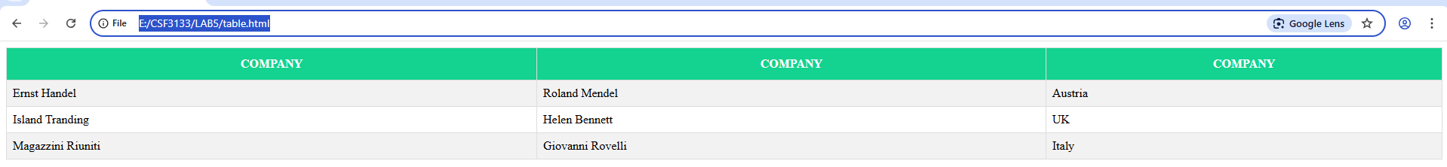

5.9 CSS Navigation Bar
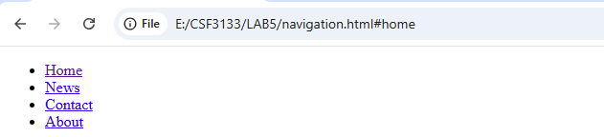
Style remove bullets and margin and padding from the list.
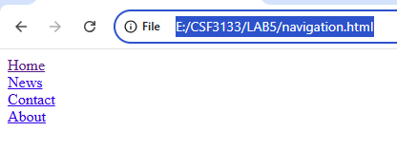
Style to create basic vertical navigation bar
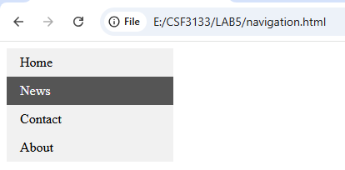
Change style to create horizontal navigation bar

