Chesapeake Bay Project - more plots plz

Table of Contents

# Plot a few parameters against each other

## Parameters vs temperature

WHOLE 5-DAY BIOCHEMICAL OXYGEN DEMAND MG/L vs Temp: R2 = 0.0197

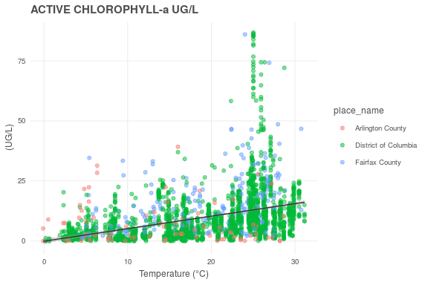ACTIVE CHLOROPHYLL-A UG/L vs Temp: R2 = 0.1386

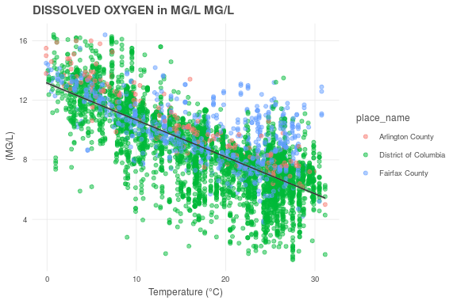DISSOLVED OXYGEN IN MG/L MG/L vs Temp: R2 = 0.5506

HARDNESS AS CACO3 MG/L vs Temp: R2 = 0.0063

AMMONIUM NITROGEN AS N (FILTERED SAMPLE) MG/L vs Temp: R2 = 0.0053

NITRITE+NITRATE NITROGEN AS N (FILTERED SAMPLE) MG/L vs Temp: R2 = 0.0918

NITRITE NITROGEN AS N (FILTERED SAMPLE) MG/L vs Temp: R2 = 0.0233

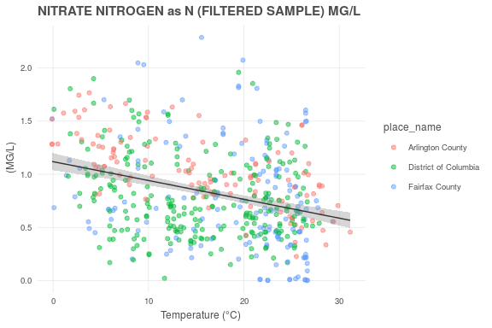NITRATE NITROGEN AS N (FILTERED SAMPLE) MG/L vs Temp: R2 = 0.1051

PH CORRECTED FOR TEMPERATURE (25 DEG C) SU vs Temp: R2 = 0.0036

SALINITY UNITS IN PPT AND EQUAL TO PRACTICAL SALNITY UNITS (PSU) PPT vs Temp: R2 = 0.0692

SECCHI DEPTH M vs Temp: R2 = 0.0140

TOTAL ALKALINITY AS CACO3 MG/L vs Temp: R2 = 0.0163

TOTAL DISSOLVED NITROGEN MG/L vs Temp: R2 = 0.0962

TOTAL DISSOLVED PHOSPHORUS MG/L vs Temp: R2 = 0.0035

TOTAL SUSPENDED SOLIDS MG/L vs Temp: R2 = 0.0060

TURBIDITY; NEPHELOMETRIC METHOD NTU vs Temp: R2 = 0.0096

## Parameters vs oxygen

WHOLE 5-DAY BIOCHEMICAL OXYGEN DEMAND MG/L vs Dissolved Oxygen: R2 = 0.0243

ACTIVE CHLOROPHYLL-A UG/L vs Dissolved Oxygen: R2 = 0.0699

HARDNESS AS CACO3 MG/L vs Dissolved Oxygen: R2 = 0.0346

AMMONIUM NITROGEN AS N (FILTERED SAMPLE) MG/L vs Dissolved Oxygen: R2 = 0.0025

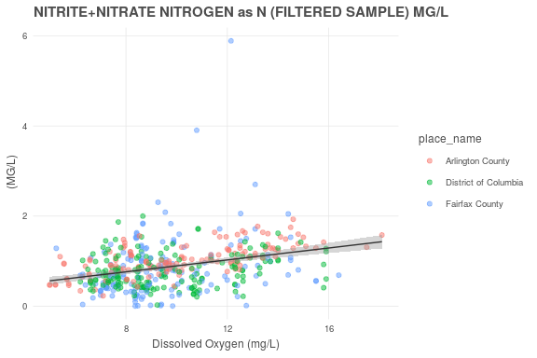NITRITE+NITRATE NITROGEN AS N (FILTERED SAMPLE) MG/L vs Dissolved Oxygen: R2 = 0.1068

NITRITE NITROGEN AS N (FILTERED SAMPLE) MG/L vs Dissolved Oxygen: R2 = 0.0581

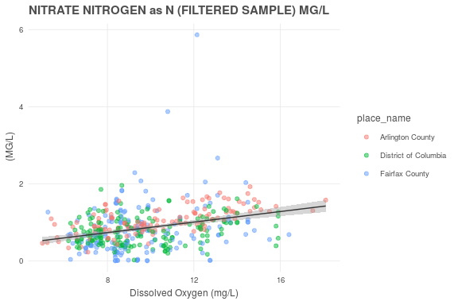NITRATE NITROGEN AS N (FILTERED SAMPLE) MG/L vs Dissolved Oxygen: R2 = 0.1074

PH CORRECTED FOR TEMPERATURE (25 DEG C) SU vs Dissolved Oxygen: R2 = 0.0017

SALINITY UNITS IN PPT AND EQUAL TO PRACTICAL SALNITY UNITS (PSU) PPT vs Dissolved Oxygen: R2 = 0.0614

SECCHI DEPTH M vs Dissolved Oxygen: R2 = 0.0381

TOTAL ALKALINITY AS CACO3 MG/L vs Dissolved Oxygen: R2 = 0.0035

TOTAL DISSOLVED NITROGEN MG/L vs Dissolved Oxygen: R2 = 0.0973

TOTAL DISSOLVED PHOSPHORUS MG/L vs Dissolved Oxygen: R2 = -0.0014

TOTAL SUSPENDED SOLIDS MG/L vs Dissolved Oxygen: R2 = 0.0026

TURBIDITY; NEPHELOMETRIC METHOD NTU vs Dissolved Oxygen: R2 = -0.0000

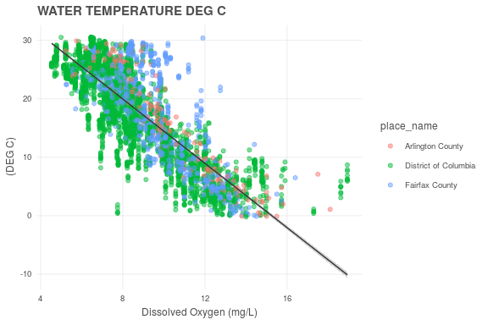WATER TEMPERATURE DEG C vs Dissolved Oxygen: R2 = 0.6943

## Parameters vs nitrogen

WHOLE 5-DAY BIOCHEMICAL OXYGEN DEMAND MG/L vs Dissolved Nitrogen: R2 = 0.0070

ACTIVE CHLOROPHYLL-A UG/L vs Dissolved Nitrogen: R2 = 0.0066

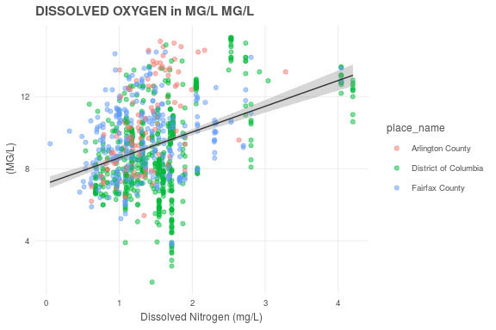DISSOLVED OXYGEN IN MG/L MG/L vs Dissolved Nitrogen: R2 = 0.1415

HARDNESS AS CACO3 MG/L vs Dissolved Nitrogen: R2 = -0.0040

AMMONIUM NITROGEN AS N (FILTERED SAMPLE) MG/L vs Dissolved Nitrogen: R2 = 0.0767

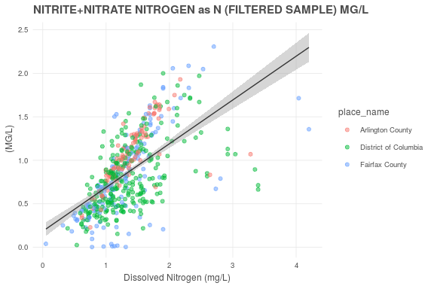NITRITE+NITRATE NITROGEN AS N (FILTERED SAMPLE) MG/L vs Dissolved Nitrogen: R2 = 0.3626

NITRITE NITROGEN AS N (FILTERED SAMPLE) MG/L vs Dissolved Nitrogen: R2 = 0.0367

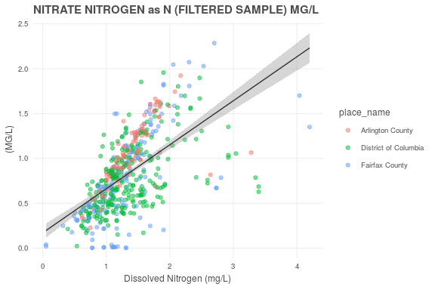NITRATE NITROGEN AS N (FILTERED SAMPLE) MG/L vs Dissolved Nitrogen: R2 = 0.3513

PH CORRECTED FOR TEMPERATURE (25 DEG C) SU vs Dissolved Nitrogen: R2 = 0.0198

SALINITY UNITS IN PPT AND EQUAL TO PRACTICAL SALNITY UNITS (PSU) PPT vs Dissolved Nitrogen: R2 = 0.0590

SECCHI DEPTH M vs Dissolved Nitrogen: R2 = 0.0143

TOTAL ALKALINITY AS CACO3 MG/L vs Dissolved Nitrogen: R2 = 0.0254

TOTAL DISSOLVED PHOSPHORUS MG/L vs Dissolved Nitrogen: R2 = 0.0177

TOTAL SUSPENDED SOLIDS MG/L vs Dissolved Nitrogen: R2 = 0.0201

TURBIDITY; NEPHELOMETRIC METHOD NTU vs Dissolved Nitrogen: R2 = 0.0268

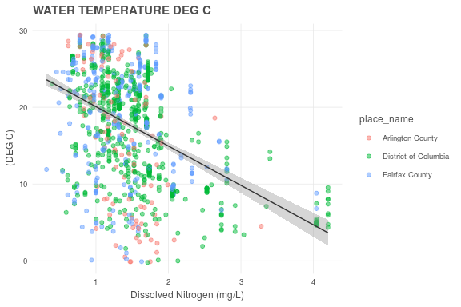WATER TEMPERATURE DEG C vs Dissolved Nitrogen: R2 = 0.1974

## Parameters vs phosphorus

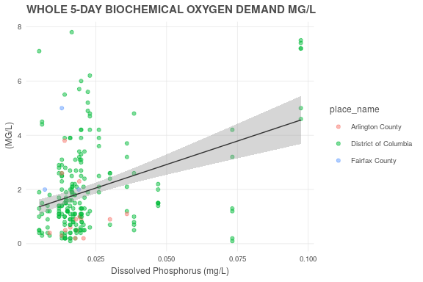WHOLE 5-DAY BIOCHEMICAL OXYGEN DEMAND MG/L vs Dissolved Phosphorus: R2 = 0.1360

ACTIVE CHLOROPHYLL-A UG/L vs Dissolved Phosphorus: R2 = 0.0186

DISSOLVED OXYGEN IN MG/L MG/L vs Dissolved Phosphorus: R2 = 0.0029

HARDNESS AS CACO3 MG/L vs Dissolved Phosphorus: R2 = 0.0754

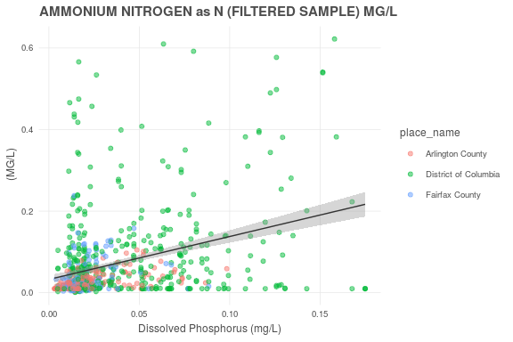AMMONIUM NITROGEN AS N (FILTERED SAMPLE) MG/L vs Dissolved Phosphorus: R2 = 0.1170

NITRITE+NITRATE NITROGEN AS N (FILTERED SAMPLE) MG/L vs Dissolved Phosphorus: R2 = 0.0209

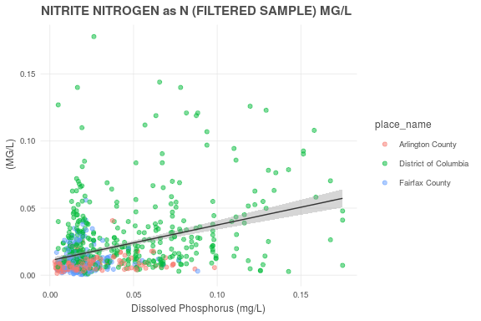NITRITE NITROGEN AS N (FILTERED SAMPLE) MG/L vs Dissolved Phosphorus: R2 = 0.1398

NITRATE NITROGEN AS N (FILTERED SAMPLE) MG/L vs Dissolved Phosphorus: R2 = 0.0251

PH CORRECTED FOR TEMPERATURE (25 DEG C) SU vs Dissolved Phosphorus: R2 = 0.0744

SALINITY UNITS IN PPT AND EQUAL TO PRACTICAL SALNITY UNITS (PSU) PPT vs Dissolved Phosphorus: R2 = 0.0078

SECCHI DEPTH M vs Dissolved Phosphorus: R2 = 0.0656

TOTAL ALKALINITY AS CACO3 MG/L vs Dissolved Phosphorus: R2 = -0.0021

TOTAL DISSOLVED NITROGEN MG/L vs Dissolved Phosphorus: R2 = 0.0256

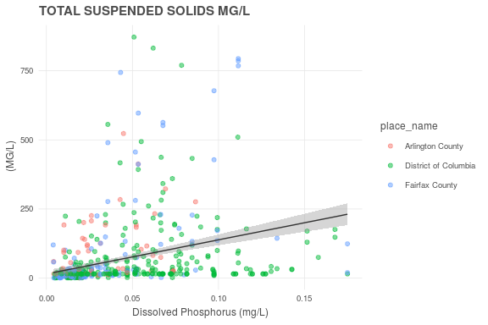TOTAL SUSPENDED SOLIDS MG/L vs Dissolved Phosphorus: R2 = 0.1065

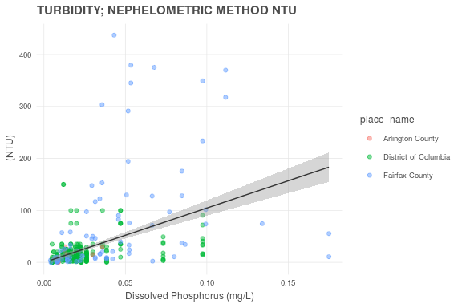TURBIDITY; NEPHELOMETRIC METHOD NTU vs Dissolved Phosphorus: R2 = 0.1935

WATER TEMPERATURE DEG C vs Dissolved Phosphorus: R2 = 0.0136

## Parameters vs turbidity

WHOLE 5-DAY BIOCHEMICAL OXYGEN DEMAND MG/L vs Turbidity: R2 = 0.0651

ACTIVE CHLOROPHYLL-A UG/L vs Turbidity: R2 = 0.0152

DISSOLVED OXYGEN IN MG/L MG/L vs Turbidity: R2 = -0.0002

HARDNESS AS CACO3 MG/L vs Turbidity: R2 = 0.0725

AMMONIUM NITROGEN AS N (FILTERED SAMPLE) MG/L vs Turbidity: R2 = 0.0074

NITRITE+NITRATE NITROGEN AS N (FILTERED SAMPLE) MG/L vs Turbidity: R2 = 0.0277

NITRITE NITROGEN AS N (FILTERED SAMPLE) MG/L vs Turbidity: R2 = 0.0030

NITRATE NITROGEN AS N (FILTERED SAMPLE) MG/L vs Turbidity: R2 = 0.0208

PH CORRECTED FOR TEMPERATURE (25 DEG C) SU vs Turbidity: R2 = 0.0385

SALINITY UNITS IN PPT AND EQUAL TO PRACTICAL SALNITY UNITS (PSU) PPT vs Turbidity: R2 = 0.0046

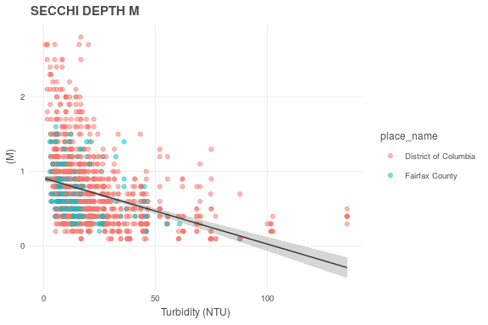SECCHI DEPTH M vs Turbidity: R2 = 0.1311

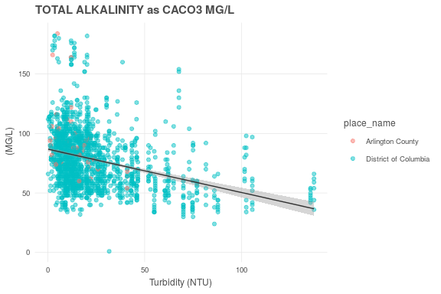TOTAL ALKALINITY AS CACO3 MG/L vs Turbidity: R2 = 0.1068

TOTAL DISSOLVED NITROGEN MG/L vs Turbidity: R2 = 0.0257

TOTAL DISSOLVED PHOSPHORUS MG/L vs Turbidity: R2 = 0.0502

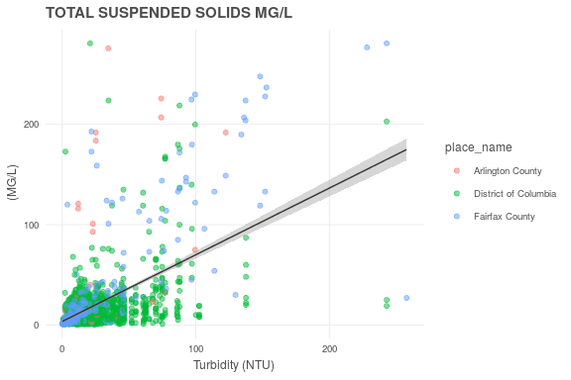TOTAL SUSPENDED SOLIDS MG/L vs Turbidity: R2 = 0.3017

WATER TEMPERATURE DEG C vs Turbidity: R2 = 0.0062