Chapter 7: Congestion

Exercise 7.1

a) If preferences are quasilinear then in every Pareto Optimal allocation in which all consumers consume Big Macs there is the same amount of driving for each and the total amount of highway expenditures.

The set of feasible allocations is composed of the vectors 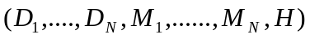such that total expenditures on Big Macs, fuel and highways add to the total wealth of its citizens:

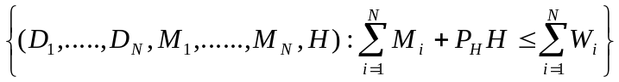

The Samuelson condition for an efficient amount of driving by resident is that the sum of all residents’ marginal rates of substitution between 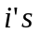driving and their own consumption of Big Macs equals the resource cost of driving by :

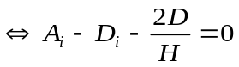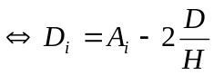.

The Samuelson condition for an amount of highway expenditures is that the sum of resident’s MRS between highway expenditures and Big Macs equals the cost of highway expenditures:

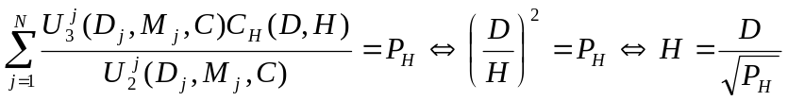

Since we have the same amount of driving for each resident then total amount of driving is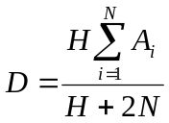.

The solution is then:

- 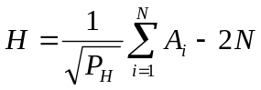
- 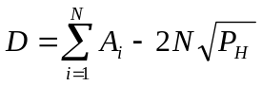
- 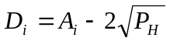

b) If no tolls are charged then the congestion externality is not internalized and each resident maximizes his own utility without taking into account that his decision has a negative effect on the utility of the other residents.

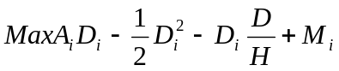

The optimal amount of driving in this case is 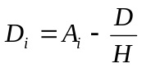.

Taking the efficient amount of D and H as given then 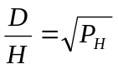.

The Nash equilibrium amount of driving for each resident is 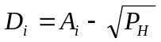.

c) We want a system of uniform tools for driving that induce at least approximate Pareto efficient behaviour.

In the efficient allocation the amount of driving by each resident is equal to 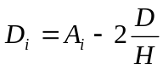 while in the Nash equilibrium is . As one can see each resident drives more than what is efficient when no toll is charged to internalized the externality they impose.

To compute the uniform toll (t):

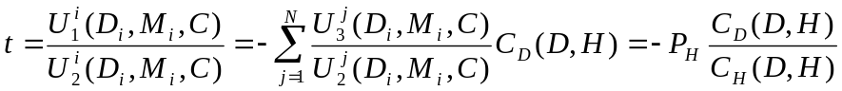
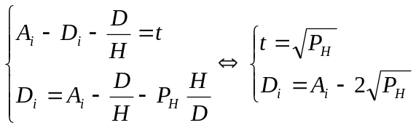

So the toll 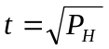 induces each resident to drive the efficient amount.

Exercise 7.2.

a) The equilibrium condition under these circumstances will lead to an outcome where it takes 45m no matter which route one takes to get to West Potato:

Time it take if one uses the belt line = Time it takes if one uses the straight line

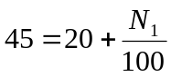

So, 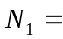2500 commuters will use the road and 3500 commuters will use the freeway.

Since it takes each commuter 45 minutes to get to West Potato the total amount of minutes (m) per morning spent by all commuters is:

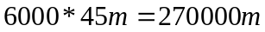

b) The social planner will minimize the total commuting time in order to decide how many commuters will permit to use the Middle Potato road.

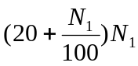 is the total amount of minutes spent by all commuters who use the road.

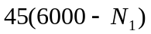is the total amount of minutes spent by all commuters who use the freeway.

The social planner’s problem is to choose 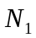 to minimize the sum of and :

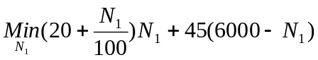

So the social planner will permit 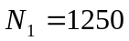commuters to use the middle Potato road.

The time each commuter would spend when using the road is 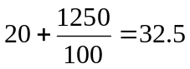 minutes.

Total time spend in the middle Potato road is 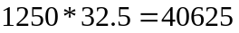minutes.

The number of commuters who will use the freeway is 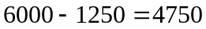 and total amount of time spent in the freeway is 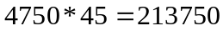 minutes.

So the total amount of minutes per morning spent by all commuters is the sum of the total amount of minutes spent by all commuters who use the middle Potato road and the total amount of minutes spent by all commuters who use the freeway: 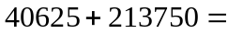254375 minutes < 270000 minutes.

c) Given that the government’s objective is to minimize the total amount of time that people spend commuting then from question b) we know that the commuting time in the middle Potato road must be 32.5 minutes.

If one person takes the freeway then he/she bears a time cost in monetary terms of 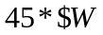.

If one person takes the road he/she bears a time cost in monetary terms of 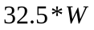. But he/she also must pay the toll so his/her total costs are 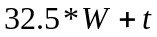.

The toll that the government must charge for driving on the road through Middle Potato is such that each commuter is indifferent between the two alternative routes, that is, between taking the road or the freeway:

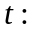 =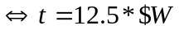

So the toll is equal to the time saved by the commuter who uses the road in monetary terms.

The number of commuters who use the road is such that 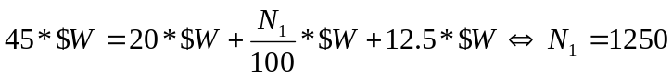.

With this toll the government will collect a revenue of 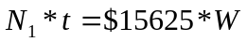.

Each commuter is much better off (evaluated in dollars) in 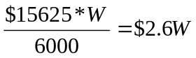compared to the equilibrium with no tolls.

Exercise 7.3.

The price each commuter bears if going around is and the price of going straight is 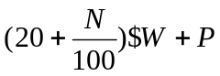.

The monopolist will choose the highest toll he can charge given that commuters can always take the alternative route.

The demand curve for the road is given by 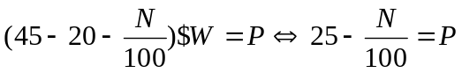.

To find the revenue-maximizing quantity and price, the monopolist chooses P and N in order to maximize his total revenue (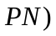taking into consideration that the demand curve is 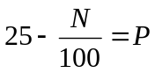.

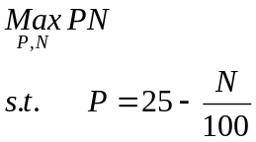

The price that the monopolist will set is P=12.5$W. This is the amount of the toll charged by the social planner and it corresponds to the time saved by road users in monetary terms. This is the maximum amount that each commuter is willing to pay to use the road.
At this price the number of people who will use the road is then 1250.

Conclusion: The monopolist will act as a social planner given that he faces the competition of an alternative route and the maximum amount that the monopolist can charge is the monetary evaluation of the time saved by those who use the road.

Exercise 7.4.

The government objective is to maximize the total value of time saved from commuting net of the sum of money spent on road building.

The total value of time saved from commuting is the product of the time saved by each commuter in monetary terms and total commuters: 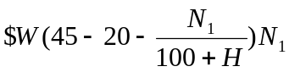.

Total expenditure in road construction is 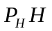.

The government’s problem is 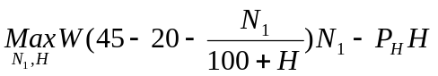.

The solution to the previous maximization problem is 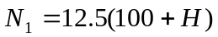 and 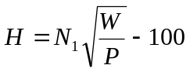.

Congestion is given by 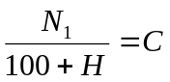so with we have that 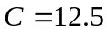.

The level of congestion is constant no matter the increase in the road size. So if the road is widened it will just increase the number of commuters in a way that congestion will be unchanged. This means that the congestion function is homogeneous of degree zero that is it exhibits “constant returns to scale”.

Since congestion is unchanged the time it takes each commuter to make the trip is 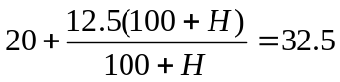minutes.

If it pays to widen the road then 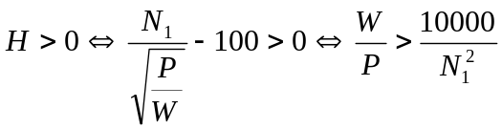.

Exercise 7.5.

Since we have constant returns to scale in the congestion function then the level of congestion is unchanged and the time it takes each commuter to make the trip using the road is 32.5 minutes.
On the other hand, the toll that the government can charge to each commuter is such that commuters are indifferent between using the road and the freeway. So the toll charge would be 12.5W.

From exercise 7.4 we know that 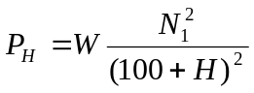. Another consequence of the having a constant returns to scale congestion function is that the revenue from the toll charged exactly covers construction costs: 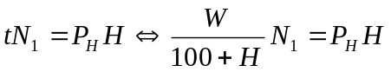.

The government will construct the road if:

Marginal revenue marginal cost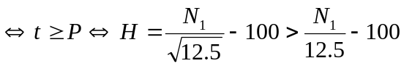.

If the government charges a toll then the optimal amount of highway expenditures will be higher because the government will construct more roads.

