# CA400 – User Manual

# Project Title: Mini Mental State Examination Application

|  |  |
| --- | --- |
| Student Name: | Matthew Nolan |
| Student ID: | 16425716 |
| Student Name: | Michael O’Hara |
| Student ID: | 16414554 |
| Project Supervisor: | Prof. Gareth Jones |
| Date Completed: |  |

# Contents

## Download and Installation

***1.0.1*** *Steps to Install*

## 1.1 Using the application

***1.1.1*** *Registering to use the application*

***1.1.2*** *Login to the application*

***1.1.3*** *Navigating through the application*

***1.1.4*** *Adding a new patient*

***1.1.5*** *Starting the exam*

## 1.0 Download and Install

## 1.1 Using the application

*NOTE: Screenshots in this manual are taken from Windows version of the Application*

## **1.1.1** *Registering to use the application*

The first step for the medical professional is to register to use our application. They click on the register button and this will bring them to a Register page. From here the medical professional is brought to a from where they will fill in their desired Username and Password and they click submit/ Once they’ve submitted this our backend code will check if the username and password are already in the database. If they are the user will be prompted with an alert saying they must choose a new username and password. If there is no conflict, then the user is added to the database and an entry into the doctor table and given a doctor ID.

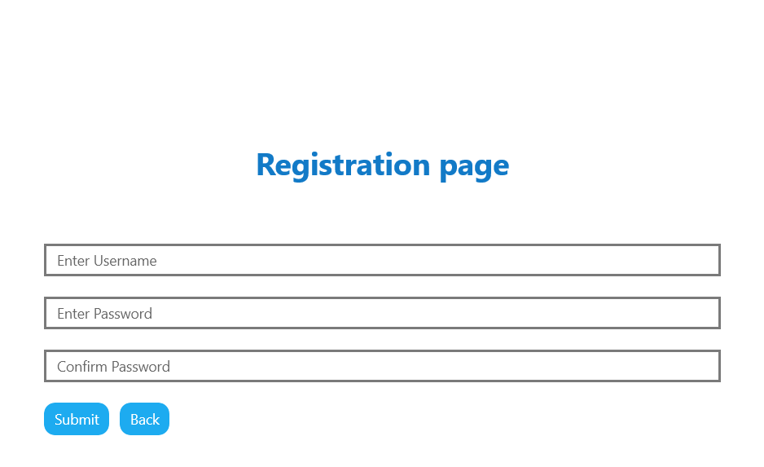

## **1.1.2** *Login*

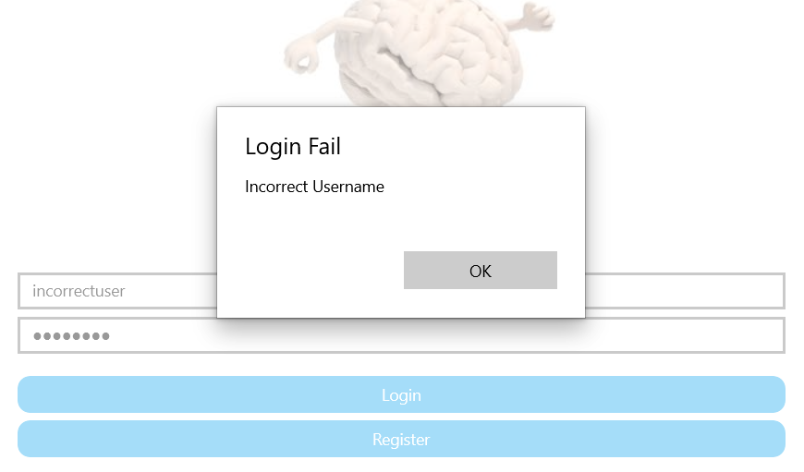The above image is the Login page for our application. Here the user will enter their username and password. The entered details will be checked against the values of our database and if they match values in our database then the user will be given access to the application.

If the details are incorrect then the user will be greeted with a pop up like this

## **1.1.3** *Navigating through the application*

## 

This is the side bar navigation is how the medical professional would navigate through the application. From here they can go to the ‘Home’, ‘Patients’ and ‘Exam’ pages. The content of these pages will be discussed later. There is a button down the bottom of the menu for the medical professional to logout of the application. Once this is clicked the app will go back to the main login screen

## **1.1.4** *Adding a new patient*

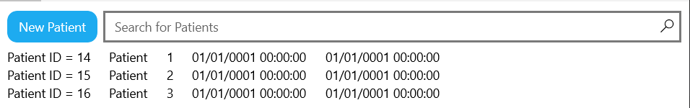

The medical professional can navigate to this page from the sidebar menu which was discussed previously. From here the medical professional can view the patients in their care and they can add a new patient record from here by clicking the “New Patient” button up the top left corner. From here the medical professional is brought to this screen.

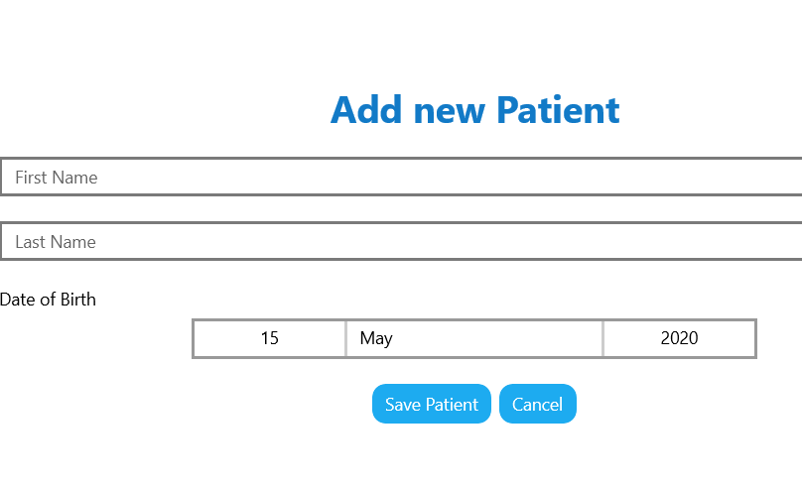

On this screen the doctor adds patients first name and last and their date of birth. When they hit Save Patient, a new record is added to the patient table. This also creates a patient ID which a doctor can select to link the patient to them. When the patient is saved to the database the medical professional is greeted with this pop message.

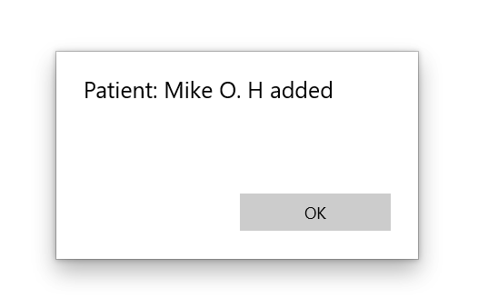

## **1.1.5** *Starting an exam*

This is the exam section of the application. From the screenshots below it outlines the layout of the examination, the questions of the exam are displayed on the left and on the right there is text boxes for the patient to enter the responses.

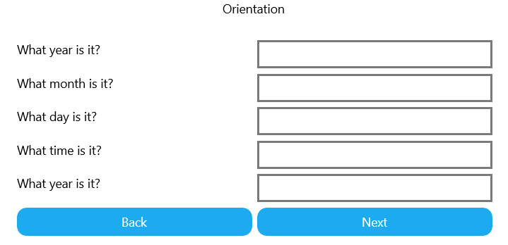Another example of the questions in the exam includes the ability to draw on inside an area on the screen.

