Functional Specification

## ***0. Table of contents***

### Introduction

#### 1.1 Overview

#### 1.2 Business Context

#### 1.3 Glossary

### General Description

#### 2.1 Product / System

#### 2.2 User Characteristics and Objectives

#### 2.3 Operational Scenarios

#### 2.4 Constraints

### Functional Requirements

#### 3.1 Carry Out Exam

#### 3.2 Process Results

#### 3.3 Store Results

#### 3.4 Graph Results

#### 3.5 Predict the progression

#### 3.6 Login System

### System Architecture

#### 4.1 System Architecture Diagram

#### 4.2 System Architecture Brief Description

### High-Level Design

### Preliminary Schedule

#### 6.1 Task List

#### 6.2 GANTT Chart

### Appendices

## 

## 

## 

## 

## 

## 

## 

## 

## 

## 

## 

## 

## 

## 

## ***1. Introduction***

### **1.1 Overview**

*Provides a brief overview of the system / product to be developed. It should include a description of the need for the system, briefly describe its functions and explain how it will work with other systems (if appropriate).*

Our project is based on the Mini Mental State Exam (MMSE). The MMSE is a 30-point questionnaire which is used in clinical and research practices to measure cognitive impairment in patients, also used in medicine to screen for dementia. The examination includes questions that gauge the patient’s sense of date and time, sense of location, short-term memory, basic mathematics, naming objects and complex cognitive functions like drawing.The purpose of the exam is to accurately estimate the severity and rate of progression of cognitive impairment in a patient and to also follow the course of changes in the patient over time. The way in which the exam is administered now is with pen and paper. We plan to modernize this and make it into an application to be used in the aforementioned fields. Our idea is to create an application which will allow the test to be carried out in a more efficient manner by either the medical professional or in some cases the patient themselves. We plan on converting the examination to an electronic version that can be conducted and administered on a device, such as a tablet.

### **1.2 Business Context**

*Provides an overview of the business organization sponsoring the development of this system / product or in which the system / product will / could be deployed. Note - may not be applicable to all projects*

Information management systems are essential in the ever-growing modern day healthcare system. These systems are designed to handle the acquisition of information from multiple sources and the distribution of the information in a concise and efficient manner.Our project is an example of one of these systems and we believe that it can be deployed in numerous hospital and medical practices in which the MMSE examination is carried out.

### **1.3 Glossary**

*Define and technical terms used in this document. Only include those with which the reader may not be familiar.*

## 

* ***MMSE*** - Mini-Mental state examination.

## ***2. General Description***

### **2.1 Product / System Functions**

*Describes the general functionality of the system / product.*

The General functionality of our MMSE application is:

**Conducting and Administering the test -** The main functionality of our application is the ability to conduct and administer the MMSE on a chosen device.The flexibility of our allows for the application to be used by the two different user groups, the medical professionals and the patients.In general, the examination is conducted by the medical professional but due to the scoring of the examination varying from little to no apparent cognitive impairment (scoring 25 or more) to Severe levels of cognitive impairment

(scoring 9 or less), we believe that some patients are capable to carry out the examination themselves, once it has been administered by an overseeing medical professional.

**Gathering and Presenting information -** One of the main advantages of our application is its ability to efficiently and effectively gather and present information. Regarding gathering information, this will mainly be conducted when the test is being carried out. The patient’s information will be taken and stored along with their examination results once they have completed the MMSE. The patients results will be stored alongside any previous results and will be linked to the patient for easier information retrieval. In relation to presenting the information, the medical professional will be able to view and analyse their patients previous results visually by using graphs. We hope to be able to add in the ability to predict the next score of the patient using their previous results.

### 

### **2.2 User Characteristics and Objectives**

*Describes the features of the user community, including their expected expertise with software systems and the application domain. Explain the objectives and requirements for the system from the user's perspective. It may include a "wish list" of desirable characteristics, along with more feasible solutions that are in line with the business objectives.*

Our user community can be split into two categories, medical professionals and patients. Medical professionals are familiar with information management systems as they are used throughout the healthcare system, therefore they will have some technical experience. The patient user group will have varying levels of experience depending on multiple factors such as age, background and diagnosis. Due to the varying levels of experience within our user groups, users of our application will not need any previous technical experience.

The User Interface of the application will be clean and user friendly as we don’t want to add any stress to the user. The colors we use will be neutral and not too aggressive as to upset the users. We will make sure the font is easy to read and use a big size as not to strain the eyes.

The other side of the application will only be accessible by the medical professional and will be where they can see the previous results of test and also be able to see the graph of the progression of the impairment. We then aim to be able to predict how fast the progression will move in the future. We are still looking into ways to make sure the process is as accurate as possible.

### **2.3 Operational Scenarios**

*This section should describe a set of scenarios that illustrate, from the user's perspective, what will be experienced when utilizing the system under various situations.*

*In the article Inquiry-Based Requirements Analysis (IEEE Software, March 1994), scenarios are defined as follows:*

*In the broad sense, a scenario is simply a proposed specific use of the system. More specifically, a scenario is a description of one or more end-to-end transactions involving the required system and its environment. Scenarios can be documented in different ways, depending up on the level of detail needed. The simplest form is a use case, which consists merely of a short description with a number attached. More detailed forms are called scripts.*

|  |  |
| --- | --- |
| **Scenario ID** | 1 |
| **User Objective** | Medical Professional Logs in |
| **User Action** | The medical Professional logs in using their authenticated account |
| **Comments** | Each medical professional account will have patients which are under their care linked to it |

|  |  |
| --- | --- |
| **Scenario ID** | 2 |
| **User Objective** | Medical Professional sets up MMSE. |
| **User Action** | The medical Professional will input the users information and choose which test will be carried out |
| **Comments** | The medical professional must be logged in using their authenticated account. |

|  |  |
| --- | --- |
| **Scenario ID** | 3 |
| **User Objective** | Medical Professional conducts MMSE |
| **User Action** | The medical Professional carry out the MMSE for the patient |
| **Comments** | The test must be setup first |

|  |  |
| --- | --- |
| **Scenario ID** | 4 |
| **User Objective** | Patient carries out MMSE themselves |
| **User Action** | The patient uses the device to carry out the test. |
| **Comments** | The test must be setup first and the medical professional must approve of this first |

|  |  |
| --- | --- |
| **Scenario ID** | 5 |
| **User Objective** | The test results are stored |
| **User Action** | Once the test is finished the medical professional must confirm that the test has been carried out and then selects save results |
| **Comments** | The results will be linked to the patient and the medical professional that administered the test. |

|  |  |
| --- | --- |
| **Scenario ID** | 6 |
| **User Objective** | Medical Professional reviews MMSE results |
| **User Action** | The medical Professional will select which patient’s results they wish to see. |
| **Comments** | The results will be presented using different methods of visual presentations. |

|  |  |
| --- | --- |
| **Scenario ID** | 7 |
| **User Objective** | Predicts the results of the patients |
| **User Action** | The medical Professional will select the predict option and it will give an estimate as to what the patient’s next result will be. |
| **Comments** | Before being able to predict the next result, the application will need an amount of previous results. |

|  |  |
| --- | --- |
| **Scenario ID** | 8 |
| **User Objective** | Adding new Patients |
| **User Action** | The medical Professional will input all information regarding the patient |
| **Comments** | The medical professional must accurately take the patient’s information. |

### **2.4 Constraints**

*Lists general constraints placed upon the design team, including speed requirements, industry protocols, hardware platforms, and so forth.*

Our main constraints will be:

* Making the application accessible, usable and flexible:

We need to make sure the User Interface is usable and accessible to all users. This will involve making sure the colors are not contrasting. It will also involve making sure the font is clear and easy to read and the language used is simple and concise.

* Complying with GDPR:

We need to make sure that any personal data that is collected and stored complies with the General Data Protection Regulation. GDPR lays out responsibilities to ensure the privacy and protection of personal data, provides data subjects with certain rights, and assigns powers to regulators to ask for demonstrations of accountability or even impose fines in cases where an organisation is not complying with GDPR requirements.

* Making sure testing is carried out in accordance with ethical policies:

We need to make that any testing carried out must be done in accordance with all ethical policies. We also need to make sure that any patients the application may be used have been informed of what is happening and are capable of giving informed consent to the data being used for our testing.

* Accurately scoring and predicting results:

We also need to make sure our method for prediction is as accurate as possible for it to be useful. We hope it can be used to aid in the diagnosis and treatment of patients. This means if its not accurate then it may lead to misdiagnosis.

## 

## 

## 

## ***3. Functional Requirements***

*This section lists the functional requirements in ranked order. Functional requirements describes the possible effects of a software system, in other words, what the system must accomplish. Other kinds of requirements (such as interface requirements, performance requirements, or reliability requirements) describe how the system accomplishes its functional requirements.*

*As an example, each functional requirement could be specified in a format similar to the following:*

* ***Description -*** *A full description of the requirement.*
* ***Criticality -*** *Describes how essential this requirement is to the overall system.*
* ***Technical issues -*** *Describes any design or implementation issues involved in satisfying this requirement.*
* ***Dependencies with other requirements -*** *Describes interactions with other requirements.*

### 

### **3.1 Carry out the examination**

* **Description:**

This is the main functionality of our application. We will make it so the test is able to be carried out electronically either by a medical professional or by the patient themselves. The method of examination will be decided by the medical professional based off the level of motor skills and mental faculty retained by the patient.

* **Criticality**

Since this is the main functionality of our project it will be the main focus of our work on the application. Once this has been completed we will then begin to add the other features mentioned in this section

* **Technical Issues**

Making the User Interface clean and user friendly to be easy to use and to not upset or distress patients.

* **Dependencies with other requirements**

This section doesn’t depend on any of the other section

### **3.2 Process the results of the examination**

* **Description:**

This section will mainly be the backend of our application, it will take the answers and check them to see if they are correct and return the result to the medical professional

* **Criticality**

This will be the other main function of our application and will have to be completed once the questionnaire. This is needed for the medical professional to be able to make a diagnosis.

* **Technical Issues**

We have to make sure our grading is accurate and fast as incorrect results could lead to misdiagnosis.

* **Dependencies with other requirements**

This section depends on the ability to complete the examination as we need the data provided to process

### 

### **3.3 Store Results:**

* **Description:**

The storing of the results from previous tests for a patient to allow the medical professionals to refer back to them at a later date if needed.

* **Criticality**

This is critical to the application as the previous results will be used in the prediction of progression of cognitive impairment .

* **Technical Issues**

Like with the login system we need to make the stored results are secure and protected. We also need to insure that the results have been correctly linked to the patient

* **Dependencies with other requirements**

Depends on the ability to carry out the test.

### **3.4 Graph Results:**

* **Description:**

Graphing of the results from previous tests will allow us to track the cognitive impairment in patients from test to test. This allows the medical professional to alter treatment if necessary.

* **Criticality:**

This function is needed as it would provide a quick and easy visual representation of how the patient is scoring on the test.

* **Technical Issues:**

We need to determine an efficient method of graphing the data on the backend in order for it not to take a long time to render the graph.

* **Dependencies with other requirements:**

This piece of functionality depends on the ability to store the previous results as we need the old results to fill out the data on the graph.

### 

### **3.5 Predict the progression of the impairment**

* **Description:**

This will use the previous results to determine the rate of progression of cognitive impairment. This would allow the medical professional to make early calls when treating the patient.

* **Criticality:**

This isn’t a critical need for the project but we feel it would be a useful feature if implemented successfully?

* **Technical Issues:**

We need to make sure the algorithm we use to predict the progression is accurate as diagnosis may be made from our result.

* **Dependencies with other requirements:**

This part will depend on the storing of previous results, as this will be the data we use to calculate the progression. It will also depend on the graphing of results as this will be where will display the predicted rate of progression.

### **3.6 Login System for Medical Professionals:**

* **Description:**

The Login System will allow medical professionals to login using their staff number of staff ID. This will allow them to view results of previous tests of the patients in their care or to administer the test to a new patient.

* **Criticality:**

Essential for record keeping and for keeping patient records secure

* **Technical Issues:**

Keeping passwords secure and data secure without making logging too cumbersome

* **Dependencies with other requirements:**

## 

## 

## 

## 

## 

## 

## 

## 

## 

## ***4. System Architecture***

*This section describes a high-level overview of the anticipated system architecture showing the distribution functions across (potential) system modules. Architectural components that are reused or 3rd party should be highlighted.*

#### **4.1 System Architecture Diagram**

## 

#### **4.2 System Architecture Brief Description**

The user will interact with our application with either the web application or the iOS/Android version depending on the resources available. The medical professional will login using their staff ID. They will then select which function they would like to use out of the “Carry Out Exam” “Patient Lookup” or “Questions. Then based on their selection they will be brought to the desired screen.

If the selection was “Carry Out Exam” then they will be brought to the options for exam screen to select the desired settings for the exam.

The “Patient Lookup” will be where the medical professional can search for and view patient records to view or refer back to.

The “Questions” section will be where the medical professional can see a list of questions that the exams contains, this could be used if a question in the exam needs to be added, removed or updated.

The results of exams will be stored in our database. This will allow us to view, store, update and delete records. We will use either mySQL or MongoDB for this.

We will use the Xamarin Forms as an abstraction layer between our C# code and the Android and iOS platforms. This will allow us to deploy our applications to these platforms without having to write specific code for each platform

## 

## 

## 

## 

## 

## 

## 

## 

## ***5. High-Level Design***

*This section should set out the high-level design of the system. It should include one or more system models showing the relationship between system components and the systems and its environment. These might be object-models, DFD, etc.*

#### 5.1 Context Diagram

#### 

#### 5.2 Data Flow Diagram

## 

## 

## 

## 

## 

## 

## 

## 

## 

## 

## 

## ***6. Preliminary Schedule***

### 6.1 Task List

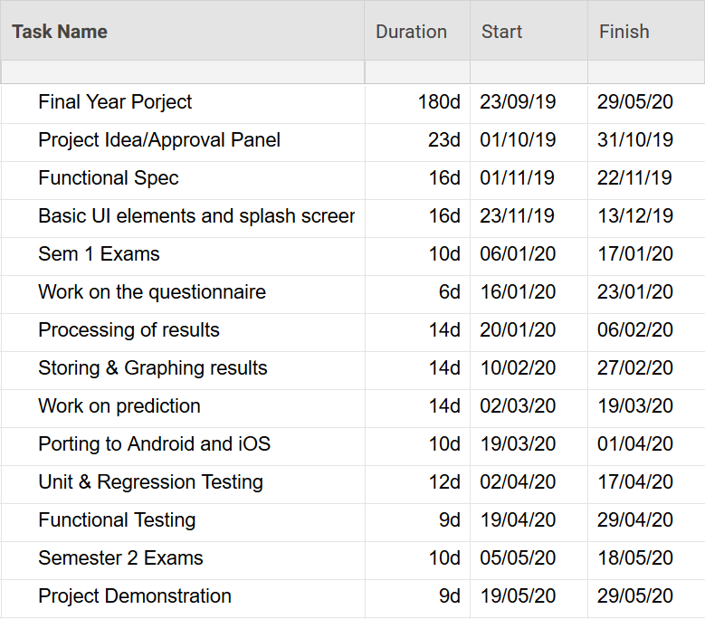

Above is the list of tasks we have to do in order to complete the project, an estimated time to completion and start and finish dates. These tasks may spawn smaller tasks and could have the possibility of introducing bugs we did not forsee. These will be tackled in a timely manner as to not have us stray to far from the timeline we have set ourselves.

### 6.2 GANTT CHART

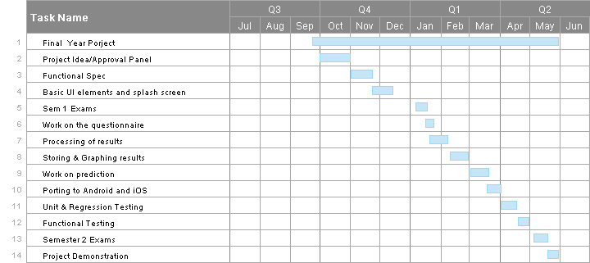

The preliminary schedule is pictured above in our GANTT chart. We have begun the design process of how we want our application to look. We have to put a good bit of thought into this as it needs to be easy to use and user friendly. We aim to have the UI decided upon, the questionnaire finished and the ability to process results done by the end of January/ early February. This will also provide us time to study for our exams in January. By the end of April we plan to have the storing, graphing and predicting of results and the login system completed. This will allow us to use the final few weeks to iron out bugs and make tweaks where necessary.

## 

## 

## 

## 

## 

## 

## 

## 

## ***7. Appendices***

*Specifies other useful information for understanding the requirements.*

* <https://www.ncbi.nlm.nih.gov/projects/gap/cgi-bin/GetPdf.cgi?id=phd001525.1> This describes in detail each section of the MMSE.