# JavaScript

My Role was to provide some JavaScript functionality to the Group F Banking Application. My contribution would be graded on the level and complexity of the JavaScript implemented.

## Validation and events

throughout this application, I implemented a lot of JavaScript functionality to make sure the information included in the forms was correct. This can be easily done if the form calls on a JavaScript function. This was done on all of the pages in the *register_pages* folder. The script would read in the values from the IDs in the form and check to see that they contained the right information.

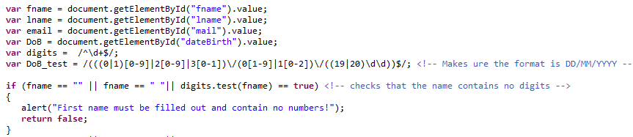

An alert would be returned displaying the error to the user so that they can correct it. This method was applied across all the “Register Pages”.

There was also validation carried out on the *accountPage.jsp* and *adminUser.jsp* pages. For every form in the application, JavaScript validation was used.

## Animations

JavaScript also has the capability to implement some animations. The anime.js script (template from <https://tobiasahlin.com/moving-letters/> ) was used to animate the motto of the GFB (“Fluent in Finance”) across the screen in the *index.html, login.jsp* and *accountPage.jsp* pages. The letters were originally set to be invisible using the opacity setting and then were faded in gradually using the delay function.

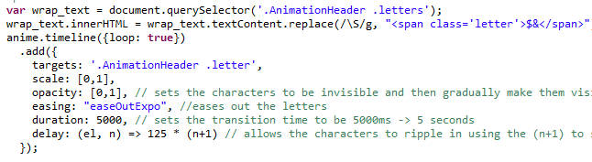

There was also a slideshow done on the index.html page. The basis of this slideshow was taken from <https://www.w3schools.com/w3css/w3css_slideshow.asp> and it was modified to suit the application. There were 3 slides, coupled with captions that showed on screen for 5 seconds and then move onto the next photo.

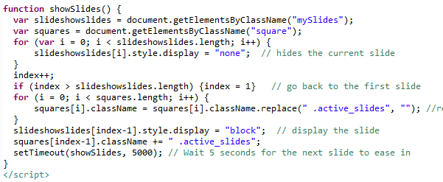

On the *accountPage.jsp*, there was also some JavaScript which took the id and balance of a user passed by the LoginServlet.java page and stored it in local storage.

# Other contributions

## Index.html

I was given the task to create the index.html page. As mentioned above, I provided the JavaScript functionality, but I also wrote the entire body including the CSS file associated with this page. It is the landing page for the application. The dynamic sidebar that was already coded by one of my colleagues was also implemented into this page.

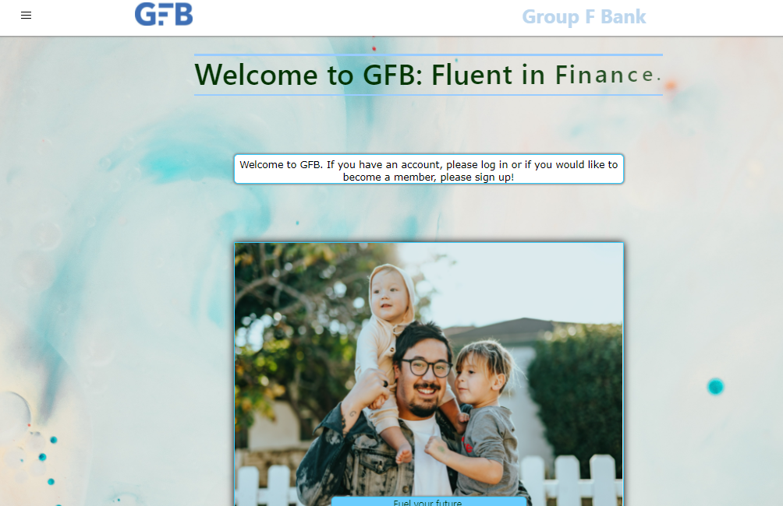

## UserStatements.jsp

I was also delegated the task of creating a script that returns the users transactions. The users ID was passed to this page through a form that had the ID as a hidden element that was triggered when the statements button was selected. The *UserStatements.jsp* page connects to the Database using the username and password of the user and the select statement is executed:



This statement then accesses the database and retrieves the information while displaying the following page

