MOBILE CHARGER
Project Progress Log
Semester Project
Submitted By – NAGA SIVA MOHITH BOMMISETTY [EE26BTECH11218] & OOTA HARSHA SAI RAM [EE26BTECH11220]

This log covers building a mobile charger circuit (transformer → bridge rectifier → filter capacitor → 7805 regulator → USB output), soldered on perfboard, along with designing a 3D-printed enclosure for it in FreeCAD.

Summary
Date | Milestone
21 Sept | Circuit soldered on perfboard; transformer turned out faulty (noise + low output).
22 Sept | Transformer replaced; first FreeCAD enclosure attempt kept giving fuse/tree errors.
24 Sept | Restarted enclosure model with a cleaner Pad/Pocket structure and labelled tree.
25 Sept | 3D enclosure model finished (mounting bosses, rails, USB cutout, screw panel).
26 Sept | Swapped 100 µF capacitor for 2200 µF — original wasn't smoothing ripple enough.

Day 1 — 21 September
Soldered the circuit onto the perfboard as per the schematic — bridge rectifier (4 diodes), filter capacitor, 7805 regulator, and USB output. [3], [5]-[8].
On testing, ran into two problems: the transformer was making a buzzing noise, and its output voltage was too low for the 7805 to regulate properly to 5V. Used an AI assistant to help troubleshoot the circuit [1].
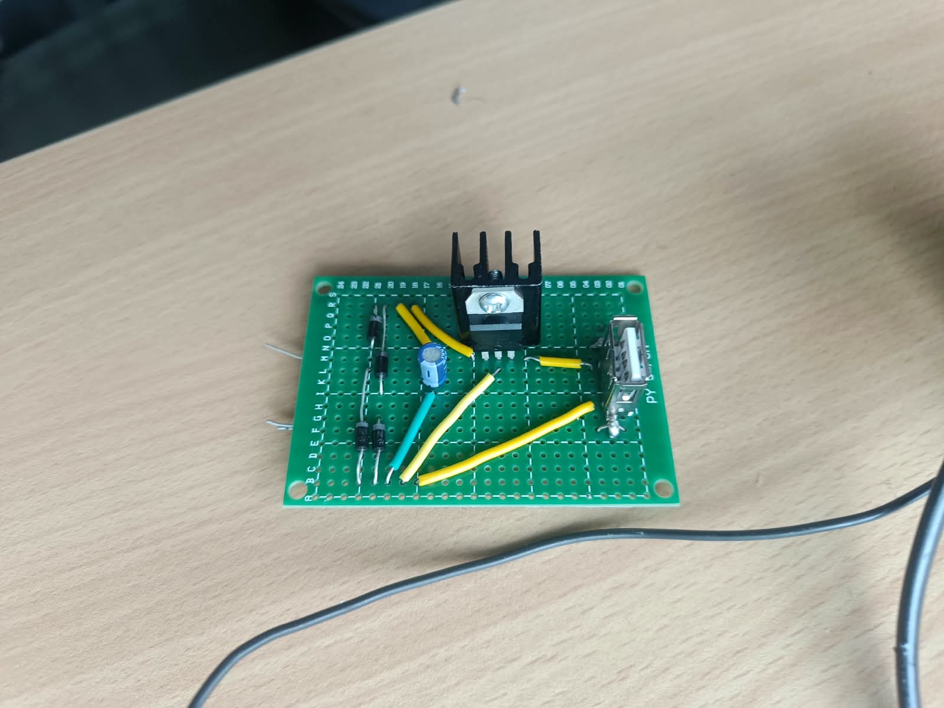
Fig. 1 — Perfboard after initial soldering: 7805 (with heatsink), diodes, and USB output mounted; transformer connected separately.

Day 2 — 22 September
Got the faulty transformer replaced. Also started working on the 3D model for the enclosure in FreeCAD alongside this.
The first modelling attempt kept giving rendering errors, mostly from using Boolean fuse operations between bodies wrong, plus the feature tree was messy and unlabelled so it was hard to even find what was causing the errors. Used an AI assistant for FreeCAD modelling guidance [1][2], and referred to a YouTube tutorial for modelling tips and advice. [4].
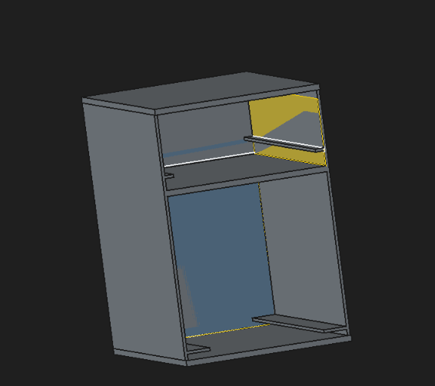
Fig. 2 — First enclosure attempt: two-compartment shell (transformer bay below, perfboard bay above).
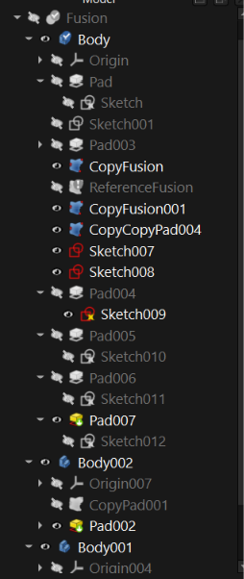
Fig. 3 — Feature tree of the first attempt, showing the messy and unlabelled Fuse/Pad structure that caused rendering errors.

Day 3 — 24 September
Started the enclosure model over from scratch. This time avoided unnecessary fuse operations, stuck to simple Pads and Pockets on one Body, and renamed each feature as I went so the tree stayed clean and easy to debug.
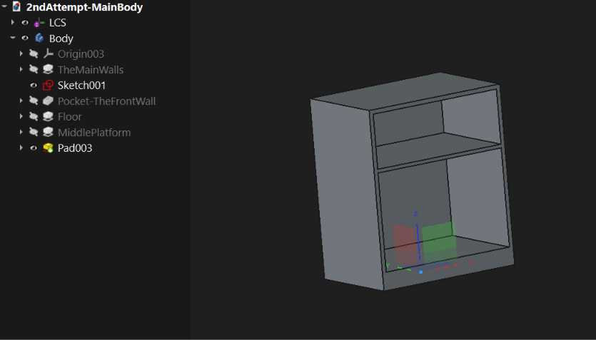
Fig. 4 — Second attempt: clean feature tree (TheMainWalls, Pocket-TheFrontWall, Floor, MiddlePlatform, ...) and the resulting shell with a visible middle platform.

Day 4 — 25 September
Finished the 3D model: bottom floor with screw bosses and pilot holes for the transformer tabs, a middle platform separating the transformer and perfboard compartments, slide-in rails for the perfboard, a USB cutout, and a screw-mounted front panel.
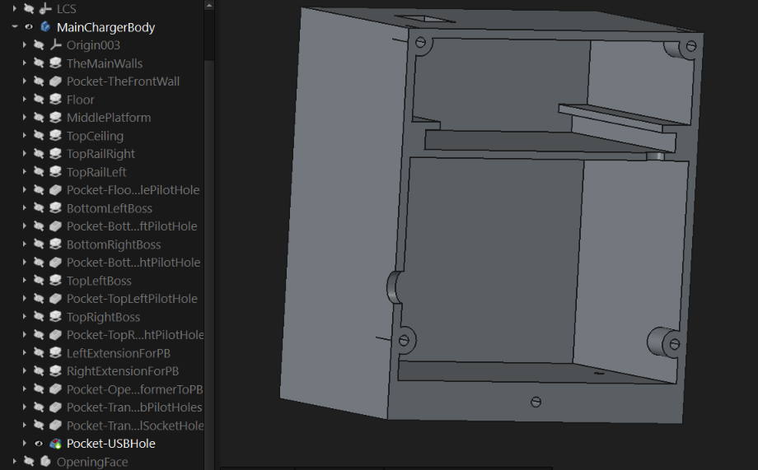
Fig. 5 — Completed enclosure body (MainChargerBody) with full feature tree: rails, bosses, pilot holes, USB cutout and opening face.
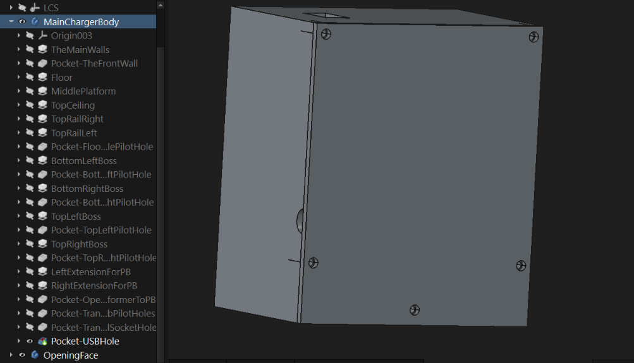
Fig. 6 — Side view of the completed enclosure showing the four corner mounting screws for the front panel and the USB cutout on the side wall.

Day 5 — 26 September
During testing, found the 100 µF filter capacitor wasn't enough to smooth the rectified voltage properly — there was noticeable ripple at the 7805's input. Swapped it for a 2200 µF capacitor, which smoothened the ripple more than the previous 100 µF capacitor and gave a more stable 5V output. [9], [10].
With the 100 µF cap, the high ripple was enough to make the phone refuse to charge or drop to a barely-there trickle current instead of charging normally — likely tripping the phone's input voltage protection (UVLO/OVLO) and/or breaking the fast-charge handshake. [1]. After the 2200 µF swap, charging behaved normally again.
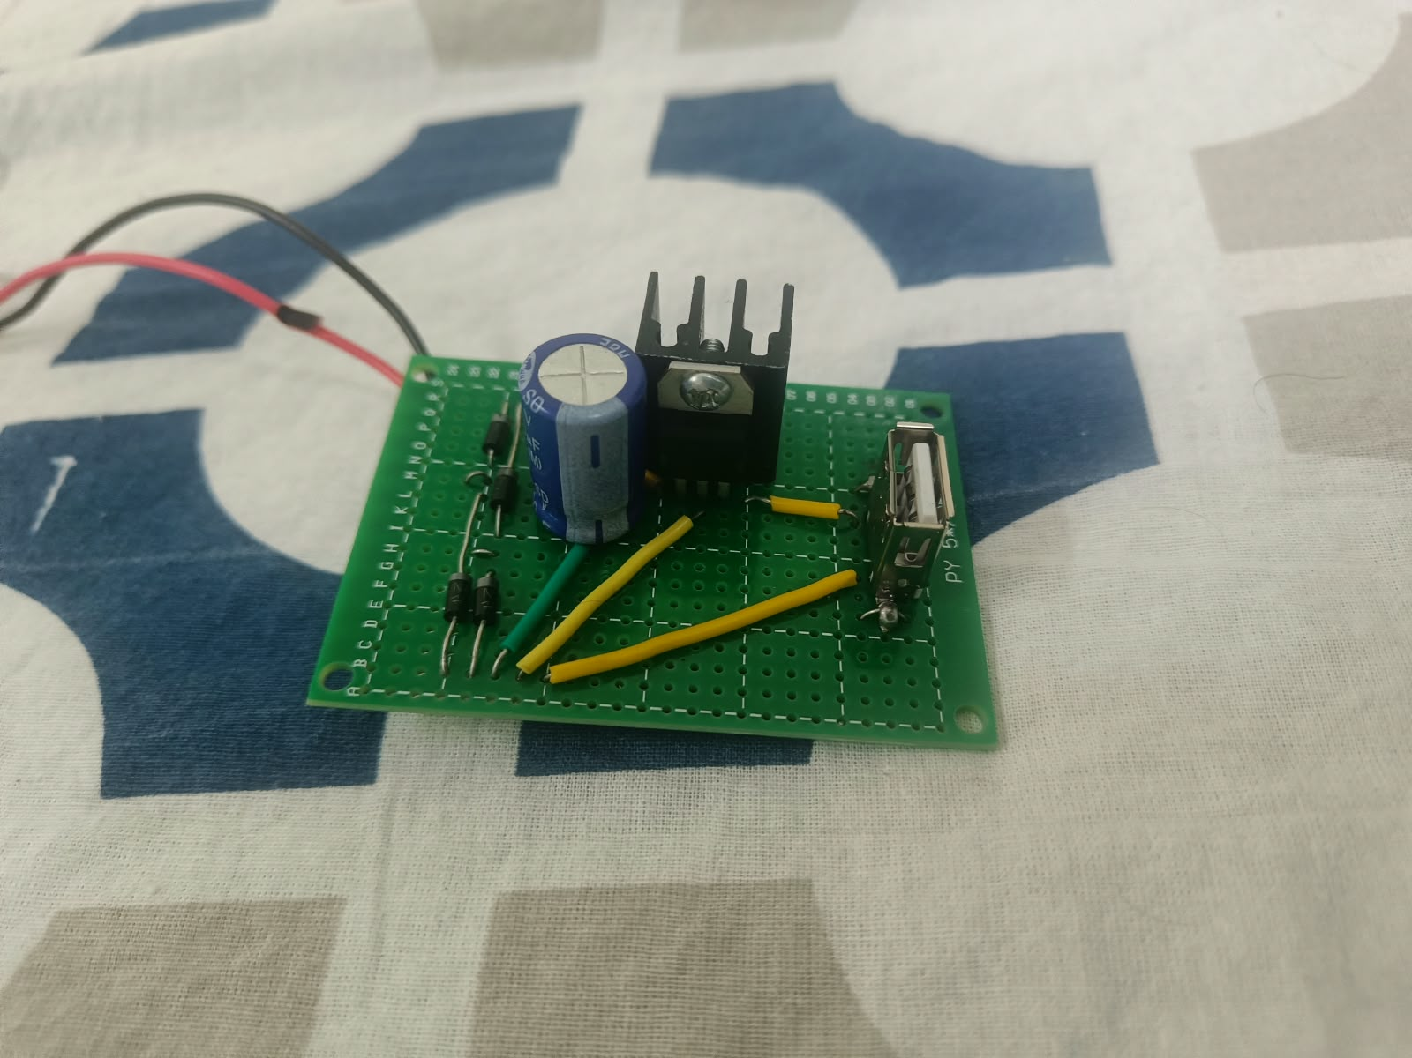
Fig. 7 — Final perfboard build with the 2200 µF filter capacitor in place and mains input leads soldered on.

References
[1] Anthropic, Claude (Sonnet), Large language model, 2026. [Online]. Available: https://claude.ai
[2] Google, Gemini, Large language model, 2026. [Online]. Available: https://gemini.google.com
[3] ALL ABOUT ELECTRONICS. “What is Heat Sink? Why Heat Sinks are used in Electronics? How Heat Sink Works? Heat Sink Explained”, Youtube, March 2019, [Online]. Available: https://www.youtube.com/watch?v=LA6H_rGoJsI
[4] Deltahedra. “FreeCAD - Ultimate Complete Beginner Tutorial”, Youtube, Nov 2025, [Online]. Available: https://www.youtube.com/watch?v=E14m5hf6Pvo
[5] Polonium Technologies. “LM7805 Voltage Regulator Explained | Pinout, Features, Applications & Limitations”, Youtube, Oct 2025. [Online]. Available: https://www.youtube.com/watch?v=cIP_QH5TTHk\
[6] M Electro Expert. “How to make DC Power Supply Project || DIY DC 5v Mobile Charger”, Youtube, Feb 2023. [Online]. Available: https://www.youtube.com/watch?v=gtMcQeLSiSM&t=403s
[7] How Do You? DIY. “Using Perfboard | Soldering Basics | Soldering for Beginners”, Youtube, Nov 2010. [Online]. Available: https://www.youtube.com/watch?v=l9Kbr8cPqOE&t=10s
[8] Marc de Vinck. “Perfboard Soldering Tutorial | Make Your Arduino Circuit Permanent”, Youtube, Oct 2019. [Online]. Available: https://www.youtube.com/watch?v=a3wDEcORRR4
[9] Studying L Plus. “52- Smoothing capacitors”, Youtube, May 2020. [Online]. Available: https://www.youtube.com/watch?v=UkSO70SMuqI
[10] The Engineering Mindset. “Full Wave Bridge Rectifier + Capacitor filters + half wave rectifier”, Youtube, March 2021. [Online]. Available: https://www.youtube.com/watch?v=RiRyzLl4Y8U

