UGV (BLUETOOTH GAMEPAD CONTROLLED)
Project Progress Log
Semester Project
Submitted By – NAGA SIVA MOHITH BOMMISETTY [EE26BTECH11218] & OOTA HARSHA SAI RAM [EE26BTECH11220]
This log covers building an Unmanned Ground Vehicle (UGV) on a two-wheel chassis. An ESP32 drives the two DC motors through an L293D motor driver, and the vehicle is controlled wirelessly over Bluetooth from the Dabble gamepad app on a phone.
Summary
Day | Milestone
Day 1 | Got the parts and assembled the UGV. While testing the motors we found loose battery wire connections and replaced the wires.
Day 2 | Implemented the Dabble gamepad code. Left and right turned out reversed because we had given them the wrong way round, so we changed the connections to match the code. The UGV now works fine from the Dabble gamepad.
Day 1
Got all the parts and assembled the UGV: the two-wheel chassis with the ESP32 and the motor driver wired on a breadboard, powered from a holder with two 18650 cells (Fig. 1). When we tried to test the motors they did not run properly, and on checking we found that the wires connecting the battery were loose. We replaced the battery, which fixed the problem.
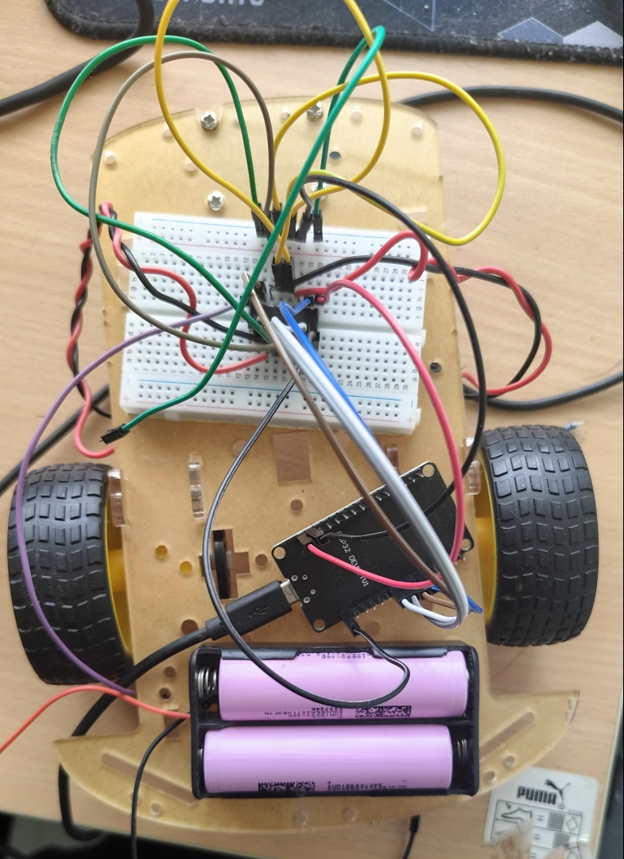
Fig. 1 — Assembled UGV: ESP32 and breadboard wiring on the chassis, powered by two 18650 cells.
Day 2
Implemented the firmware using the DabbleESP32 library with the gamepad module. The ESP32 starts Bluetooth under the name UGV_ESP32, and the phone connects to it from the Dabble app. The motor driver inputs follow our schematic: GPIO 32 and 33 for Motor A, and GPIO 25 and 26 for Motor B. Speed is set with PWM at a fixed cruise value of 200 (out of 255), and the motors are driven through analogWrite() on the driver input pins.
The D-pad of the Dabble gamepad (Fig. 2) is used for all movement, as listed in Table 1. Releasing the buttons stops both motors. Left and right are pivot turns, with the two wheels spinning in opposite directions.
Table 1 — D-pad controls (as implemented in the final code).
Button | Motor A | Motor B | Action
Up | Forward | Forward | Move forward
Down | Reverse | Reverse | Move backward
Left | Reverse | Forward | Pivot left
Right | Forward | Reverse | Pivot right
None pressed | Off | Off | Stop

When we first ran the code, left and right were reversed: the UGV turned right when we pressed left and the other way round. The mistake was ours, as we had given the left and right directions the wrong way round while writing the code. Instead of rewriting the logic, we changed the motor connections to match the code. After this the UGV responds correctly to all four buttons and works fine.
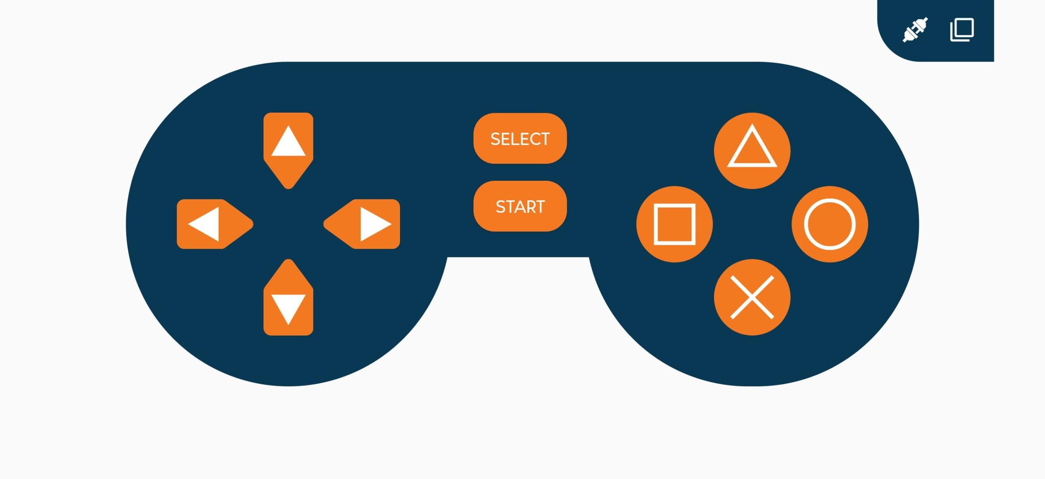
Fig. 2 — Dabble gamepad interface used to control the UGV.

