Explain the advantages and disadvantages of Hamiltonian Monte Carlo and Sequential Monte Carlo versus Metropolis-Hastings Monte Carlo.

Markov Chain Monte Carlo Sampling (MCMCS) is a general framework for sampling from probability distributions, particularly when it is difficult to directly sample from the distribution of interest. MCMCS creates a Markov chain, which is a sequence of random variables, such that the sampling distribution of the variables converges to a desired distribution over a large number of iterations.

The most well-known MCMC algorithm is the Metropolis-Hastings algorithm. The Metropolis-Hastings algorithm is a specific MCMC algorithm used for sampling from a target probability density distribution. It works by iteratively proposing new candidate states and accepting or rejecting them based on a certain acceptance criterion.

Markov Chain Monte Carlo Sampling (MCMCS) [e.g., Metropolis Hastings Monte Carlo Sampling (MHMCS)] gives us very accurate estimates even for complex probability distributions. MCMCS is inefficient in that it takes a long time to get those accurate answers.

[](https://us-prod.asyncgw.teams.microsoft.com/v1/objects/0-eus-d11-26a770b300e60aee82aaabb42644692f/views/imgo)

Hamiltonian Monte Carlo Sampling HMCS uses gradient information for the proposal step. In addition to selecting a point based on the Metropolis-Hastings criterion, it looks at a direction that yields highest gradient ascent. HMCS results in faster moves to interesting regions, more efficient search of distribution of interest, and faster collection of answers. Calculating a gradient is costly and only works with continuous distributions.

[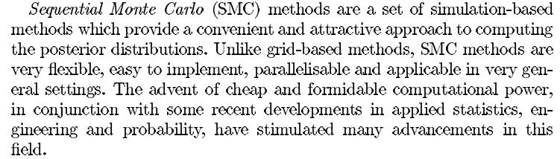](https://us-prod.asyncgw.teams.microsoft.com/v1/objects/0-eus-d4-855de9b2a06cf7c6185d83fd7cc6a889/views/imgo)

SMCS is primarily used for filtering and inference in dynamic or time-series models, where you want to estimate the hidden states of a system that evolves over time in the presence of noisy observations.

MHMCS sampling is a general-purpose Markov Chain Monte Carlo (MCMC) method used for estimating the posterior distribution of a parameter or set of parameters in a static model. It is not inherently designed for sequential or time-series data.

SMC and MHMCS are not directly comparable.