1. **Solar System**
2. **Basic Concept**

>> Light has both energy, wavelength

Smaller the wave length, bigger the energy

>> **solar thermal energy (STE) Solar.**

the conversion of the radiant energy from the sun into heat,

which can then be used for such purposes as space and hot water heating,

industrial process heat, or power generation. ... solar thermal energy.

When a dark surface is placed in sunshine, it absorbs solar energy and heats up.

**>> Solar Thermal**

Using the sun’s thermal energy for heating and/or electricity generation

1) Concentrated solar power (CSP)

2) Solar Photovoltaic (Solar PV) technology,

- we convert light directly into electricity.

The average price of electricity generated this way is already similar to that of fossil fuels

3) Modern solar PV panels operate at around 20% efficiency,

meaning they can turn 20% of the light energy that strikes them into electricity.

**Link :**

<https://climatescience.org/advanced-energy-solar/>

1. **Actual Implementation**

The sensors attached to the system sense the conditions and Arduino analyze the data received from these sensors about parameters. It has a Wi-Fi module which help in connecting the mobile [18]. All these parameters are uploaded to the cloud and the user can have access of these real time parameters any time

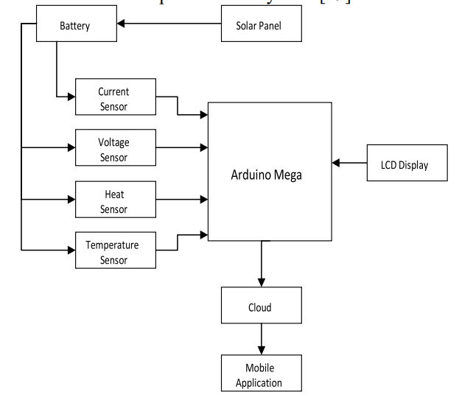

1. **Wind Power System**

* **Basic Concept**

>> Wind Power

Wind power comes from large wind turbines, which turn the kinetic energy of wind into electrical energy.

>> Onshore vs Offshore Wind

Onshore wind is the one that blows from the sea towards the land.

On the other hand, offshore wind is the type of wind that blows from the land towards the sea.

The winds usually occur due to differences in pressure, in the atmosphere.

For example, when there exists a difference in pressure

within the atmosphere, air will shift from areas with higher pressure

to areas with lower pressure. This, in return, results in the creation of winds at various speeds.

These effects are what takes place during the sea breeze

and land breeze.

For instance, if the atmospheric pressure is high,

and with a clear sky, the land warms up in the daytime and gets cold by nighttime.

The result of this is that wind will blow from the sea at daytime towards the land,

while at night, it will blow from the land towards the sea.

>> Why Offshore wind ?

The winds out in the ocean are much stronger and consistent

that the winds on land.

This made it necessary to improve the wind turbines technology

and use it in the ocean where they can produce more power

>> How to produce more wind power

There are two main ways to produce more wind power within a given area.

First, the size of the rotor and blades can be increased to cover a wider area and thus,

increasing the capacity of the turbines.

Second, the turbine and blades can be raised higher up into the atmosphere

where winds are steadier which would increase the turbine’s capacity factor.

In order to make onshore wind turbines bigger,

materials and designs must be considered

in order to withstand the stressors from high altitudes and strong winds.

Several non-technical factors must also be taken into account such as transportation

and infrastructure limitations, land use concerns, and the presence of large birds.

One of the largest wind power plants in the United States is the Alta Wind Energy Center,

located in California with an installed capacity of 1.55 gigawatts.

-- 2 factors --

1) Rated power: Turbines make more power when the wind is faster, right?

Yes, right. But at some point this stops and faster wind won’t lead to more energy.

This point is called **Rated power**, and **the higher it is**, the better.

2) Capacity factor:

This is the fraction of time a turbine is running at its rated power.

If we build a turbine in a region with little wind, it will rarely reach its rated power.

Therefore it will have a low capacity factor.

Currently, onshore wind turbines operate at only a 34% capacity factor.

-- Let's increase --

1) Bigger is better - Increasing rated power

In recent years, wind turbines have been getting bigger. The image below shows how the diameter of turbines in the US has increased over the last 20 years:

While bigger turbines do cost more to construct, they also produce more energy so they are cheaper in the long run.

However, the blades are now getting so enormous that transporting them

from the factory is becoming a lot harder.

This means we have to build the turbines on-site,

which can be more expensive.

Bigger turbines also experience greater forces from the wind,

so need to be built out of stronger material, which can be difficult to produce

2) Increase the capacity factor!

How could we increase the capacity factor of wind turbines?

(Remember: the capacity factor describes how often it’s running at full power.

Also important: more reliable wind means more reliable power

Generally speaking, the wind at sea is both faster and more constant than on land. Therefore, wind turbines at sea (called offshore turbines) can generate more power, more consistently

**2) Actual Implementation**

• First part consists of wired/wireless many sensors and devices network which are responsible for sensing and measuring the data of wind turbine and environment.

• Second part is an IoT gateway device which provides the communication between IoT devices, sensors and cloud. Ex) Rasberry Pi

• Third part is the cloud which provides a quick and convenient way to store the large amount of data that obtained from different sensors and devices.

• Fourth part is data visualization for real timemonitoring. It provides precious insight that helps maintain the reliability, availability, and performance of a measured system. This helps users react fast changing and emerging situations

Ex) PowerBI. Node-Red

