**IoT Farm Energy Management (Solar) System**

Bumjun Oh, Hyeongyu Lee, Jiacheng Wang, Hanbyeol Lee, Sangje Jeong, Minji Lee, and Eric T. Matson

Author’s affiliation (will be updated later)

Chung-Ang University & Purdue University

addresses (will be updated later)

wjc847867030@gmail.com, dhsys199@gmail.com,  yhb18340@gmail.com, dlgusrb09@gmail.com, jun915350@gmail.com, lee3450@purdue.edu  and  ematson@purdue.edu

***Abstract—* Amongst renewable energy sources, solar power energy is gaining popularity thanks to low carbon dioxide emission and increasing efficiency. Populations who are taking part in agricultural activities tend to rely on electricity generated from a long distance and solar power energy is not an exception. Photovoltaic(PV) solar panels are one of the ways to harness solar power into renewable energy with only a major initial cost but low maintenance. However, due to the tendency of solar energy systems being far away from the electricity users, energy health monitoring in real time and maintaining recovery from faults is the key goal. This report suggests a way to interact and maintain an off-grid solar energy system from many miles away.**

***Index Terms—* AWS, CAT.5e, CH340, CLI, COM, DC, Ethernet cable, LoRa, LoRaWAN, Modbus protocol, MongoDB, MPPT, MQTT, Node-Red, NoSql, PV, Register, RJ45, RS232, RS485, Serial communication protocol, USB,  database, server, solar charge controller,**

1. **INTRODUCTION**

The purpose of this project is to build a module that monitors the real-time status of an off-grid solar energy system via communication with a solar charge controller and LoRa device to send data through a long distance. The main use of the application is rural areas with difficult access to solar energy due to distance.

1. **LITERATURE REVIEW**

Author Ambuj Gupta, Rishabh Jain, Rakshita Joshi and Ravi Saxena,[1] introduces an idea about IoT based solar energy monitoring system. The main aim of this system is to monitor and analyze solar setup, the rang is from the smallest PV arrays to the biggest solar farms operating in the world. Based on the modern world technology, everything could be accessible via the internet. Therefore, the system aims to collect data from the IoT platform which could help the user monitoring of the data in a real-time. The whole process become a real-time monitoring. The whole process used Raspberry Pi to receive data from Analog to Digital converter on the Lab View platform, and a DC transducer to converts an available DC input into the appropriate DC signal that could be received. Overall, this paper provides that solar monitoring and analyzing system could be installed in an easy, stable, and reliable way.

Suprita M. Patil, M. Vijayalashmi, and Rakesh Tapaskar,[2] introduces a solar energy remote management system, the system could monitor the power and energy usage, and the main objective of this system is to use the Arduino to monitor the current and voltage value. The data stored in cloud could be analyzed by using the MatLab. The Arduino used for reading the sensor values, Raspberry Pi used for as a server, by connected Arduino and Raspberry Pi, the data information will display on the web through Raspberry Pi, for these data information that received will be upload into the cloud.

Mirsad Hyder Shah and Nasser Hassan Abosaq,[3] explained an experimental work that using for real-time and low-cost monitoring system for solar energy management. By using the Node-Red and NodeMCU, the system is able to monitor the current and voltage of the solar panel. Moreover, the paper also explained that the typical solar panel waste about 15-20% of their max power potential due to magnetic declination. To solve this problem, the paper explained by correcting the tilt angle to improve the solar panel efficiency.

1. **ENVIRONMENT SETTING**
2. *Raspberry Pi Setting*

The application is currently using Raspberry Pi 3 Model B running the 32-bit Raspberry Pi OS. It has Python 3 and Python 3 IDLE for Python script editing and running. It is required to have various python modules and libraries to execute communication with solar charge controller.

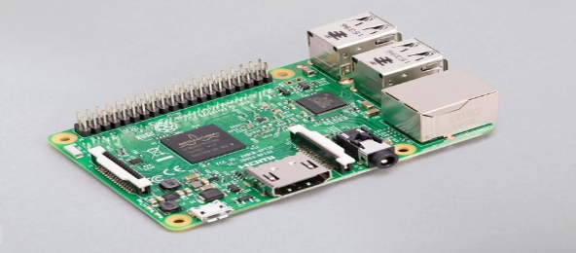

Fig. 1. Raspberry Pi 3 Model B

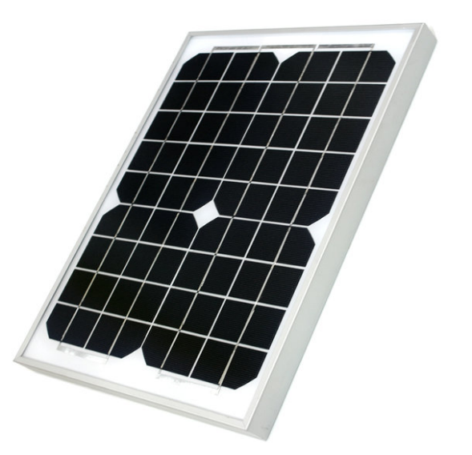

Fig. 2. Photovoltaic solar panel

1. *Photovoltaic Solar Panel*

The photovoltaic solar panel (shortly PV panel ) used in this application generates 30W(watts) with 18V output. It generates electricity with the solar cells attached to it and sends electricity through direct current(DC) electric wires.

1. *MPPT solar charge controller*

The equipment that is used in this project is MPPT solar charge controller manufactured by a company named EPSOLAR, model named XTRA3120N. The controller receives electricity generated from the solar panels. Simultaneously, the controller either charges connected batteries or gives output load for immediate use of electricity. The controller has a micro computing unit(MCU) inside that monitor and saves real-time data that has been generated by the flow of electric current. The data are stored in 16-bit registers and single-bit coils. This equipment can have communications with other devices via RS485 serial communication with Modbus protocol. It uses a physical port that is widely used for internet connection, such as the RJ45 port for COM.

1. *12V Lead-acid Battery*

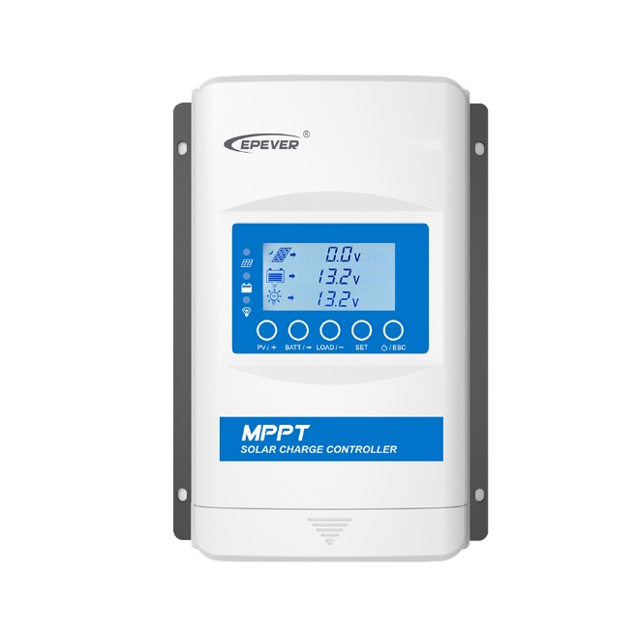

Fig. 3. EPEVER XTRA3210N

Solar charge controller needs to save power in a battery that has the compatible voltage input and ampere according to the controller. The controller can charge batteries with input voltage of 38v. However, since the solar panel’s optimal output voltage is 18v, a battery with lower input volt rate is needed.

Fig. 5. 12v 2a lead-acid battery

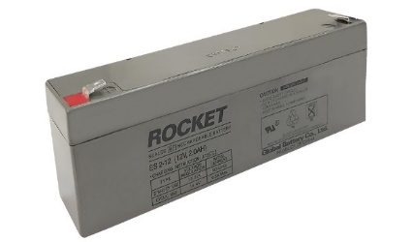

1. *Improvised USB to RS485 cable*

The EPSOLAR company produces and sells communication cables that can allow users to connect between PCs and controllers. However, the project uses an improvised and an economical way that can function identically to the official product. Here are the materials to make up the USB to RS485 cable:

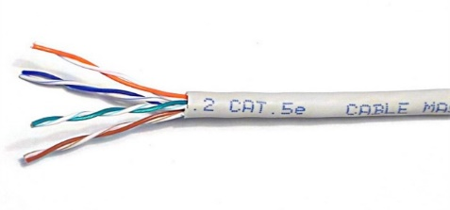

Fig. 6. CAT. 5e cable

* 1. *CAT.5e:* Category 5eethernet cable should be peeled off on one end to make connection with the USB to RS485 module which is described after.

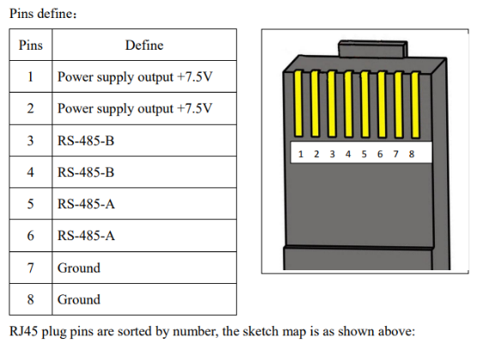

Fig. 7. Pin layout of CAT.5e cable

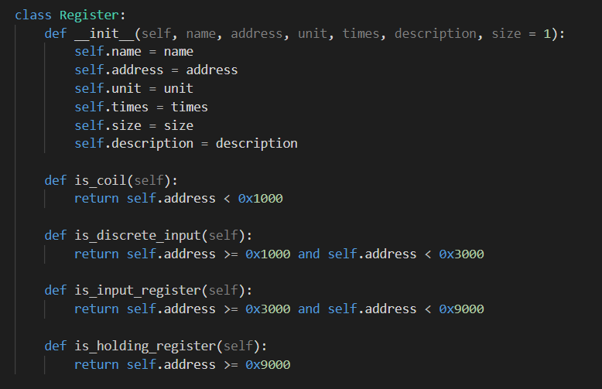

Fig. 10. Register class

* 1. *USB to RS485 module:*

This module has several components that allow data flow from RS485 Modbus protocol to USB. The improvising process requires connecting CAT.5e wires number 4(RS-485-B) and number 6(RS-485-A)( green and blue respectively), to the screw terminal with ‘A’ and ‘B’ accordingly.

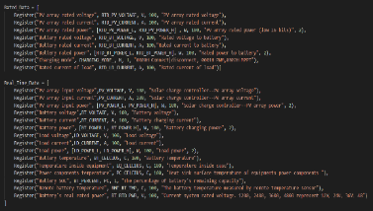

Fig. 11. Register arrays

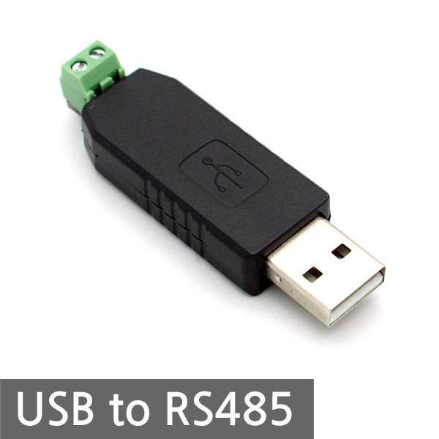

Fig. 8. USB to RS485 module

1. *Python scripts for communication between controller and Pi*
   1. *Register addresses:* The solar charge controller uses 16-bit addresses and single-bit coils to as a Modbus protocol. There are read input register, read and write holding registers, read and write coils and read discrete inputs. The datasheet of these addresses was saved in the script as constants for easier use.
   2. *Register object arrays:* Using the previous addresses, all related data such as variable name, unit, descriptions are saved to an instance of a class named ‘Register’. Collection of those instances form arrays by their categories.

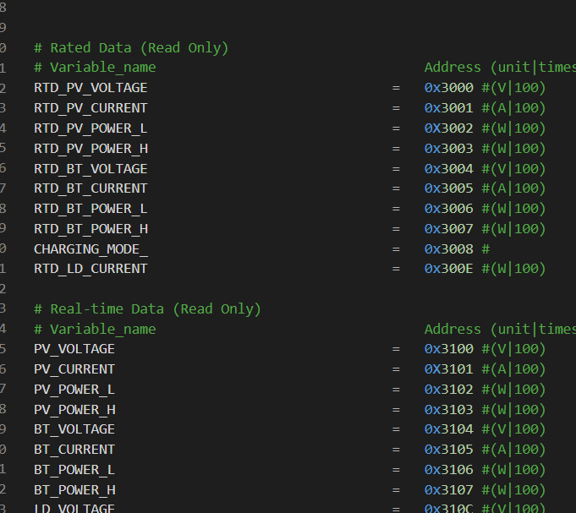

Fig. 9. Register address constants example

* 1. *Main:* The main python script firstly checks the connection with the solar charge controller and if connection is made, then makes another connection to the database server (MongoDB) to upload generated data in real-time. When connection with the database server is finally done, the running script is ready to receive data from the controller and save individual data from each register to a dictionary. Iteration in the register arrays allow to refer to different data representing different things like the voltages and currents of PV panels and batteries. Once the dictionary is filled with data that were requested, the dictionary is finally sent to the database with respective time stamp and object ids.

1. *AWS EC2 Instance for Deployment*

AWS EC2 Ubuntu Instance was used as a remote server. Amazon EC2 Instance is a virtual server in Amazon’s Elastic Compute Cloud for running applications on the AWS infrastructure.[4]

AWS is a comprehensive, evolving cloud computing platform. EC2 is a service that enables business subscribers to run application programs in the computing environment.

Fig. 12. AWS EC2 Instance

1. *Node-Red Application for Data Visualization*

Electricity, Temperature, Humidity and other info had to be shown in detail by web Application so that User can easily see the current status of Solar panel system.

Node-Red Framework was used for Data Visualization which shows the data extracted from database in real-time.

Node-Red is a flow-based development tool for data visualization. It provides web-browser based flow editor.

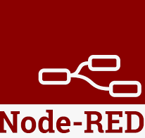

Fig. 13. Node-Red Framework

1. *MongoDB Database for Database*

MongoDB is an open source, nonrelational database management system that uses flexible documents instead of tables and rows to process and store various forms of data.[5]

Solar Panel info coming from the solar controller is saved to MongoDB through Raspberry Pi.

Database saved in MongoDB is displayed by Node-Red Framework

**

Fig. 14. MongoDB Database

1. **DATA AND RESULTS**
2. *Data from solar charge controller*

Real-time data with Real-time status of the controllers are requested and sent to Raspberry Pi and again sent to the database.

1. *AWS EC2 Server Running*

Virtual server in Amazon’s Elastic Compute Cloud runs applications on the AWS infrastructure.

<http://18.116.64.150:1880> is the link of the Solar Energy Management System.

1. Node-RED

Interacting with MongoDB, Node-red shows the controller’s Real time data using AWS EC2 Instance as a Server.

The Node-RED pages consist of main tracer and gauge. Main tracer shows the real time data from the MPPT controller. Data mainly consist of Solar , Battery, DC Load, Controller, Energy Information. Real-time Voltage data of PV, Battery, DC Load are shown as Chart also so that use can compare them easily. The data from the controller are sent to MongoDB which is a storage in this system.

On the other hand , Gauge shows outward humidity and temperature data. User can also see the real-time change of data with Chart below the page.

Displayed data is updated per 30 seconds, according to the timestamp. Most Recent data is shown every 30 seconds.

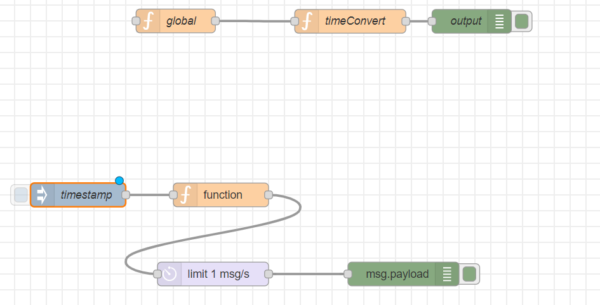

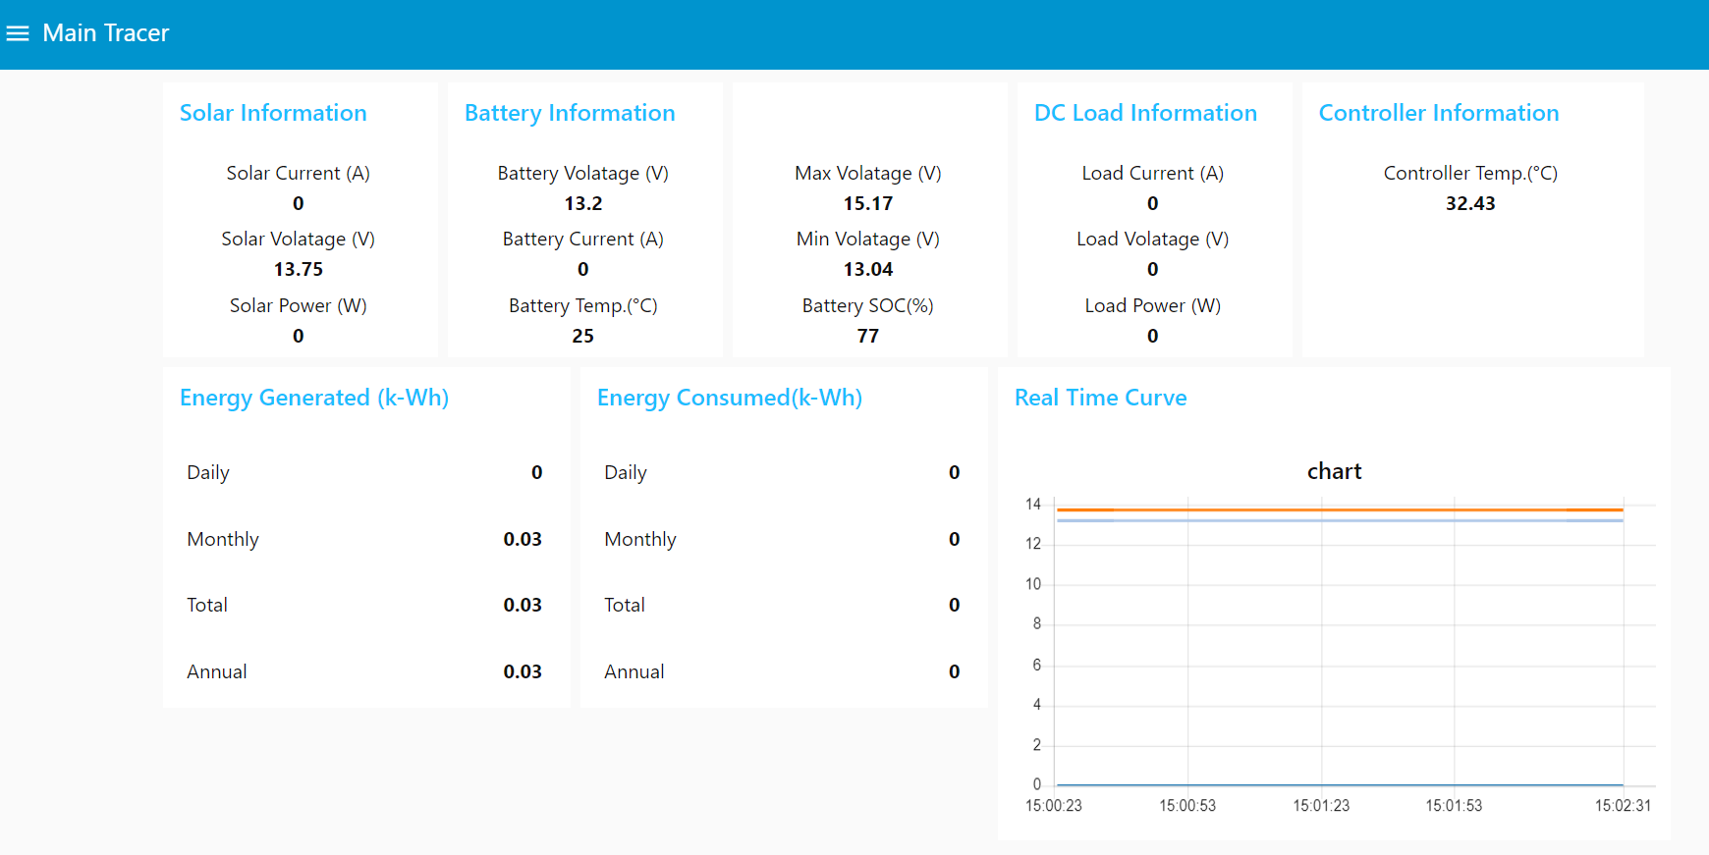

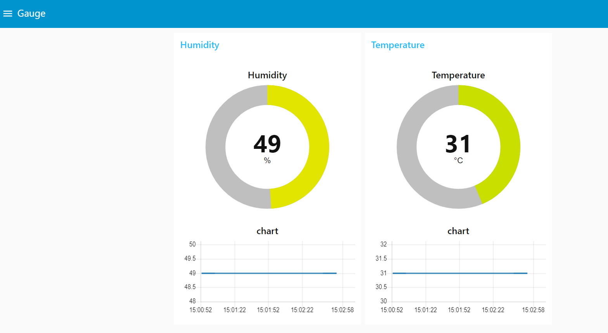

1. **DISCUSSION**
2. Solar Panel to Controller
3. *Photovoltaic(PV) Solar Panel*: The Solar Energy could be an electric energy to use eco-friendly in our life. Photovoltaic(PV) solar panels are chosen to receive and charge the energy.
4. *The MPPT solar charge controller*: This controller either charges connected batteries or gives output load for immediate use of electricity. The controller has a micro computing unit(MCU) inside those monitors and saves real-time data that has been generated by the flow of electric current. The data are stored in 16-bit registers and single-bit coils. It uses a physical port that is widely used for internet connection, such as the RJ45 port for COM.
5. Controller to Raspberry pi
6. *Raspberry pi*:

Raspberry pi works simultaneously as a LoRa module and as a device that pulls data from the controller. This device is a bridge between the solar charge controller and the LoRa gateway that will be installed from many miles away. Although this device pulls data with no errors, there is an assumption that the script and the equipment used for the connection cannot be applied to different types of solar charge controllers.

1. *MPPT controller*: This equipment can have communications with other devices via RS485 serial communication with Modbus protocol.
2. *Connection*: RS485 module has several components that allow data flow from RS485 Modbus protocol to USB. The improvising process requires connecting CAT.5e wires number 4(RS-485-B) and number 6(RS-485-A)( green and blue respectively), to the screw terminal with ‘A’ and ‘B’ accordingly.
3. Setting up in LoRa Network
4. Raspberry pi to MongoDB
5. *Raspberry pi*: Raspberry Pi 3 Model B running the 32-bit Raspberry Pi OS has Python 3 and Python 3 IDLE for Python script editing and running.
6. *MongoDB:* MongoDB is a NoSql database that has a collection of documents that conveys multiple data of the charge controller distinguished by its own timestamp. The interval between documents could be set from 30 seconds to a minute for visualization in Node-Red.
7. *Python script*: The main python script firstly checks the connection with the solar charge controller and if connection is made, then makes another connection to the database server (MongoDB) to upload generated data in real-time. When database server is connected, the running script is ready to receive data from the controller and save individual data from each register to a dictionary.
8. MongoDB to Node-RED
9. Node-RED:

Node-RED Framework was used for visual programming. Data saved MongoDB is requested by Node-Red. As a response, Node-RED receives the data of solar panel which was saved by Raspberry pi.

There are 2 pages showing the Info. 1st is Main Tracer and 2nd is Gauge.

Main Tracer shows the Solar, Battery, DC Load, Controller info. Additionally, it shows data on amount of Energy generated and consumed.

Gauge page shows current temperature and humidity info of solar panel.

All the info is updated every 30 seconds as Node-RED request new info to the MongoDB per 30 seconds.

User is able to see the most recent data of solar panel, so that they can efficiently manage the solar panel system.

1. Connection
2. **CONCLUSION**
3. **ACKNOWLEDGEMENTS**

We would like to thank Purdue University for taking us as participants of IoT project this summer. We would like to thank Minji Lee for her dedication of being the supervisor throughout the whole program, giving us detailed information for documentation and practical tools for the progress of the project. Especially, would like to give thanks for helping with Node-Red Framework. Her advice was very helpful with getting familiar with Node-Red Framework. We would also like to show gratitude to the professors at Purdue University. Professor Eric Matson's guidance clarified the right way of our project and Professor Anthony Smith provided useful detailed information to help develop our project and make a breakthrough during hard moments. We all were able to make progress and improve our skills during the program thanks to the contribution of the professors and supervisors mentioned above.

1. **REFERENCES**

[1] S. M. Patil, M. Vijayalashmi and R. Tapaskar, "IoT based solar energy monitoring system," 2017 International Conference on Energy, Communication, Data Analytics and Soft Computing (ICECDS), 2017, pp. 1574-1579, doi: 10.1109/ICECDS.2017.8389711.

[2] A. Gupta, R. Jain, R. Joshi and R. Saxena, "Real time remote solar monitoring system," 2017 3rd International Conference on Advances in Computing, Communication & Automation (ICACCA) (Fall), 2017, pp. 1-5, doi: 10.1109/ICACCAF.2017.8344723.

[3] Mirsad, H. S., & Nasser, H. A. (2020). IoT based efficient solar panel monitoring. 3C Tecnologia, 9(4), 87-93. Retrieved from https://www.proquest.com/scholarly-journals/iot-based-efficient-solar-panel-monitoring/docview/2477688312/se-2?accountid=13360

[4] Contributor, T. T., &amp; Wigmore, I. (2021, July 16). What is an Amazon EC2 instance? SearchAWS. https://searchaws.techtarget.com/definition/Amazon-EC2-instances.

[5] By: IBM Cloud Education. (n.d.). mongodb. IBM. https://www.ibm.com/cloud/learn/mongodb.