RESEARCH PROTOCOL
Version: 2.1.2
Use of GLP-1 receptor agonists and subsequent risk of acute liver injury – An analysis in the OMOP CDM (GLP1-ALI)
Content

Version Control 2
List of Abbreviations 3
Responsible Parties 4
Investigators 4
Disclosures 4
Abstract 5
Amendments and Updates 6
Milestones 7
Rationale and Background 8
Study Objectives 9
Research Methods 10
Study Design 10
Data Sources 10
Study Population 10
Exposures and Comparators 11
Outcomes 12
Covariates 14
Negative Controls 14
Analysis Plan 14
Study Diagnostic Thresholds 16
Strengths and Limitations 17
Protection of Human Subjects 18
Plans for Disseminating and Communicating Study Results 18
Appendix 18
Cohort Definitions 18
Negative Controls 18
References 19

Version Control
Version | Date | Changes
0.0.1 | 29 Sep 2024 | Set up basic document. Added study population, comparators, outcomes.
0.0.2 | 30 Sep 2024 | Edited during first kickoff meeting. Adjusted study population, comparators, outcomes.
0.0.3 | 6 Oct 2024 | Filled out research methods section including rationale/background, design, data sources, population cohort definitions, exposures, outcomes, comparators, data analysis, study diagnostic thresholds.
2.0.0 | 20 Oct 2024 | Updated information based on new ALI shift from DILI outcome
2.1.0 | 28 Oct 2024 | Updated ALI outcome based on discussion with Dr. Sree, Dr. Jack, and Dr. Keiko
2.1.1 | 1 Nov 2024 | Updated ALI outcomes and cohort definitions
2.1.2 | 13 Nov 2024 | Updated title. Postponed SCCS. Updated exposure criteria. Updated secondary outcome definitions.

List of Abbreviations
Abbr. | Definition | Notes
ALI | Acute Liver Injury
GLP-1 | Glucagon-Like Peptide-1
T2DM | Type 2 Diabetes Mellitus

Responsible Parties

Investigators
Evelyn Goh (National University of Singapore, e0983111@u.nus.edu)

Disclosures

Abstract
Background and Significance
Study Aims
Study Description
- Population
- Comparators
- Outcomes
- Design
- Timeframe

Amendments and Updates

Milestones

Rationale and Background
Glucagon-like peptide-1 (GLP-1) agonists are a class of medications used to treat type 2 diabetes mellitus (T2DM) and obesity. GLP-1 an endogenous hormone released in response to food consumption, lowering blood glucose through insulin secretion and glucagon inhibition, suppressing appetite, and delaying gastric emptying.
GLP-1 agonists were licensed in the last 20 years for use in overweight patients with T2DM because of benefits with reducing glycated hemoglobin A1c and facilitating weight loss. The US FDA approved the first GLP-1 agonist (exenatide) in 2005.
Currently, the types of GLP-1 agonists that are currently marketed globally are:
Long-acting agonists:
- dulaglutide (Trulicity®)
- exenatide extended-release (Bydureon®)
- liraglutide (Victoza®)
- semaglutide injection (Ozempic®)
- semaglutide tablets (Rybelsus®)
Short-acting agonists:
- exenatide (Byetta®)
- lixisenatide (Adlyxin®)
Clinical trial data, as well as the US FDA Adverse Event Reporting System did not identify a risk of liver enzyme elevation with GLP-1 agonists despite US and Canadian product inserts of liraglutide-containing products lists “elevation of liver enzymes” as an adverse reaction under the Postmarketing Experience section. However, liraglutide-containing products in other countries do not carry any information on the risk of liver enzyme elevation. Likewise, not all GLP-1 agonists labels contain ‘elevation of liver enzymes’ as an adverse reaction as well.
Amidst this uncertainty, some case reports of acute liver injury (ALI) have appeared in the literature. A large-scale observational comparative effectiveness study found that GLP-1 RAs were more effective than other classes of anti-diabetic medicines in the second line setting. However, risk of ALI was not examined in the case report or other subsequent studies. Usage of some GLP-1 agonists are increasing tremendously following recent findings of randomized trials and market approval for obesity. Understanding the safety profile of GLP-1 agonists is therefore ever more critical.

Study Objectives
This study aims to evaluate the risk of acute liver injury (ALI) and drug-induced liver injury (DILI) in users of GLP-1 agonists diagnosed with type 2 diabetes mellitus (T2DM) through both cohort and self-controlled case series (SCCS) methodologies
- Cohort: among patients with T2DM, what is the relative risk of ALI incidence when prescribed with second-line GLP-1 agonists compared to other classes of anti-diabetes medicines?

- SCCS: among patients with T2DM and who have been prescribed GLP-1 agonists, what is the relative incidence of developing ALI/DILI within an exposure risk period compared to baseline?

Research Methods

Study Design
Cohort Study
The cohort study will be retrospective cohort of patients with diagnosis of T2DM and who are second-line users of GLP-1 agonists (with prior Metformin use of at least 90 days) compared to other classes of anti-diabetes medication. The outcome analysed will be the risk of developing ALI.
- Comparators were chosen based on the LEGEND-T2DM study (https://ohdsi-studies.github.io/LegendT2dm/Protocol).

SCCS
Among patients with T2DM and who have been prescribed GLP-1 agonists, what is the relative incidence of developing ALI within an exposure risk period of six months compared to baseline, where baseline can be defined as:
  - Periods where no medication is being taken, and/or,
  - Periods where other medication (as defined in the cohort study) is being taken.
The SCCS will be conducted as a secondary study after the initial cohort study has provided more information and direction about the incidence of ALI in our OMOP CDM cohorts.

Data Sources
Both electronic health records (EHR) and claims databases will be analysed. From EHR, we will take lab values based on the definition of ALI. From claims, we will take diagnostic codes.

Study Population
Cohort Study
Inclusion criteria
- All adults (≥18 years) diagnosed with T2DM will be included.
- At least 30 days of Metformin use prior to index date.
- At least 365 days of observation period prior to index date.
Exclusion criteria
- Prior history of T1DM or secondary diabetes
- Those with existing history of chronic liver disease or liver injury prior to taking of GLP-1 agonists will be excluded.
- Those with acute liver injury within one year prior to index date will be excluded.
- More than 30 days of insulin exposure before index date.

SCCS
All adults (≥18 years) diagnosed with T2DM who are taking GLP-1 agonists and have reported cases of ALI will be included.
For SCCS, we may not exclude the same exclusion criteria as with the cohort study. To be updated.

Exposures and Comparators
Cohort Study
The following second-line medications listed are exposures for the cohort study. As switching between agonists can be common, stratification should take this into account.
GLP-1 RA | Non-GLP-1 RA
Long-acting agonists:  - dulaglutide (Trulicity®)  - exenatide extended-release (Bydureon®)  - liraglutide (Victoza®)  - semaglutide injection (Ozempic®)  - semaglutide tablets (Rybelsus®) | Empagliflozin (SGLT2 inhibitor) | Sitagliptin (DPP4 inhibitor)
Short-acting agonists:
- exenatide (Byetta®)
- lixisenatide (Adlyxin®)

Patients must have one year of observation prior to index date and at most 30 days of insulin exposure prior to index date. The cohort will be classified as outlined in the figure below:

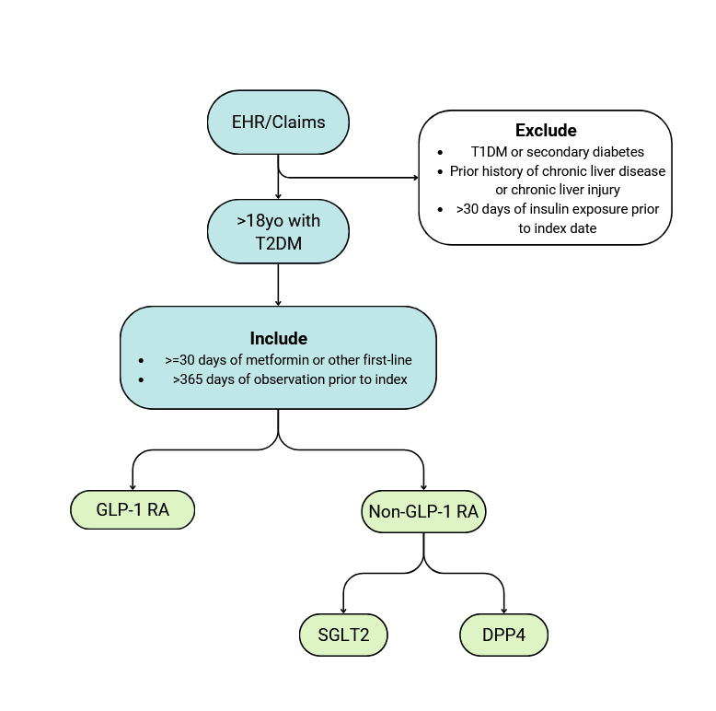
Figure 1 - Inclusion/exclusion criteria

Patients on other anti-diabetic medications at time of entry into cohort are included as part of a sensitivity analysis. A search should be conducted on Metformin (first-line medication) and insulin prescriptions.
SCCS
Any of the above listed long-acting and short-acting GLP-1 agonists are exposures for the SCCS.
Cohort Definition Summary
Target Cohort | Comparator Cohorts
Second-line new users of GLP-1 RA  - Diagnosed with prior T2DM  - No history of T1DM or secondary diabetes  - At least 90 days of Metformin use prior to index date  - No prior GLP-1 RA use  - At least 365 days of observation prior to index date | Second-line new users of DPP4  - Diagnosed with prior T2DM  - No history of T1DM or secondary diabetes  - At least 90 days of Metformin use prior to index date  - No prior DPP4 use  - At least 365 days of observation prior to index date
Second-line new users of SGLT2
- Diagnosed with prior T2DM
- No history of T1DM or secondary diabetes
- At least 90 days of Metformin use prior to index date
- No prior SGLT2 use
- At least 365 days of observation prior to index date

Outcomes
The outcome is acute liver injury, defined as follows:
Primary outcome | Acute hepatic injury or jaundice defined by diagnostic codes.  Based on the OHDSI Phenotype Library, the following are classified as broad definitions:  - Acute Hepatic Injury with no pre-existing liver disease  - Acute Hepatic Failure in persons with no pre-existing liver disease  - All events of Acute Liver Injury, NO viral hepatitis or alcoholic hepatic failure  Based on findings in Athena, the following are also included:  - Chemical and Drug Induced Liver Injury  - Drug-induced Disorder of Liver  - Other injury of liver  - Unspecified injury of liver  - Injury of liver or gallbladder
Secondary outcomes | Elevated ALT, ALP, and/or bilirubin liver enzymes  - Any one of the following lab test combinations:  - ≥ 5 x upper limit of normal (ULN = 41 U/L) alanine aminotransferase (ALT)  - ≥ 2 x ULN (ULN = 130 U/L) alkaline phosphatase (ALP)  - ≥ 3 x ULN ALT (ULN = 41 U/L) and >2 x ULN bilirubin (ULN = 24 µmol/L )  - At least 1 confirmation of normal liver enzyme during the 90 days prior to index date.  - At least 90 days of observation period
 | Cholelithiasis and/or cholecystitis by diagnostic code

Outcome will be sorted by diagnostic codes for acute liver injury (broad definition) and subsequently confirmed by elevated ALT, ALP, and/or bilirubin (narrow definition). Secondary outcomes for cholelithiasis and cholecystitis are also included. Sensitivity analyses will be done to confirm the viability of all outcomes.

Covariates
Large-scale propensity score method will be used to adjust for baseline characteristics.

Negative Controls
Cohort Study
To be defined in appendix. Select pairs where no causal effect is expected.

SCCS
No negative controls selected

Analysis Plan
This study will use the Strategus pipeline to call HADES library packages for the following purposes:
Data Characterization
Cohort Diagnostics | Evaluate measurement error in target, comparator, indication, outcome cohorts through CohortDiagnostics package.
Cohort Features | HADES Characterization and FeatureExtraction – identify patient features in exposure group with outcome vs. no outcome from data prior to observation  - Demographics (age, sex, group, race/ethnicity)  - Prior medical history/diagnosis  - Prior drug exposures  - Prior procedures, measurements, devices, observations  - Risk scores
Incidence Rates | HADES Characterization to calculate (based on intent-to-treat)  - Incidence in GLP-1 RA (#outcomes during GLP1 exposure period/total person days)  - Incidence in Non-GLP-1 RA (#outcomes during non-GLP1 exposure period/total person days)
Time-to-Event | Calculate time to incidence of outcome.

Cohort Study
Comparative Cohort Study | HADES CohortMethod + Cyclops.  - Large-scale propensity score to match exposure cohorts with comparators.  - Sensitivity analysis based on year restriction  - Cox proportional hazards to estimate risk of DILI via ITT  - Residual bias via negative controls

Self-Controlled Case-Series
SCCS | HADES SelfControlledCaseSeries + Cyclops  - Relative incidence of DILI

Study Diagnostic Thresholds
- PS distribution
- Patient characteristics table before/after PS adjustment
- Negative control calibration plot for RB
- Kaplan-Meier plots for Cox
Cohort Study
Covariate Balance (SMD) | <0.1
Empirical Equipoise (PS) | Preference score distribution overlap Equipoise > 0.25
Residual Bias (EASE) | <0.25
Meta-analysis Heterogeneity | <0.4
Meta-analysis MDRR | <10

Self-Controlled Case-Series
Pre-exposure | >0.05
Time Trend | >0.05
EASE | <0.25
Meta-analysis Heterogeneity | <0.4
Meta-analysis MDRR | <10

Strengths and Limitations

Protection of Human Subjects
Participating institutions should seek IRB approval for this study as necessary.

Plans for Disseminating and Communicating Study Results
Results will be shared/discussed during the OHDSI APAC Symposium if sufficient data has been gathered. This work will be presented at conferences and published as a manuscript.

Appendix

Cohort Definitions

Negative Controls

References
Salehi et al. 2024. Liraglutide and Liver Injury: Rare Case Report with Literature Review Endocrine, Metabolic & Immune Disorders - Drug Targets doi: 10.2174/0118715303180615231011053011
Neahusan et al. 2021. Autoimmune Hepatitis-like Drug Injury of the Liver Associated with the Glucagon-like Peptide 1 (GLP-1) Agonist Dulaglutide. The American Journal of Gastroenterology doi: 10.14309/01.ajg.0000785004.17193.b9
Parvataneni et al. 2021. An Exceedingly Rare Case of Liraglutide-Induced Liver Injury Case Rep Gastrointest Med. doi: 10.1155/2021/6306149
Andrade, R. J., Chalasani, N., Björnsson, E. S., Suzuki, A., Kullak-Ublick, G. A., Watkins, P. B., … Aithal, G. P. (2019). Drug-induced liver injury. Nature Reviews Disease Primers, 5(1). doi:10.1038/s41572-019-0105-0

