# **Study dianosticis**

## Diagnostics plot: MDCR

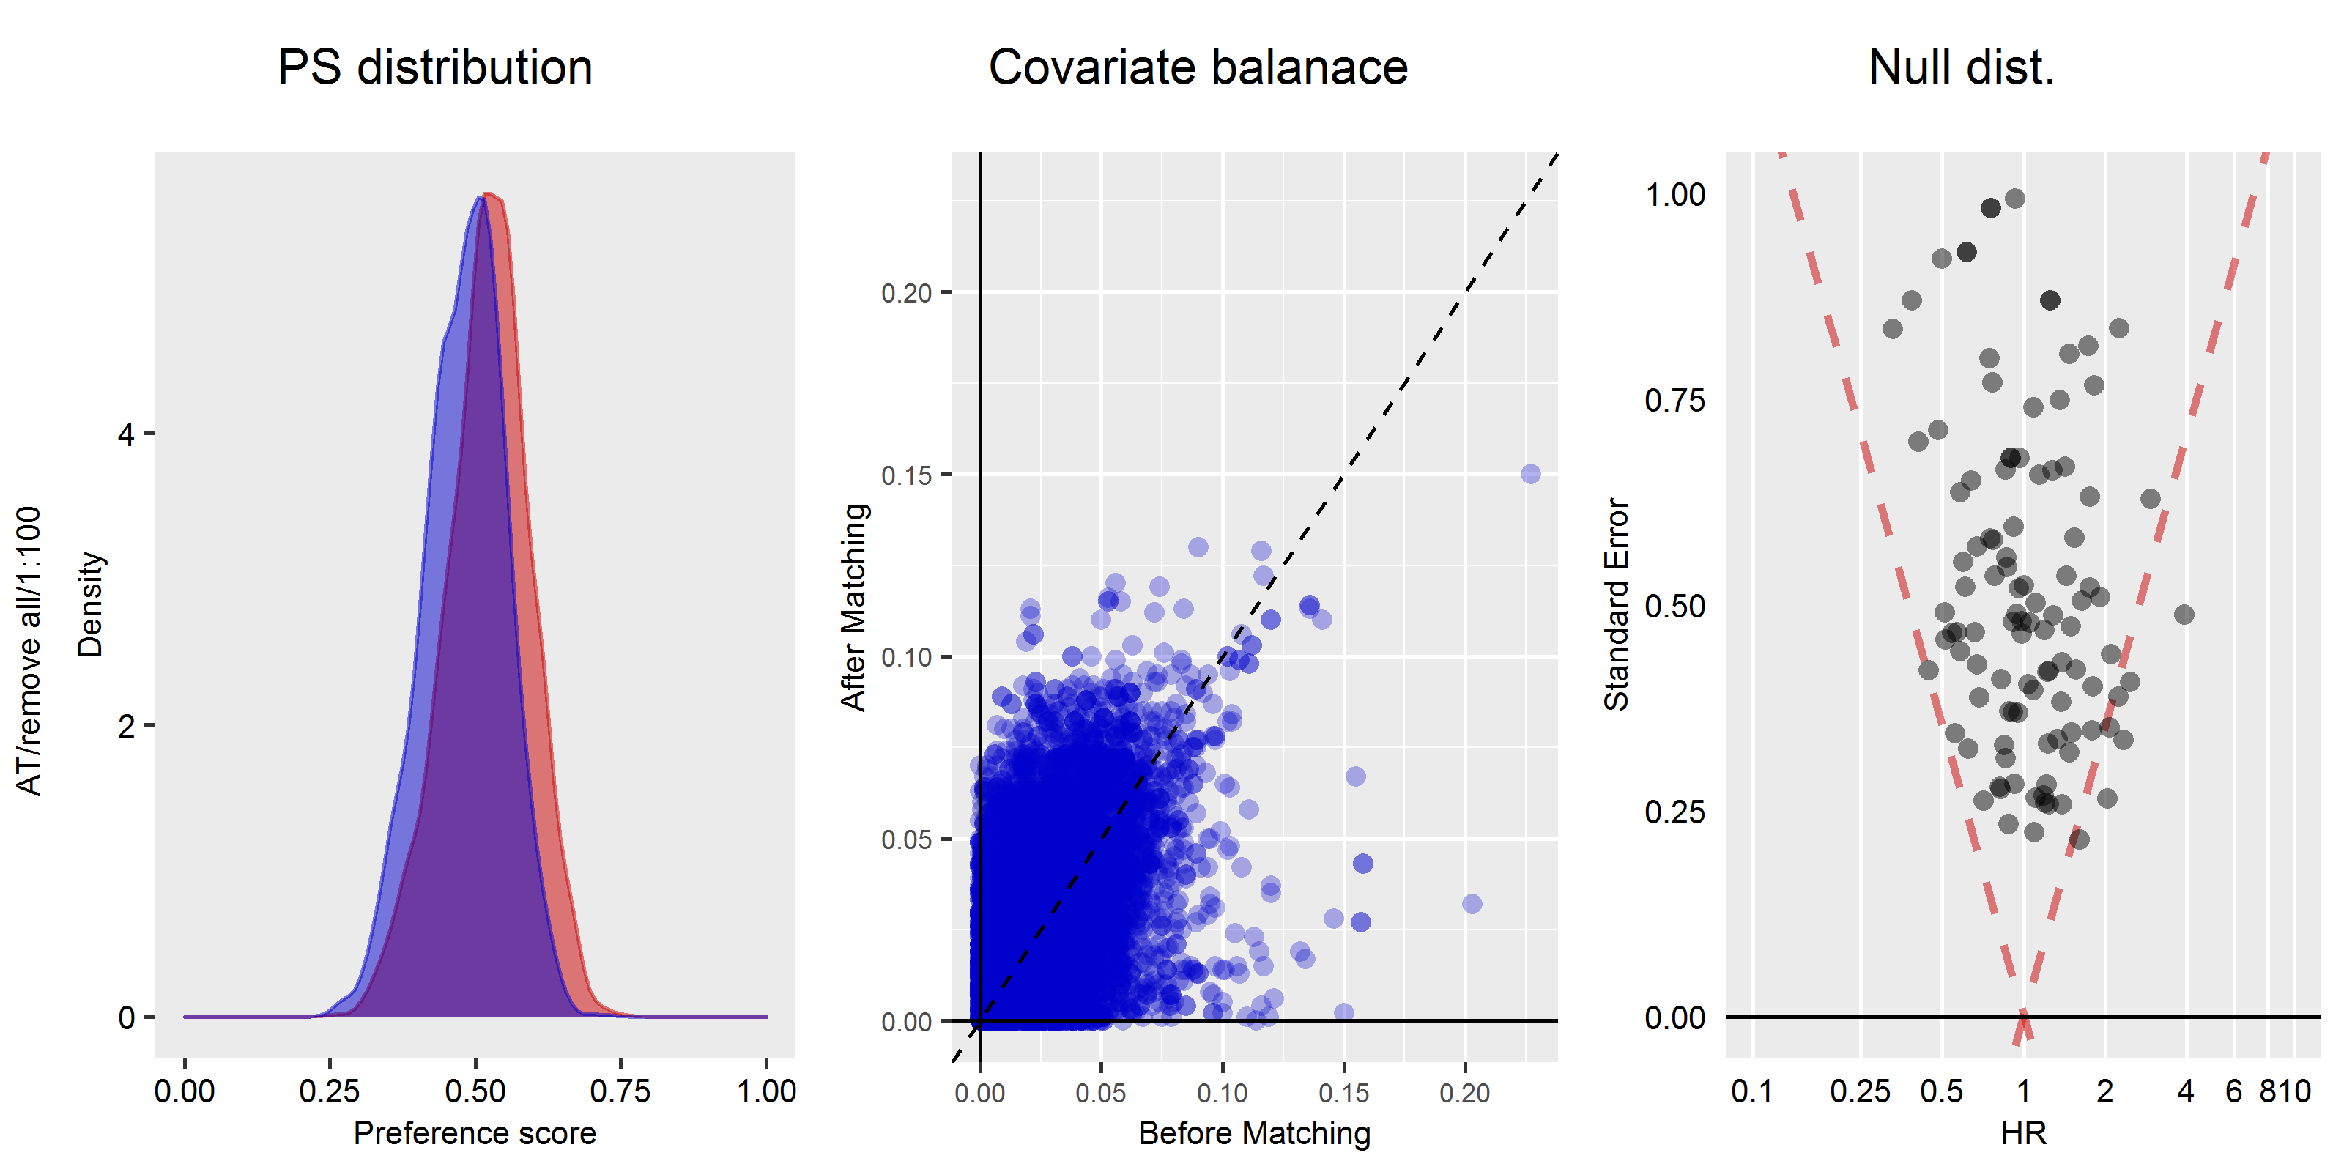

## Diagnostics plot: Optum

