
Quality Assurance - Technical test

The task is to test our website what3words.com.

Part 1: Web UI Testing with Cypress
- Using Cypress you will need to write tests for the website's search function.
- You'll write tests for different search examples, such as searching for specific addresses and dealing with errors.
- Create a new git repository from the project provided
- Extend the project provided to write the tests and reuse as much of the existing project as you can.
- Follow best coding practices (SOLID, DRY, KISS, leverage OOP principles)
- Write clear, maintainable code
- When you’ve finished add the project to github and share with vibha-w3w and w3wtim
- Include instructions on how to execute the test

Task 1: Functional automation for web UI testing using Cypress.

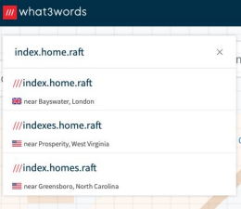

Open https://what3words.com/daring.lion.race and perform a search for any address to make yourself comfortable with the search functionality.

Automate the following test cases:

- Extending the project provided write new tests for the following test cases
- Search for the 3 word address certified.potato.vine and select it from the returned suggestions
- Search for ‘Tower Bridge’ and select ‘Tower Bridge hotel’ from the returned suggestions
- Open the menu and select the ‘three word address language’ menu option. Change it to German and then search the German 3 word address for the latitude longitude position 51.521251, -0.20358600 and select the address from the results. Latitude longitude positions can be searched for in the search box.
- Search for ‘hear.limited.frown.know’ and confirm that an error message appears containing the text “No Address found.”

Part 2: Share - Action Tab Test Cases
- You need to write test cases for the website's "Share" feature. These are just written test cases and shouldn't be automated.
- Add the document with your test cases to the repository.
- Your tests can be a simple checklist, such as checking for correct spelling and grammar.
Overall, this test is about showing your skills in software testing and writing good code.

Write test cases for the Share - action tab functionality. These may include the expected results or be a simple checklist.
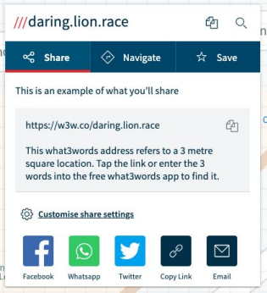

For example, a checklist might contain:
● All spelling is correct
● All grammar is correct
● Words correctly describe the purpose of the application

