Dear Sir/Madam,
Emperial Waste is pleased to present our proposal centered on efficient skip container rentals and refuse pickups tailored to meet your waste management needs. We specialize in providing durable skip bins for rent and offer prompt, reliable pickup services to help keep your environment clean and organized.
Whether you need skips for residential, commercial, or industrial use, our team is equipped to deliver and collect with ease and professionalism.
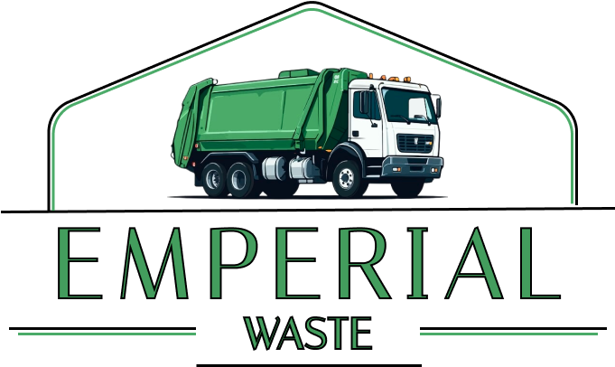
In addition to waste container rentals and pickups, we also provide professional fumigation, disinfection, and pest control services. With over six years of industry experience including operations prior to the COVID-19 outbreak Emperial Waste has built a solid reputation for delivering trusted and quality services.
For inquiries regarding our services, pricing, or payment terms, please don’t hesitate to contact us.
We’re here to help!
Contact us:
024 582 5120
026 943 2505
We look forward to serving you.
Sincerely,
The Emperial Waste Team.
Stephen Ohemeng
general manager

_____________________

