TECHNICAL REPORT
Object-Oriented Programming Term Paper
Design and Implementation of a
Cybersecurity Incident Reporting System (CRS)
A JavaFX Desktop Application Demonstrating Core
Object-Oriented Programming Principles
Project / Repository:
OOP-Term-Paper- (CybersecurityReportSystem)
Submitted as part of the requirements for the
Object-Oriented Programming course
July 2026

Table of Contents
1. Introduction
2. Problem Statement
3. Objectives of the System
4. Scope of the System
5. Methodology
6. System Design
7. Description of Classes and Methods
8. GUI Design Explanation
9. OOP Concepts Implemented
10. Screenshots and Outputs
11. GitHub Repository Link
12. Challenges Encountered
13. Conclusion
14. Recommendations
15. References

1. Introduction
Object-Oriented Programming (OOP) is a programming paradigm built around the idea of bundling data and the behaviour that operates on that data into a single unit called an object. Its four pillars — encapsulation, inheritance, abstraction, and polymorphism — allow developers to model complex, real-world problems as collections of interacting objects rather than a single, monolithic procedure. This report documents the design, implementation and evaluation of a Cybersecurity Incident Reporting System (referred to in the source code and this report as “CRS”), a desktop application built in Java using the JavaFX framework as the practical component of an Object-Oriented Programming term paper.
An incident reporting system is a category of software used by organisations to capture, triage and track security or operational incidents — for example phishing attempts, ransomware deployments, denial-of-service activity, or unauthorised access attempts. Such systems typically distinguish between two classes of user: a reporting user (subscriber) who logs incidents as they are observed, and an administrator/operator who reviews, escalates and resolves those incidents. The CRS project implements this two-role model and uses it as a vehicle to demonstrate encapsulation, inheritance, abstraction and polymorphism in a non-trivial, GUI-driven Java application.
This report analyses the actual source code contained in the submitted project archive (a Maven-based JavaFX project named CybersecurityReportSystem) rather than a hypothetical or idealised design. It describes what the system does today, how its classes are organised, which OOP concepts are demonstrated and where, what has been verified to work, and what remains incomplete or would need to be addressed before the system could be considered production-ready.

2. Problem Statement
Organisations frequently rely on ad-hoc channels — email, spreadsheets, verbal reports — to communicate security incidents from front-line staff to the personnel responsible for handling them. This approach has several well-known weaknesses: incidents are not centrally visible, there is no consistent severity classification, there is no audit trail of when an incident was reported or by whom, and there is no straightforward way for an administrator to see which incidents are outstanding versus resolved.
The CRS project addresses a scaled-down version of this problem. It provides a single desktop application with role-based access: a subscriber (reporting) role that can submit structured incident reports through a form, and an administrator role that can view all submitted incidents in a table, escalate high-severity incidents, and mark incidents as resolved. The problem is intentionally bounded to a scope appropriate for a term paper: the system does not attempt to solve enterprise-scale concerns such as distributed deployment, persistent storage, or regulatory compliance, but it does demonstrate, in working code, how OOP principles can be used to structure a role-based reporting workflow.

3. Objectives of the System
The stated and demonstrated objectives of the CRS project are:
- To provide a login mechanism that authenticates a user and routes them to a role-appropriate dashboard (Subscriber or Admin).
- To allow a subscriber to submit an incident report describing a threat type, severity level, affected system and free-text description.
- To allow an administrator to view all logged incidents in a tabular dashboard and to mark selected incidents as resolved.
- To automatically escalate incidents whose severity level meets or exceeds a defined threshold and to alert the operator when this occurs.
- To validate incident data (e.g. severity must be an integer between 1 and 5, mandatory fields must not be empty) before it is accepted into the system.
- To demonstrate, in a single working codebase, the four core OOP principles — encapsulation, inheritance, abstraction and polymorphism — using classes and relationships that are meaningful to the incident-reporting domain rather than contrived examples.

4. Scope of the System

4.1 In Scope
- A JavaFX desktop GUI with a login screen (FXML-based) and two role-specific dashboards built programmatically (Mainapp for subscribers, Admin for administrators).
- In-memory storage of incident reports and user accounts for the duration of a single application run (no database or file persistence).
- Two hard-coded demonstration accounts — one SUBSCRIBER and one ADMIN — used to exercise the login and role-routing logic.
- Basic client-side validation of the incident submission form (required fields, numeric severity in range 1–5).
- A severity-based escalation rule that raises a JavaFX alert dialog when an incident's severity is 4 or 5.

4.2 Out of Scope
- Persistent storage: there is no database, file, or serialization layer — all data (users and incidents) is lost when the application closes.
- User registration, password recovery, or password hashing/encryption — the “Sign Up” button on the login screen is present in the FXML layout but has no attached event handler.
- Network communication, multi-user concurrency, or a client–server architecture — the application is a single-user, single-process desktop program.
- Automated test coverage — JUnit 5 is declared as a Maven dependency, but no test classes exist in the submitted source tree.
- Several supporting packages (helper, helpers, dialogue, docs.diagrams, docs.images) are present as empty placeholder classes and are not yet implemented.

5. Methodology
The system was built using an incremental, feature-by-feature approach typical of a small, single-developer academic project. The project's own Git history reflects this progression, with commits corresponding to project scaffolding, dashboard construction, and user-login functionality.

5.1 Technology Stack
Component | Technology / Version
Language | Java (source/target level 25, per pom.xml)
GUI Framework | JavaFX 21.0.6 (javafx-controls, javafx-fxml)
Supporting UI Libraries | ControlsFX 11.2.1, FormsFX 11.6.0
Build Tool | Apache Maven (with Maven Wrapper) and the javafx-maven-plugin
Testing Framework (declared, unused) | JUnit Jupiter 5.12.1
View Definition | FXML (Login.fxml, hello-view.fxml) plus programmatic JavaFX layout (Admin.java, Mainapp.java)
Version Control | Git, hosted on GitHub

5.2 Development Approach
- Requirements were interpreted from the assignment brief for an OOP term paper: build a non-trivial application that visibly demonstrates encapsulation, inheritance, abstraction and polymorphism.
- The domain (cybersecurity incident reporting) was chosen because it naturally supports a role hierarchy (subscriber vs. admin) and a data-validation-heavy entity (the incident report itself).
- Core domain classes (User, Role, IncidentReport) were modelled first, followed by the abstract processing layer (IncidentLogProcessor / CoreIncidentProcessor), and finally the JavaFX views and controllers that wire the domain classes to the UI.
- Manual, exploratory testing was used during development (running the application and exercising the login and reporting forms) rather than automated unit tests.

6. System Design
The system follows a loosely layered structure common in small JavaFX applications: a presentation layer (FXML views and programmatically built JavaFX scenes), a control layer (FXML controllers), a service layer (business logic and in-memory data access) and a model layer (plain data-holding classes). The layering is not strictly enforced through interfaces, but the package structure (com.crs.main, com.crs.controller, com.crs.services, com.crs.model) reflects this separation of concerns.
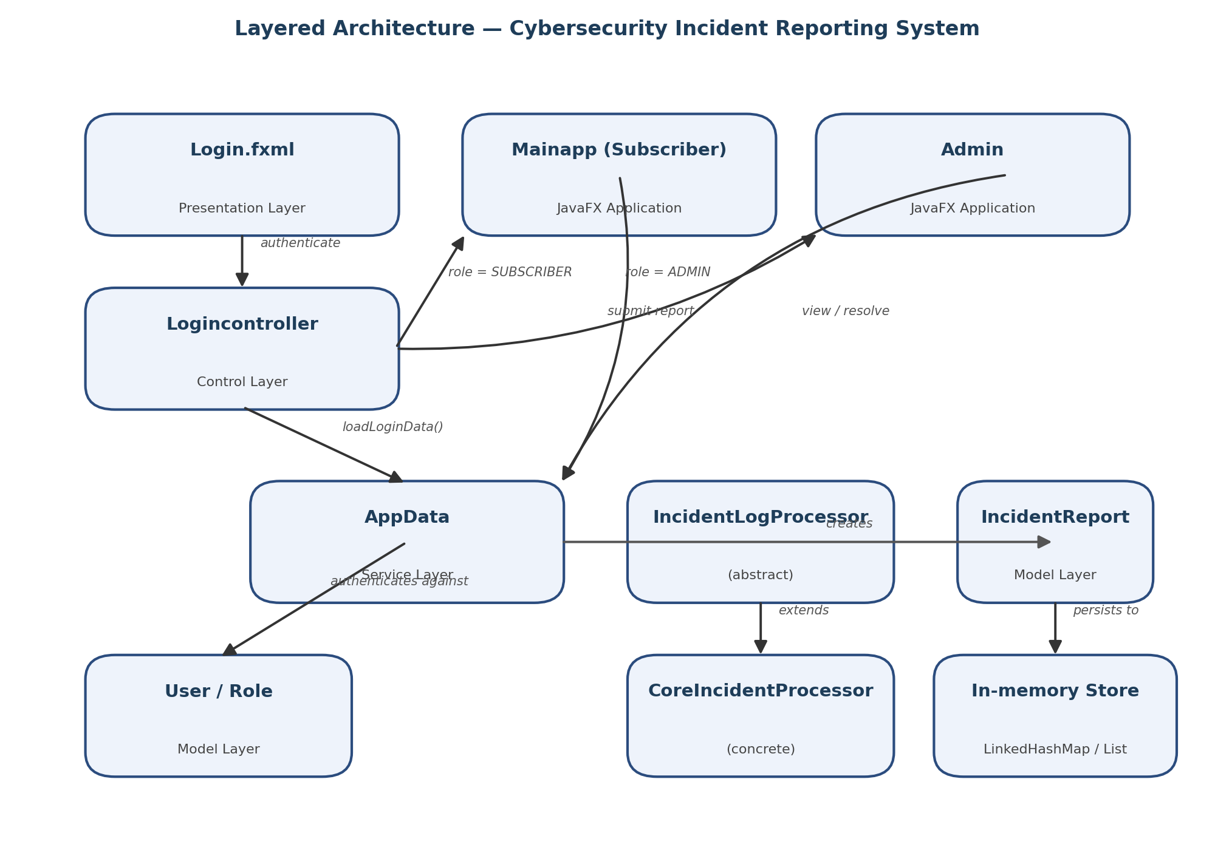
Figure 1: Layered architecture of the Cybersecurity Incident Reporting System

6.1 Application Flow
- Launcher.main() starts the JavaFX runtime and launches LoginApp, which loads Login.fxml into the primary Stage.
- Logincontroller.initialize() populates an in-memory user list via AppData.loadLoginData() (two hard-coded demonstration accounts).
- On clicking “Login”, Logincontroller.handleLogin() looks up a User whose email and password match the entered credentials.
- If a match is found, Logincontroller.openDashboard() inspects the user's Role and replaces the current Scene's root with either a Mainapp (SUBSCRIBER) or an Admin (ADMIN) view, reusing the same Stage.
- Mainapp presents both an incident-submission form and a read-only incident table for the logged-in subscriber; Admin presents the incident table together with a “Resolve Selected Incident” control.
- Submitting the form constructs a new IncidentReport (validating severity and required fields), assigns it a generated ID (“LOG-XXXXXX” via UUID), and stores it in AppData; the on-screen TableView is then refreshed from AppData.

6.2 Class Diagram
The diagram below summarises the principal classes discussed in Section 7 and the relationships between them: inheritance between IncidentLogProcessor and CoreIncidentProcessor, association between the controller and service classes, and composition/aggregation between AppData and the domain model classes.
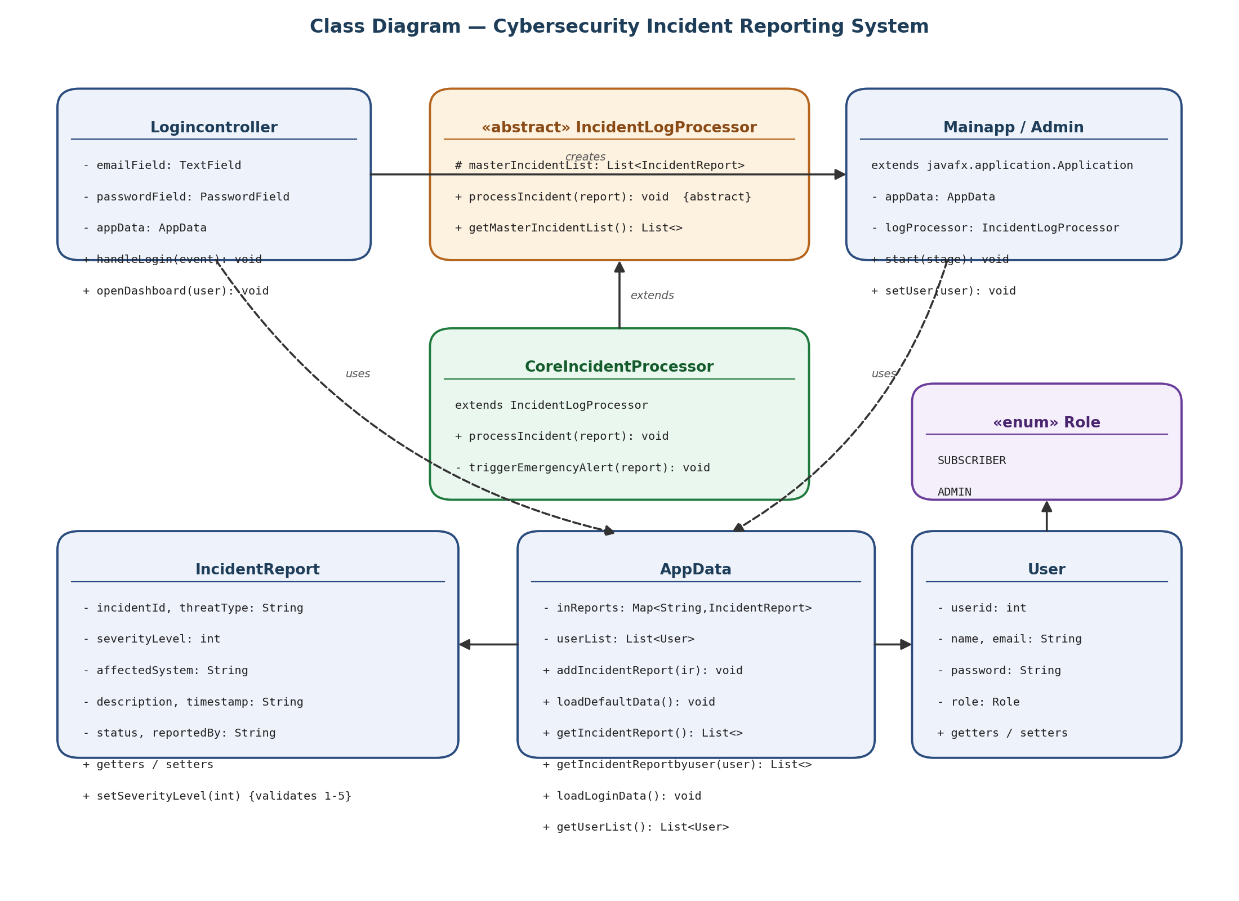
Figure 2: Class diagram of the core CRS classes

7. Description of Classes and Methods

7.1 com.crs.model package

Role (enum)
A simple enumeration with two constants, SUBSCRIBER and ADMIN. It is used throughout the system to decide which dashboard a user is routed to after login and, implicitly, what that dashboard allows them to do.

User
A plain data class (a JavaBean) encapsulating a user's identity and credentials: userid, name, email, password and role. Every field is private and exposed only through public getters and setters, which is the textbook definition of encapsulation. The class currently stores the password as plain text with no hashing, which is discussed further in Section 12 (Challenges) and Section 14 (Recommendations).

7.2 com.crs.services package

IncidentReport
Represents a single reported incident. Its fields — incidentId, threatType, severityLevel, affectedSystem, description, timestamp, status and reportedBy — are all private. The constructor accepts the caller-supplied fields, automatically stamps the report with the current timestamp (via LocalDateTime.now()), and initialises status to "OPEN". Critically, the setter setSeverityLevel(int) enforces a business rule directly in the model: it throws an IllegalArgumentException if the value is outside the 1–5 range, meaning the class actively protects its own internal consistency rather than trusting the caller — a strong example of encapsulation.

IncidentLogProcessor (abstract class)
Declares the abstract method processIncident(IncidentReport report) and holds a protected static ObservableList shared by all subclasses (masterIncidentList), together with a static getMasterIncidentList() accessor. As an abstract class it cannot be instantiated directly; it exists purely to define a contract that concrete processors must fulfil, which is the class's role as an abstraction layer.

CoreIncidentProcessor
The sole concrete subclass of IncidentLogProcessor in the current codebase. Its override of processIncident(report) contains the escalation rule: if a report's severity level is 4 or 5, the report's status is set to "ESCALATED" and a private helper, triggerEmergencyAlert(report), pops up a JavaFX warning dialog. The report is then appended to the shared masterIncidentList. This class demonstrates both inheritance (it extends IncidentLogProcessor) and polymorphism (it supplies the concrete behaviour behind the parent's abstract method).

AppData
Acts as the in-memory data-access/service layer for the whole application. It stores incident reports in a LinkedHashMap keyed by incident ID (preserving insertion order) and a separate List<User> for accounts. Its public methods — addIncidentReport, loadDefaultData, getIncidentReport, getIncidentReportbyuser, loadLoginData and getUserList — are the only way other classes are meant to read or write this data, again reflecting encapsulation at the service-layer level. loadDefaultData() seeds two sample incidents for demonstration purposes; loadLoginData() seeds the two demonstration user accounts.

DataStore
A small utility class exposing two static methods, getUserEmail() and getUserPassword(), which return hard-coded demonstration credentials. It appears to be an earlier or alternative mechanism for supplying default credentials and is not currently invoked by Logincontroller, which instead uses AppData.loadLoginData().

7.3 com.crs.main package

Launcher
Contains the JVM entry point (public static void main). Its sole responsibility is to call Application.launch(LoginApp.class, args), handing control to the JavaFX runtime.

LoginApp
A JavaFX Application subclass whose start(Stage) method loads Login.fxml through an FXMLLoader and displays it in a 450×300 Scene. It is the very first window a user sees.

Mainapp
The subscriber-facing Application subclass. It builds two side-by-side panels programmatically: a submission form (buildFrontendPanel()) and a read-only TableView of the current user's own incidents (buildBackendPanel()). It holds its own AppData instance, an IncidentLogProcessor reference (currently unused — the call to logProcessor.processIncident(...) is commented out), and a currentUser set via setUser(User) by the login controller.

Admin
Structurally a near-duplicate of Mainapp, but intended for the administrator role. It shows only the backend (table) panel together with a “Resolve Selected Incident” button that calls markIncidentResolved(), which sets the selected row's status to "RESOLVED" and refreshes the table. Like Mainapp, its buildFrontendPanel() method and its IncidentLogProcessor field exist but are not actively wired into the visible UI (the frontend panel is commented out in start(Stage)).

7.4 com.crs.controller package

Logincontroller
The FXML controller bound to Login.fxml (declared via fx:controller). Its initialize() method (invoked automatically by the FXML loader) seeds demonstration accounts through AppData.loadLoginData(). handleLogin(ActionEvent) reads the email and password fields, searches the seeded user list for a match using a Java Stream filter, and either shows an informational alert (invalid credentials / empty field) or calls openDashboard(User), which decides — based on Role — whether to instantiate a Mainapp or an Admin and reuse the current Stage to display it.

HelloController
A minimal, template-generated controller left over from the default JavaFX/Maven archetype (hello-view.fxml). It is not part of the incident-reporting workflow and appears to be scaffolding retained from the project's initial setup.

7.5 Placeholder / stub packages
The archive also contains several packages whose classes are currently empty stubs (a class declaration with no members): helper.exception, helper.AuthenticationException, helper.InvalidInputException, helpers.DateUtil, dialogue.UserDialog, com.crs.util.ValidationUtil, and the docs.diagrams / docs.images packages (class_diagram, sequence_diagram_login, use_case_diagram, dashboard_screen, incidents_screen, login_screen, reports_screen, users_screen). These appear to be scaffolding for planned features — custom exception types, input validation helpers, date utilities, and documentation assets — that had not yet been implemented at the time of submission.

8. GUI Design Explanation
The GUI is built with a mixture of FXML-declared layouts and layouts constructed directly in Java code.

8.1 Login Screen (Login.fxml)
A centred VBox containing a title label, a GridPane with two label/input pairs (Email and Password, the latter using a PasswordField to mask input), a “Login” button wired to Logincontroller#handleLogin, and a “Sign Up” button that is present visually but has no onAction handler attached, meaning it does not currently perform any action when clicked. A message label placeholder exists for future inline validation feedback.

8.2 Subscriber Dashboard (Mainapp)
Built entirely in Java rather than FXML. The window is split into two panels inside an HBox: a left-hand “Incident Reporting Portal” form (a ComboBox of threat categories, a severity TextField, a target-system TextField, a description TextArea, and a “Dispatch Incident Report” button), and a right-hand “Security Operations Command Dashboard” table showing the current subscriber's own previously reported incidents (Log ID, Threat Type, Severity, Affected Asset, Triage Status, Log Timestamp, Description columns).

8.3 Administrator Dashboard (Admin)
Shows only the table/dashboard panel (the submission form is present in code but commented out of the visible layout), plus a “Resolve Selected Incident” button that lets the administrator select a row and mark it resolved. This reflects the intended separation of duties: subscribers report incidents, administrators triage and close them.

8.4 Visual Style
Both dashboards use inline JavaFX CSS strings (background colours, border radii, font weights) rather than an external stylesheet; a src/main/style.css file exists in the project but is currently empty. Colour choices are used semantically — orange/red tones for the submission button and escalation alerts, green tones for resolve actions and the backend panel header — giving the interface a security-operations-centre aesthetic appropriate to the domain.

9. OOP Concepts Implemented
The project's stated pedagogical purpose — as an OOP term paper — is reflected directly in code comments within the services package, several of which explicitly call out which principle a class is meant to illustrate. The table below summarises where each of the four pillars appears in the codebase.
Concept | Where it is implemented | How it is demonstrated
Encapsulation | IncidentReport, User, AppData | All fields are private; access is only through getters/setters. IncidentReport.setSeverityLevel() actively validates its input (1–5) and throws IllegalArgumentException otherwise, protecting the object's internal invariants rather than merely storing data.
Abstraction | IncidentLogProcessor (abstract class) | Declares the abstract method processIncident(IncidentReport) and hides the underlying storage mechanism (masterIncidentList) behind a static accessor, defining a contract for “processing an incident” without specifying how any particular processor does it.
Inheritance | CoreIncidentProcessor extends IncidentLogProcessor | CoreIncidentProcessor inherits the shared incident list and the abstract contract from its parent class and adds its own concrete behaviour (triggerEmergencyAlert) on top of what it inherits.
Polymorphism | CoreIncidentProcessor.processIncident() overriding IncidentLogProcessor.processIncident() | Code that holds a reference typed as IncidentLogProcessor (e.g. the logProcessor field in Mainapp/Admin) can invoke processIncident() and have the JVM dispatch to CoreIncidentProcessor's overriding implementation at runtime — classic run-time (dynamic) polymorphism. (Note: as discussed in Section 12, this call path is currently commented out in the UI classes, so the mechanism is implemented but not exercised in the running application.)

9.1 Additional Observations
- Method overloading (compile-time / ad-hoc polymorphism) is not used anywhere in the codebase; the only form of polymorphism present is the run-time, inheritance-based kind described above.
- Interfaces are not used; abstraction is achieved solely through an abstract class (IncidentLogProcessor). A future iteration could introduce interfaces (e.g. an Auditable or Notifiable interface) to demonstrate multiple-interface implementation.
- Enumerations (Role) are used as a lightweight, type-safe alternative to string or integer constants for representing a fixed set of user roles.
- Composition/aggregation is visible in AppData, which holds collections of IncidentReport and User objects without those classes being aware of AppData — a one-directional “has-a” relationship typical of a service/repository layer.

10. Screenshots and Outputs
The submitted project archive includes a docs/images package intended to hold screenshots of the running application (dashboard_screen, incidents_screen, login_screen, reports_screen, users_screen) and a docs/diagrams package intended to hold design diagrams (class_diagram, sequence_diagram_login, use_case_diagram). In the submitted archive, all eight of these files are empty placeholder Java classes rather than actual image or diagram assets, and the accompanying src/docs/report.pdf is an empty file. No rendered screenshots of the running application were therefore available to include in this report.
Based on direct inspection of the FXML and Java layout code (Sections 8 and 9), the expected visual output at runtime is as follows:
- Login screen: a centred form with Email and Password fields, a blue “Login” button and a green “Sign Up” button (currently inactive), sized 450×300 pixels.
- Subscriber dashboard: a 1150×650 window split into a white incident-submission form on the left and a table of the subscriber's own incidents on the right, titled “Subscriber | Cybersecurity Incident Reporting System”.
- Administrator dashboard: a 1150×650 window showing only the incident table and a “Resolve Selected Incident” control, titled “Admin | Cybersecurity Incident Reporting System”.
- Escalation alert: a modal JavaFX warning dialog titled “CRITICAL THREAT ESCALATION”, shown when CoreIncidentProcessor.processIncident() is invoked on a report with severity 4 or 5 (see Section 12 regarding this code path currently being disconnected from the UI).
It is recommended that, before final submission or presentation, the application be run locally (e.g. via mvn clean javafx:run) and genuine screenshots be captured and inserted into this section, replacing the placeholder classes in docs/images with actual .png or .jpg assets.

11. GitHub Repository Link
The project is version-controlled with Git and hosted on GitHub at the following location, as configured in the project's remote origin:
https://github.com/ohenebakofiokyere1/OOP-Term-Paper-
The repository's commit history shows an incremental build-up of the project across five commits: an initial commit, project setup, general progress, dashboard construction, and finally user-login functionality — consistent with the feature-by-feature methodology described in Section 5.

12. Challenges Encountered
Direct inspection of the codebase surfaces several concrete implementation challenges and unresolved issues, in addition to the general challenges any student would expect to encounter when learning JavaFX and OOP concurrently:

12.1 Duplication between Mainapp and Admin
Mainapp and Admin contain almost identical code for building the incident-submission form and the incident table (buildFrontendPanel(), buildBackendPanel(), executeReportSubmission(), markIncidentResolved() are duplicated near-verbatim between the two classes). This suggests that a common superclass or shared component was planned but not factored out — a natural opportunity to apply the very inheritance principle the project sets out to demonstrate.

12.2 Polymorphic processor not wired into the UI
Both Mainapp and Admin instantiate an IncidentLogProcessor (as a CoreIncidentProcessor), but the call to logProcessor.processIncident(structuralReport) in executeReportSubmission() is commented out in both classes. As a result, the escalation logic and emergency alert defined in CoreIncidentProcessor are never triggered by the running application; incident status is set to "ESCALATED" only if that call path is re-enabled.

12.3 Reference comparison instead of value comparison
AppData.getIncidentReportbyuser(String reporteduser) filters using a.getReportedBy() == reporteduser, which compares String references rather than String content. Because Java does not guarantee that two equal strings share the same reference (especially when one originates from a User.getName() call and the other from a literal or a different object), this comparison can silently fail to match incidents that were, in fact, reported by the given user. The correct form would use .equals() (or Objects.equals() to guard against null).

12.4 No persistence layer
All data — both user accounts and incident reports — exists only in memory (via AppData's Map and List fields) and is lost when the application exits. Implementing a persistence layer (a file, an embedded database such as SQLite, or serialization) was outside the scope actually completed.

12.5 Plain-text credentials
User passwords are stored and compared as plain strings, both in AppData.loadLoginData() and in the alternate DataStore utility class. There is no hashing (e.g. BCrypt) or salting, which would be a prerequisite for any real-world deployment.

12.6 Incomplete supporting packages
Several packages that would typically house cross-cutting concerns — custom exceptions (helper.AuthenticationException, helper.InvalidInputException), input validation (com.crs.util.ValidationUtil), date formatting (helpers.DateUtil), and reusable dialogs (dialogue.UserDialog) — exist only as empty class stubs. Validation and exception handling that would ideally live in these classes is instead implemented ad hoc, inline, inside Admin/Mainapp's executeReportSubmission() method using generic Exception and IllegalArgumentException types.

12.7 Inactive UI elements
The “Sign Up” button on the login screen has no onAction handler, so it currently has no effect when clicked; this is consistent with the project's scope excluding account registration (Section 4.2).

12.8 Learning-curve challenges
Beyond issues visible directly in the code, a student building this kind of project typically has to learn JavaFX's Scene/Stage model and FXML/controller wiring, ObservableList/TableView data binding via PropertyValueFactory, Maven module configuration for JavaFX (module-info.java, the javafx-maven-plugin), and how to balance validation logic between the UI layer and the domain model — all of which are reflected in the structure of the final codebase.

13. Conclusion
The Cybersecurity Incident Reporting System successfully demonstrates the four core pillars of Object-Oriented Programming within a coherent, domain-relevant application rather than through isolated, contrived examples. Encapsulation is visible in the way IncidentReport and User protect their internal state and enforce business rules (such as the 1–5 severity range) at the point of mutation. Abstraction is embodied in the IncidentLogProcessor abstract class, which defines a processing contract independent of any specific implementation. Inheritance and polymorphism work together through CoreIncidentProcessor, which extends the abstract processor and supplies the concrete, overriding behaviour that would be dispatched at run time through a supertype reference.
At the same time, the codebase is clearly an in-progress academic project rather than a finished product: the escalation logic exists but is currently disconnected from the live UI event handler, data does not persist beyond a single run, several supporting packages are unimplemented stubs, and at least one filtering method contains a reference-equality bug that would need correcting before the feature it supports (viewing a subscriber's own incidents) could be fully trusted. None of these issues undermine the project's core pedagogical goal — demonstrating OOP principles in working code — but they are worth acknowledging honestly, both because they represent realistic lessons in software engineering and because they define a clear path for future improvement.

14. Recommendations
Based on the review of the current codebase, the following improvements are recommended for future iterations of this project:
- Re-enable the logProcessor.processIncident(...) call in Mainapp/Admin so that the escalation and alerting logic in CoreIncidentProcessor is actually exercised by the running application, and add a corresponding unit test to lock in the expected behaviour.
- Fix the reportedBy comparison in AppData.getIncidentReportbyuser() to use .equals() rather than == so that a subscriber's own incidents are matched reliably.
- Extract the duplicated form-building and table-building logic in Mainapp and Admin into a shared abstract base class or reusable component, turning an existing weakness into an additional, well-motivated demonstration of inheritance.
- Introduce a lightweight persistence layer (for example, serialising AppData to a JSON or CSV file on exit and reloading it on startup, or migrating to an embedded database such as SQLite) so that incident and user data survive across application runs.
- Hash and salt stored passwords (e.g. with BCrypt) instead of storing and comparing them as plain text, even in a demonstration system, to build good security habits.
- Populate the currently empty helper.* and com.crs.util.ValidationUtil classes with real custom exception types and validation logic, and route the ad hoc validation currently inline in executeReportSubmission() through them.
- Add JUnit test classes exercising IncidentReport's validation logic, AppData's CRUD-style methods, and the login-matching logic in Logincontroller, since JUnit Jupiter is already declared as a project dependency but currently unused.
- Wire up the “Sign Up” button (or explicitly remove it) so that the login screen does not present an affordance that has no effect.
- Capture real screenshots of each screen and replace the placeholder classes in docs/images and docs/diagrams with actual image assets, then reference them directly in this report.
- Consider introducing at least one interface (for example, a Notifiable or Auditable interface implemented by CoreIncidentProcessor) to complement the existing abstract-class-based abstraction and demonstrate interface-based design as well.

15. References
1. Oracle Corporation. The Java Tutorials — Object-Oriented Programming Concepts. https://docs.oracle.com/javase/tutorial/java/concepts/
2. Gosling, J., Joy, B., Steele, G., Bracha, G., Buckley, A. The Java Language Specification. Oracle/Addison-Wesley.
3. OpenJFX Project. JavaFX Documentation. https://openjfx.io/
4. Apache Software Foundation. Apache Maven Documentation. https://maven.apache.org/guides/
5. JUnit Team. JUnit 5 User Guide. https://junit.org/junit5/docs/current/user-guide/
6. Gamma, E., Helm, R., Johnson, R., Vlissides, J. (1994). Design Patterns: Elements of Reusable Object-Oriented Software. Addison-Wesley.
7. Project source code: OOP-Term-Paper- / CybersecurityReportSystem repository (submitted archive), analysed directly for this report.

