4 input NAND

Boolean equation

* (A&B&C&D)’ = ( ( (A&B)’&C)’&D)’

Verilog coding

`timescale 1ns / 1ps

module nandga(

input a, b, c, d,

output e

);

assign e = ~(a&b&c&d);

endmodule

module nandgb(

input a, b, c, d,

output e, f, g

);

assign e = ~(a&b);

assign f = ~(e&c);

assign g = ~(f&d);

endmodule

RTL Schematic

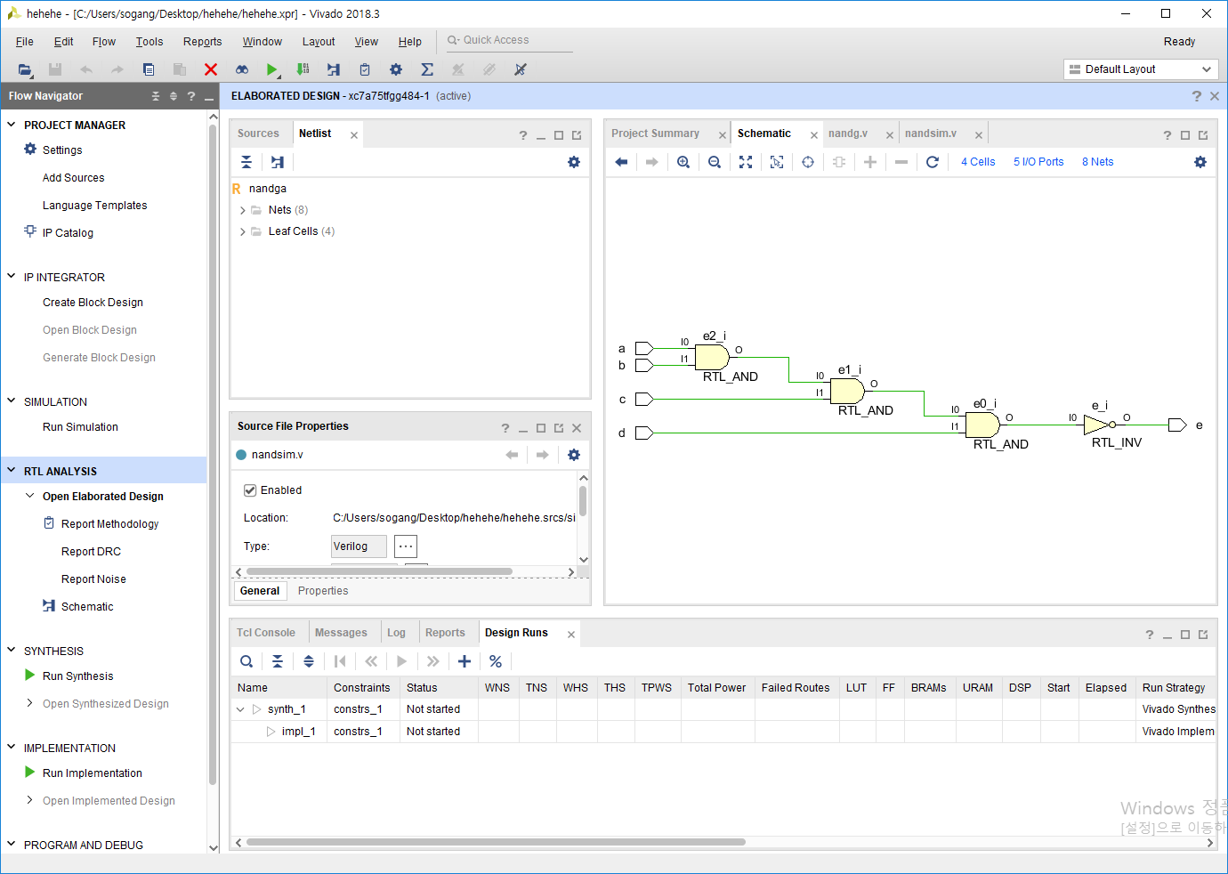

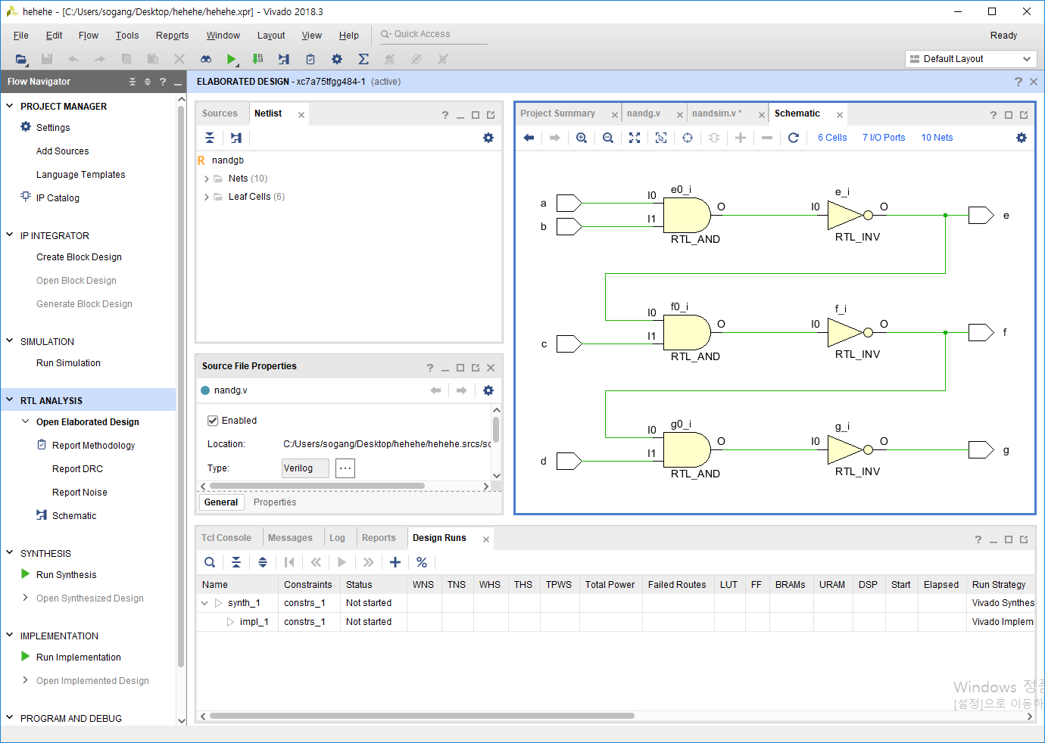

|  |  |  |  |  |  |  |
| --- | --- | --- | --- | --- | --- | --- |
| **In A** | **In B** | **In C** | **In D** | **Out E** | **Out F** | **Out G** |
| 0 | 0 | 0 | 0 | 1 | 1 | 1 |
| 0 | 0 | 0 | 1 | 1 | 1 | 1 |
| 0 | 0 | 1 | 0 | 1 | 1 | 1 |
| 0 | 0 | 1 | 1 | 0 | 1 | 1 |
| 0 | 1 | 0 | 0 | 1 | 0 | 1 |
| 0 | 1 | 0 | 1 | 1 | 0 | 1 |
| 0 | 1 | 1 | 0 | 1 | 0 | 1 |
| 0 | 1 | 1 | 1 | 0 | 1 | 1 |
| 1 | 0 | 0 | 0 | 1 | 1 | 0 |
| 1 | 0 | 0 | 1 | 1 | 1 | 0 |
| 1 | 0 | 1 | 0 | 1 | 1 | 0 |
| 1 | 0 | 1 | 1 | 0 | 1 | 0 |
| 1 | 1 | 0 | 0 | 0 | 1 | 0 |
| 1 | 1 | 0 | 0 | 1 | 0 | 1 |
| 1 | 1 | 0 | 1 | 1 | 0 | 1 |
| 1 | 1 | 1 | 0 | 1 | 0 | 1 |
| 1 | 1 | 1 | 1 | 0 | 1 | 0 |

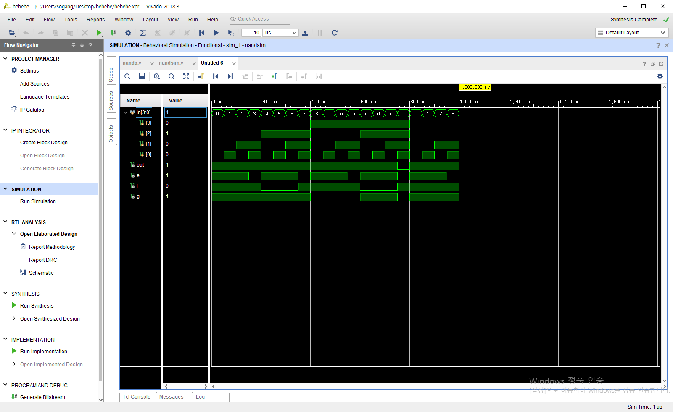

NOR

(A+B+C+D)’ = (((A+B)’+C)’+D)’

coding

`timescale 1ns / 1ps

module norgA(

input a, b, c, d,

output e

);

assign e = ~(a|b|c|d);

endmodule

module norgB(

input a, b, c, d,

output e, f, g

);

assign e = ~(a|b);

assign f = ~(e|c);

assign g = ~(f|d);

endmodule

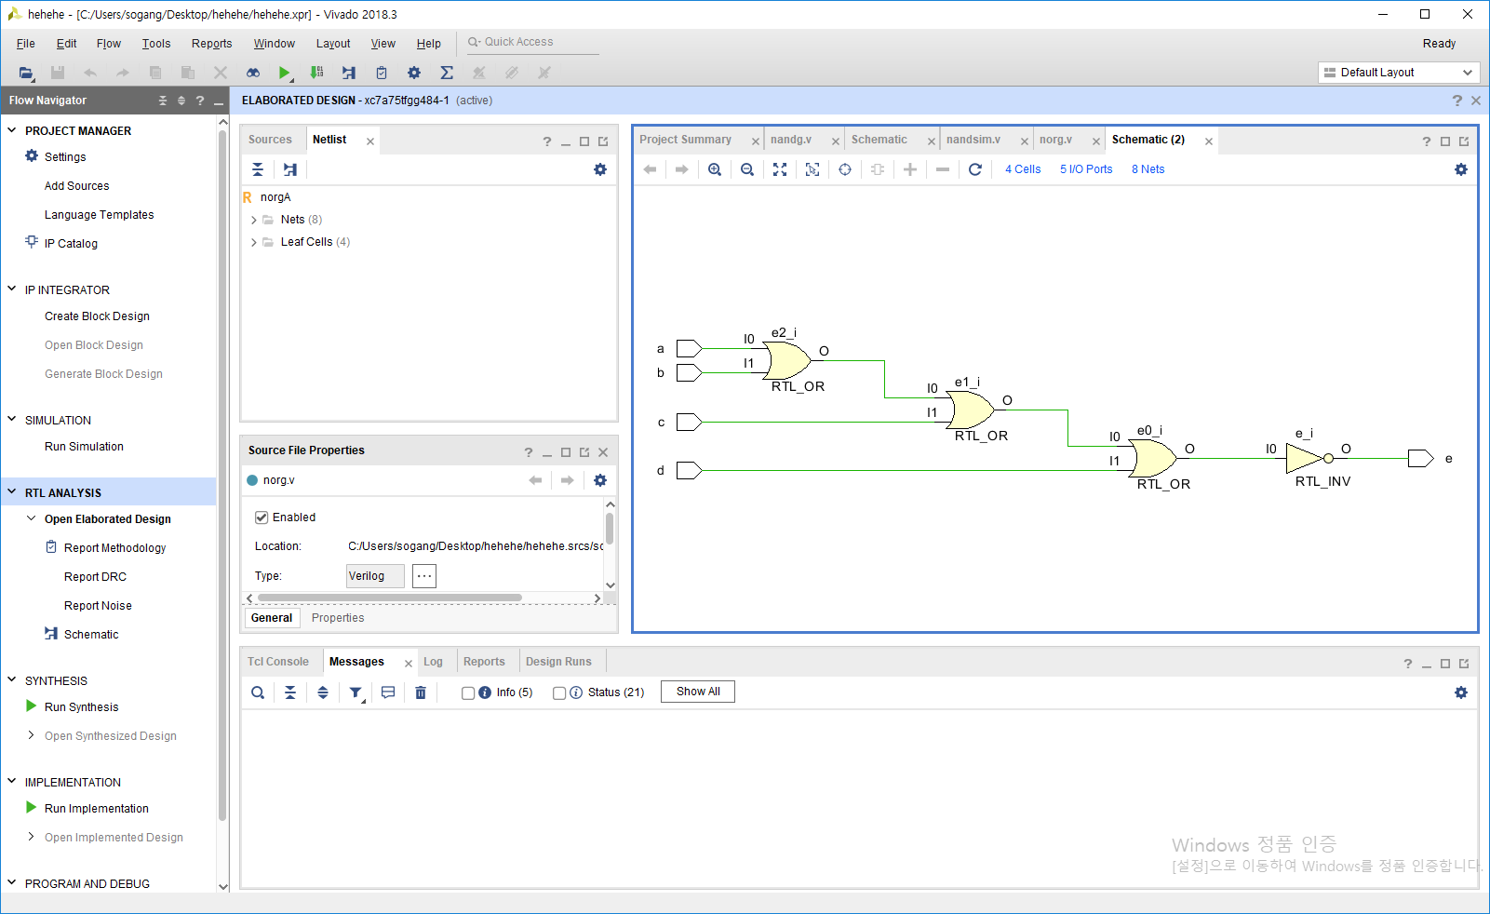

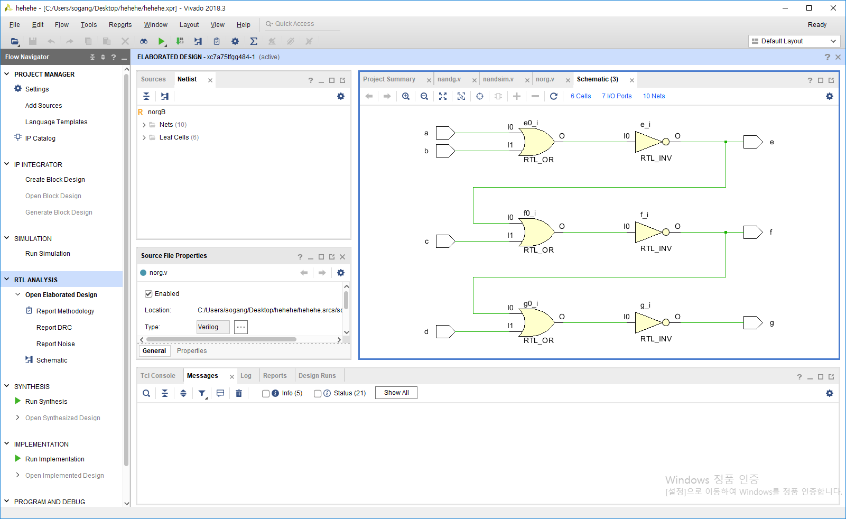

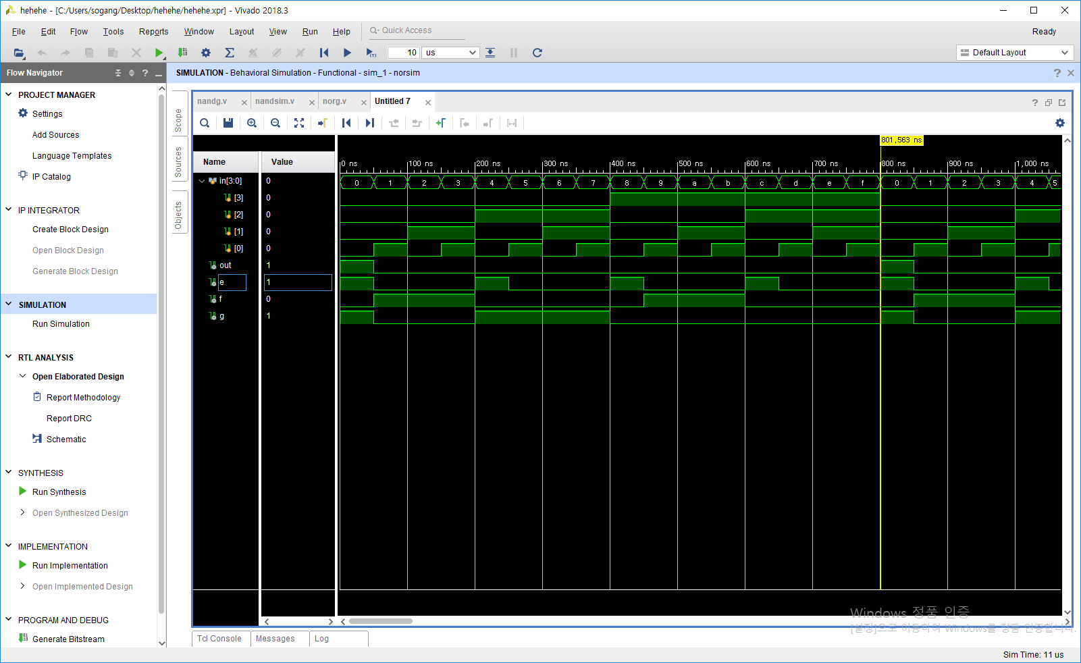

|  |  |  |  |  |  |  |
| --- | --- | --- | --- | --- | --- | --- |
| **In A** | **In B** | **In C** | **In D** | **Out E** | **Out F** | **Out G** |
| 0 | 0 | 0 | 0 | 1 | 0 | 1 |
| 0 | 0 | 0 | 1 | 0 | 1 | 0 |
| 0 | 0 | 1 | 0 | 0 | 1 | 0 |
| 0 | 0 | 1 | 1 | 0 | 1 | 0 |
| 0 | 1 | 0 | 0 | 1 | 0 | 1 |
| 0 | 1 | 0 | 1 | 0 | 0 | 1 |
| 0 | 1 | 1 | 0 | 0 | 0 | 1 |
| 0 | 1 | 1 | 1 | 0 | 0 | 1 |
| 1 | 0 | 0 | 0 | 1 | 0 | 0 |
| 1 | 0 | 0 | 1 | 0 | 1 | 0 |
| 1 | 0 | 1 | 0 | 0 | 1 | 0 |
| 1 | 0 | 1 | 1 | 0 | 1 | 0 |
| 1 | 1 | 0 | 0 | 1 | 0 | 0 |
| 1 | 1 | 0 | 1 | 0 | 0 | 0 |
| 1 | 1 | 1 | 0 | 0 | 0 | 0 |
| 1 | 1 | 1 | 1 | 0 | 0 | 0 |

XOR

A^B^C^D = (((A^B)^C)^D) ?

Verilog code

`timescale 1ns / 1ps

module xorga(

input a, b, c, d,

output e

);

assign e = a^b^c^d;

endmodule

module xorgb(

input a, b, c, d,

output e, f, g

);

assign e = a^b;

assign f = e^c;

assign g = f^d;

endmodule

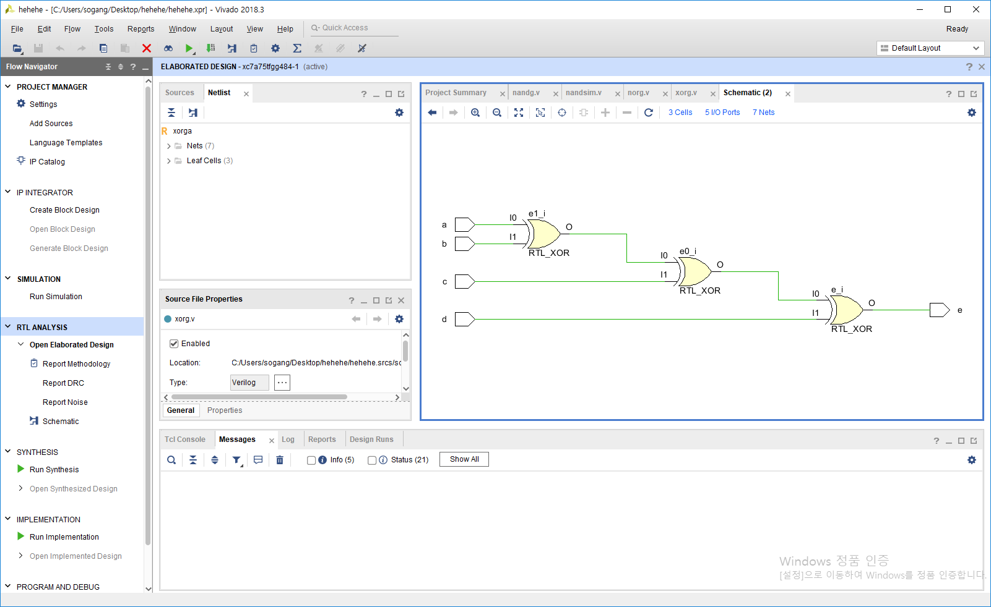

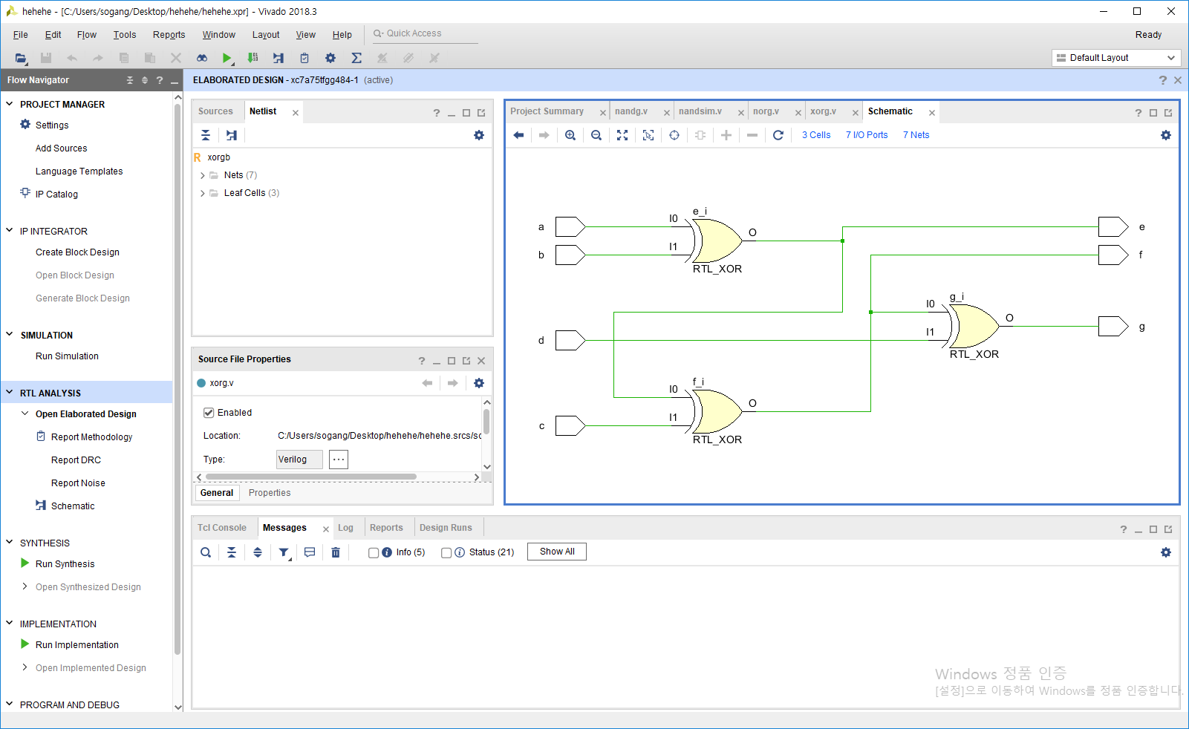

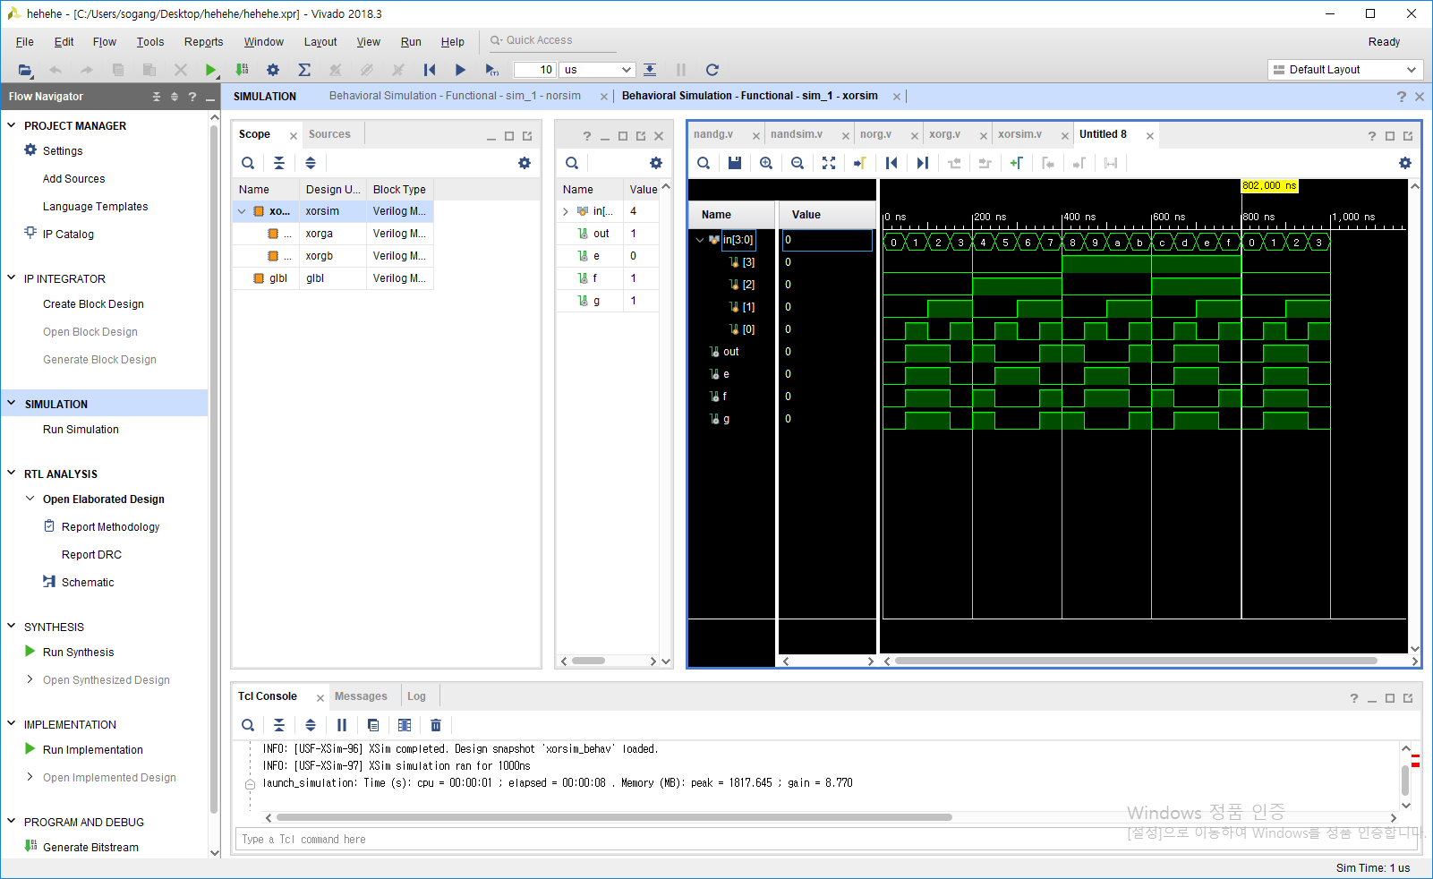

|  |  |  |  |  |  |  |
| --- | --- | --- | --- | --- | --- | --- |
| **In A** | **In B** | **In C** | **In D** | **Out E** | **Out F** | **Out G** |
| 0 | 0 | 0 | 0 | 0 | 0 | 0 |
| 0 | 0 | 0 | 1 | 1 | 1 | 1 |
| 0 | 0 | 1 | 0 | 1 | 1 | 1 |
| 0 | 0 | 1 | 1 | 0 | 0 | 0 |
| 0 | 1 | 0 | 0 | 0 | 1 | 1 |
| 0 | 1 | 0 | 1 | 1 | 0 | 0 |
| 0 | 1 | 1 | 0 | 1 | 0 | 0 |
| 0 | 1 | 1 | 1 | 0 | 1 | 1 |
| 1 | 0 | 0 | 0 | 0 | 0 | 1 |
| 1 | 0 | 0 | 1 | 1 | 1 | 0 |
| 1 | 0 | 1 | 0 | 1 | 1 | 0 |
| 1 | 0 | 1 | 1 | 0 | 0 | 1 |
| 1 | 1 | 0 | 0 | 0 | 1 | 0 |
| 1 | 1 | 0 | 1 | 1 | 0 | 1 |
| 1 | 1 | 1 | 0 | 1 | 0 | 1 |
| 1 | 1 | 1 | 1 | 0 | 1 | 0 |

AOI

Boolean equation

`timescale 1ns / 1ps

module aoi(

input a, b, c, d,

output e

);

assign e = ~((a&b)|(c&d));

endmodule

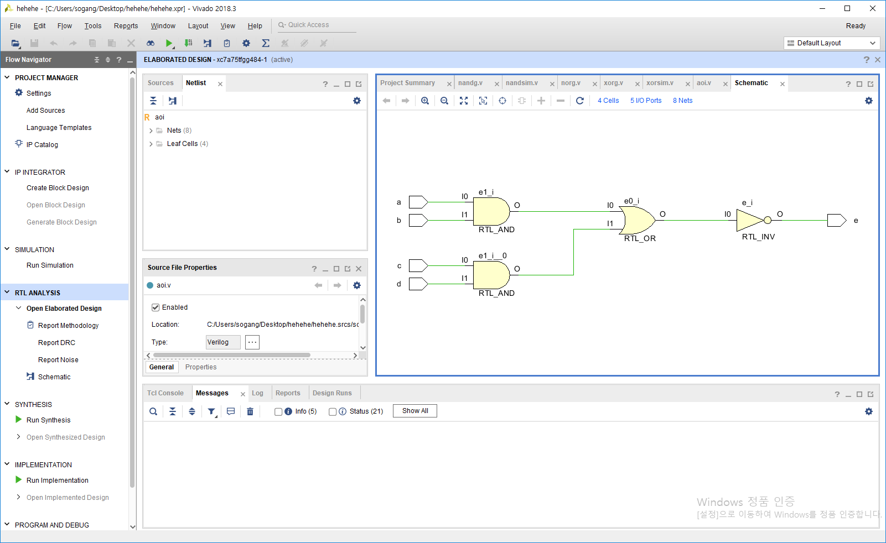

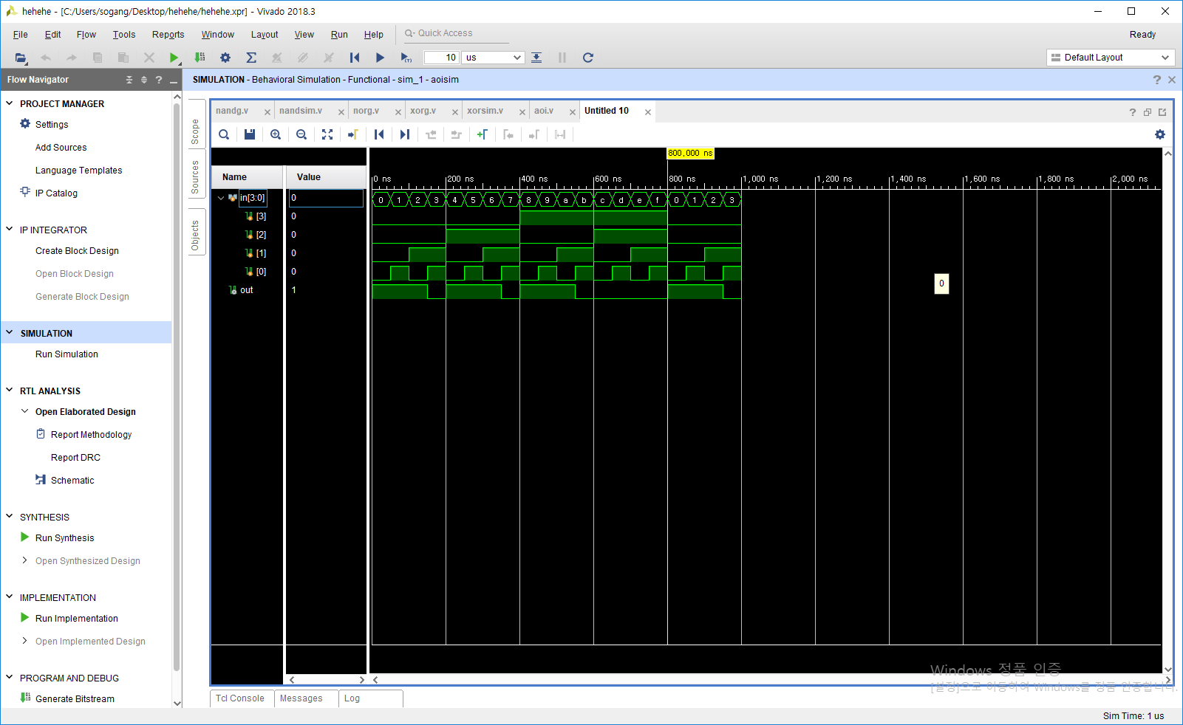

|  |  |  |  |  |
| --- | --- | --- | --- | --- |
| **In A** | **In B** | **In C** | **In D** | **Out E** |
| 0 | 0 | 0 | 0 | 1 |
| 0 | 0 | 0 | 1 | 1 |
| 0 | 0 | 1 | 0 | 1 |
| 0 | 0 | 1 | 1 | 0 |
| 0 | 1 | 0 | 0 | 1 |
| 0 | 1 | 0 | 1 | 1 |
| 0 | 1 | 1 | 0 | 1 |
| 0 | 1 | 1 | 1 | 0 |
| 1 | 0 | 0 | 0 | 1 |
| 1 | 0 | 0 | 1 | 1 |
| 1 | 0 | 1 | 0 | 1 |
| 1 | 0 | 1 | 1 | 0 |
| 1 | 1 | 0 | 0 | 0 |
| 1 | 1 | 0 | 1 | 0 |
| 1 | 1 | 1 | 0 | 0 |
| 1 | 1 | 1 | 1 | 0 |