Half adder

Verilog code

Kmap(sop)

schematic

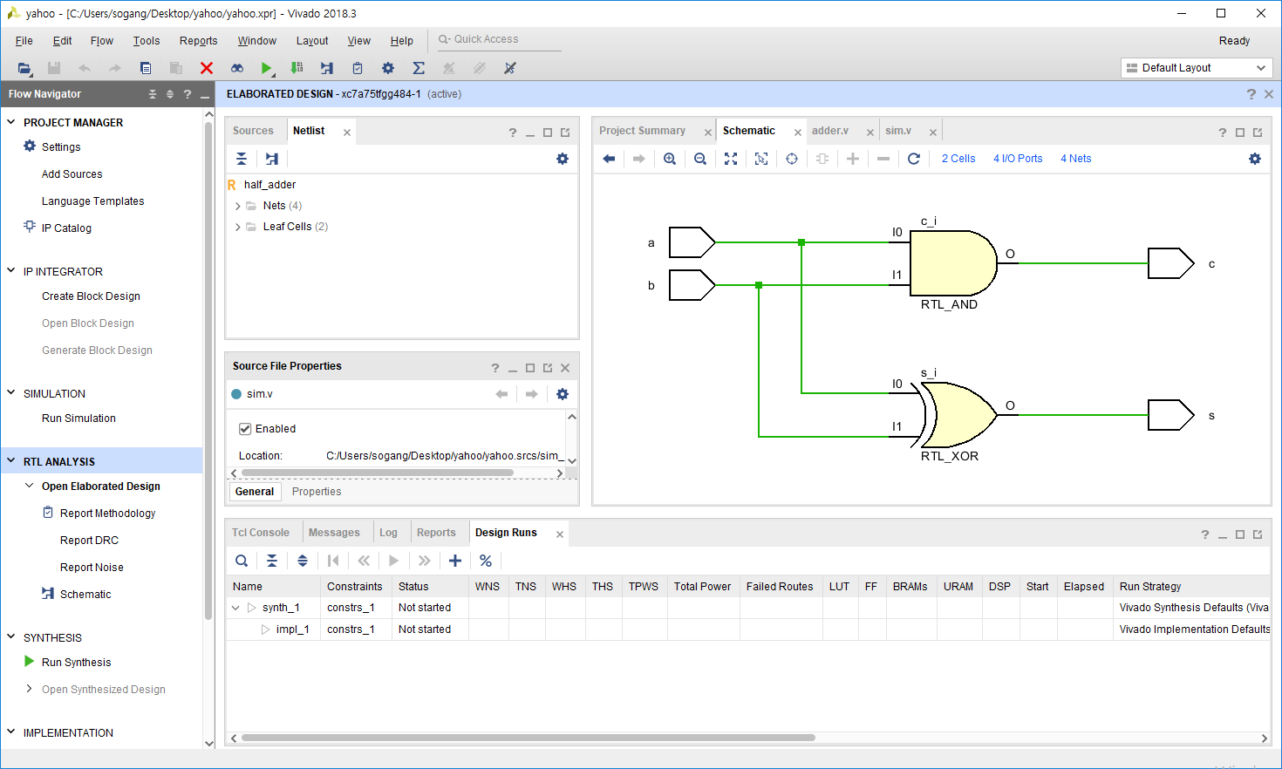

simulation

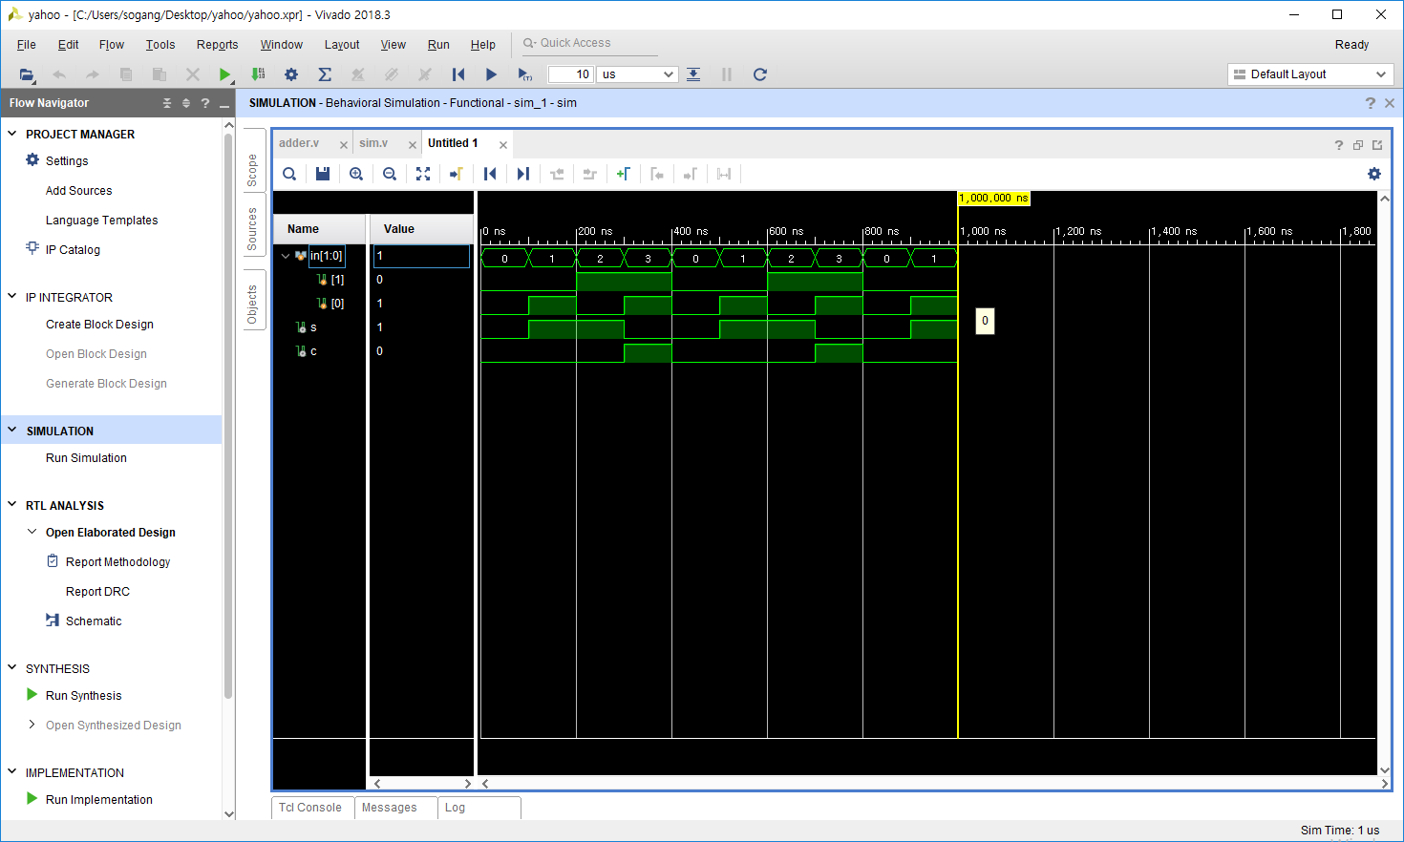

Truth table

|  |  |  |  |
| --- | --- | --- | --- |
| **Input** | | **Output** | |
| A | B | S | C |
| 0 | 0 | 0 | 0 |
| 0 | 1 | 1 | 0 |
| 1 | 0 | 1 | 0 |
| 1 | 1 | 0 | 1 |

Fpga

Full adder

|  |  |  |  |  |
| --- | --- | --- | --- | --- |
| **Input** | | | **Output** | |
| Cin | B | A | S | Cout |
| 0 | 0 | 0 | 0 | 0 |
| 0 | 0 | 1 | 1 | 0 |
| 0 | 1 | 0 | 1 | 0 |
| 0 | 1 | 1 | 0 | 1 |
| 1 | 0 | 0 | 1 | 0 |
| 1 | 0 | 1 | 0 | 1 |
| 1 | 1 | 0 | 0 | 1 |
| 1 | 1 | 1 | 1 | 1 |

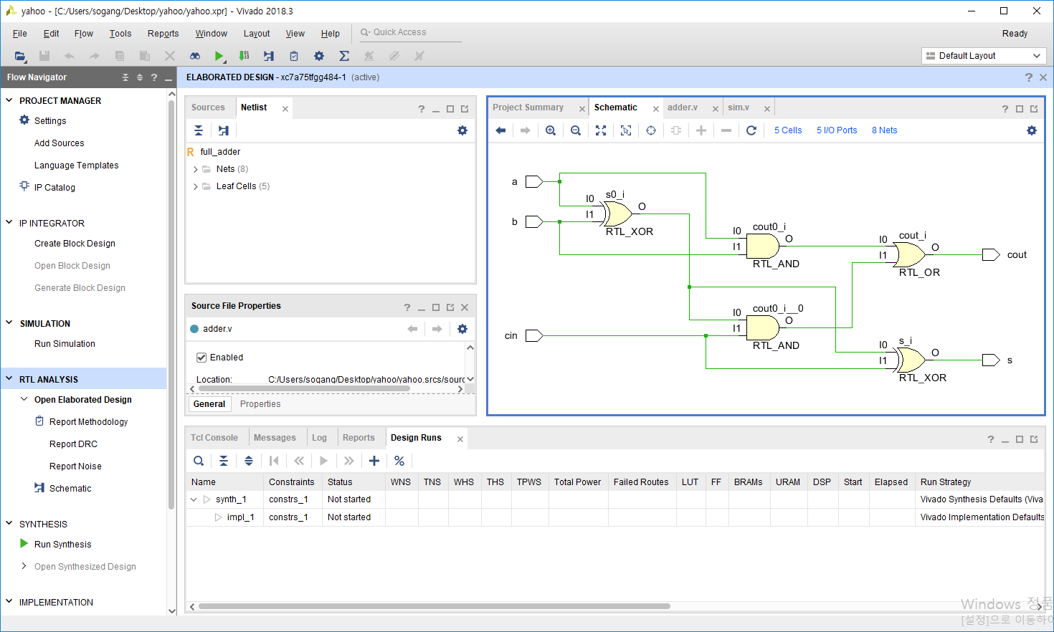

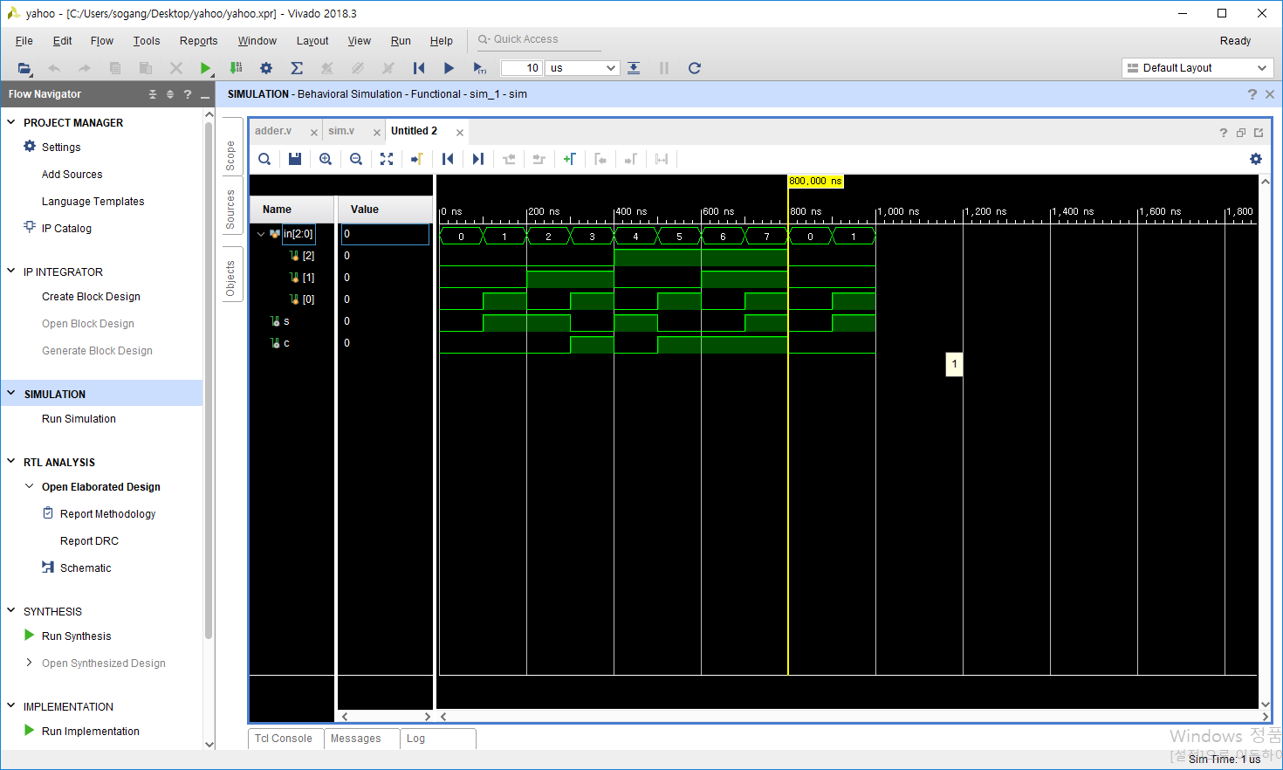

Half sub

|  |  |  |  |
| --- | --- | --- | --- |
| **Input** | | **Output** | |
| A | B | borrow | D |
| 0 | 0 | 0 | 0 |
| 0 | 1 | 1 | 1 |
| 1 | 0 | 0 | 1 |
| 1 | 1 | 0 | 0 |

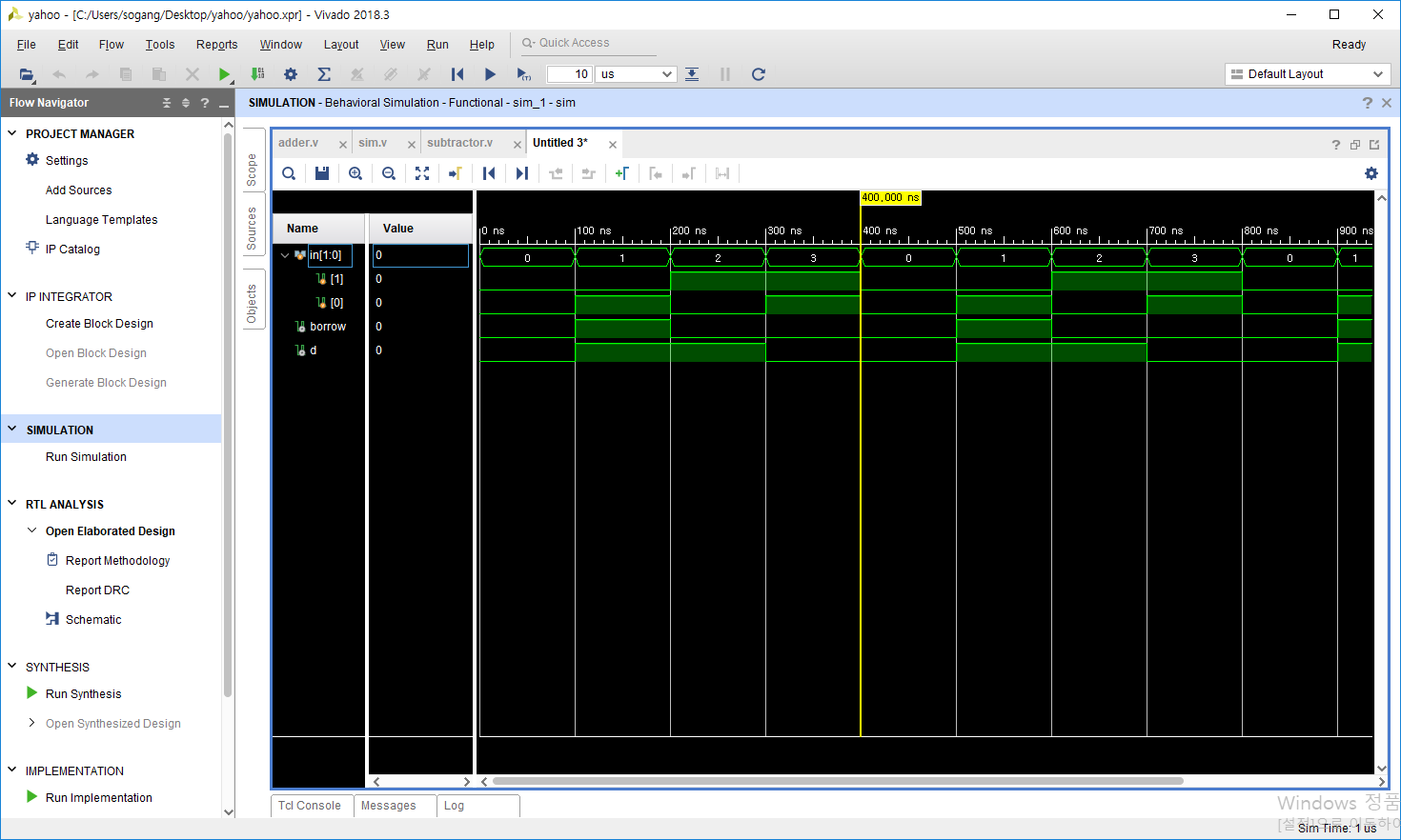

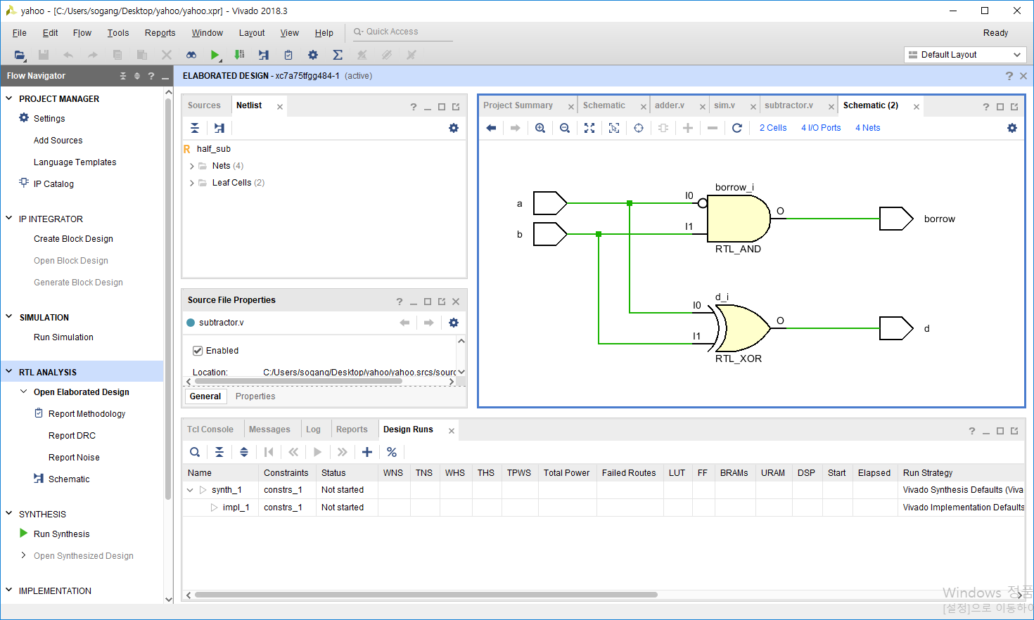

|  |  |  |  |  |
| --- | --- | --- | --- | --- |
| **Input** | | | **Output** | |
| An | Bn | Bn-1 | bn | Dn |
| 0 | 0 | 0 | 0 | 0 |
| 0 | 0 | 1 | 1 | 1 |
| 0 | 1 | 0 | 1 | 1 |
| 0 | 1 | 1 | 1 | 0 |
| 1 | 0 | 0 | 0 | 1 |
| 1 | 0 | 1 | 0 | 0 |
| 1 | 1 | 0 | 0 | 0 |
| 1 | 1 | 1 | 1 | 1 |

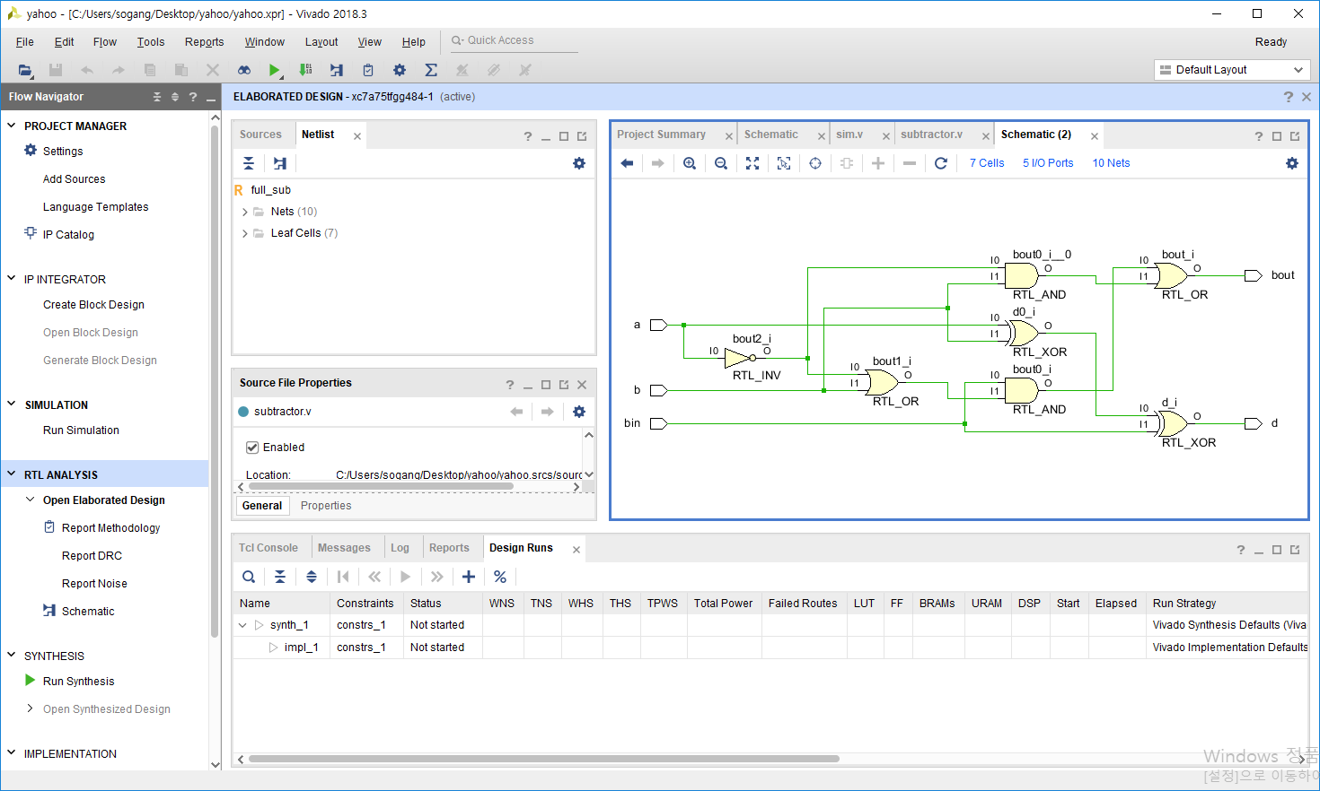

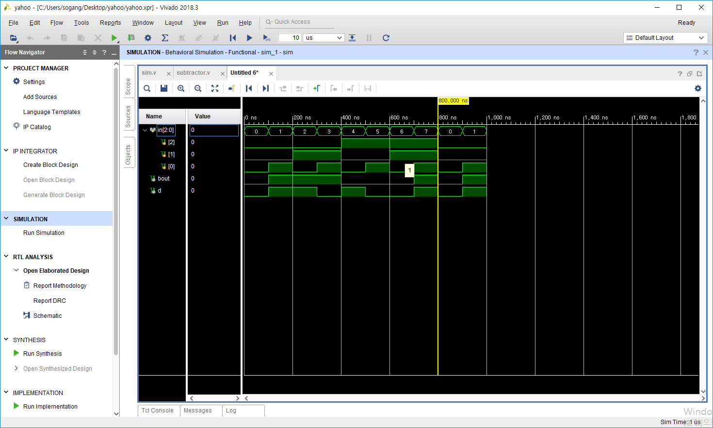

8421 to 2421

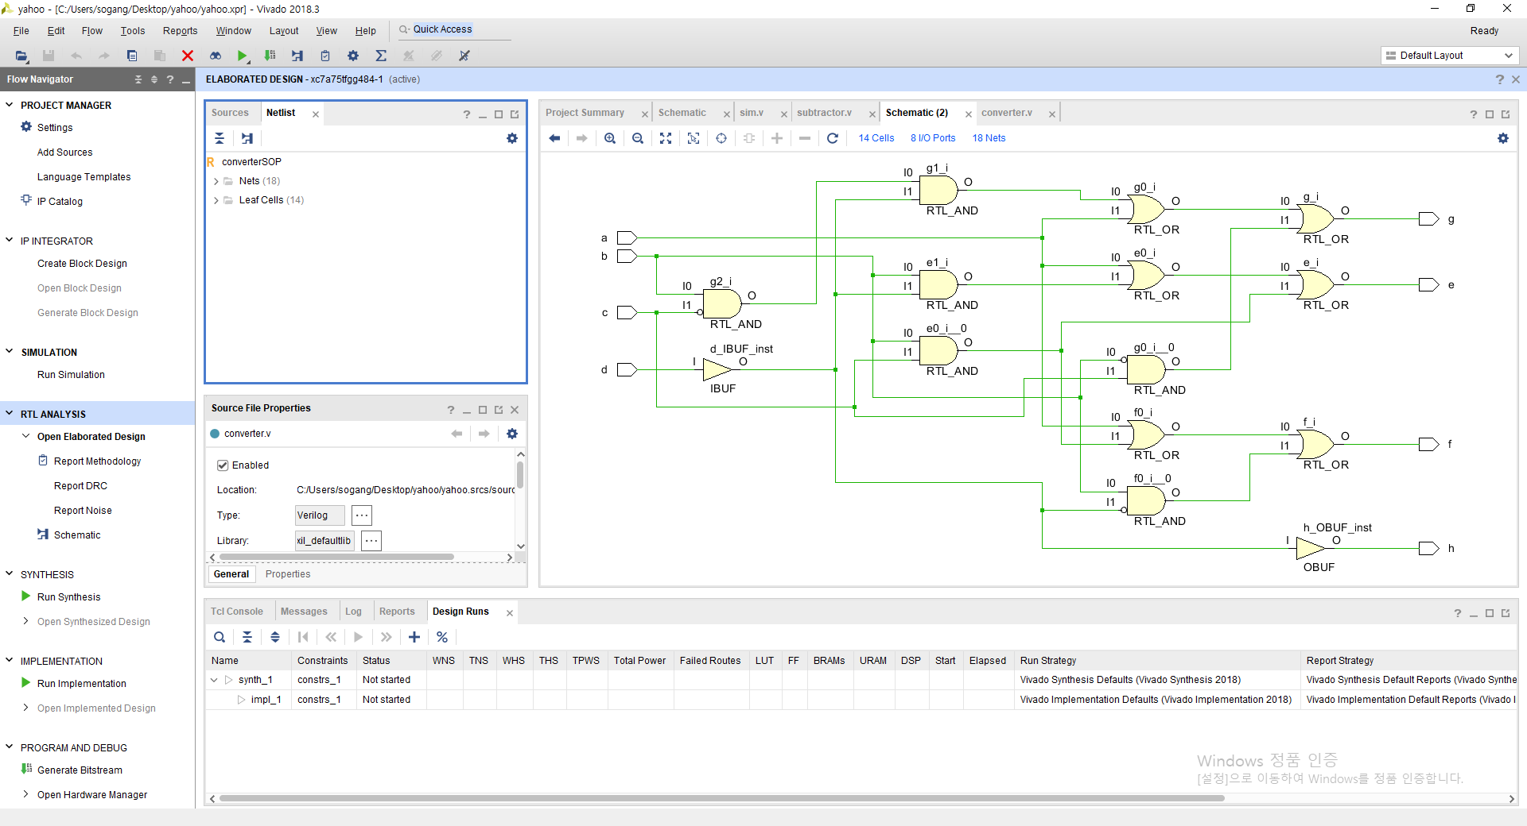

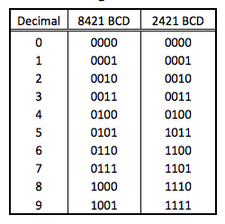

|  |  |  |  |  |  |  |  |  |
| --- | --- | --- | --- | --- | --- | --- | --- | --- |
|  | A | B | C | D | E | F | G | H |
| 0 | 0 | 0 | 0 | 0 | 0 | 0 | 0 | 0 |
| 1 | 0 | 0 | 0 | 1 | 0 | 0 | 0 | 1 |
| 2 | 0 | 0 | 1 | 0 | 0 | 0 | 1 | 0 |
| 3 | 0 | 0 | 1 | 1 | 0 | 0 | 1 | 1 |
| 4 | 0 | 1 | 0 | 0 | 0 | 1 | 0 | 0 |
| 5 | 0 | 1 | 0 | 1 | 1 | 0 | 1 | 1 |
| 6 | 0 | 1 | 1 | 0 | 1 | 1 | 0 | 0 |
| 7 | 0 | 1 | 1 | 1 | 1 | 1 | 0 | 1 |
| 8 | 1 | 0 | 0 | 0 | 1 | 1 | 1 | 0 |
| 9 | 1 | 0 | 0 | 1 | 1 | 1 | 1 | 1 |
| 10 | 1 | 0 | 1 | 0 | x | x | x | x |
| 11 | 1 | 0 | 1 | 1 | x | x | x | x |
| 12 | 1 | 1 | x | x | x | x | x | x |

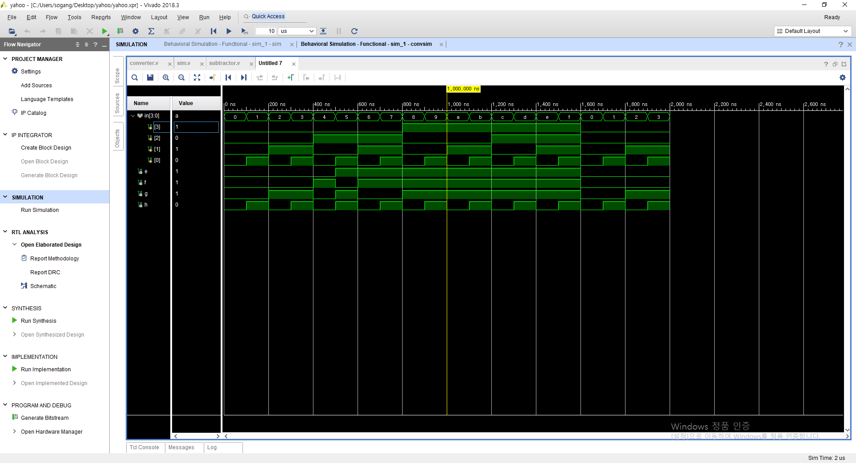

9이후 don’t care