Parity bit generator

|  |  |  |  |  |
| --- | --- | --- | --- | --- |
| **In A** | **In B** | **In C** | **In D** | **Out P** |
| 0 | 0 | 0 | 0 | 0 |
| 0 | 0 | 0 | 1 | 1 |
| 0 | 0 | 1 | 0 | 1 |
| 0 | 0 | 1 | 1 | 0 |
| 0 | 1 | 0 | 0 | 1 |
| 0 | 1 | 0 | 1 | 0 |
| 0 | 1 | 1 | 0 | 0 |
| 0 | 1 | 1 | 1 | 1 |
| 1 | 0 | 0 | 0 | 1 |
| 1 | 0 | 0 | 1 | 0 |
| 1 | 0 | 1 | 0 | 0 |
| 1 | 0 | 1 | 1 | 1 |
| 1 | 1 | 0 | 0 | 0 |
| 1 | 1 | 0 | 1 | 1 |
| 1 | 1 | 1 | 0 | 1 |
| 1 | 1 | 1 | 1 | 0 |

`timescale 1ns / 1ps

module ParityGen(

input a, b, c, d,

output p

);

assign p = (a^b)^(c^d);

endmodule

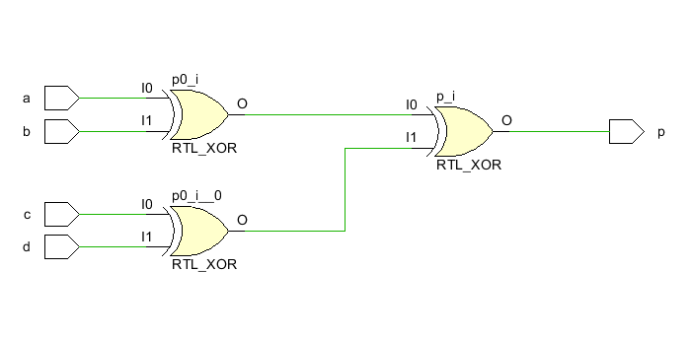

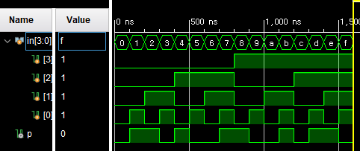

Parity checker

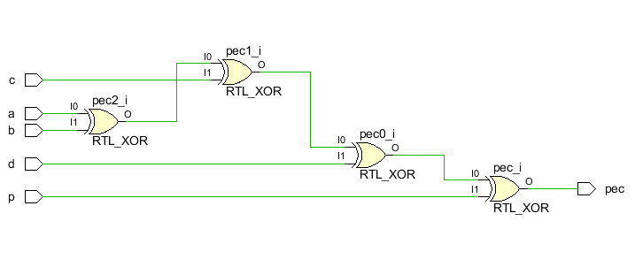

|  |  |  |  |  |  |
| --- | --- | --- | --- | --- | --- |
| a | b | c | d | p | pec |
| 1 | 1 | 1 | 0 | 0 | 1 |
| 1 | 1 | 1 | 0 | 1 | 0 |
| 1 | 1 | 1 | 1 | 0 | 0 |
| 1 | 1 | 1 | 1 | 1 | 1 |
| 1 | 1 | 0 | 0 | 0 | 0 |
| 1 | 1 | 0 | 0 | 1 | 1 |
| 1 | 1 | 0 | 1 | 0 | 1 |
| 1 | 1 | 0 | 1 | 1 | 0 |
| 1 | 0 | 1 | 0 | 0 | 0 |
| 1 | 0 | 1 | 0 | 1 | 1 |
| 1 | 0 | 1 | 1 | 0 | 1 |
| 1 | 0 | 1 | 1 | 1 | 0 |
| 1 | 0 | 0 | 0 | 0 | 1 |
| 1 | 0 | 0 | 0 | 1 | 0 |
| 1 | 0 | 0 | 1 | 0 | 0 |
| 1 | 0 | 0 | 1 | 1 | 1 |
| 0 | 1 | 1 | 0 | 0 | 0 |
| 0 | 1 | 1 | 0 | 1 | 1 |
| 0 | 1 | 1 | 1 | 0 | 1 |
| 0 | 1 | 1 | 1 | 1 | 0 |
| 0 | 1 | 0 | 0 | 0 | 1 |
| 0 | 1 | 0 | 0 | 1 | 0 |
| 0 | 1 | 0 | 1 | 0 | 0 |
| 0 | 1 | 0 | 1 | 1 | 1 |
| 0 | 0 | 1 | 0 | 0 | 1 |
| 0 | 0 | 1 | 0 | 1 | 0 |
| 0 | 0 | 1 | 1 | 0 | 0 |
| 0 | 0 | 1 | 1 | 1 | 1 |
| 0 | 0 | 0 | 0 | 0 | 0 |
| 0 | 0 | 0 | 0 | 1 | 1 |
| 0 | 0 | 0 | 1 | 0 | 1 |
| 0 | 0 | 0 | 1 | 1 | 0 |

module ParityCheck(

input a, b, c, d, p,

output pec

);

assign pec = a^b^c^d^p;

endmodule

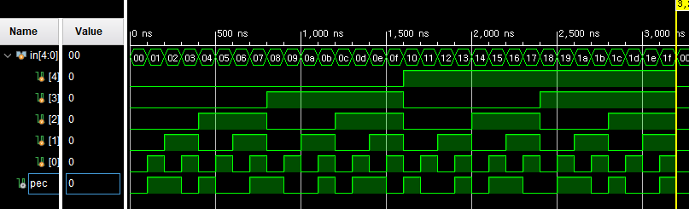

2 bit binary comparator

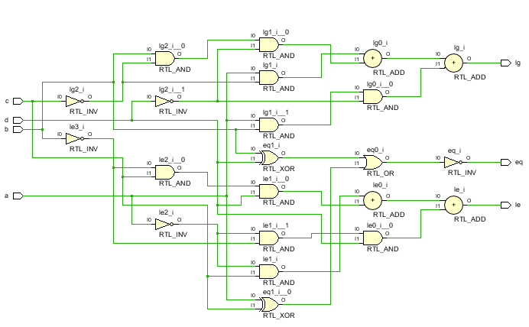

|  |  |  |  |  |  |  |
| --- | --- | --- | --- | --- | --- | --- |
| **In A** | **In B** | **In C** | **In D** | **Out F1** | **Out F2** | **Out F3** |
| 0 | 0 | 0 | 0 | 0 | 1 | 0 |
| 0 | 0 | 0 | 1 | 0 | 0 | 1 |
| 0 | 0 | 1 | 0 | 0 | 0 | 1 |
| 0 | 0 | 1 | 1 | 0 | 0 | 1 |
| 0 | 1 | 0 | 0 | 1 | 0 | 0 |
| 0 | 1 | 0 | 1 | 0 | 1 | 0 |
| 0 | 1 | 1 | 0 | 0 | 0 | 1 |
| 0 | 1 | 1 | 1 | 0 | 0 | 1 |
| 1 | 0 | 0 | 0 | 1 | 0 | 0 |
| 1 | 0 | 0 | 1 | 1 | 0 | 0 |
| 1 | 0 | 1 | 0 | 0 | 1 | 0 |
| 1 | 0 | 1 | 1 | 0 | 0 | 1 |
| 1 | 1 | 0 | 0 | 1 | 0 | 0 |
| 1 | 1 | 0 | 1 | 1 | 0 | 0 |
| 1 | 1 | 1 | 0 | 1 | 0 | 0 |
| 1 | 1 | 1 | 1 | 0 | 1 | 0 |

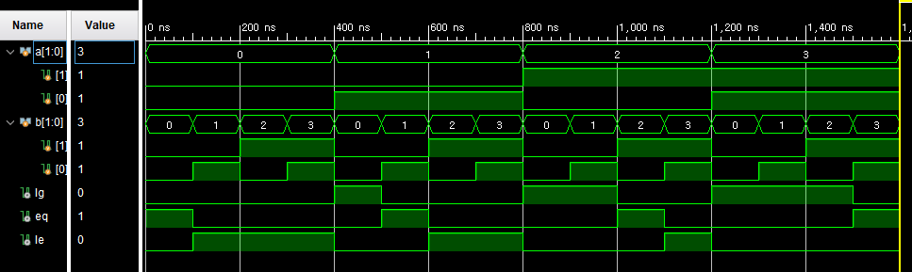

module cmp(

input a, b, c, d,

//input a1, a0, b1, b0,

output lg, eq, le

);

/*wire x1, x0;

assign x1 = a1&b1+~a1&~b1;

assign x0 = a0&b0+~a0&~b0;

assign eq = x0&x1;

assign lg = a1&~b1+x1&a0&~b0;

assign le = ~a1&b1+x1&~a0&b0;*/

//assign eq = ~a1&~a0&~b1&~b0 + ~a1&a0&~b1&b0 + a1&~a0&b1&~b0 + a1&a0&b1&b0;

//assign lg = a1&~b1 + a0&~b1&~b0 + a1&a0&~b0;

//assign le = ~a1&b1 + ~a0&b1&b0 + ~a1&~a0&b0;

assign lg = (a&~c)+(b&~c&~d)+(a&b&~d);

assign eq = ~((b^d)|(a^c));

assign le = (~a&c)+(~b&c&d)+(~a&~b&d);

endmodule