**Experiment no: 03**

Question no.1. What is least squares approximation of functions? Explain it.

Answer: Least squares is a statistical method used to determine a line of best fit by minimizing the [sum of squares](https://www.investopedia.com/terms/s/sum-of-squares.asp) created by a mathematical function. A "square" is determined by squaring the distance between a data point and the regression line or mean value of the data set. The least squares approach limits the distance between a function and the data points that a function is trying to explain. It is used in regression analysis, often in [nonlinear regression](https://www.investopedia.com/terms/n/nonlinear-regression.asp) modeling in which a curve is fit into a set of data.

2. Why it is important for an engineer?

Answer: Importance of Linear regression:

1. Studying engine performance from test data in automobiles
2. Least squares regression is used to model causal relationships between parameters in biological systems
3. OLS regression can be used in weather data analysis
4. Linear regression can be used in market research studies and customer survey results analysis
5. Linear regression is used in observational astronomy commonly enough. A number of statistical tools and methods are used in astronomical data analysis, and there are entire libraries in languages like Python meant to do data analysis in astrophysics.

Main file from example:

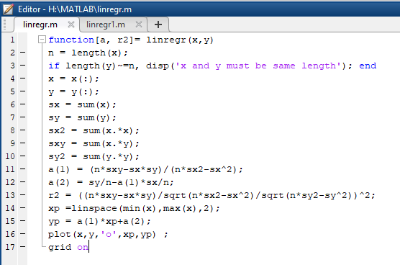

Input File & Output command window:

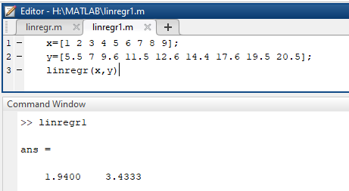

Output curve:

