Experiment No: 04

Question no.1: What is the main difference between interpolation and least square approximation?

Answer: The main difference between interpolation and least square approximation are:

|  |  |
| --- | --- |
| Interpolation  approximation | Least square  approximation |
| * Interpolation is such approximation, in which the function φ (x) goes exactly through given points [xi, yi ] , where yi =f (xi ) . Sometimes we also require that functions f and φ have the same derivatives in points xi. | * Least-square method is such approximation, in which φ (x) is interlaced between given points [xi, yi] in such a way, that the distance between functions f and φ is in some sense minimal. Usually the function φ (x) does not go through points [xi, yi]. |
| * Interpolation is like an algorithm without a "brain": it tries to achieve perfect match to the given data | * Regression is the same algorithm with the power to generalize. It won't fit perfectly to your data but at least it will try to learn some insights from it. |

Main file of lab sheet example:

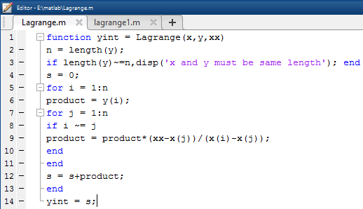

Input file: Output in command window:

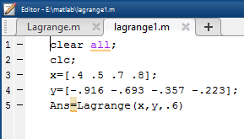 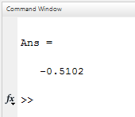

Question no.2. Make a m-file to implement Inverse Lagrange Interpolation.

Problem: Given the following tables of values

|  |  |  |  |  |
| --- | --- | --- | --- | --- |
| X | 0.4 | 0.5 | 0.7 | 0.8 |
| Y | -0.916 | -0.693 | -0.357 | -0.223 |

Find the value of x when y=0.6

Answer:

Main File:

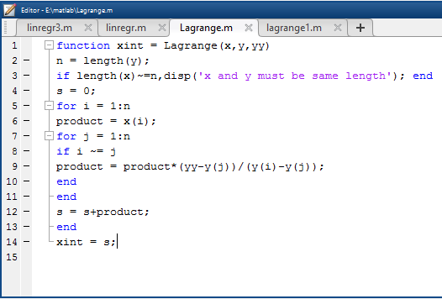

Input File: 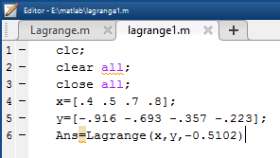

On command Window: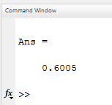

Note: So we can see that the result of the inverse Lagrange opposite to the inverse Lagrange output.

Question no.3. Is it possible to find the value of f (0.9) using the above m-file? Justify your answer.

Answer: Yes, it is possible.

Main file:

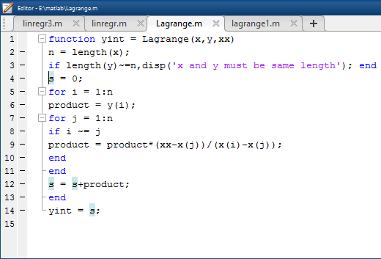

Input File: Output on command window:

