Experiment No.5

Program Name: An M-File to implement Newton interpolation.

Problem: Values of x (in degrees) and sin x are given in the following table:

|  |  |  |  |  |  |  |
| --- | --- | --- | --- | --- | --- | --- |
| x (in degrees) | 15 | 20 | 25 | 30 | 35 | 40 |
| sin x | 0.258819 | 0.3420201 | .4226183 | .5 | .5735764 | .6427876 |

Determine the value of sin 38°.

Main File:

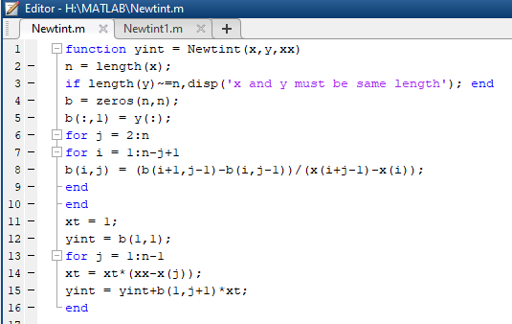

Input & output file:

