Experiment No.6

Program Name: An M-File to implement the Trapezoidal Rule.

Problem: Evaluate I = ∫11+𝑥𝑑𝑥10 correct to three decimal places with h=0.125.

Main File:

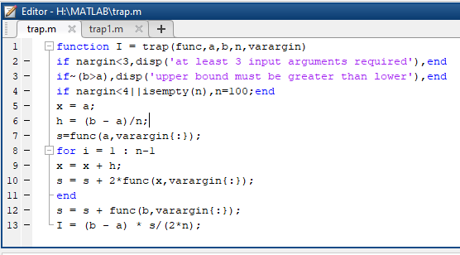

Input & output file:

