Experiment No.7

Program Name: An M-File to implement the Trapezoidal Rule for unequally spaced data.

Problem: Use the information in the following Table to integrate the function f(x) = 0.2 + 25x − 200x2 + 675x3 − 900x4 + 400x5.

|  |  |  |  |  |  |  |
| --- | --- | --- | --- | --- | --- | --- |
| x | 0 | .12 | .22 | .32 | .36 | .40 |
| f(x) | .2000 | 1.309729 | 1.3052 | 1.743393 | 2.074903 | 2.45600 |

|  |  |  |  |  |  |  |
| --- | --- | --- | --- | --- | --- | --- |
| x | .44 | .54 | .64 | .70 | .80 |  |
| f(x) | 2.842985 | 3.507297 | 3.181929 | 2.363000 | .23200 |  |

Main File:

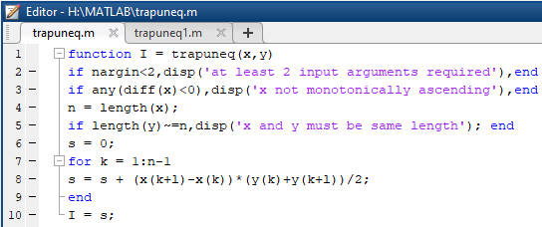

Input & output file:

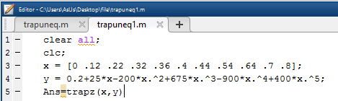

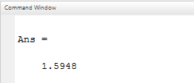

Question no.1. Compare the above program with previous program (Matlab Program No:06)

Answer: The above program is used for equally spaced data and this program is used as unequally spaced data.

Question no.2. Is it possible to implement Trapezoidal rule for equally spaced data by the above program?

Answer: Yes, it is possible to implement Trapezoidal rule for equally spaced data by the above program.